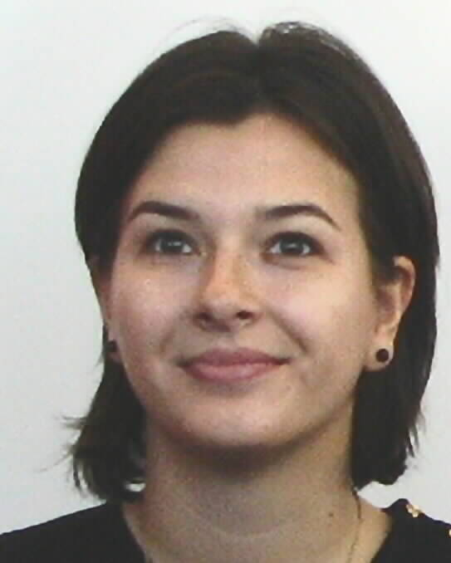 **TEODORA VELU**

Kirchbodenstrasse 80, 8800 Thalwil(ZH), Switzerland

Telephone +41 79 1295808;

email: [velu_teodora@yahoo.com](mailto:velu_teodora@yahoo.com)

B – work permit

**INTERNATIONAL HR PROFESSIONAL**

Results oriented HR professional with broad experience in all HR areas including Project Management, Business Partner, HR processes, Recruitment, HR Technology, Employee Engagement, Performance Management. Highly effective at adapting to international, fast paced organizations with challenging client groups and projects. Open for expanding responsibilities while taking new professional and personal growth opportunities in either HR function or Project Management area.

**CAREER HISTORY**

10.2014 - **HR PROCESS EXCELLENCE LEAD EU**

Present **Mondelez Europe GmbH(former Kraft Foods), HQ, Zurich, Switzerland**

* Report to Director HR Solutions, EU
* HR Process Expert and integral member of the Mondelez Business Services Hire To Retire Project team
* Project Manager for process mapping, fit-gap analysis, standard operating procedures writing across EU
* Lead and drive key business HR projects with focus on process optimization and standardization on local and regional level
* Change Manager for the HR Employee Center upgrade, Global Mobility Policies change, Echo-sign implementation etc.
* Support and enable the Mondelez Europe HR Solutions Leadership team and associated agenda;

01.2013 - **HR COORDINATOR (Commercial & Global Chocolate)**

09.2014 **Mondelez Europe GmbH(former Kraft Foods), HQ, Zurich, Switzerland**

* Reported to Manager HR Solutions, CH
* Supported all operational and administrative HR topics for the regional commercial categories and functions in the European Head Office
* Established solid partnerships with HRBLs, people managers, employees in order to provide first-class solutions and delivery
* Improved/redesigned processes within the HR Solutions team
* Created value through projects I lead or I was member of(Echo-sign implementation, Employee events for expats, Contractors management)
* Launched the Mondelez Management Assistants Academy – learning and development platform for the Assistants in Mondelez headquarters

11.2011 - **HR COORDINATOR (Swiss Headquarter and UK)**

10.2012 **Biogen Idec HQ, Zug, Switzerland**

* Reported to Senior HR Director Europe, 400 employees in portfolio
* Mapped all HR processes in all european sites which enabled the setup of the HR Shared Services
* Provided high quality customer service on all HR matters to all employees in the UK and Swiss business units
* Designed and delivered the monthly HQ Newsletter

06.2010 - **HR MANAGER**

10.2011 **Ford Romania S.A. - National Sales Company**

* Reported to Managing Director(dotted line reported to HR Director Europe)
* Ramped up the new commercial national Ford office organization
* Ensured effective communication to/from employees and company management resulting in improved working environment
* Monitored smart business objectives for all employees with annual performance reviews and detailed development plans
* Managed compensation reviews, salary benchmarks, 360 evaluations
* Increased employee satisfaction for their employer with over 30 % based on executed, dedicated HR actions
* Implemented a detailed succession planning tool to exchange expatriates with locals for costly reasons

11.2008 – **HR ANALYST**

06.2010 **BearingPoint GmbH Germany Romanian Branch**

* Reported to HR Senior Consultant, 60 employees
* Provided support in all HR administrative matters
* Ensured accuracy for submitted payroll data, delivered pay slip, answered relevant questions to employees
* Facilitated employees’ visas and work permits application(e.g. E101)
* Improved employees’ benefits system
* Conducted entire recruitment process for all IT & Accounting open positions
* Implemented successfully the SAP HR (Time & Attendance) module

11.2007 - **HR ASSISTANT**

11.2008 **AVIA MOTORS (Skoda Dealership)**

* Reported to HR Director, 200 employees
* Assisted HR Department in all HR related matters (Personnel administration, Time Management)
* Identified new recruiting channels based on open positions’ particularities
* Run the primary recruiting and selection process
* Maintained good connection with the Romanian Labor Authorities
* Kept updated the Job Descriptions
* Developed and assisted the implementation of orientation programs for new hires

05.2006 - **PR ASSISTANT**

11.2007 **Huawei Technologies S.R.L.**

* Reported to Visa Manager, 300 employees
* Coordinated the entire process for obtaining work or residence permit according to law
* Improved relations with the Romanian institutions
* Optimized waiting time needed for obtaining visa/work/residence permit
* Reduced the penalties costs generated by exceeding the allowed reside time

**ACADEMIC QUALIFICATIONS**

2007-2009 Titu Maiorescu University

**Master of Psychology in Human Resources**

2003-2007 University of Bucharest

**Bachelor in Psychology and Science of Education**

**LANGUAGE SKILLS**

Romanian: mother tongue English: Fluent

German: Intermediate-B1- taking classes French: Beginner

**ADDITIONAL SKILLS**

SAP (CATS, SHARP), ADOBE ECHO-SIGN, IREQUEST, ORACLE, LOTUS NOTES, PEOPLE SOFT, MDS, IRIS, ETC.