"45-DAYS DATA ANALYST REMOTE INTERNSHIP AT ELEVATE LABS"

A PROJECT REPORT
Submitted in partial fulfilment of the requirement for the award of the degree
of
BACHELOR OF TECHNOLOGY (B. Tech)
in Information Technology
by

Gaurav Singh Shekhawat 229302573



Department of Information Technology
MANIPAL UNIVERSITY JAIPUR JAIPUR-303007
RAJASTHAN, INDIA

November 2025
Manipal University Jaipur




Date: 08/11/2025

CERTIFICATE

This is to certify that the project titled "45-Days Data Analyst Remote Internship" is a record of the Bonafide work done by GAURAV SINGH SHEKHAWAT (229302573) submitted in partial fulfilment of the requirements for the award of the Degree of Bachelor of Technology (B. Tech) in Information Technology of Manipal University Jaipur, during the academic year 2025-26.

Mr. Ravinder Kumar
Project Guide, Dept of Information Technology
Manipal University Jaipur

Dr. Pratishtha Mathur
HOD, Dept of Information Technology Manipal University Jaipur

Off Jaipur Ajmer Express Highway VPO Dehmi Kalan Tehsil Sanganer, Jaipur Rajasthan (INDIA) 303007 http://www.jaipur.manipal.edu

Date 08/11/2025

CERTIFICATE

This is to certify that the project entitled "45-Days Data Analyst Remote Internship" was carried out by GAURAV SINGH SHEKHAWAT (229302573) at ELEVATE LABS, BENGALURU under my guidance during August, 2025 to September 2025.

Mr. Rohan Gupta
Industrial Mentor Lead Data Analyst
Elevate Labs,
Bengaluru

ACKNOWLEDGMENTS

I would like to express my sincere gratitude to everyone who supported me throughout this industrial training.

I am deeply grateful to my industrial mentor, Mr. Rohan Gupta (Lead Data Analyst, Elevate Labs), for his invaluable guidance, mentorship, and for providing me with the opportunity to work on challenging, real-world projects.

I extend my heartfelt thanks to Dr. Pratistha Mathur (HoD, Department of Information Technology) and my faculty coordinator, Mr. Ravinder Kumar, for their support and for facilitating this training opportunity. Their encouragement and academic guidance were instrumental in bridging the gap between theory and practice.

My sincere thanks also go to the Dean of Engineering of Manipal University Jaipur, Dr. Kuldip Singh Sangwan, and all the faculty members of the Department of Information Technology whose assistance was sought during this project. Their collective support created a conducive learning environment.

Finally, I would like to thank my family and friends for their constant encouragement and belief in me.

ABSTRACT

This report details a 45-day intensive remote data analyst internship completed at Elevate Labs. The program was designed to provide practical, hands-on experience in the complete data analysis lifecycle, from raw data ingestion and cleaning to final interactive visualization and insight generation. The internship centered on mastering the synergy between industry-standard tools, requiring the use of SQL for data extraction, advanced MS Excel for data cleaning and preliminary analysis, and Power BI for sophisticated data modelling and business intelligence dashboarding.

The curriculum was project-based, consisting of six distinct weekly projects with progressively increasing complexity. These projects covered diverse domains, including bike sales, customer demographics, e-commerce, streaming media (Spotify), and financial stock analysis. The internship culminated in a capstone project that integrated all learned skills (SQL, Excel, and Power BI) to provide a comprehensive analysis of a bike shop's performance.

The core learning objective was to move beyond technical execution and focus on generating contextual insights, asking the right business questions, and translating complex data into a clear, actionable story for stakeholders.

LIST OF FIGURES

Figure No | Figure Title | Page No
1 | Week 1 - Bike Sales Dashboard (Excel) | 11
2 | Week 2 - Customer Demographics Pivot Charts (Excel) | 13
3 | Week 3 - Store Annual Report Dashboard (Excel) | 15
4 | Week 4 - Spotify Top Tracks Dashboard (Power BI) | 17
5 | Week 5 - Adani Stock Analysis Dashboard (Power BI + Excel) | 19
6 | Week 6 - Bike Shop Analysis Capstone Dashboard (Power BI + SQL + Excel) | 21

Contents
 |  |  |  |  | Page No
Acknowledgement |  |  |  |  | i
Abstract |  |  |  |  | ii
List Of Figures |  |  |  |  | iii
List Of Tables |  |  |  |  | iv
Chapter 1 |  |  | INTRODUCTION |  | 8
 | 1.1 | Introduction to the Internship
 | 1.2 | Problem Statement
 | 1.3 | Objectives
 | 1.4 | Scope of the Internship
Chapter 2 |  |  | CORE METHODOLOGIES AND TOOLS |  | 9
 | 2.1 | The Analytical Process
 | 2.2 | Core Technology Stack
Chapter 3 |  |  | PROJECT IMPLEMENTATION & METHODOLOGY |  | 10
 | 3.1 | Week 1: Foundations in Excel (Bike Sales Analysis)
 | 3.2 | Week 2: Advanced Excel (Customer Demographics)
 | 3.3 | Week 3: Excel Dashboarding (Store Annual Report)
 | 3.4 | Week 4: Introduction to Power BI (Spotify Top Tracks)
 | 3.5 | Week 5: Advanced Power BI (Adani Stock Analysis)
 | 3.6 | Week 6: Capstone Project (Bike Shop Analysis)
Chapter 4 |  |  | KEY RESULTS AND LEARNINGS |  | 22
 | 4.1 | Summary of Key Insights
 | 4.2 | Key Skills Developed
Chapter 5 |  |  | CONCLUSION AND FUTURE PLAN |  | 23
5.1 |  |  | Conclusion
5.2 |  |  | Future Plan
REFERENCES |  |  |  |  | 24

1.Introduction

  - Introduction to the Internship

This report outlines the work completed during a 45-day (6-week) remote data analyst internship with Elevate Labs. The program was structured as an intensive, project-based experience designed to simulate the real-world challenges and workflows faced by a professional data analyst. The focus was on practical application and the end-to-end development of data products.

  - Problem Statement

The core problem addressed throughout the internship was the conversion of raw, disparate, and often "messy" datasets into clean, structured, and actionable business intelligence. Many organizations possess vast amounts of data but lack the systematic process to clean, model, and visualize it to make informed, data-driven decisions. This internship was designed to develop and apply that systematic process.

  - Objectives

The primary objectives of the internship were:
- To learn and apply a systematic data analysis process: Data Cleaning, Data Modelling, and Data Visualization.
- To gain hands-on proficiency in industry-standard tools: Advanced MS Excel, SQL, and Power BI.
- To develop critical skills in data storytelling and the generation of "contextual insights" rather than just reporting numbers.
- To master the integration of these tools for a seamless end-to-end analytical workflow (SQL → Excel → Power BI).

  - Scope of the Internship

The scope of the internship covered six distinct weekly projects, each building upon the skills of the last. It began with foundational data cleaning and dashboarding in MS Excel. It then progressed to advanced data segmentation and the creation of interactive reports. Following this, the focus shifted to the business intelligence tool Power BI, covering data transformation in Power Query, DAX measures, and dashboard design with diverse datasets (streaming media, time-series financial data). The internship culminated in a capstone project that required using SQL to extract and join data, Excel for validation, and Power BI for the final comprehensive dashboard.

- Core Methodologies and Tools

  - The Data Analysis Lifecycle

A core learning from the internship was the importance of a structured process. Each project followed this four-step lifecycle:

- Process is Key (Data Cleaning & Preparation): This was the most critical step. It involved learning to systematically identify and handle duplicates, missing values, outliers, and inconsistent data types. A clean dataset is the mandatory foundation for any accurate analysis.

- Tool Integration (Data Modelling & Extraction): This phase involved using the right tool for the job. SQL was used to extract and aggregate data from relational databases. Excel was used for quick, ad-hoc analysis and validation. Power BI was used to build robust data models (Star Schemas) that connect multiple tables for complex analysis.

- Contextual Insights (Analysis): The real value of an analyst is not in the tools, but in asking the right business questions. This step involved translating data into a story, such as understanding why one customer segment behaves differently from another, not just observing that they do.

- Visualization & Sharing (Reporting): The final step involved presenting the findings in a clear, concise, and interactive manner. This meant building dashboards in Excel and Power BI that allow a non-technical stakeholder to understand the insights and make decisions.

  - Core Technology Stack

    - MS Excel

- Use Case: The primary tool for Weeks 1-3. Used for data cleaning, ad-hoc analysis, and dashboarding.

- Key Skills: Advanced Formulas (IF, VLOOKUP), Conditional Formatting, Power Query (for data transformation), Pivot Tables, Pivot Charts, and Slicers (for interactive dashboards).

    - SQL (Structured Query Language)

- Use Case: Integrated in Week 6. Used for extracting data from a relational database.

- Key Skills: Writing complex queries with SELECT, FROM, WHERE, GROUP BY, and JOIN (specifically INNER JOIN and LEFT JOIN) to combine data from multiple tables into a single, clean dataset for analysis.

    - Microsoft Power BI

- Use Case: The primary tool for Weeks 4-6. Used for professional business intelligence and visualization.

- Key Skills:
  - Power Query Editor: For robust data cleaning and transformation (ETL).
  - Data Modelling: Building a relational "Star Schema" by creating relationships between fact and dimension tables.
  - DAX (Data Analysis Expressions): Writing formulas (e.g., CALCULATE, SUM, AVERAGE) to create new measures and KPIs.
  - Visualization: Designing interactive, multi-page dashboards with slicers, filters, and a variety of visuals.

- Project Implementation and Methodology

This module focused on building a strong foundation in data manipulation and visualization using MS Excel, SQL and MS Power BI.

  - Week 1: Foundations in Excel (Bike Sales Analysis)

    - Project Objective

To take a raw, messy bike sales dataset and perform the entire analysis workflow within Excel to identify which customer segments are most likely to purchase a bike.

    - Dataset Description

The dataset was a single flat file containing ~1000 rows of customer demographic and sales data. Key columns included: Income, Marital Status, Gender, Commute Distance, Education, Age, and Purchased Bike (Yes/No).

    - Methodology

- Data Cleaning: Identified and removed duplicate rows. Corrected inconsistencies in string values (e.g., standardized 'M' and 'S' to 'Married' and 'Single').

- Data Transformation: Created a new 'Age Bracket' column (Adolescent, Middle Age, Old) from the 'Age' column using nested IF statements.

- Visualization: Built four key Pivot Charts to analyse:
  - Average Income by Gender and Purchase Status.
  - Purchase Count by Age Bracket.
  - Purchase Count by Commute Distance.

- Dashboarding: Assembled the charts into a single dashboard and added Slicers for 'Marital Status', 'Education', and 'Region' to make the report interactive.

    - Implementation & Results
Figure 1: Week 1 - Bike Sales Dashboard (Excel)

    - Key Insights

- Income & Gender: Males with higher average incomes were more likely to purchase a bike (Avg. Income $60,124 for buyers vs. $56,208 for non-buyers).

- Age: The 'Middle Age' demographic (40-60) was the most valuable customer segment, with the highest number of purchases.

- Commute: The '0-1 Miles' commute distance was the largest customer segment, indicating a strong local or recreational customer base.

Figure 1: Bike Sales Dashboard (Excel)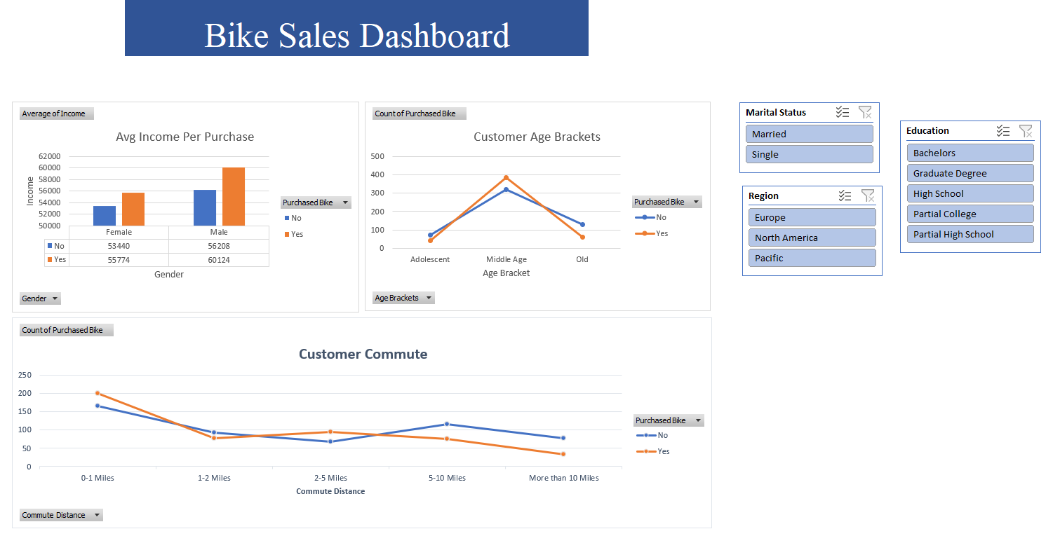
  - Week 2: Advanced Excel (Customer Demographics)

    - Project Objective

To master data segmentation and analysis using advanced Pivot Table techniques on a new customer demographics dataset.

    - Methodology

This project focused purely on analysis and segmentation. Instead of a single dashboard, the methodology was to create multiple, distinct Pivot Charts to answer specific, granular questions about the customer base. This involved analyzing the intersection of Job Industry, State, and Wealth Segment.

    - Implementation & Results

Three primary analyses were conducted:

- By Job Industry: A bar chart showing the count of customers in each industry.

- By State: A bar chart comparing customer counts in 'New South Wales', 'Queensland', and 'Victoria'.

- By Wealth Segment: A bar chart segmenting customers into 'Affluent', 'High Net Worth', and 'Mass Customer'.

Figure 2: Week 2 - Customer Demographics Pivot Charts (Excel)

    - Key Insights

- Job Industry: 'Manufacturing' and 'Financial Services' were the two largest job industries, making them prime targets for marketing.

- Wealth Segment: The 'Mass Customer' segment was the largest group, indicating the brand has broad appeal beyond high-net-worth individuals.

- Geography: 'New South Wales' was the state with the highest concentration of customers.

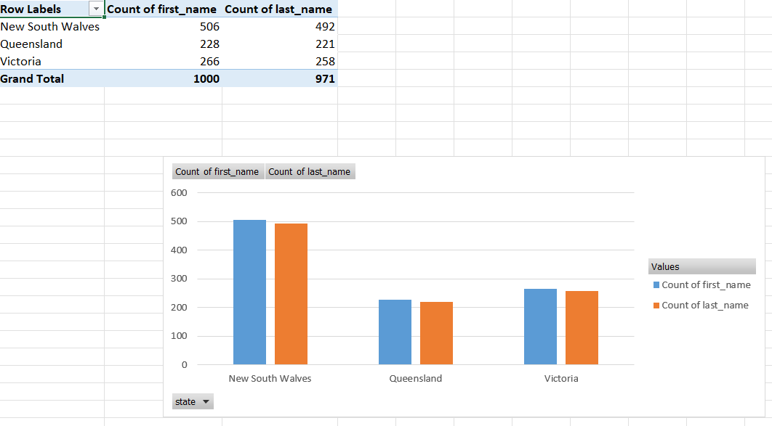
Figure 2: Customer Demographics (Excel)
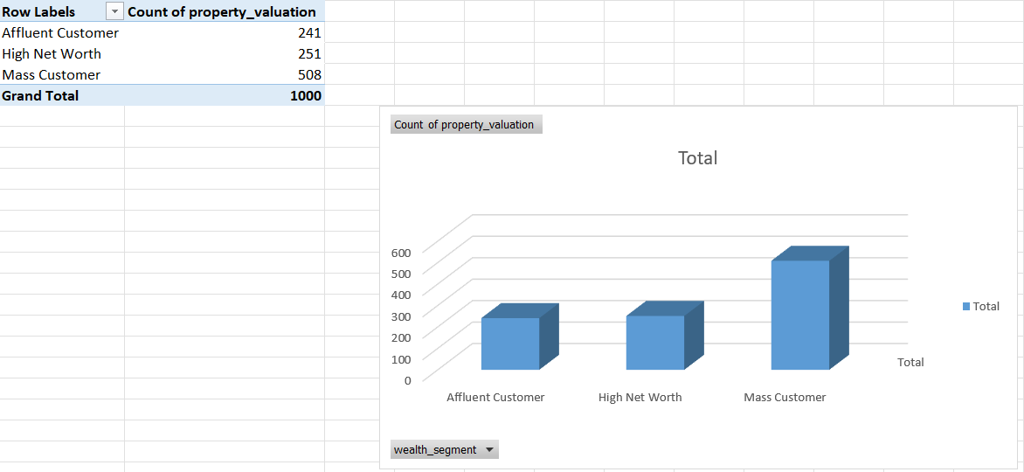
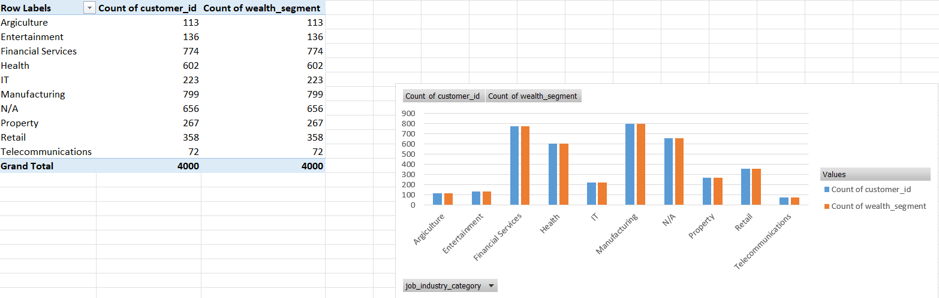
  - Week 3: Excel Dashboarding (Store Annual Report)

    - Project Objective

To aggregate a full year of e-commerce sales data into a single, cohesive, and interactive executive dashboard in Excel, providing a high-level overview of the store's 2022 performance.

    - Methodology

- Data Consolidation: Aggregated 12 months of sales data into a single master table.

- KPI Development: Identified 6 key performance indicators to visualize:
  - Orders vs. Sales (Time-Series)
  - Sales: Men vs. Women (Donut Chart)
  - Order Status (Donut Chart)
  - Sales: Top 5 States (Bar Chart)
  - Orders: Age vs. Gender (Bar Chart)
  - Orders: Channels (Pie Chart)

- Dashboarding: Assembled all 6 Pivot Charts onto one sheet.

- Interactivity: Added Slicers for 'Month', 'Channel', and 'Category' that were connected to all charts, allowing a manager to filter the entire year's performance.

    - Implementation & Results

Figure 3: Week 3 - Store Annual Report Dashboard (Excel)

    - Key Insights

This dashboard provided several immediate, actionable insights:

- Top Performers: 'Maharashtra' was the top-performing state, generating 2.99M in sales.

- Channel Dominance: 'Amazon' was the dominant sales channel, accounting for 35% of all orders.

- Demographics: 'Women' were the primary customer base, driving 64% of sales.

- Operations: The store maintained a high 92% order delivery (fulfillment) rate, with only 3% 'Cancelled'.
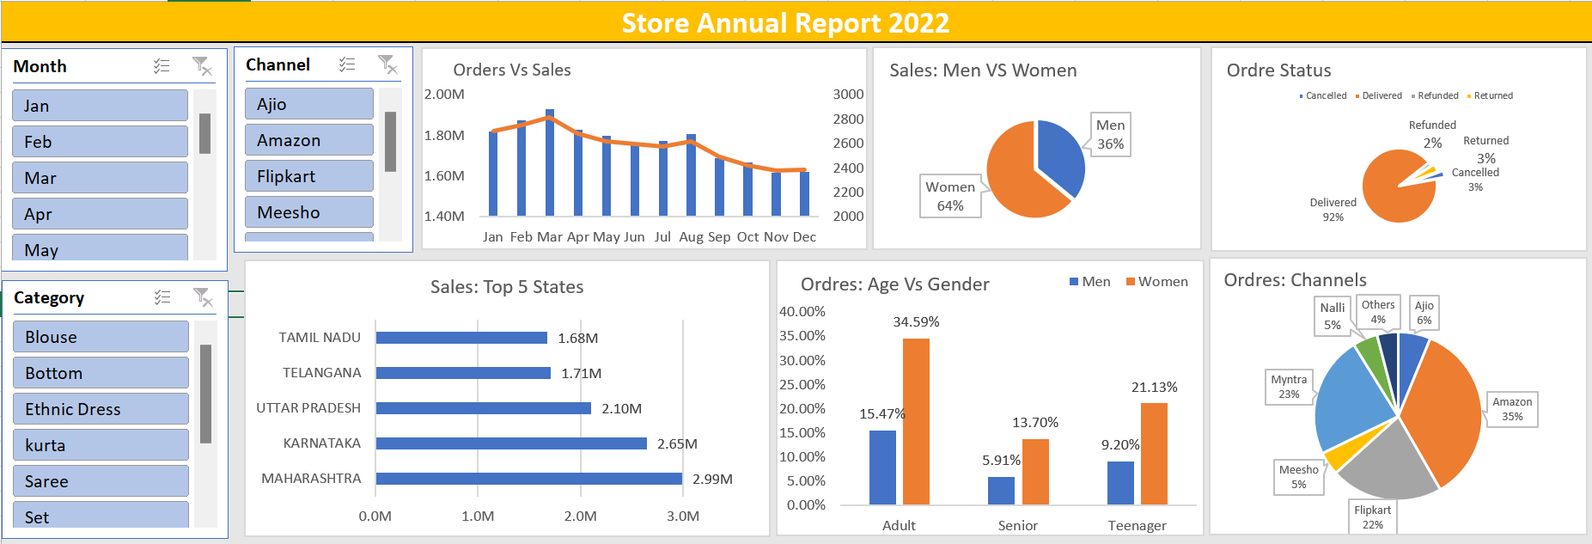
Figure 3: Store Sales Dashboard (Excel)

  - Week 4: Introduction to Power BI (Spotify Top Tracks)

3.4.1. Project Objective

To transition from Excel to Power BI by analyzing a global Spotify dataset. The goal was to learn the fundamentals of Power BI, including Power Query, DAX, and visualization.

3.4.2. Methodology

- Data Transformation: Imported the Spotify dataset into Power BI and used the Power Query Editor for data transformation and cleaning.

- DAX Measures: Wrote basic DAX (Data Analysis Expressions) measures to create new metrics, such as Sum of streams, Sum Artist count, and Average Stream per Year.

- Visualization: Designed a dark-mode dashboard featuring KPIs, slicers, a donut chart for 'Top 10 Artists', and a bar chart for 'Sum of streams by track_name'.

3.4.3. Implementation & Results

Figure 4: Week 4 - Spotify Top Tracks Dashboard (Power BI)

3.4.4. Key Insights

- Scale: The Weeknd's 'Blinding Lights' was the most-streamed track at 4 billion, showcasing Power BI's ability to handle and visualize data at a large scale.

- Interactivity: The dashboard allows a user to dynamically filter all visualizations by 'Artist' or 'Year', providing a much more fluid analytical experience than a static Excel chart.

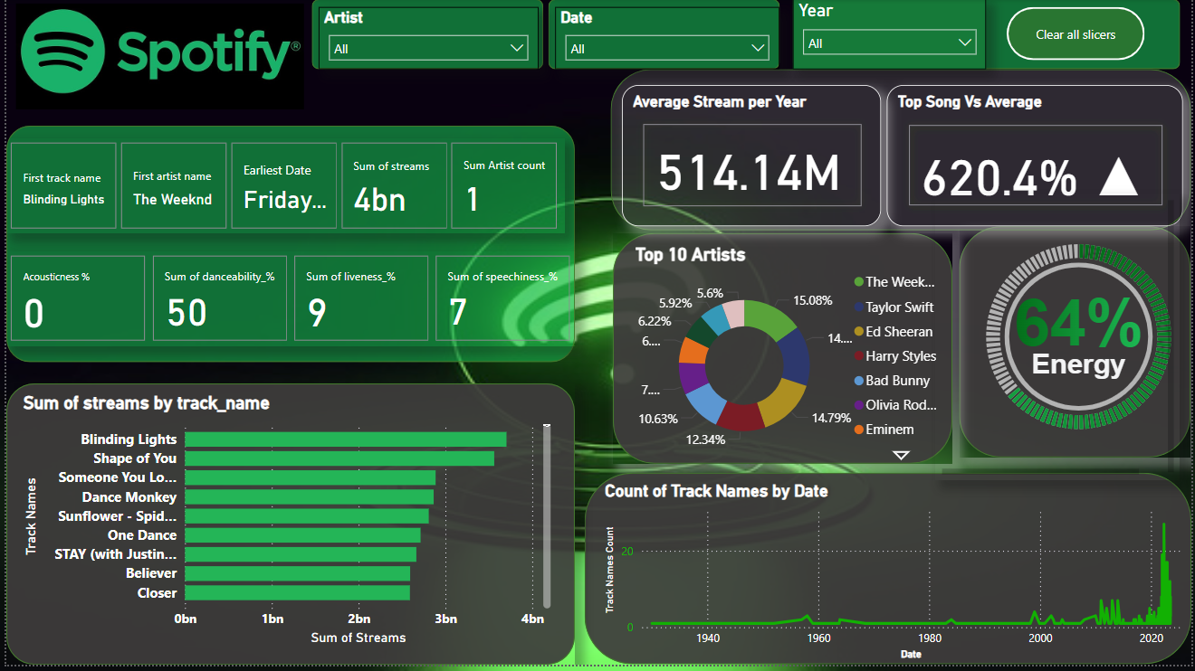
Figure 4: Spotify Music Streams Analysis Dashboard (Power BI)
  - Week 5: Advanced Power BI (Adani Stock Analysis)

3.5.1. Project Objective

To apply Power BI to a more complex time-series dataset, analyzing the historical stock performance of Adani Enterprises.

3.5.2. Methodology

- Time-Series Analysis: Focused on visualizations that effectively show trends over time.

- KPI Development: Created KPIs for key financial metrics, including Avg of 52W H (3.91K), Avg of 52W L (1.14K), Close Total (667.66K), and Volume Total (876M).

- DAX Aggregations: Created new measures to aggregate data by quarter ('Quaterly Aggregrates') and by month ('Monthly Totals'), providing different levels of granularity.

- Visualization: Used line charts to show daily and monthly trends in open/close prices and trading volume.

3.5.3. Implementation & Results

Figure 5: Week 5 - Adani Stock Analysis Dashboard (Power BI)

3.5.4. Key Insights

- Volatility Correlation: The 'Monthly Totals' chart clearly visualizes the strong correlation between periods of high trading volume and significant price volatility.

- Holistic View: The dashboard provides a 360-degree view of the stock's performance, from high-level annual KPIs to granular daily totals, which is essential for investors.

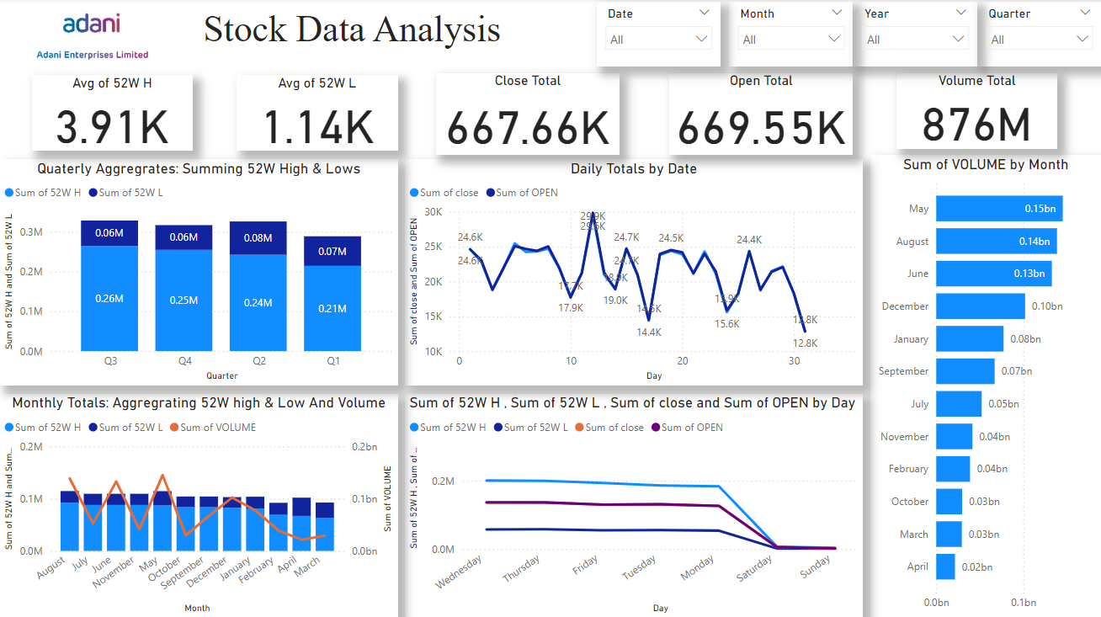
Figure 5: Adani Enterprise Stock Data Analysis (Power BI + Excel)
  - Week 6: Capstone Project (Bike Shop Analysis)

3.6.1. Project Objective

To execute a comprehensive, end-to-end data analysis project that integrates all skills learned during the internship: SQL for extraction, Excel for validation, and Power BI for modelling and visualization.

3.6.2. Methodology (The End-to-End Workflow)

This project simulated a real-world analyst task:

- SQL (Extraction): The data was in a relational database. I wrote SQL queries using JOIN to combine multiple tables (e.g., Riders, Trips, Payments, Seasons) into a single, clean, and structured table.

- Excel (Validation): The extracted data was briefly imported into Excel for a quick validation pass to check for any anomalies or cleaning errors from the query.

- Power BI (Modeling & Visualization):
  - The final, clean dataset was imported into Power BI.
  - A relational data model (Star Schema) was built to connect fact tables (trips) with dimension tables (riders, dates).
  - Advanced DAX measures were written for Sum of riders, Sum of revenue, and Sum of profit.
  - A comprehensive dashboard was built to answer key business questions: "Who are our customers?", "When are we making money?", and "How much are we making?"

3.6.3. Implementation & Results

Figure 6: Week 6 - Bike Shop Analysis Capstone Dashboard (Power BI)

3.6.4. Key Insights

The final dashboard provided deep, actionable insights for the business:

- Customer Base: The business is overwhelmingly driven by its loyal customer base. 81.17% of riders are 'registered', while only 18.83% are 'casual'.

- Peak Season: Season 3 ('Summer') is the most profitable season, generating $4.9M in revenue, significantly more than any other quarter.

- Peak Hours: The hourly profit heatmap (bottom-left table) shows two clear peaks: 8 AM and 5-6 PM. This strongly suggests the business's primary use case is for work commutes.

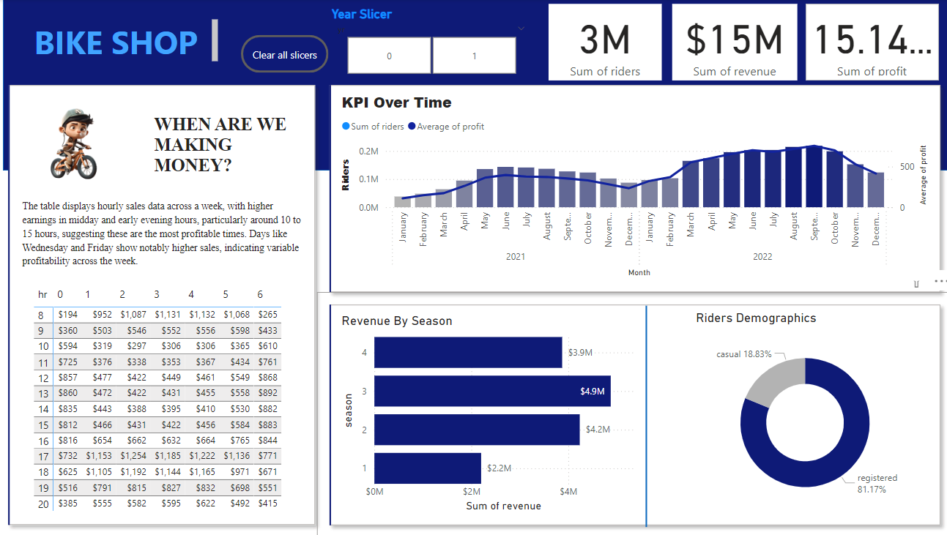
Figure 6: Bike Shop Sales Analysis Dashboard (Power BI + SQL + MS Excel)
4.1. Summary of Key Insights

The projects yielded several actionable business insights:
- Sales & Demographics (Weeks 1, 2): Customer age and job industry are strong predictors of purchasing behavior. 'Middle Age' and 'Manufacturing/Financial' sectors are key segments.
- E-commerce Performance (Week 3): Performance is heavily concentrated in specific states ('Maharashtra') and channels ('Amazon'), presenting opportunities for targeted growth or diversification.
- Time-Series Analysis (Week 5): Trading volume is a strong corollary to price volatility in financial markets.
- Business Operations (Week 6): The bike shop's business is overwhelmingly driven by a loyal 'registered' user base (81%) and follows clear seasonal (Summer) and daily (commute hours) peaks.

4.2. Key Skills Developed

The internship successfully developed three core competencies:
- Process is Key: A deep understanding of the systematic process—from the critical first step of data cleaning to modelling and final visualization—is essential for accurate analysis.
- Contextual Insights: The real value of an analyst is not in reporting data, but in asking the right business questions and translating the "what" (e.g., "sales are down") into the "why" (e.g., "sales are down because of a drop in a specific segment").
- Tool Integration: Mastered the practical, real-world synergy between tools: using SQL to extract, Excel to quickly clean and validate, and Power BI to model and present the final story.

5. Conclusion and Future Plan

5.1. Conclusion

The 45-day data analyst internship at Elevate Labs was a comprehensive, challenging, and highly valuable experience that successfully bridged the gap between academic knowledge and practical industry application. By completing six distinct, progressively complex projects, I have gained tangible proficiency in the end-to-end data analysis workflow and the core tools (Excel, SQL, Power BI) required in the field. The internship reinforced that data analysis is an iterative process that combines technical skill with business acumen and creative storytelling to drive meaningful decisions.

5.2. Summary of Key Skills Developed

This internship successfully developed three core competencies:
- Process is Key: A deep understanding of the systematic process—from the critical first step of data cleaning (which often took 80% of the time) to modelling and final visualization—is essential for accurate analysis.
- Contextual Insights: The real value of an analyst is not in reporting data, but in asking the right business questions and translating the "what" (e.g., "sales are up") into the "why" (e.g., "sales are up because our registered rider segment grew by 15%").
- Tool Integration: Mastered the practical, real-world synergy between tools: using SQL to extract, Excel to quickly clean and validate, and Power BI to model and present the final, compelling story.

5.3. Future Plan

While these projects provided descriptive and diagnostic insights, the next logical step is to move into predictive and prescriptive analytics. Future work based on these projects would involve:
- Predictive Modelling: Applying machine learning models (like the one from the CRM project) to these datasets to forecast sales, predict customer churn, or identify factors leading to stock volatility.
- Automation: Automating the data refresh cycle for the Power BI dashboards to create true real-time business intelligence.
- Cloud Deployment: Deploying the Power BI reports to the Power BI Service to make them accessible to stakeholders across an organization on any device.

6. References

- Microsoft Corporation. (2024). Power BI Documentation. [Online]. Available: https://docs.microsoft.com/en-us/power-bi/
- Microsoft Corporation. (2024). Excel help & learning. [Online]. Available: https://support.microsoft.com/en-us/excel
- Chandoo (Purna Duggirala). (2024). Excel & Power BI Tips. [Online]. Available: https://chandoo.org/
- SQLTutorial.org. (2024). SQL Tutorial. [Online]. Available: https://www.sqltutorial.org/
- Guy in a Cube. (2024). Power BI Tips and Tricks. [Online]. Available: https://guyinacube.com/

