Rmd to word template here are some words to make this title run into two pages and words

Gaurav Kandlikar

April 18, 2018

# Single title

## R Markdown

This is an R Markdown document. Markdown is a simple formatting syntax for authoring HTML, PDF, and MS Word documents. For more details on using R Markdown see [http://rmarkdown.rstudio.com](http://rmarkdown.rstudio.com/).

Here’s a citation to (Bever, Westover, and Antonovics 1997).

When you click the **Knit** button a document will be generated that includes both content as well as the output of any embedded R code chunks within the document. You can embed an R code chunk like this:

### Here’s a third heading

summary(cars)

## speed dist   
## Min. : 4.0 Min. : 2.00   
## 1st Qu.:12.0 1st Qu.: 26.00   
## Median :15.0 Median : 36.00   
## Mean :15.4 Mean : 42.98   
## 3rd Qu.:19.0 3rd Qu.: 56.00   
## Max. :25.0 Max. :120.00

#### Here’s a fourth heading

## Including Plots

You can also embed plots, for example:

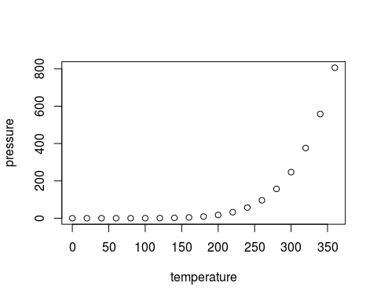

Note that the echo = FALSE parameter was added to the code chunk to prevent printing of the R code that generated the plot.

## References

Bever, James D., Kristi M. Westover, and Janis Antonovics. 1997. “Incorporating the Soil Community into Plant Population Dynamics the Utility of the Feedback Approach.” *The Journal of Ecology* 85 (5). JSTOR: 561. doi:[10.2307/2960528](https://doi.org/10.2307/2960528).