MINI PROJECT REPORT
ON
“Farmer Crop & Expense Tracker”
Submitted in partial fulfillment of the requirements for the
Full Stack Development Mini Project

Student Name | Pranav Kedar
Roll No. | ____________________________
Class / Division | TY B.Tech / IT
Project Title | Farmer Crop & Expense Tracker

1. Project Overview

1.1 Problem Statement
Many farmers track sowing dates and farming expenses in notebooks or memory. Over a season, it can be difficult to find the total cost for each crop. Without a clear record of seed, fertilizer, labour and other expenses, calculating profit or loss becomes confusing. This project provides a simple local website to record crop details, save crop-wise expenses and enter sale income. It then shows total expenses and the final result for completed crops.

1.2 Objectives
• To record each crop’s name, seed variety, sowing date and land area.
• To add, view, edit and delete crop-wise expense records.
• To calculate profit or loss when the crop season is completed.

1.3 Technology Stack
Frontend | HTML / CSS / JavaScript
Backend | Node.js / Express.js
Database | Local MongoDB
API / Communication | REST API (JSON)
Tools | VS Code / Terminal / Browser / Postman (optional)
2. System Design

2.1 System Architecture / Workflow

2.2 Main Modules / Features
Sr. No. | Module / Feature | Short Description
1 | Crop Records | Save or edit sowing details.
2 | Expense Tracking | Record dated expenses.
3 | Season Completion | Enter income after harvest.
4 | Profit / Loss | Compare income and expenses.

2.3 Database Design
Collections: crops (name, seed variety, sowing date, area, status, income) and expenses (cropId, category, date, amount, note). cropId links each expense to its crop.

3. Implementation and Results

3.1 Implementation Summary
HTML forms collect crop and expense details, CSS controls the layout, and JavaScript validates inputs and sends JSON requests to Express REST API routes. Express validates the data and stores records in local MongoDB. Crop and expense records can be added, viewed, edited and deleted. Profit/loss for a completed crop = sale income minus its total expenses.

3.2 Output Screenshots
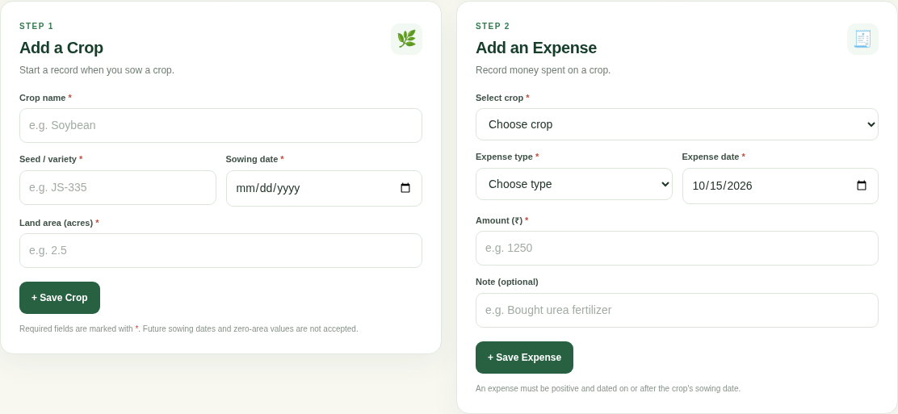 | 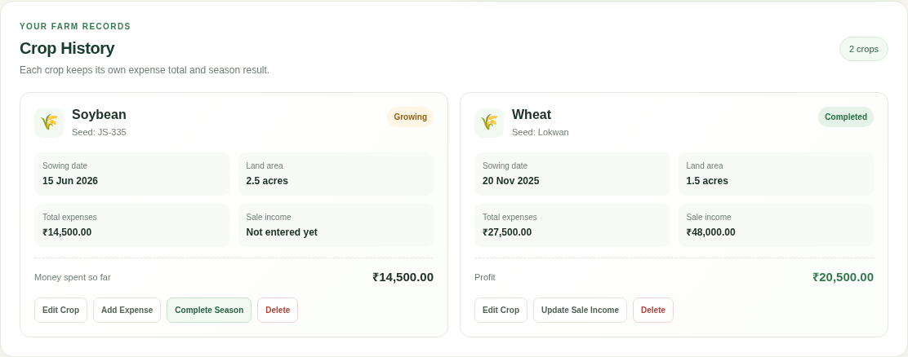
Screenshot 1: Crop & Expense Forms | Screenshot 2: Crop History & Results

3.3 Testing / Result
Feature Tested | Expected Result | Status
Form validation | Invalid or empty entries are rejected. | Pass
Profit/loss calculation | Sale income minus crop expenses is shown. | Pass
MongoDB CRUD | Crop and expense records are stored and updated. | Verify locally

4. Conclusion
The Farmer Crop & Expense Tracker gives a farmer a simple way to record crop details, track crop-wise spending and review each season. It uses HTML, CSS and JavaScript for the frontend, Express REST APIs for data handling, and local MongoDB for storage. When a season is completed, sale income is compared with recorded expenses to show profit or loss. The project demonstrates basic CRUD operations, form validation and a one-to-many relationship between crops and expenses. Future improvements could include printable reports, multiple farmer accounts and Marathi language support.

