Experiment No. 10
Mini Project: Study Task Manager
Mobile Application Development – Android

Aim
To design and develop a complete Android application – a Study Task Manager that lets students add, track, complete and delete study tasks stored in a local database.

Apparatus / Software Required

Hardware
- Computer / laptop (min. 8 GB RAM)
- Android phone or emulator

Software
- Android Studio (latest stable) with Android SDK
- Java (JDK 17 bundled with Android Studio)
- SQLite (built into Android) and the RecyclerView library

Theory
A complete Android application combines several concepts: multiple Activities connected by Intents, a data layer to store information permanently, and a list UI to display it. This project uses SQLite through SQLiteOpenHelper for local storage, a RecyclerView with a custom Adapter to show the task list efficiently by reusing item views, and Intents to move between the list screen and the Add Task screen.

Features of the app
- Add a task with title, subject, due date (date picker) and priority.
- View all tasks in a list, pending tasks first.
- Mark a task as done (shown with strike-through) or undo it.
- Delete a task after a confirmation dialog.
- Live summary of pending and total tasks; data stays saved after closing the app.

Implementation Steps

Step 1: Creating the project
Open Android Studio → New Project → Empty Views Activity. Name: StudyTaskManager, package: com.example.studytaskmanager, language: Java, minimum SDK: API 24.

Step 2: Database and project setup
- Add the RecyclerView dependency in app/build.gradle and sync.
- Create the Task model class and DBHelper (SQLiteOpenHelper) with a tasks table.
- Create AddTaskActivity and register it in the manifest.
Column | Type | Purpose
id | INTEGER (PK, auto) | Unique task id
title | TEXT | Task name
subject | TEXT | Subject / course
due_date | TEXT | Due date (dd/mm/yyyy)
priority | TEXT | Low / Medium / High
done | INTEGER | 0 = pending, 1 = completed

Step 3: Designing the UI
activity_main.xml has a summary bar, a RecyclerView with an empty-state message, and an Add Task button. item_task.xml defines one row (checkbox, title, details, delete button). activity_add_task.xml has two EditTexts, a date button, a RadioGroup for priority and a Save button.

Step 4: Adding functionality
- DBHelper: methods to add, read, update (done) and delete tasks.
- TaskAdapter: binds each Task to a row and reports checkbox and delete clicks through a listener interface.
- MainActivity: loads tasks in onResume() so the list refreshes after adding; handles toggle and delete.
- AddTaskActivity: validates input, shows a DatePickerDialog, saves the task and closes with finish().

Step 5: Running the application
Run the app, tap Add Task, fill in the details and save. The task appears in the list. Tick the checkbox to complete it, use Delete to remove it, and restart the app to confirm the data is still there.

Files Used / Code Changes
File | Folder | Description
MainActivity.java | java | Home screen: loads tasks, handles toggle/delete, opens Add Task screen.
AddTaskActivity.java | java | Input form with validation and date picker; saves to database.
TaskAdapter.java | java | RecyclerView adapter that fills each list row.
DBHelper.java | java | SQLite database creation and all database operations.
Task.java | java | Model class holding one task's data.
activity_main.xml, activity_add_task.xml, item_task.xml | xml | Layouts of the two screens and one list row.
AndroidManifest.xml | xml | Declares both activities.
strings.xml | xml | Stores all text labels.
build.gradle (notes) | gradle | RecyclerView dependency to add.

Components Used
- Activities (MainActivity, AddTaskActivity) and explicit Intent
- SQLiteOpenHelper / SQLiteDatabase and Cursor
- RecyclerView, LayoutManager and custom Adapter with ViewHolder
- DatePickerDialog and AlertDialog
- EditText, RadioGroup, CheckBox, Button, TextView, Toast

Important XML Attributes Used
Attribute | Purpose
android:id | Unique id to access a view in Java
layout_weight | Gives the list all remaining screen space
android:hint / inputType | Hint text and keyboard type of input fields
android:checked | Sets the default selected priority (Medium)
android:parentActivityName | Parent screen for back navigation
android:gravity / layout_gravity | Aligns content (centered empty-state message)

Important Java Methods Used
Method | Purpose
onCreate() / onUpgrade() | Create and upgrade the database table
insert() / update() / delete() / rawQuery() | Add, change, remove and read rows
moveToNext() / getString() / getInt() | Read values from a Cursor
onCreateViewHolder() / onBindViewHolder() | Create and fill list rows in the adapter
notifyDataSetChanged() | Refreshes the list after data changes
onResume() | Reloads the list when returning to the screen
DatePickerDialog / AlertDialog.Builder | Pick a date and confirm deletion
startActivity() / finish() | Open the Add Task screen and return to the list

Errors Faced & Troubleshooting
Error | Solution
Unresolved reference to RecyclerView | Add the recyclerview dependency in build.gradle and sync.
List not updated after adding a task | Call loadTasks() in onResume() so it runs when returning.
Wrong checkboxes ticked while scrolling | Remove the old listener, then call setChecked() in onBindViewHolder().
App crashes opening Add Task | Register AddTaskActivity in AndroidManifest.xml.
Old data missing after changing table | Increase DB_VERSION or uninstall the app so onUpgrade() / onCreate() runs.

Output
The home screen shows the summary and the task list, with pending tasks first and completed tasks struck through. Add Task opens the form; after saving, the new task appears in the list. Data remains after restarting the app. (Screens below are illustrative samples; replace them with real screenshots from your device.)
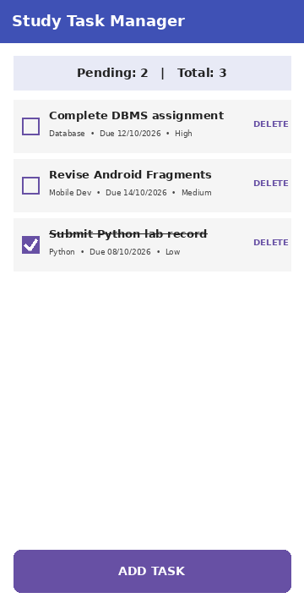  Fig 1: Task list screen | 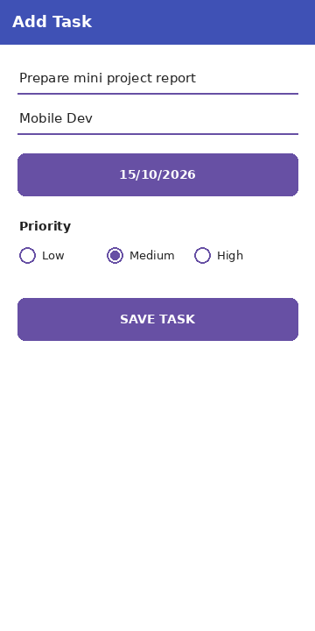  Fig 2: Add Task screen

Conclusion
A complete Android application, the Study Task Manager, was designed and developed using multiple activities, Intents, SQLite storage and a RecyclerView. The mini project combined the concepts learned in the earlier experiments into a working, useful app.

C | A | P | T | SIGN

