Retail
Web
Application

Content

Title Page No

- Introduction 1

- Tech used 2

- Backend 2

- DB Design 3

- Microservices 7

- Frontend 9

- Api Testing 10

Introduction

E-Commerce, also known as electronic commerce or internet commerce, is an activity of buying and selling goods or services over the internet or open networks. So, any kind of transaction (whether money, funds, or data) is considered as E-commerce. So, E-commerce can be defined in many ways, some define E-Commerce as buying and selling goods and services over the Internet, others define E-Commerce as retail sales to consumers for which the transaction takes place on open networks. The buying and selling of products, services, and digital products through the Internet all fall under the umbrella of e-commerce.

Objective

The main objective for building this web application is that we have to implement whatever we have done in our training and successfully implement the concepts given in the training.

Tech Used

1.FrontEnd

1.Html,
2.Css
3.TypeScript
4.Angular

2.Backend

1.Java
2.Spring boot
3.Jwt Authentication
4.Microservices
5.MySql
6.JWT

Backend

The whole backend is built on microservices architecture. In this application there are
8 microservices. We are using MySQL database and we have one Database with 7 tables. The Microservice are built with the help of Spring Boot.

DB Schema

There is one Database and 7 tables

1.user

This table contains all the Details of user who are Doing Signup which contains the Fields userid(PK), name,email,contactNumber, password.Now when user is signup, we are storing their data in table user.

2.catalog

This table contains all the product categories, It contains the fields cat_id(PK), image,
title. Basically we are displaying all these categories in the frontend so when user click on those, we can data add to category.

3.Product

This table contains all the products, it contains fields prod_id(PK),prod_name,prod_price,prod_desc,cat_id(FK).Here cat_id we are using as a foreingn key.

4.Cart-Items

This table contains all the item user has in his cart. It contains the fields like cartItemsId(PK),Prod_id,Pro_desc,prod_price,prod_quantity,prod_image,userId(FK)
here we are using userID as foreingn key.

5.Order

This table contains all the item user ordered. It contains orderItem(PK),prod_id,
prod_quantiy,userId(FK),orderId(Fk). Here for every item a orderItem row will be generated and Order ID is unique for every order which is foreign key refrence to token table.

6.OrderToken

This table will contain orders id for every order user does and address for delivery and date, time of order made. It contains fields order_id(pk), userId(Fk), name, Address,
pincode,date,time.

7.Payment

This table will contain The payment that user will do for his order.Fields in this table are payment_id(PK), order_id(Fk),amount,date,time.

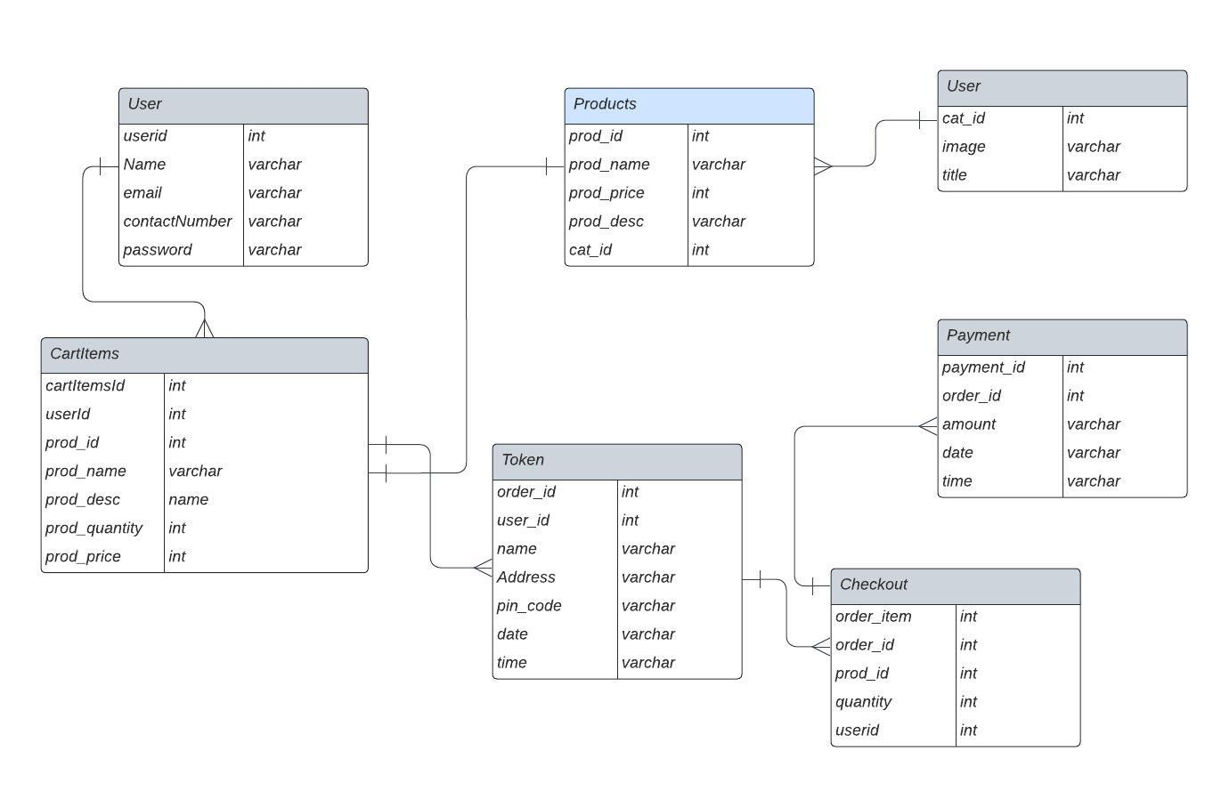
Figure 1.1 DB Schema (Of The project to be build)

Microservices

Signup Microservices

This Service will interact with every new user. Because to buy items from he has to register first. Here we are receiving the data from the client and service then interacts with JPA for storing the data in the table.

Dependencies used
1.web,JPA,Devtools,MySqlConnector.

Login Services

This Service is interacting with every existing user. When user enter his credentials, we check in our user table there his data is present or not after that spring security checks that user credential is vailed or not. After successful authentication we give the user a token so that he can use that token and can go anywhere in the app. Here we are using Spring security to authenticate the user. We are also using JWT token for session-based logout. And we are setting the expiry time 30 minutes after every token generation and user will be automatically logged out after the token expired.

Dependencies Used.
1.Web,Jpa,Jwt,SpringSecurity,mySqlConnector,Devtools.
Spring boot version – 2.7.9

Catalog Service

This Service is responsible for providing the categories of the project. It uses category table for that. This service also communicates with product Service for getting the products based on category. So when user click on any category the request comes to catalog service it then calls product service and ask for the data based on the category id, and when product service give data back, then it gives back to client.

Dependencies Used
1.web,JPA,Devtools,MySqlConnector.

Product Service

This Service is responsible for client request for the products. It has table
name product. So, when catalog service request it for the data with specific category id, then it interact table product using jpa and gets the data. It also fetches all data for showing all the products.

Dependencies Used: web,JPA,Devtools,MySqlConnector.

Cart Services

These services interact with client when uses adds item to cart, then post request from client comes to services. Then services calls jpa to save the data in the cart Item table with respect to user_id.so now when user do login every time, we load their cart items using get request that already added previously by calling this cart Services. This service comes into picture only when user is logged. It also has on API named deleteByCartId
so that when click on delete icon we call this api to delete the item with id of that cart item.

DependenciesUSed:web,JPA,Devtools,MySqlConnector.

Checkout And Order Service

When items are added in the cart and user want to check out, this services needs is there. It has two tables named order_item, token_orderId.
It gets name,adress, userId from the client and calls Cart Microservice to get the Cart items of the user. After that it calls jpa of token_orderId to save address and gets the order id. And using order id it saves the data to order_item table which stores products that are ordered and amount that are to be paid.

Dependencies Used: Web,JPA,Devtools,MySqlConnector.

Payment Services

This service is called by order service when user click on payment ,client request to order the item. Then order service makes post request to payment to save the amount paid by user. Where it saves the paymentAmount, orderid,date and time of payment.

Dependencies Used: Web, JPA, DevTools, MySQL Connector.

Frontend

We are using Angular for developing the frontend in which we divided the whole view in the form of components, and we are developing them.
The Components are
- Home Components
- Category Components
- Product Components
- Cart Components
- Footer Component
- Checkout Component
- Payment Component

API Testing

In the use case I have also performed the API testing for all the running microservice which I have made and are running successfully. I have attached a few of them here in the document

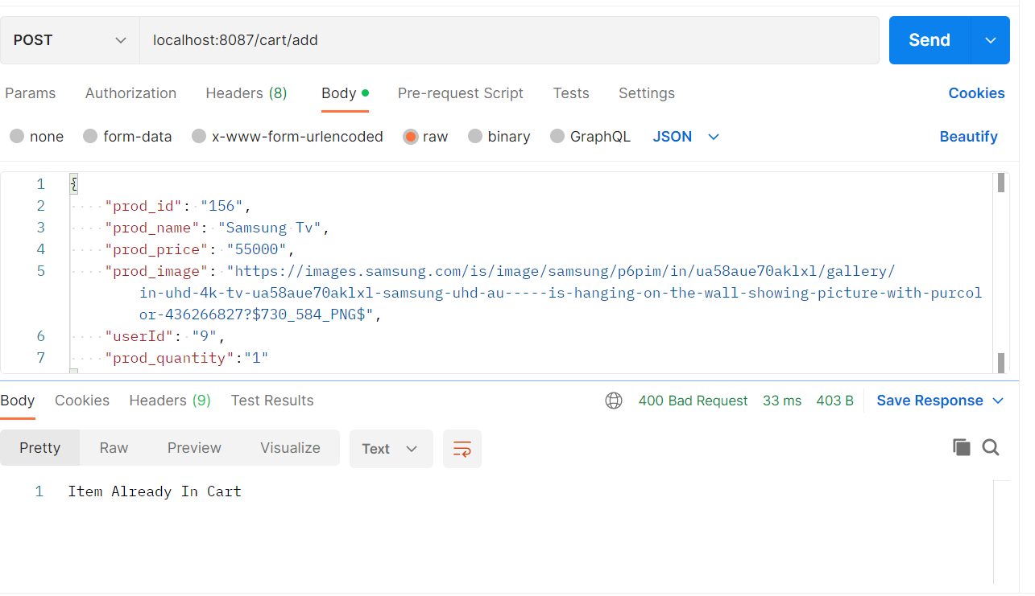
Fig 8.1 Api Testing For Cart Microservice(add)
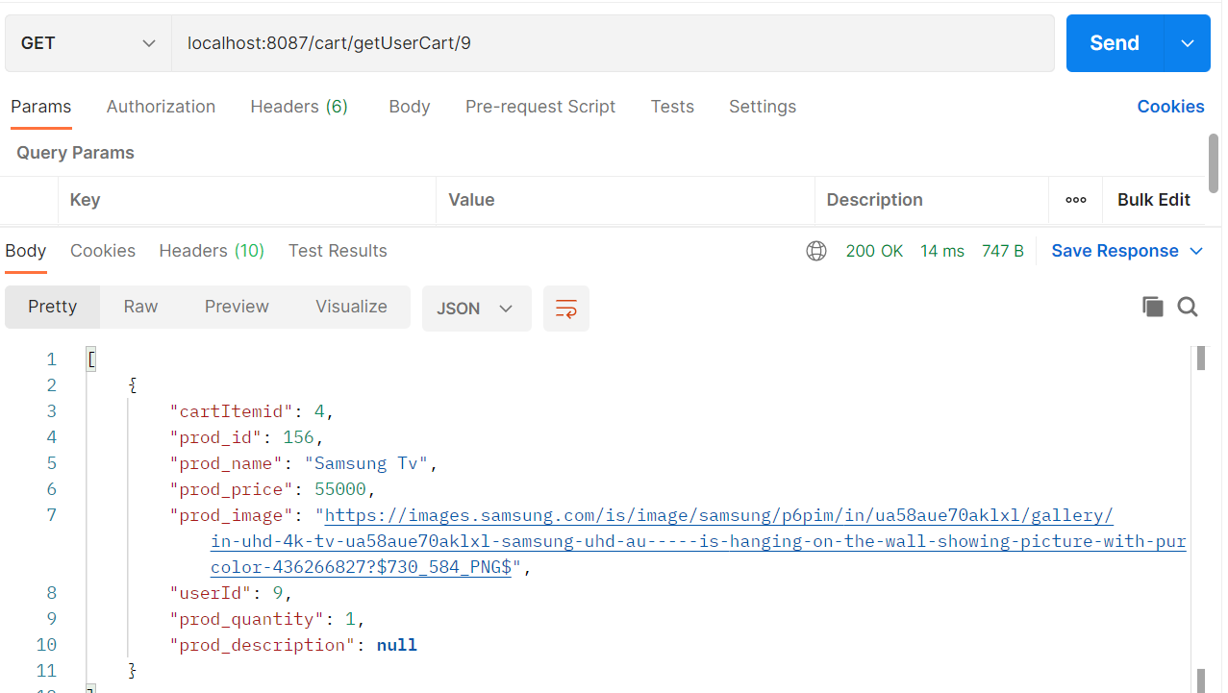
Fig 8.2 Api Testing for Cart Microservice(detail of cart of user using userID)

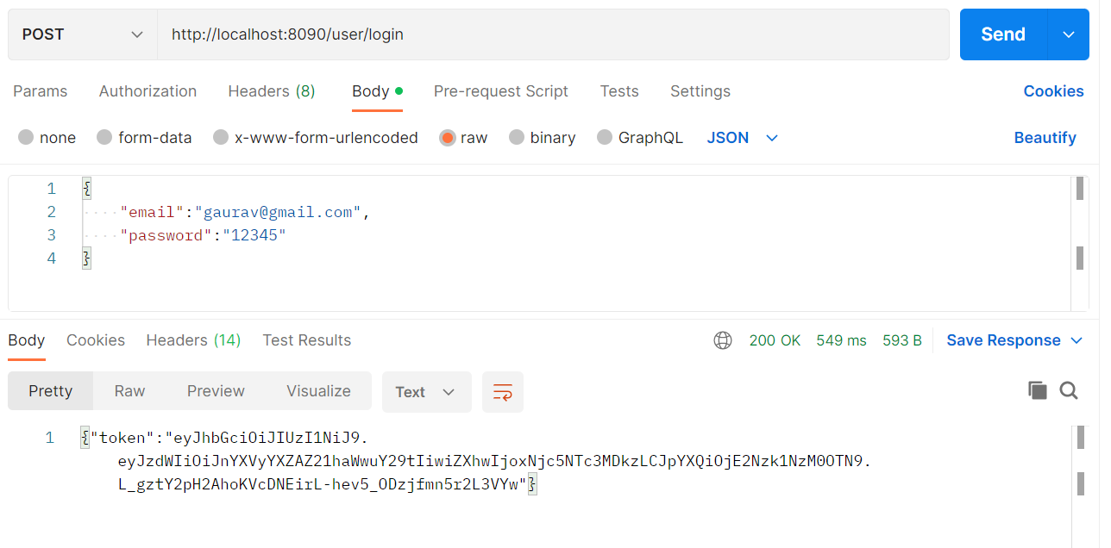
Fig 8.3 Api Testing for Login Microservice

These are some snippets of all the microservices that I have built in the use case.

