SIGMA

About SIGMA

Sigma is a one stop app where users can integrate searching on google, finding files on local machine but giving voice input. The app takes Voice / Text input query on a desktop application created using Python with tkinter library.

We attempted to build a QnA machine learning model, on a dataset but, we could not complete it because of the time constraints.

We have used Azure Cognitive Services to convert speech to text.

Installing

>>git clone https://github.com/gauravuttarkar/Sigma.git

>> cd Sigma

>> pip install -r requirements.txt

Usage

Go to Sigma directory
>> python3 window.py

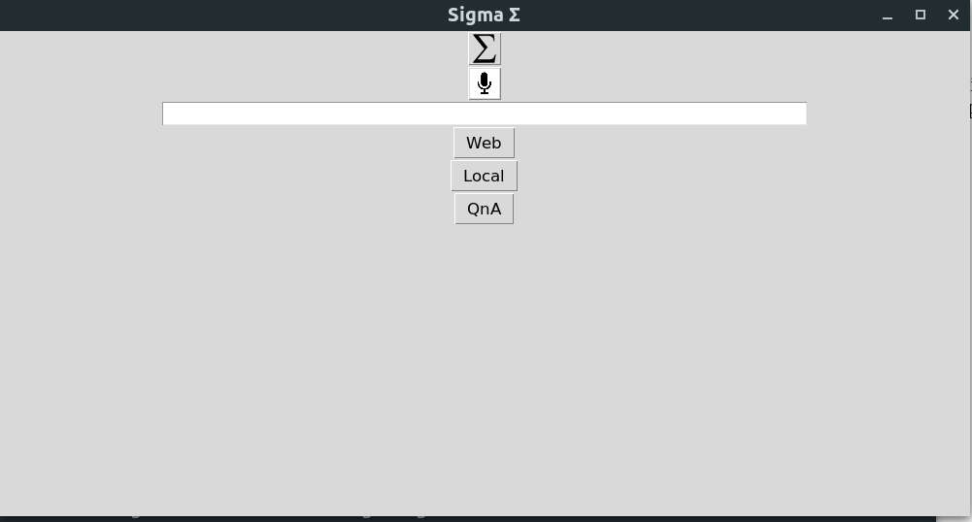

WEB DOMAIN

On getting the window click on Mic to record the voice input for query.
You can also choose to enter the query in the text box and continue

On clicking Web it searches the query string in google and opens it on the default browser.

LOCAL DOMAIN

2.) If you want to find a file on your machine:
Enter the name of the file and click Local to get a list of files found.

On clicking the Buttons Which have the path of file name search the required file opens.

