Literature Review: Credit Card Fraud Detection Using Machine Learning
Gaurav Jain  Department of Computer Engineering  Vivekanand Education Society's Institute of Technology, Mumbai  D12B, Roll No. 20  2024.gaurav.jain@ves.ac.in | Palash Matani  Department of Computer Engineering  Vivekanand Education Society's Institute of Technology, Mumbai  D12B, Roll No. 38  2024.palash.matani@ves.ac.in

Abstract: Credit card fraud detection is a rare-event classification problem in which accuracy is a misleading measure. This review surveys the base paper by Tanouz et al. (2021) and the related work on card-fraud classifiers, class-imbalance handling (under-sampling, SMOTE, class weights, gradient boosting), evaluation practice (precision-recall analysis, data leakage, confidence intervals) and model explanation (LIME). We identify weaknesses in the base paper’s evaluation, namely a small balanced test set, preprocessing before the train-test split, and an “ROC-AUC” that matches balanced accuracy, and describe how our mini project re-tests them on the public ULB dataset. In our run, Random Forest precision fell from 94.68% on a paper-style balanced test set to 4.30% on a test set with the real fraud rate when trained on under-sampled data.
Keywords: credit card fraud, class imbalance, SMOTE, XGBoost, precision-recall, LIME

1. Introduction
Credit card fraud is a rare-event detection problem: in the widely used ULB dataset, only 492 of 284,807 transactions (0.17%) are fraudulent [1]. A model that labels every transaction “genuine” is therefore 99.83% accurate and catches nothing. This is why the literature on fraud detection is as much about how to train and evaluate on skewed data as about which classifier to use [2, 3].
This review covers the five bodies of work our mini project builds on: (i) the base paper by Tanouz et al. [4]; (ii) earlier machine-learning studies on card fraud [1, 5, 6]; (iii) class-imbalance techniques such as under-sampling, SMOTE and gradient boosting [2, 7, 8]; (iv) evaluation practice, in particular precision-recall analysis and data leakage [9, 10, 11]; and (v) model explanation with LIME [12]. We close with the gap our project addresses.

2. Base paper: Tanouz et al. (2021)
Tanouz et al. [4] compare four classifiers (Decision Tree, Random Forest, Logistic Regression, Naive Bayes) on the ULB dataset and report that Random Forest performs best, with 96.77% accuracy, 100% precision and 91.11% recall. Their pipeline normalises Time and Amount, under-samples the genuine class to a 1:1 ratio, drops features that correlate with the class label, removes outliers, and only then splits the data 70/30 for training and testing.
The paper is easy to follow and a reasonable starting point, but four weaknesses limit how far its numbers can be trusted:
- Test set is balanced and tiny. The reported metrics are consistent with a test set of about 124 transactions, roughly 45 of them fraud (we recovered this by solving for confusion matrices that match all four reported rows). The real fraud rate is 0.17%, so precision on such a set says little about deployment.
- Preprocessing before the split. Under-sampling, feature selection by correlation with the label, and outlier removal all use label information before the test set is separated, which is a form of data leakage [11].
- “ROC-AUC” appears to be balanced accuracy. The reported AUC values match (sensitivity + specificity) / 2 within about 0.01 for every model, which is what you get when AUC is computed from hard 0/1 predictions instead of probabilities.
- Differences between models are a few transactions. With about 124 test rows, Random Forest and Logistic Regression differ by about two errors; no confidence intervals or repeated splits are given.
These points define what our project re-tests. Figure 1 contrasts the base paper’s pipeline with the protocol we use instead.
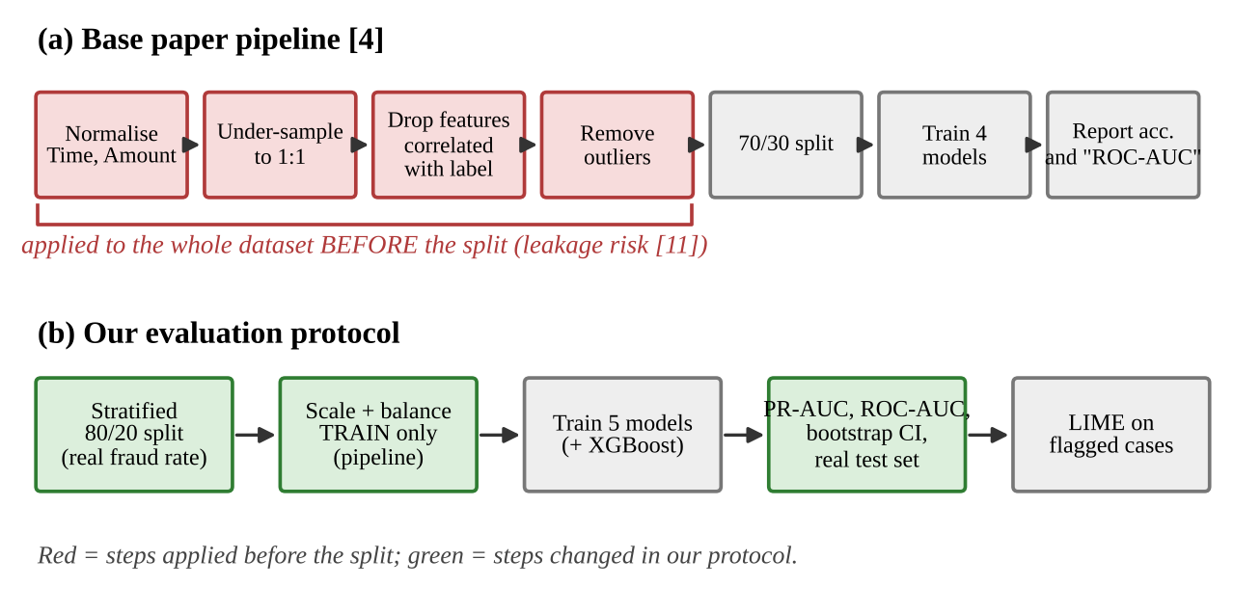
Figure 1. The base paper’s pipeline [4] compared with the evaluation protocol used in our project.

3. Related work on card fraud detection
Early comparative work already showed that ensemble methods beat single models on fraud data. Bhattacharyya et al. [5] compared Support Vector Machines, Random Forests and Logistic Regression on real card transactions and found Random Forests to be the strongest overall, though with a clear precision-recall trade-off. Randhawa et al. [6] later tested a wide range of learners, including boosting, and combined them by majority voting, reporting that hybrid ensembles outperformed individual classifiers on both a public and a real-world dataset.
The practitioner view is more cautious. Dal Pozzolo et al. [3] argue that fraud detection differs from textbook classification in three ways: the classes are extremely imbalanced, fraud patterns drift over time, and only a small fraction of alerts can be investigated by humans each day. For that last reason they recommend ranking-based metrics such as precision among the top-ranked alerts over accuracy. The ULB dataset itself comes from this line of work [1]. It holds two days of European card transactions from September 2013, with 28 PCA-transformed features (V1 to V28), plus Time, Amount and the label, so it is anonymised and cannot be extended with domain features.
The common pattern across these studies is that tree ensembles are strong baselines on this data. The base paper’s choice of Random Forest as best model [4] is consistent with that, even if its evaluation is not.

4. Handling class imbalance
He and Garcia’s survey [2] groups imbalance remedies into sampling, cost-sensitive learning and algorithm-level changes. Three are relevant here.
- Random under-sampling throws away majority-class rows until the classes are balanced. It is fast and is what the base paper uses [4], but it discards most genuine transactions (here, over 99% of them) and, as Dal Pozzolo et al. show, shifts the predicted probabilities so that they overstate fraud risk unless recalibrated [1].
- SMOTE (Chawla et al. [7]) creates synthetic minority examples by interpolating between a fraud case and its nearest fraud neighbours. A 15-year review [14] notes that it can help weak learners but also adds noise and gives little gain for strong tree ensembles on some datasets.
- Cost-sensitive learning keeps all data and instead weights errors on the rare class more heavily (class weights, or scale_pos_weight in boosting).
Figure 2 organises these remedies and marks which ones the base paper used.
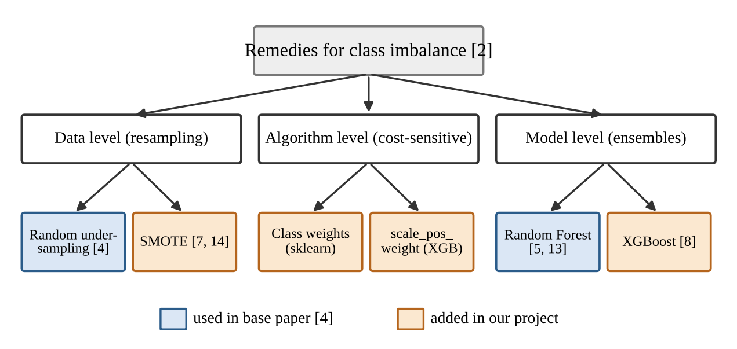
Figure 2. Taxonomy of class-imbalance remedies [2], showing which were used in the base paper and which our project adds.
On the model side, Random Forests [13] average many decorrelated trees and are robust with default settings. XGBoost [8] adds gradient-boosted trees with regularisation and native handling of sparse data, and is a standard strong baseline on tabular problems; it was not tested in the base paper. Our project adds it, together with SMOTE and class weights, as the “improved” side of the comparison.

5. Evaluation: why the metric and the split matter
On imbalanced data, ROC curves can look excellent while the model is practically useless, because the false-positive rate is divided by a huge number of genuine transactions. Davis and Goadrich [10] show that a curve dominates in ROC space if and only if it dominates in precision-recall (PR) space, but PR curves expose differences that ROC hides. Saito and Rehmsmeier [9] reach the same conclusion empirically and recommend PR plots for imbalanced classification. We therefore report PR-AUC (average precision) next to a probability-based ROC-AUC.
The second issue is leakage. Kaufman et al. [11] define leakage as information in the training process that would not be available at prediction time. Any step that uses labels, such as correlation-based feature removal or under-sampling, must be fitted on the training portion only. The same applies to scalers. Resampling must never touch the test set, which should keep the real fraud rate so that precision and false-alarm counts mean what they would in practice.
The third issue is uncertainty. With very few positives, differences of one or two errors are noise. Bootstrap confidence intervals, or repeated stratified cross-validation, are the minimum needed before calling one model better than another. These three points (PR-based metrics, split before preprocessing, confidence intervals) are the evaluation protocol we adopt in Part B of the project.

6. Explaining individual alerts
Fraud analysts need to know why a transaction was flagged, not only that it was. LIME (Ribeiro et al. [12]) explains one prediction by fitting a simple, interpretable model around that single case and reporting which features pushed the score up or down. It works with any classifier, which suits a comparison of several models.
There is a limit specific to this dataset: V1 to V28 are anonymised PCA components, so an explanation such as “V14 was low” identifies an influential component but not a real-world behaviour like location or merchant type. We use LIME to show three cases (a caught fraud, a missed fraud, a normal transaction) and state this limitation explicitly.

7. Research gap and our contribution
The literature agrees that tree ensembles work well on card fraud [3, 5, 6], and that imbalance and evaluation need care [2, 9, 11]. What the base paper [4] lacks is an evaluation on a test set with the real fraud rate, probability-based metrics, and any measure of uncertainty. Our mini project fills that gap in three steps: (A) re-implement the paper’s pipeline as described, (B) re-evaluate the same four models, plus XGBoost, with the split done first and balancing applied to training data only, and (C) explain flagged cases with LIME.
The measured results from our own run on the Kaggle ULB data support the concerns raised above. Table 1 compares Random Forest, the paper’s best model, across settings.
Table 1. Random Forest under different evaluation settings.
Setting | Test set | Prec. % | Recall % | False alarms
Paper, as reported [4] | ~124 rows, balanced | 100.00 | 91.11 | 0
Our re-implementation, paper-style | 247 rows, balanced | 94.68 | 86.41 | 5
Same model, under-sampled training, real test | 56,962 rows, 98 fraud | 4.30 | 91.84 | 2,004
Random Forest + SMOTE, real test | 56,962 rows, 98 fraud | 88.30 | 84.69 | 11
Figure 3 shows the precision-recall curves of the strongest configurations. Three findings follow. First, the paper’s near-perfect precision does not survive a realistic test set: with under-sampling, every genuine fraud caught comes with about 22 false alarms. Second, hard-label “ROC-AUC” equals balanced accuracy for all four models in our reproduction, while the probability-based ROC-AUC differs (Random Forest: 91.47% vs 95.4%). Third, among the stronger configurations, Random Forest + SMOTE (PR-AUC 0.880, 95% bootstrap CI 0.815 to 0.933), Random Forest without balancing (0.873) and XGBoost with class weights (0.872) have heavily overlapping intervals, so we cannot claim that SMOTE or XGBoost is a clear improvement.
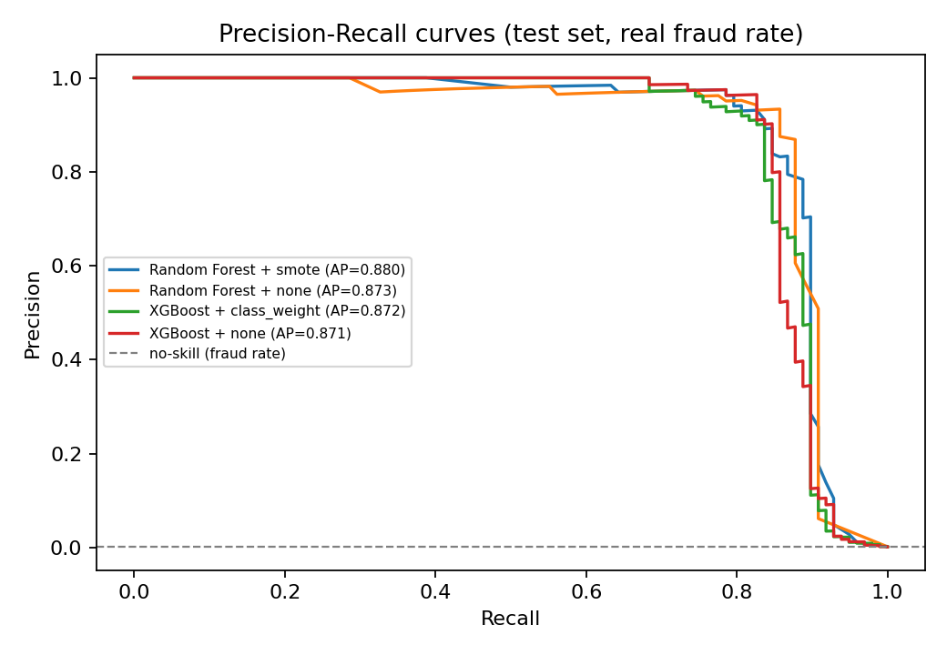
Figure 3. Precision-recall curves of the top four configurations on the real-fraud-rate test set (our run). The curves lie close together, matching the overlapping confidence intervals.
Limitations. One dataset covering two days; anonymised features, so explanations are not business-interpretable; our outlier rule and scaler differ from the paper’s unspecified ones; one random split. Future work: time-ordered splits to test concept drift, repeated cross-validation, and cost-based thresholds using the transaction amount.

References
- A. Dal Pozzolo, O. Caelen, R. A. Johnson, G. Bontempi, “Calibrating probability with undersampling for unbalanced classification,” IEEE Symposium Series on Computational Intelligence (SSCI), 2015.
- H. He and E. A. Garcia, “Learning from imbalanced data,” IEEE Transactions on Knowledge and Data Engineering, 21(9), 1263-1284, 2009.
- A. Dal Pozzolo, O. Caelen, Y.-A. Le Borgne, S. Waterschoot, G. Bontempi, “Learned lessons in credit card fraud detection from a practitioner perspective,” Expert Systems with Applications, 41(10), 4915-4928, 2014.
- D. Tanouz, R. R. Subramanian, D. Eswar, G. V. P. Reddy, C. V. N. M. Praneeth, A. R. Kumar, “Credit Card Fraud Detection Using Machine Learning,” 5th International Conference on Intelligent Computing and Control Systems (ICICCS), 2021. DOI 10.1109/ICICCS51141.2021.9432308.
- S. Bhattacharyya, S. Jha, K. Tharakunnel, J. C. Westland, “Data mining for credit card fraud: A comparative study,” Decision Support Systems, 50(3), 602-613, 2011.
- K. Randhawa, C. K. Loo, M. Seera, C. P. Lim, A. K. Nandi, “Credit card fraud detection using AdaBoost and majority voting,” IEEE Access, 6, 14277-14284, 2018.
- N. V. Chawla, K. W. Bowyer, L. O. Hall, W. P. Kegelmeyer, “SMOTE: Synthetic minority over-sampling technique,” Journal of Artificial Intelligence Research, 16, 321-357, 2002.
- T. Chen and C. Guestrin, “XGBoost: A scalable tree boosting system,” Proceedings of the 22nd ACM SIGKDD International Conference on Knowledge Discovery and Data Mining, 785-794, 2016.
- T. Saito and M. Rehmsmeier, “The precision-recall plot is more informative than the ROC plot when evaluating binary classifiers on imbalanced datasets,” PLoS ONE, 10(3), e0118432, 2015.
- J. Davis and M. Goadrich, “The relationship between precision-recall and ROC curves,” Proceedings of the 23rd International Conference on Machine Learning (ICML), 233-240, 2006.
- S. Kaufman, S. Rosset, C. Perlich, O. Stitelman, “Leakage in data mining: Formulation, detection, and avoidance,” ACM Transactions on Knowledge Discovery from Data, 6(4), 15, 2012.
- M. T. Ribeiro, S. Singh, C. Guestrin, “Why should I trust you? Explaining the predictions of any classifier,” Proceedings of the 22nd ACM SIGKDD International Conference on Knowledge Discovery and Data Mining, 1135-1144, 2016.
- L. Breiman, “Random forests,” Machine Learning, 45(1), 5-32, 2001.
- A. Fernandez, S. Garcia, F. Herrera, N. V. Chawla, “SMOTE for learning from imbalanced data: Progress and challenges, marking the 15-year anniversary,” Journal of Artificial Intelligence Research, 61, 863-905, 2018.

