EA Metamodel Explorer: High-Level Requirements
Nov 3, 2026 · @Gaurav
EA Metamodel Explorer is a free, open-source enterprise architecture repository: a governed metamodel, an architecture repository, diagrams, reports and documents, with sign-in through the organisation's directory and an MCP server so people can connect the language model of their choice to the repository. It runs as a set of Docker containers started with docker compose up from one configuration file, and functionally it is the server version of the EA Repository Workbench. Wherever a mature open-source product already does a job (diagrams, sign-in, reports, documents) it is used as it is, with its own screens. Each requirement here is broken down in the detailed requirements workbook (EA_Explorer_Requirements.xlsx).

1. Purpose and scope
The product gives an architecture team one shared, governed place for its metamodel, its architecture content and the diagrams, reports and documents built on it, without licence fees and on infrastructure the organisation controls.
In scope
- A home page dashboard linking to every function, and one Keycloak sign-in that opens every screen and product without another login.
- A read-only library of reference models: a cross-industry high-level model and ten industry models, which nobody (administrators included) can change.
- The TOGAF Architecture Repository for each model: metamodel, architecture capability, landscapes (baseline, transition, target), Standards Information Base, Reference Library, Governance Log, requirements and solutions landscape.
- Deep copy of any model, to use as it is or customise.
- Work copies of part of a model so teams can work in parallel, merged back with a three-way, field-by-field review.
- Metamodels: create from a template (ArchiMate 4 shipped), copy, extend with entity, attribute and relationship types, rules and lists; change in the web application and publish.
- Repository content: entities and relationships with full history and validation, and finding and removing duplicates.
- A publishing workflow: changes from CSV files and diagrams land in a staging area, are reviewed and are then published into the main repository; edits made in the web application by someone with publish rights are published at once.
- Data exchange in CSV, and models exchanged with other EA tools in The Open Group ArchiMate Model Exchange File Format (ArchiMate 4, and 3.x files).
- Diagrams: draw.io in the browser, generated from and read back into the repository.
- Standard views: pick a model and one of twenty views, and it is built as a draw.io file (separate from reports).
- Reports and dashboards in Apache Superset, including thirty standard reports; documents in Mayan EDMS, linked to entities.
- Sign-in through Keycloak (local users, Active Directory or LDAP, Microsoft Entra ID, Google), role-based authorisation per model.
- An MCP server so each user can connect their own language model client to query the repository and propose changes.
- Operations: one config file per installation with templates for laptop, single server, scale-out and cloud; docker compose up; backup and restore; health checks; audit log.
Out of scope
- Building a diagram editor, report engine, document manager or identity provider: proven open-source products are used instead, with their own screens.
- Running or hosting a language model: users bring their own and connect it through MCP.
- Excel (.xlsx) files as a data format: spreadsheets are exchanged as CSV.
- Real-time co-editing of the same diagram, a mobile app, several organisations in one installation (one installation serves one organisation), and portfolio cost management beyond attributes.
- Kubernetes: the four deployment kinds (laptop, single server, scale-out, cloud) run on Docker Compose; Helm charts can follow later, since the application containers are stateless.
Relationship to the EA Repository Workbench. The Excel Workbench (version 1.1) is the functional reference. Its metamodel structure, ArchiMate 4 seed, rule types, import preview, draw.io tagging and harvest rules, and three-way merge carry over; its reference logic in Python (model.py, drawio.py) and 166 tests port to the API. What is new is multi-user access, authorisation, a database, a web front end, the publishing workflow, backup and restore, and the MCP server. One deliberate change: the Workbench's Excel import becomes CSV.

2. Guiding principles and constraints
Nine principles decide every design choice; a component or feature that breaks one needs an explicit decision.
# | Principle | What it means in practice
P1 | Completely open source | Every component under an OSI-approved licence, with no "open core" features behind a paid edition; our own code under AGPL-3.0. Each third-party image and its licence is listed in the repository
P2 | Docker based | Everything runs in containers built from public images or our own Dockerfiles; nothing is installed on the host except Docker
P3 | One command to deploy | docker compose up -d on a fresh host gives a working system with the ArchiMate 4 template and an admin user; optional components are compose profiles
P4 | One configuration file | Each installation has one config file holding every setting that differs (host name, ports, paths, passwords, identity providers, mail, backup, storage); templates ship for four deployment kinds: laptop, single server, scale-out and cloud
P5 | Build only what is needed | Write code only for the repository, its API, its web screens for data entry, metamodel and publishing, the draw.io integration and the MCP server
P6 | Metamodel driven | No entity type, attribute or relationship type is hard-coded; the database, API, screens, templates, views and stencils follow the published metamodel
P7 | API first | The web front end, draw.io integration, CSV loads, reports and the MCP server all use the same documented REST API and the same authorisation
P8 | Nothing is lost | Every change is recorded with who, when and why; content is retired, not deleted; every operation that changes many records can be rolled back
P9 | Use open-source products as they are | Where a mature open-source, Docker-based product does a job (draw.io, Keycloak, Superset, Mayan EDMS), we use it and its own user interface. We connect it to the repository and to single sign-on; we do not rebuild its screens, and a different look from our own screens is accepted
Fixed technology choices (from the brief and the decisions since): Python, Flask, PostgreSQL, Docker and Docker Compose, draw.io, Keycloak, an MCP layer, Apache Superset for reports, Mayan EDMS for documents, React for our own screens, CSV for data exchange. No language model is shipped: users connect their own.

3. Users and roles
Roles are defined in Keycloak and granted per model, so one person can own one model and only read another. Groups from Active Directory or Entra ID map to these roles.
Role | Who | Can
System administrator | IT operations | Configure the installation, users and identity providers, backups and restores, monitoring; no content rights unless also granted
Model owner | Lead architect | Create, copy, branch and merge models; grant roles on the model; publish content and metamodel changes
Metamodel editor | EA team member | Change entity, attribute and relationship types, rules and lists in the web application; publish them if granted publish rights, otherwise submit them
Architect (editor) | Architects | Create and change entities, relationships and diagrams; load CSV files; publish their own web edits if granted publish rights; submit staged changes for review
Contributor | Application owners, analysts | Change entities assigned to them, fill CSV templates, comment; changes are always staged
Reviewer | Design authority | Review staged changes; approve and publish, or reject with a comment
Viewer | Anyone in the organisation | Read published content, diagrams, reports and documents
API client / agent | Integrations, users' own LLM clients through MCP | Act through the API with a user's token or a service account; MCP write tools only stage changes; every call audited
A language model connected through MCP never has more rights than the person using it: MCP calls carry that user's token, and anything it proposes is staged for review.

4. Functional requirements by capability area
The functions are those of the desktop Workbench, made multi-user, plus publishing, security, operations and the MCP layer. Each area has an ID prefix used in the detailed workbook.
Area | Prefix | The system shall
Models | MOD | Hold many models; create one empty, from a template or as a copy with or without content; mark it template, project or branch; archive it
Reference models and library | REF | Ship a read-only cross-industry high-level model and ten industry models that nobody can change; deep copy any model to use or customise; record lineage; pull newer reference versions into a copy by merge
Architecture repository | ARC | Present each model as the eight parts of the TOGAF Architecture Repository; hold landscapes as baseline, transition and target; a Standards Information Base; a Reference Library; a Governance Log (decisions, compliance reviews, dispensations); requirements and change requests; the solutions landscape; the EA capability; an ADM deliverables register
Metamodel | MM | Manage entity types (domain, aspect, ID prefix, style), attribute types (data types, lists, units, defaults), type–attribute mappings (required, order, section; on entity and relationship types), relationship types (verb, inverse, category, direction), allowed relationships with type groups, validation rules (13 rule types, severity, message); change them in the web application and publish as a new metamodel version (at once with publish rights, otherwise after approval)
Repository content | REP | Create, edit, retire and restore entities and relationships with Display IDs; edit many rows in a grid; show an entity with its attributes, relationships, diagrams, documents and history; impact analysis across n relationships; find, combine and delete duplicate entities and relationships
Validation | VAL | Check every write against data type, mapping and rules; validate staged change sets before they can be submitted; validate a whole model on demand and on schedule; keep and show an issues list and a data-quality score
Publishing workflow | WF | Hold changes from CSV loads, diagram harvests, exchange-file imports and MCP proposals in a staging area as change sets; submit, review, approve or reject with comments; publish approved change sets into the main repository; publish web edits at once for people with publish rights; notify the people involved; viewers and reports see published content only
Versions, branches and merge | VER | Record every change; commit a model version with a label; compare any two versions; roll back an entity, a type or a model; take work copies of part of a model, several at once, and merge each back with a three-way, field-by-field review of conflicts and duplicates
Import and export | IO | Generate CSV templates per type; load CSV files into staging with a preview and error report; export published data as CSV; accept CSV from other systems through the API; import and export The Open Group ArchiMate Model Exchange File Format (ArchiMate 4, and 3.x files), with views converted to and from draw.io
Diagrams | DIA | Open draw.io (its own editor) with ArchiMate 4 shapes and a library of the model's own entities; save diagrams with versions; harvest new or changed shapes and connectors into staging; flag stale diagrams; export images
Standard views | VIEW | On a Views page, separate from reports: select a model and one of twenty standard views, set its scope, and get a tagged .drawio file to download, save, open or export; regenerate saved views; generate in bulk; add view definitions as configuration
Reports and analytics | RPT | Provide a typed read-only view per entity and relationship type; ship Superset with thirty standard reports; people build further reports in Superset's own screens; report access by role
Documents | DOC | Run Mayan EDMS (its own screens) for documents, versions, metadata, OCR and search; link Mayan documents to entities and show those links on the entity page
Search and navigation | SRC | Search across names, descriptions and attributes; filter by type, status and attribute; save filters; navigate relationships
MCP | AI | Run an MCP server so users connect their own language model client to the repository; read tools for search, entities, relationships, reports and metamodel; write tools that only create staged change sets; the user's own permissions apply; every call audited
Ownership and collaboration | OWN | Owners per entity, comments, notifications, a personal task list, surveys to owners, embeddable read-only views
Portfolio, lifecycle and planning | PORT | Application portfolio pack (fit, criticality, TIME), lifecycle phases, obsolescence risk, planned changes and roadmaps
Security | SEC | One Keycloak sign-in that opens every screen and product (ours, draw.io, Superset, Mayan, Keycloak consoles, MCP clients) without another login, with single sign-out; local, AD/LDAP, Entra ID and Google identities; authorise by role per model and per type; API tokens; audit every change and sign-in
Administration and operations | ADM | One config file per installation, with templates for laptop, single server, scale-out and cloud; external PostgreSQL and S3-compatible storage options; health checks; scheduled and on-demand backups; restore, also across deployment kinds; logs; upgrade with database migrations. Operations insight (OPS): a health dashboard with alerts and metrics; user, feature and model usage; housekeeping of models not in use, stale work copies and change sets, unused metamodel parts and broken links
Web front end | UI | A home page dashboard with a tile for every function (including Keycloak, the repository workflow, views, reports, documents and administration) showing live counts by role; our own screens only for what no open-source product provides
API | API | Documented REST API (OpenAPI) for every function, versioned, with paging, filtering, bulk operations and webhooks
The detailed workbook breaks these into individual requirements with acceptance criteria. Every requirement is a Must and in scope for version 1.0.

Capabilities brought in from the market review
Commercial enterprise architecture repositories were reviewed from their public product pages and documentation (November 2026). The table lists what they do that this product did not yet cover, or covers less well, and the requirement taken from it; all of them are in the workbook (source "Market review"). Anything brought in from outside (survey answers, discovered applications, catalogue updates, AI proposals) lands in staging and is published through the normal workflow.
Theme | What they do | Requirement for us
Ownership | Subscriptions: Responsible, Accountable and Observer per entity | Named owners per entity with role types; a "My entities" view; notifications to subscribers
Data quality | Completion score and quality seal | Weighted completeness score per entity, set in the metamodel; an attestation state that breaks to "Check needed" when someone else edits
Collaboration | Comments, to-dos and change notifications; approvers per object type | Comments with mentions; a personal task list; mail and in-app notices; approval rules per entity and relationship type
Data collection | Surveys that write answers back to fields | Questionnaires sent to owners; answers land in staging for review
Portfolio | TIME classification, scoring models, cost on relationships (both) | An application portfolio starter pack: fit, criticality, TIME, calculated scores, currency attributes
Lifecycle and risk | Lifecycle phases with dates; end-of-life catalogue; obsolescence risk; external technology catalogue feeds | A lifecycle attribute type; relationships with valid-from and valid-to dates; end-of-life reference data (for example endoflife.date) and risk passed up through relationships
Planning | Transformations, milestones, roadmaps and scenario comparison; workspaces | Dated planned changes and "as at" views; roadmaps drawn as draw.io diagrams; branch-against-branch comparison; partial merge
Impact | An impact analysis agent; relation queries | Multi-hop "what depends on X" over chosen relationship types, as a list and a generated diagram
Visual maps | Capability heatmaps and landscape reports (both) | A capability map generated as a draw.io diagram (nested boxes coloured by any attribute), since Superset does not draw nested maps
Reference content | Industry capability catalogues; ArchiMate 3.2 and TOGAF packs | The reference model library (section 7); importable catalogue packs as CSV bundles; ArchiMate 3.2 and TOGAF metamodel packs beside ArchiMate 4
Integrations | ServiceNow, Azure, SaaS discovery, Jira (both); webhooks (both); OData and GraphQL | Connectors that load into staging; webhooks with signing and retries; a read-only OData feed for Power BI and Excel; a declarative mapping for new feeds
Visio | Visio add-in and Visio import | Import .vsdx through draw.io's converter into the harvest pipeline; no Visio add-in
Access control | Permissions per type, per field and by subscription; virtual workspaces | Rights per entity type (including import and export), per attribute, and row-level partitions applied in the API, MCP, Superset and search
Publishing to stakeholders | Presentations and a Confluence macro; publishing to Teams and SharePoint | Read-only embeddable views of entities, diagrams and dashboards
AI | An MCP server, an AI assistant and an inventory builder | Already covered by our MCP server; we add a tool that proposes entities from a diagram image or text, and MCP prompts for drafting descriptions, all into staging
Two things stand out. The products reviewed build data quality on ownership, so owners (subscriptions) should be built early in the phase. And diagram editors in this class are built on draw.io, which supports the diagram choice here.
Sources: public product pages and documentation of commercial enterprise architecture repositories (November 2026): collaboration, data quality, surveys, portfolio (TIME), lifecycle catalogues, obsolescence risk, roadmap planning, capability catalogues, authorisation, webhooks, MCP servers, AI assistants, integrations, diagramming and application rationalisation.

5. Functional architecture
The functions fall into three groups that people use directly (data entry, diagrams and reports) around one core: a staging area, a publishing workflow and the main repository. Shared services sit underneath all three.
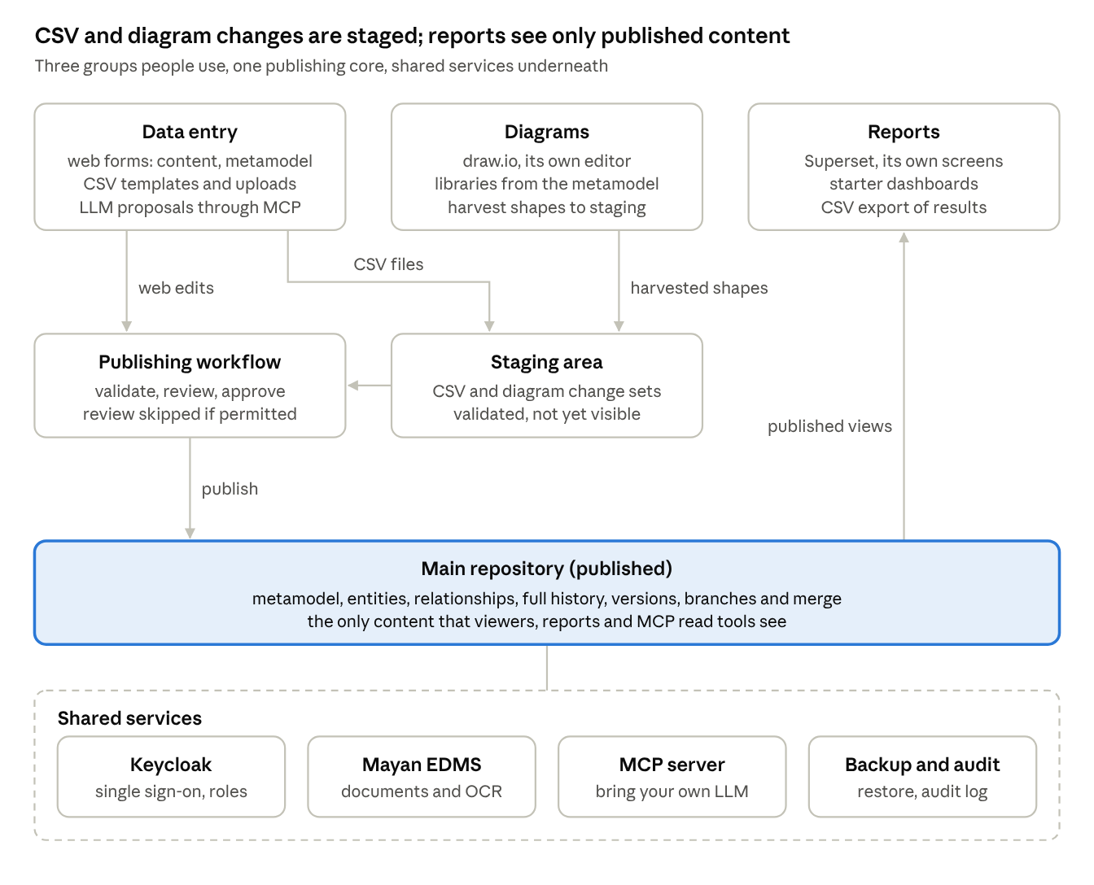
functional architecture · 3 user-facing groups, publishing core, shared services
CSV files, diagram harvests and MCP proposals always pass through staging; a web edit by someone with publish rights goes straight through the publishing step without waiting for review. Reports and MCP read tools see only the main repository.
Group | What it covers | Built from
Data entry | Web forms and grids for content; the metamodel editor; CSV templates, CSV loads and CSV export; changes proposed through MCP; branching and merging models | Our web screens and API
Diagrams | draw.io editor; shape libraries generated from the metamodel; harvest into staging; generated diagrams; stale-diagram checks; image export | draw.io as it is, plus our integration
Reports | Typed read-only views; Superset starter dashboards; ad-hoc charts and dashboards; CSV export of results; MCP read tools | Superset as it is, plus our views
Core: staging and publishing | Change sets, validation, review, publishing, history, versions, branches, three-way merge | Our API
Shared services | Sign-in and roles; documents; MCP server; backup, restore and audit | Keycloak and Mayan EDMS as they are; MCP server and backup are ours
How content reaches the main repository
- A CSV load, diagram harvest or MCP proposal creates a staged change set. It is validated as it loads; rows with errors are shown and must be fixed or dropped before the set can be submitted.
- Staged content is visible only to its author, reviewers and the model owner.
- The author submits the change set. A reviewer approves it whole or item by item, or rejects items with a comment that goes back to the author.
- On approval the set is checked again against the current main repository; anything changed there since staging is shown as a conflict to resolve. It is then published as one change set: history and audit are written and the report views refresh.
- Content and metamodel edits made in the web application are validated and published at once when the person holds publish rights on the model; otherwise they are saved as a staged change set and follow steps 3 and 4.
Home page and sign-in. Everyone lands on a home page dashboard with a tile for every function: models and library, metamodel, data entry, CSV loads, the repository workflow (staging, reviews, publishing), work copies and merge, dedupe, the architecture repository, standard views, diagrams in draw.io, reports in Superset, documents in Mayan, the MCP connection, users and sign-in in Keycloak, and administration. Tiles show live counts (my tasks, reviews waiting, staged change sets, open work copies, failed jobs, last backup) and appear according to the user's role. One Keycloak sign-in opens every tile, including the open-source products, without another login, and signing out ends every session.

6. Use cases and typical flows
The use cases are grouped the same way as the functional architecture. Each has an ID that the Use cases sheet of the workbook expands with its main steps and the requirements it needs.

6.1 Data entry and publishing
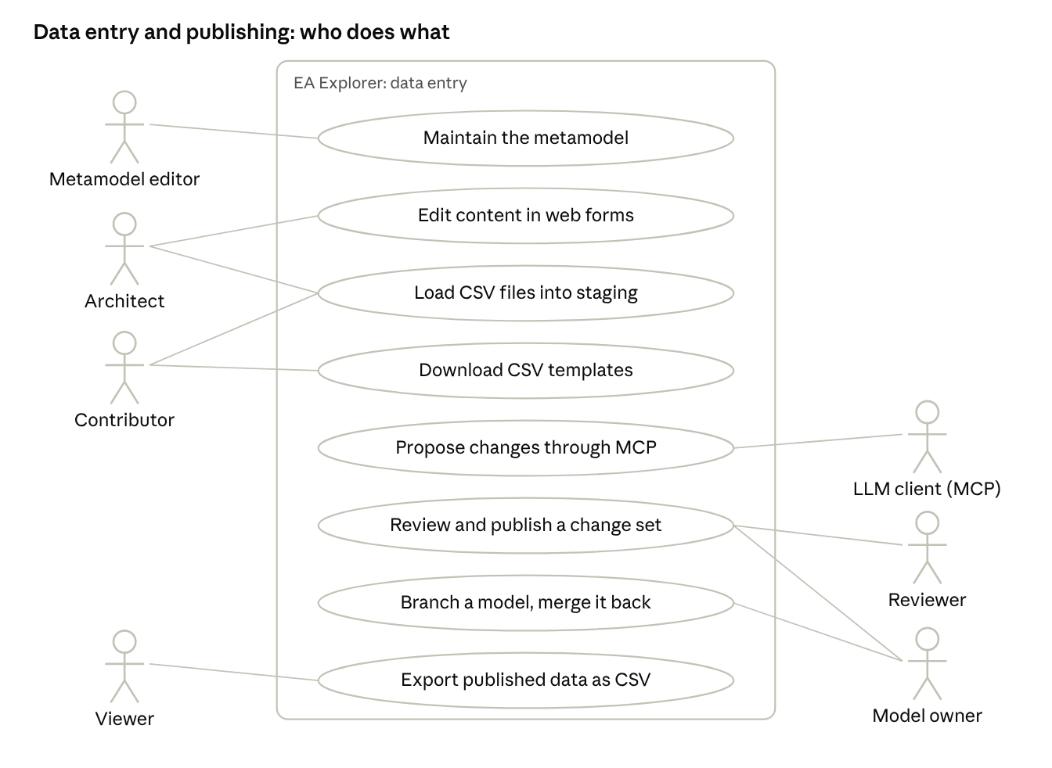
use cases · data entry and publishing
ID | Use case | Actor | Outcome
UC-DE-01 | Maintain the metamodel | Metamodel editor | Types, attributes, rules or lists changed in the web application and published (at once with publish rights, otherwise after approval); CSV templates, shape libraries and report views regenerate
UC-DE-02 | Edit content in web forms | Architect | Entity or relationship changed; published at once with publish rights, otherwise staged
UC-DE-03 | Load CSV files into staging | Contributor, Architect | A staged change set with a preview of new, changed and rejected rows
UC-DE-04 | Download CSV templates | Contributor, Architect | A zip of CSV files: one per entity type, one for relationships, one listing allowed values, headers from the published metamodel
UC-DE-05 | Propose changes through MCP | User's LLM client | A staged change set under the user's name, never a direct change
UC-DE-06 | Review and publish a change set | Reviewer, Model owner | Approved items published to the main repository; rejected items returned with comments
UC-DE-07 | Branch a model and merge it back | Model owner | A child model for a project, later merged into its parent with each conflict decided
UC-DE-08 | Export published data as CSV | Viewer | A zip of CSV files of published content for other systems

6.2 Diagrams
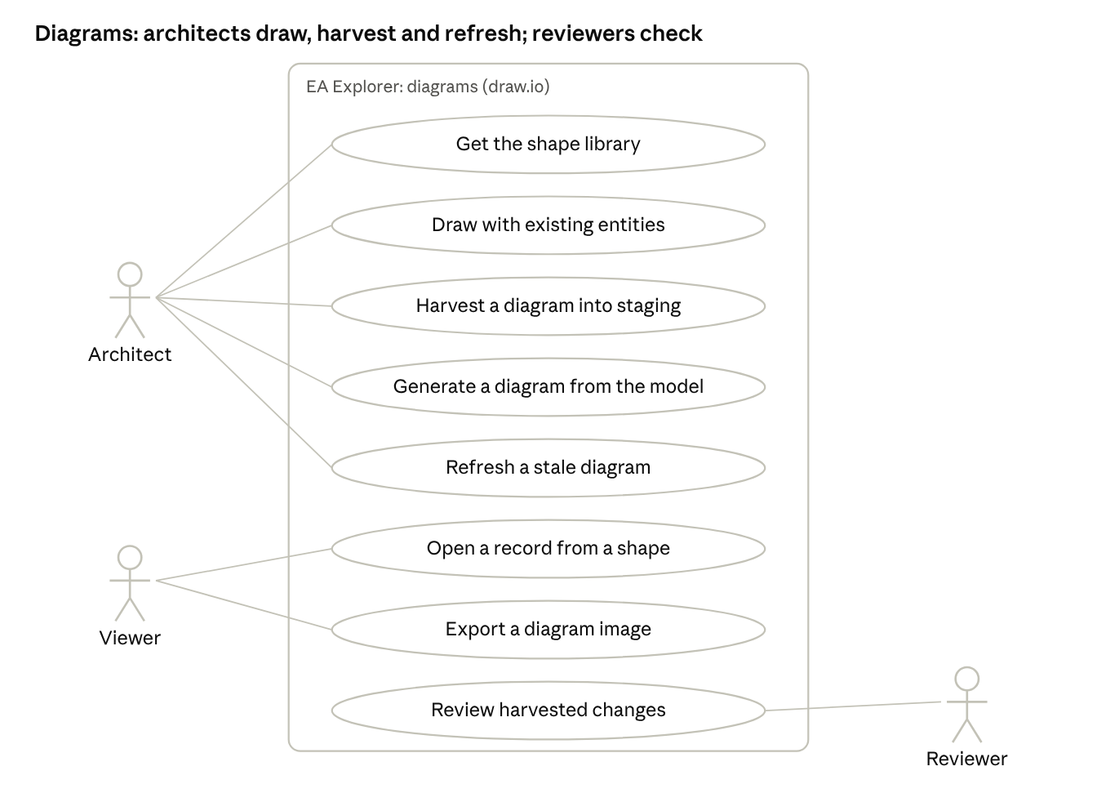
use cases · diagrams
ID | Use case | Actor | Outcome
UC-DG-01 | Get the shape library | Architect | A draw.io library with ArchiMate shapes and the model's own entities
UC-DG-02 | Draw with existing entities | Architect | A diagram whose shapes carry entity IDs
UC-DG-03 | Harvest a diagram into staging | Architect | New and changed shapes and connectors as a staged change set
UC-DG-04 | Generate a diagram from the model | Architect | A diagram laid out around chosen entities and their relationships
UC-DG-05 | Refresh a stale diagram | Architect | Labels updated after renames; retired items flagged on the diagram
UC-DG-06 | Open a record from a shape | Viewer | The entity page opens from the diagram
UC-DG-07 | Export a diagram image | Viewer | PNG, SVG or PDF; optionally filed in Mayan EDMS against the entities shown
UC-DG-08 | Review harvested changes | Reviewer | As UC-DE-06, with the diagram shown beside the changes

6.3 Reports
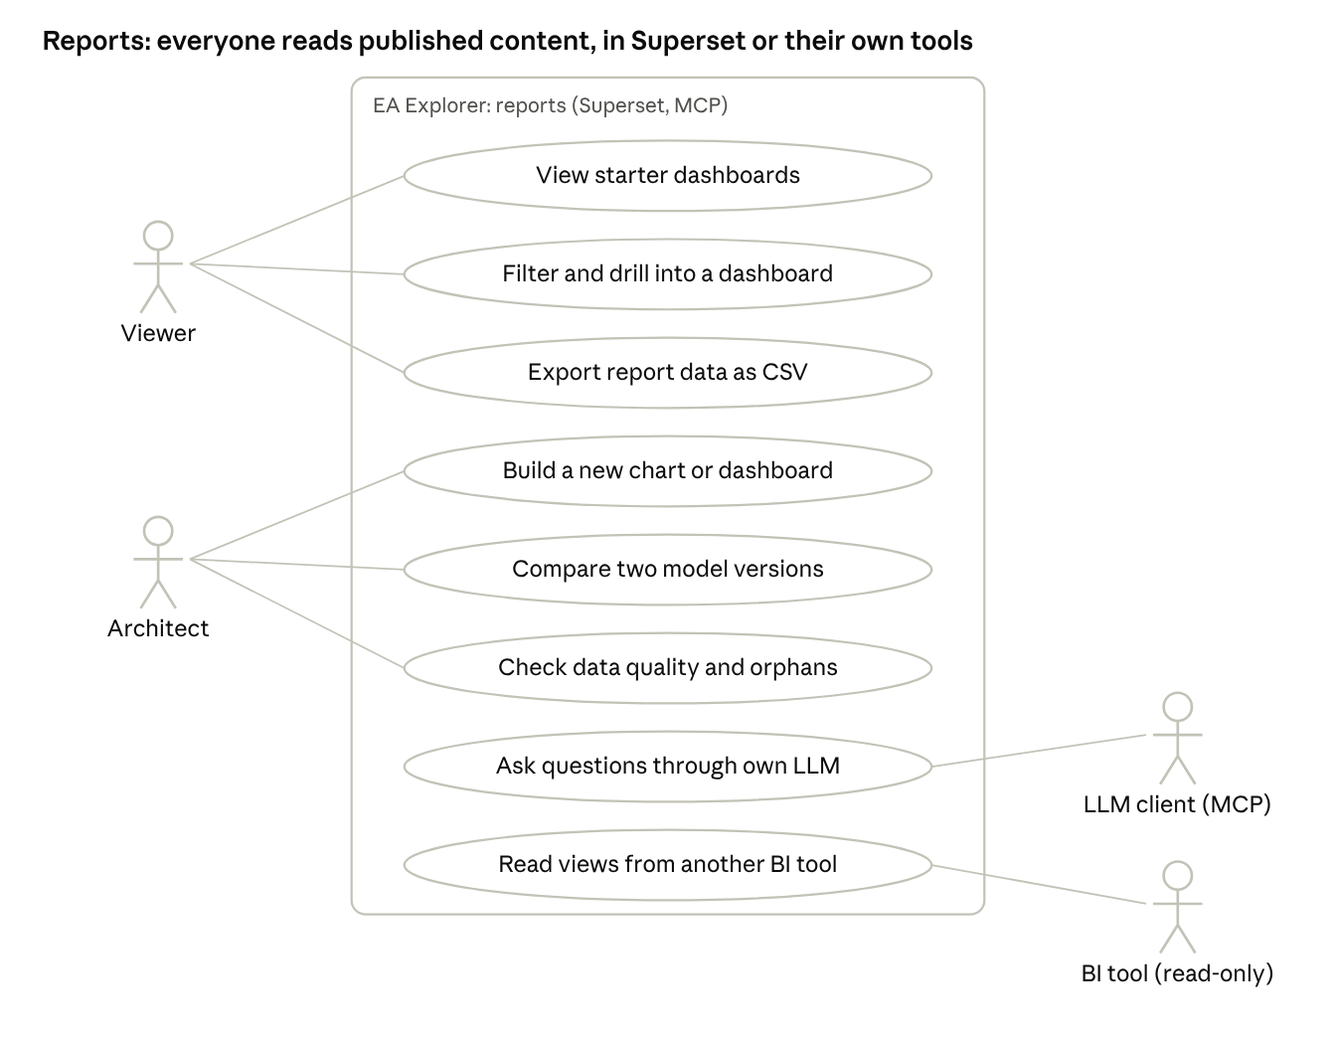
use cases · reports
ID | Use case | Actor | Outcome
UC-RP-01 | View starter dashboards | Viewer | Inventories, matrices, heatmaps and lifecycle views in Superset
UC-RP-02 | Filter and drill into a dashboard | Viewer | Filtered results, with links back to entity pages
UC-RP-03 | Export report data as CSV | Viewer | A CSV file of the report's rows
UC-RP-04 | Build a new chart or dashboard | Architect | A chart or dashboard saved in Superset and shared by role
UC-RP-05 | Compare two model versions | Architect | Added, changed and removed content between two versions or baselines
UC-RP-06 | Check data quality and orphans | Architect, Model owner | Missing values, rule failures and unrelated entities by type
UC-RP-07 | Ask questions through own LLM | User's LLM client | Answers built from MCP read tools, citing the entities used
UC-RP-08 | Read views from another BI tool | BI tool | Read-only access to the report views (for example Power BI)

6.4 Typical flows
Flow A: from staging to the main repository.
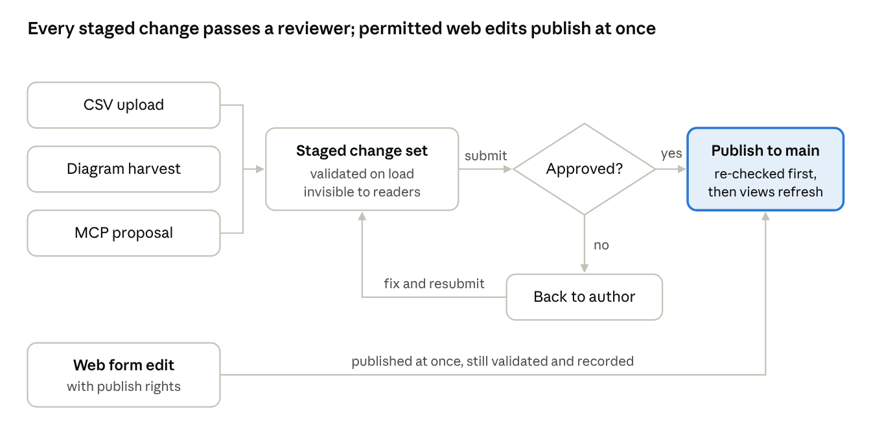
flow A · staging to publish
Flow B: branch a model and merge it back.
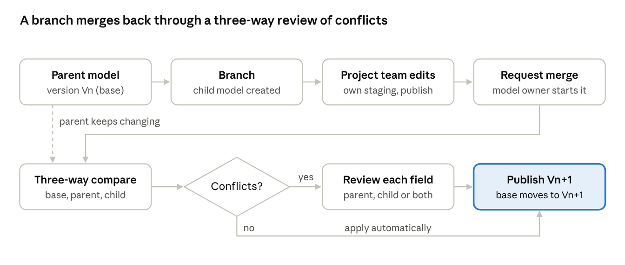
flow B · branch and merge back
- The model owner branches the parent at version Vn; the child model records Vn as its merge base.
- The project team works in the child with its own staging and publishing; the parent keeps changing in parallel.
- The model owner requests the merge. The system compares base, parent and child field by field: a change on one side only is applied automatically; the same field changed differently on both sides is a conflict.
- Each conflict is decided (keep parent, keep child, or for text keep both); diagrams are compared by their stamps. The review can be saved and resumed.
- The merge is published as one change set, creating parent version Vn+1. The merge base moves to Vn+1 only when nothing is left unresolved.
Flow C: a diagram round trip.
- The architect opens draw.io from the model and loads the shape library (UC-DG-01).
- They drag existing entities from the library and draw new shapes and connectors (UC-DG-02).
- On save, the harvest preview lists new entities, new relationships, renamed items and rule breaks; disallowed connectors are flagged (UC-DG-03).
- The architect fixes or drops flagged items and submits; the reviewer sees the diagram beside the changes and approves (UC-DG-08, Flow A).
- On publish the new shapes are tagged with their entity IDs, so the next save finds them unchanged.
Flow D: a regular CSV feed from another system.
- An integration (for example a CMDB export) produces CSV files with the template headers and posts them to the API with a service account.
- The files land in staging as one change set; rows are matched by Display ID or by type and name, and the preview is stored.
- The data owner reviews the change set and publishes it (Flow A). Rejected rows are reported back for the source system to correct.
Flow E: a question through the user's own language model.
- The user connects their LLM client to the MCP server and signs in through Keycloak.
- They ask, for example, "which applications serve the Claims process and reach end of life before 2028?"; the client calls the MCP read tools, which see only published content the user may read.
- The answer cites the entities used. If the user asks the model to fix something it found, the MCP write tool creates a staged change set for review (UC-DE-05).

7. Model library, work copies, standard outputs and the architecture repository
Every installation starts with a library of read-only reference models. People copy one to make their own working model, split the working model into work copies so teams can work in parallel, and merge the copies back. Thirty standard reports and twenty standard views work on any of these models.
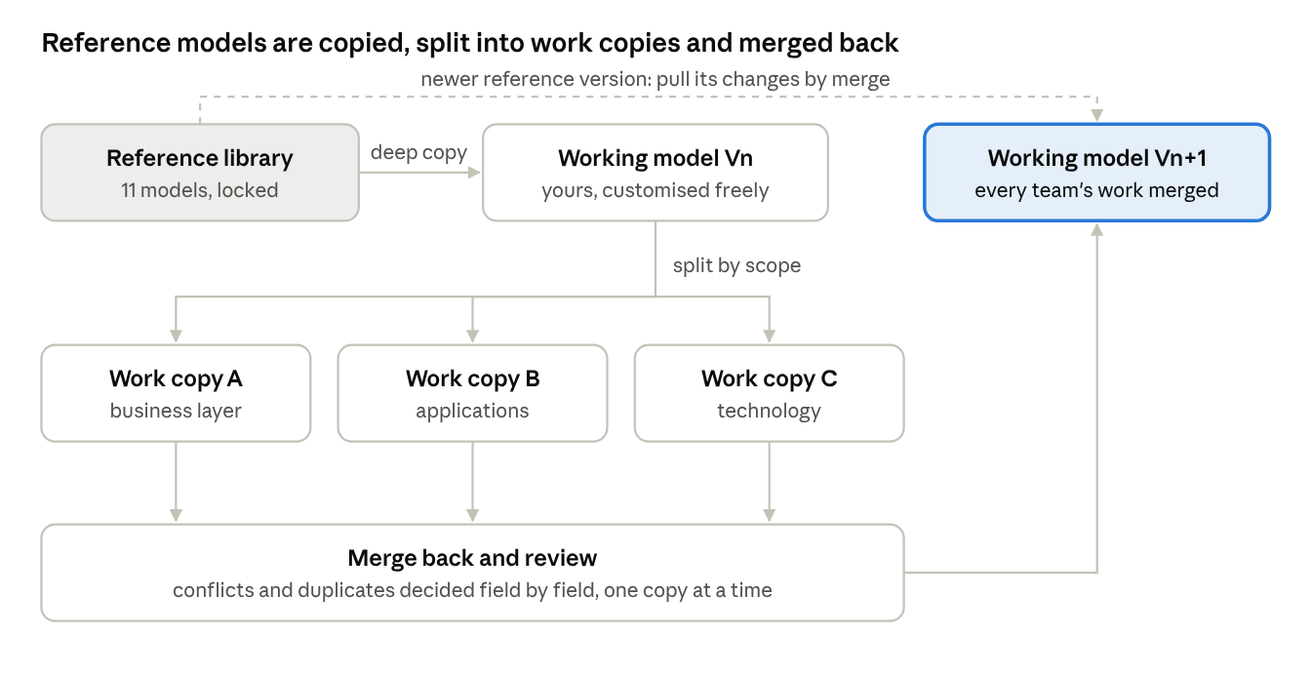
model library and work copies · copy, split, merge back
A newer release of a reference model can be pulled into a working model through the same merge, using the version it was copied from as the merge base.

7.1 Read-only reference models
- The cross-industry high-level model and the industry models are seed data. Nobody can change them, administrators included.
- Every write path (web, API, CSV, diagram harvest, MCP, merge) refuses changes to a reference model, and database triggers refuse updates and deletes on reference rows for every application and administrator role.
- Reference models are loaded or updated only by the installer or an upgrade migration, through a database role that is switched off afterwards.
- An upgrade adds a new version of a reference model beside the old one; models already copied from it are never changed.
- Reports and standard views can be run on reference models, so people can explore them before copying.

7.2 The industry library
Eleven models ship with the product: the cross-industry high-level model and ten industry models. Each industry model has capabilities to level 3, value streams, level 1 and 2 processes, business objects, typical application and technology components (generic names, no vendors), drivers and regulations, stakeholders and starter diagrams.
ID | Model | Covers | Main content
IND-00 | Cross-industry high-level model | Generic enterprise | Level 1-2 capabilities common to most organisations (strategy, customer, product, operations, finance, people, risk, technology); core value streams (acquire customer, deliver product or service, support customer, hire to retire, procure to pay, record to report); core business objects; application and technology domains
IND-01 | Insurance | Life, non-life and health insurance | Product design and pricing, distribution and intermediaries, underwriting, policy administration, claims, reinsurance, actuarial and capital, investment, customer service; value streams quote-to-bind, first notice of loss to settlement, policy servicing
IND-02 | Banking | Retail, business and corporate banking | Customer onboarding and KYC, accounts and deposits, lending and credit, cards and payments, treasury, trade finance, wealth, collections, financial crime; value streams account opening, loan origination to repayment, payment execution
IND-03 | Manufacturing | Discrete and process manufacturing | Product engineering, demand and supply planning, procurement, production planning and execution, quality, maintenance, warehousing, distribution, after-sales service; value streams order-to-cash, plan-to-produce, design-to-release
IND-04 | Healthcare | Hospitals, clinics and health funders | Patient registration and scheduling, clinical care, diagnostics, pharmacy, care coordination, health records, billing and claims, public and population health; value streams patient admission to discharge, referral to treatment
IND-05 | Mining and minerals | Exploration to sale of minerals and metals | Exploration and resource management, mine planning, extraction, processing and beneficiation, asset and fleet maintenance, health and safety, environment and rehabilitation, logistics and marketing; value streams mine-to-market, ore-to-concentrate
IND-06 | Retail and consumer goods | Store, online and omnichannel retail | Merchandising and assortment, pricing and promotions, supply chain and replenishment, store operations, e-commerce, customer loyalty, returns; value streams browse-to-buy, order-to-deliver, source-to-shelf
IND-07 | Telecommunications | Mobile, fixed and digital service providers | Product catalogue, customer and order management, service fulfilment and assurance, network planning and operations, billing and revenue management, partner management; value streams order-to-activate, trouble-to-resolve, usage-to-bill
IND-08 | Energy and utilities | Power, water and gas utilities | Generation or supply, transmission and distribution, asset management, metering and meter-to-cash, outage and field service, customer service, regulation and tariffs; value streams connect-to-supply, meter-to-cash, outage-to-restore
IND-09 | Public sector | Government departments and agencies | Policy and legislation, citizen services and case management, grants and benefits, revenue collection, licensing and permits, inspections and enforcement, public finance; value streams application-to-decision, case open-to-close
IND-10 | Transport and logistics | Freight, logistics and passenger transport | Network and route planning, booking and order management, fleet and asset management, warehousing, track and trace, customs and compliance, billing; value streams order-to-delivery, book-to-travel
The models are written for this product and aligned to public concepts. Several industry frameworks (BIAN, ACORD, TM Forum, APQC) are licensed, so their content is not copied in unless its licence allows open redistribution.

7.3 Deep copy and work copies
- Deep copy copies a whole model: metamodel, entities, relationships, attributes, diagrams, document links, owners and saved views, with new IDs. Options: metamodel only; with content; with content and diagrams; with history. The copy can be used as it is or customised freely, and its lineage (source model and version) is recorded.
- Work copies let teams partition work. A model owner takes a copy of part of a model, chosen by layer, entity types, a capability or organisation subtree, tags or a saved search. Several work copies can be open at once.
- When a new work copy overlaps an open one, the system names the overlapping entities and who holds the other copy. The model page shows who is working on what.
- Each work copy merges back on its own with a preview (Flow B in section 6.4). A copy merged after another one sees conflicts against the parent's new state, and entities created separately in two copies are offered as duplicates. After merging, a work copy is closed and kept for history, or discarded.

7.4 Removing duplicates
- A duplicate finder scores candidate pairs per entity type by normalised name, fuzzy name similarity (PostgreSQL pg_trgm), aliases, external IDs and matching attribute values.
- For each candidate group the user combines the entities, marks them "not a duplicate" (remembered for later scans) or skips them.
- Combining picks a surviving entity and the value to keep for each field, moves relationships, diagram shapes and document links to the survivor without creating double relationships, and then deletes the duplicates. Their IDs keep resolving to the survivor and they stay in history and the audit log.
- Duplicate relationships (same type, same two entities) are found and removed the same way.
- CSV loads, diagram harvests and MCP proposals flag rows that look like existing entities before staging, so duplicates are prevented as well as cleaned up.
- Every dedupe is a change set: published at once with publish rights, otherwise staged for review.

7.5 Thirty standard reports
The standard reports ship as Superset dashboards over the rpt views, installed and upgraded with the product. They are built on the standard types, so they work on reference models, copies and customised models that keep those types.
ID | Group | Report | What it shows
SR-01 | Inventory | Application portfolio inventory | Every application with owner, lifecycle, criticality, cost and TIME
SR-02 | Inventory | Business capability catalogue | Capability hierarchy with descriptions and owners
SR-03 | Inventory | Technology component inventory | Technology components with version, vendor, lifecycle and end-of-life
SR-04 | Inventory | Data entity catalogue | Business objects and data objects with owners and classification
SR-05 | Inventory | Business process catalogue | Processes by level with owners and roles
SR-06 | Inventory | Interface and integration catalogue | Application flows with source, target, data and technology
SR-07 | Inventory | Stakeholder and actor catalogue | Actors, roles, organisation units and their concerns
SR-08 | Inventory | Motivation catalogue | Drivers, goals, outcomes, principles, requirements and constraints
SR-09 | Matrix | Application against capability | Which applications support which capabilities
SR-10 | Matrix | Application against process | Which applications serve which processes
SR-11 | Matrix | Application against data entity (CRUD) | Which applications create, read, update or delete which data
SR-12 | Matrix | Application against technology | Which technology each application runs on
SR-13 | Matrix | Process against role | Which roles perform or own which processes
SR-14 | Matrix | Capability against value stream | Which capabilities enable which value stream stages
SR-15 | Matrix | Application interaction matrix | Application-to-application flows
SR-16 | Heatmap | Capability heatmap | Capabilities coloured by number of applications, maturity or any attribute
SR-17 | Heatmap | Technology lifecycle and end-of-life | Technology by lifecycle phase and end-of-support date
SR-18 | Portfolio | Application TIME quadrant | Applications by functional and technical fit (Tolerate, Invest, Migrate, Eliminate)
SR-19 | Portfolio | Criticality against technical health | Business criticality against technical health per application
SR-20 | Portfolio | Cost by capability | Application and technology cost rolled up to capabilities
SR-21 | Portfolio | Vendor concentration | Applications and technology per vendor or provider
SR-22 | Risk and impact | Impact analysis | Everything that depends on a chosen entity, by depth
SR-23 | Risk and impact | Obsolescence risk | Applications and capabilities at risk from end-of-life technology
SR-24 | Risk and impact | Single points of failure | Technology or applications with many dependants and no alternative
SR-25 | Risk and impact | Rationalisation candidates | Capabilities served by several applications; overlapping applications
SR-26 | Data quality | Completeness by type and owner | Completeness scores and missing mandatory values
SR-27 | Data quality | Orphans and missing relationships | Entities with no relationships or missing required ones
SR-28 | Data quality | Duplicate candidates | Likely duplicate entities by type with similarity score
SR-29 | Governance | Change activity | Published change sets by period, model, author and source (web, CSV, diagram, MCP, merge)
SR-30 | Governance | Version and baseline comparison | Added, changed and removed content between two versions or baselines (gap analysis)

7.6 Standard views as draw.io files
Standard views are a separate function from standard reports. On the Views page a user selects a model and a standard view from the catalogue, sets its scope, and the system prepares the diagram as a .drawio file. The file can be downloaded, saved into the model's diagrams, opened in draw.io or exported as PNG, SVG or PDF. Every shape is tagged with its entity ID, so the view can be edited and harvested like any diagram. A saved view remembers its parameters and can be regenerated from current content, and a view can be generated for every entity of a type at once (for example a context view per application).
ID | View | Layer | What it shows | Scope you choose
SV-01 | Capability map | Strategy | Capability hierarchy as nested boxes; optional colour by attribute | Model; root capability; depth; colour-by attribute
SV-02 | Value stream view | Strategy | Value stream stages left to right with the capabilities that enable each | Value stream
SV-03 | Strategy view | Strategy | Capabilities, resources and courses of action with the outcomes they serve | Scope tag or capability subtree
SV-04 | Motivation view | Motivation | Stakeholders, drivers, goals, outcomes, principles and requirements with their links | Goal or driver; depth
SV-05 | Stakeholder view | Motivation | Stakeholders with their concerns, drivers and goals | Stakeholder set
SV-06 | Organisation structure view | Business | Organisation units, actors and roles as a hierarchy | Root organisation unit; depth
SV-07 | Business process view | Business | A process with its sub-processes, roles, events and business objects | Process; depth
SV-08 | Business process cooperation view | Business | Processes and the flows and triggers between them | Process set or value stream
SV-09 | Product view | Business | A product with its services, contracts, processes and applications | Product
SV-10 | Application landscape | Application | Applications grouped by capability or domain; optional colour by lifecycle, TIME or criticality | Grouping; colour-by attribute; filter
SV-11 | Application cooperation view | Application | Applications and the flows between them | Application set; depth
SV-12 | Application usage view | Application | Applications serving business processes and roles | Process or application set
SV-13 | Information structure view | Application | Business objects and data objects with their structure and associations | Business object set
SV-14 | Technology view | Technology | Nodes, devices, system software and networks | Technology scope or location
SV-15 | Deployment view | Technology | Applications and the technology they run on | Application set
SV-16 | Layered view | Cross-layer | Business, application and technology layers for a scope, top to bottom | Root entity; depth
SV-17 | Entity context view | Cross-layer | One entity with all its direct relationships | Entity
SV-18 | Impact view | Cross-layer | Everything that depends on an entity, by hop | Entity; relationship types; depth
SV-19 | Migration view | Implementation | Plateaus with the gaps and work packages between them | Plateau set
SV-20 | Implementation view | Implementation | Work packages and deliverables with the entities they realise | Programme or work package

7.7 The architecture repository
The metamodel is one part of the TOGAF Architecture Repository. Each model also holds the other seven parts, and a navigation tree shows them for every model.
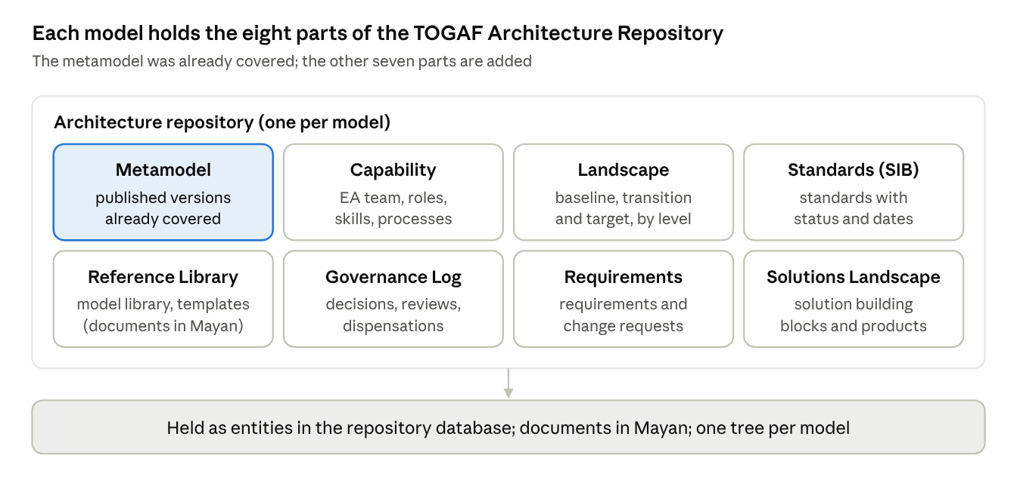
architecture repository · the eight TOGAF parts held per model
Part | What the product holds | How
Architecture Metamodel | The published metamodel and its versions | Metamodel editor (already covered)
Architecture Capability | The EA team, roles, skills, processes, tools and maturity assessments | Entities of the repository metamodel pack
Architecture Landscape | Strategic, segment and capability landscapes, each as baseline, transition and target | Versions, plateaus and work copies; gap analysis between any two
Standards Information Base | Business, data, application, technology and regulatory standards with status (trial, active, deprecated, obsolete), owner and review date | Entities linked to the entities that comply or deviate
Reference Library | Reference models, patterns, templates, guidelines, viewpoint definitions | The model library plus documents in Mayan
Governance Log | Decisions, compliance reviews and outcomes, dispensations with expiry, capability assessments, review calendar, performance measures | Entities with forms, lists and history; expiry notifications; governance dashboards
Architecture Requirements Repository | Requirements, constraints, assumptions and change requests with impact assessment | Entities traced to what realises them
Solutions Landscape | Solution building blocks and products linked to architecture building blocks | Entities and relationships
ArchiMate does not cover governance records, standards or deliverables, so the types for these parts ship as a repository metamodel pack beside ArchiMate 4, in every reference model. An ADM deliverables register tracks deliverables (for example the Request for Architecture Work, Architecture Definition Document and Architecture Contract) per engagement and phase, each linked to its document in Mayan.

8. Architecture views
Three views of the same system: what it does (functional), how its parts fit together (logical), and what actually runs (technical). In each, what we build is coloured and what comes out of the box is plain.

8.1 High-level functional architecture
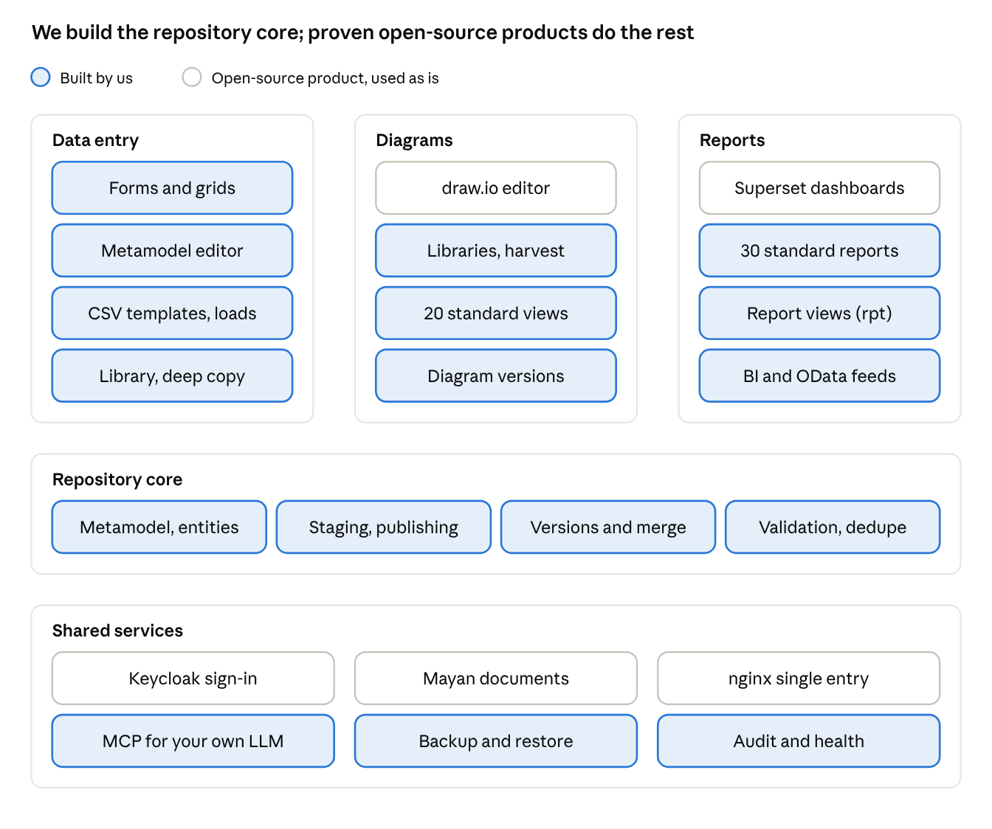
high-level functional architecture · built by us against open-source products
The functions people use are grouped as in section 5. We build the repository core, data entry, the diagram integration, the report views and the standard reports and views; draw.io, Superset, Keycloak, Mayan EDMS and nginx are used as they are.

8.2 Logical architecture
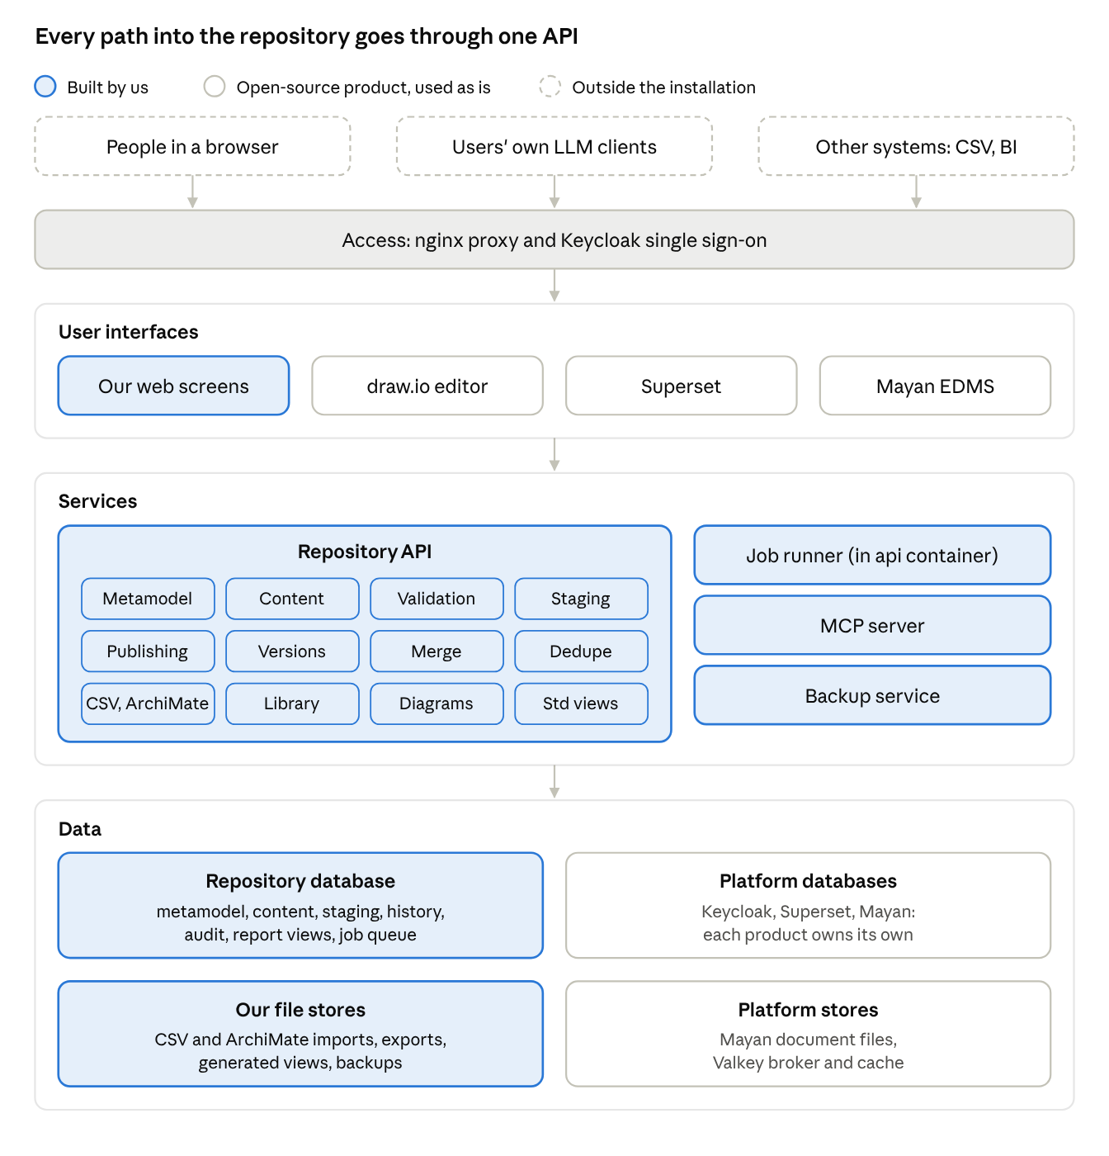
logical architecture · components and the paths between them
- One way in. Every person, LLM client and outside system comes through the nginx proxy, and every person signs in once through Keycloak.
- One writer. Only the Repository API writes repository content. Our web screens, the draw.io integration (libraries, harvest, standard views), CSV and ArchiMate exchange loads, the MCP server and the job runner all call it, so the same rules, publishing workflow and audit apply to every route.
- Read paths. Superset reads only the report views in the repository database, through a read-only role. The MCP server reads through the API with the user's token. Mayan keeps documents; the API stores only the links between documents and entities.
- Our data and theirs. The repository database and our file stores (imports, exports, generated views, backups) are ours. Keycloak, Superset and Mayan each keep their own database, and Mayan keeps its own document files and uses Valkey as its broker.

8.3 Technical architecture
The diagram shows the single-server deployment: eleven containers on two Docker networks, plus a development profile. We build four containers (web, api, mcp, backup) and one database (eaexplorer); everything else is an unmodified open-source image configured from the config file. The same containers run in every deployment kind (section 11).
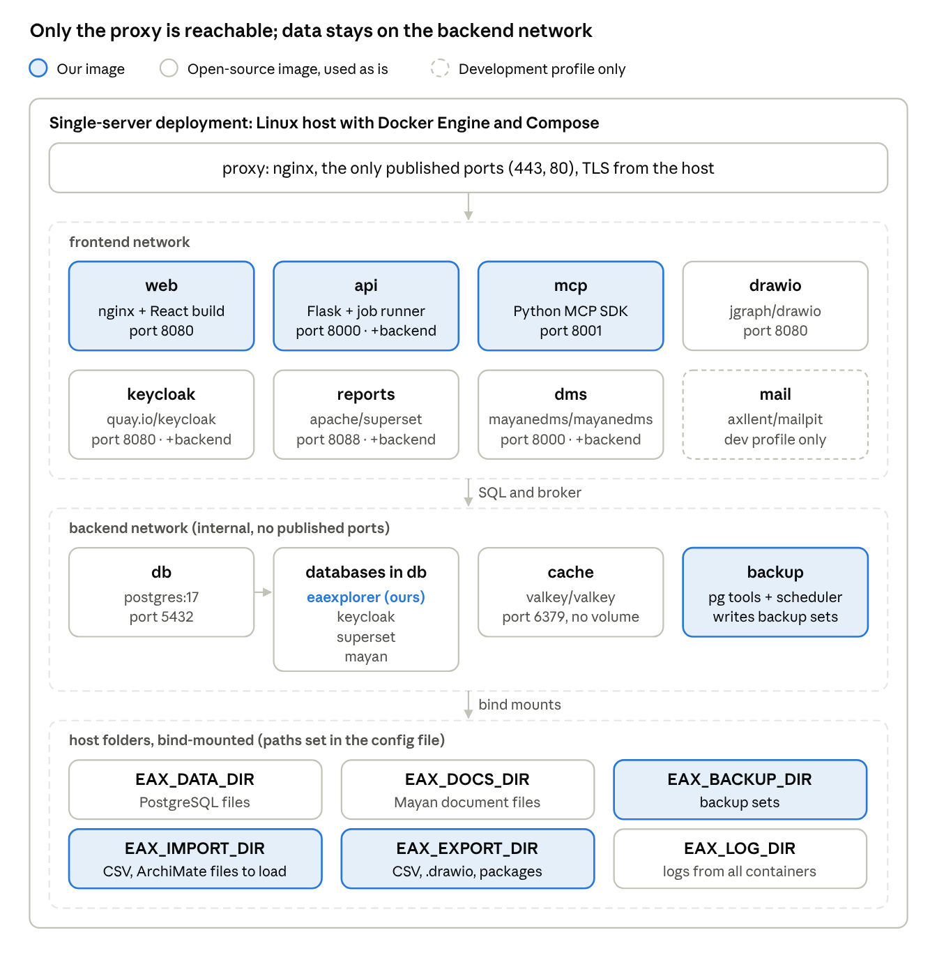
technical architecture · containers, networks, databases and host folders (single server)
Only the proxy publishes ports. The backend network is internal: only api, keycloak, reports, dms and backup join it, so the databases and Valkey cannot be reached from outside, or from web, drawio and mcp. The MCP server reaches data only through the api, with the user's own token.
Container | Provided by | Image | Internal port | Networks | Host folders | Role
proxy | Out of the box | nginx | 443 and 80, published | frontend | TLS certificate and key (read-only) | Single entry point: TLS; routes / (web), /api, /auth, /drawio, /reports, /docs, /mcp; rate and upload limits
web | Ours | Our image: nginx serving the React build | 8080 | frontend | none | Our screens: models, library, metamodel, data entry, CSV loads, staging and publishing, merge and dedupe review
api | Ours | Our image: Python, Flask, gunicorn, Procrastinate job runner | 8000 | frontend, backend | EAX_IMPORT_DIR, EAX_EXPORT_DIR | Repository API and every background job (CSV and ArchiMate loads, exports, copies, merges, dedupe scans, view and report generation)
mcp | Ours | Our image: Python MCP SDK | 8001 | frontend | none | MCP server for users' own LLM clients; calls the api
backup | Ours | Our image: PostgreSQL client tools and a scheduler | none | backend | EAX_BACKUP_DIR; EAX_DOCS_DIR read-only | Dumps of all four databases, archive of Mayan's files, retention, restore
db | Out of the box | postgres:17 | 5432 | backend | EAX_DATA_DIR | Hosts the four databases below
keycloak | Out of the box | quay.io/keycloak/keycloak | 8080 | frontend, backend | none | Single sign-on for our screens, Superset and Mayan; AD/LDAP, Entra ID, Google
drawio | Out of the box | jgraph/drawio | 8080 | frontend | none | Diagram editor, self-hosted
reports | Out of the box | apache/superset | 8088 | frontend, backend | none | Dashboards and the thirty standard reports
dms | Out of the box | mayanedms/mayanedms | 8000 | frontend, backend | EAX_DOCS_DIR | Documents, versions, metadata, OCR, search
cache | Out of the box | valkey/valkey | 6379 | backend | none (no persistence needed) | Broker and cache for Mayan; cache for Superset
mail | Out of the box (dev only) | axllent/mailpit | 8025 and 1025 | frontend | none | Catches outgoing mail in development
All containers log to standard output; the logging driver writes the logs to EAX_LOG_DIR. Internal ports are proposals for our own images and the products' defaults for the rest.
Files (Mayan's document store, diagram images, CSV imports and exports, backups) live on host paths set in the configuration file and mounted into the containers that need them. Valkey is used rather than Redis because Redis's licence has changed twice since 2024; Valkey is its BSD-licensed fork. No language model runs in the install: users connect their own through the mcp container.

8.4 Databases
One PostgreSQL container holds four databases, each with its own login so no product can read another's data. We create the repository database and its schemas; the products create and migrate their own, in empty databases and users we set up on first start.
Database | Created and owned by | Used by | What it holds | Backed up
eaexplorer | Ours (our migrations) | api; backup; Superset through a read-only role on rpt only | Schemas: library (reference models, locked by triggers), core (metamodels, entities, relationships, diagrams, document links), staging (change sets), history, audit, jobs (job queue), rpt (generated report views) | Yes
keycloak | Keycloak | keycloak | Realm, users, groups, roles, identity provider settings, sessions | Yes
superset | Superset | reports | Dashboards, charts, datasets, Superset roles; the thirty standard reports as a dashboard pack | Yes
mayan | Mayan EDMS | dms | Document records, versions, metadata, tags, workflows, search index | Yes
Valkey (not a database) | Mayan and Superset | dms, reports | Broker queues and cache only; rebuilt on restart | No
In the scale-out and cloud deployments the four databases can move to a separate or managed PostgreSQL server; only the connection settings in the config file change.

8.5 File storage
Host folder (key) | Mounted into | Holds | Written by | Backed up
EAX_DATA_DIR | db | PostgreSQL data files for all four databases | PostgreSQL | Through database dumps, not file copies
EAX_DOCS_DIR | dms (read-write), backup (read-only) | Mayan's document files and their versions | Mayan EDMS | Yes, archived by the backup container
EAX_BACKUP_DIR | backup | Database dumps, Mayan file archives, optional WAL archive | Ours (backup) | It is the backup; optionally copied off-site
EAX_IMPORT_DIR | api | CSV files and ArchiMate exchange files dropped for loading | Users and integrations; read by our api | No; files are moved to the change set once loaded
EAX_EXPORT_DIR | api | CSV exports, ArchiMate exchange files, generated .drawio views, model packages | Ours (api) | No; can be regenerated
EAX_LOG_DIR | all, through the logging driver | Container logs | Every container | No
EAX_TLS_CERT and EAX_TLS_KEY | proxy (read-only) | Certificate and private key | Administrator | Kept by the administrator, not in backups
Diagrams themselves are stored in the repository database (as draw.io XML with versions), not as files, so they are backed up with the database and covered by history and merge. In the cloud deployment the folders can be replaced by cloud storage (for example an S3-compatible bucket for Mayan and for backups).

9. Reports and documents: Superset and Mayan EDMS
Following P9, both jobs go to mature open-source products used with their own screens; we build only the connections.
Reports: Apache Superset, in every install. Superset is on the approved tools list, Apache-2.0 licensed with no paid edition, reads PostgreSQL views directly and signs in through Keycloak (OpenID Connect).
Option | Licence | For | Against
Apache Superset (recommended) | Apache 2.0 | Apache Software Foundation project (6.0 released); reads PostgreSQL views directly; dashboards, pivots, heatmaps, maps; SQL Lab for power users; sign-in through Keycloak by OpenID Connect; dashboards can be embedded | Heavier container; its permission model must be lined up with ours (a read-only database role on published views, roles synced from Keycloak)
Metabase (open-source edition) | AGPL-3.0 | Easiest for non-technical users | SAML and JWT single sign-on, and embedding without branding, are in the paid edition, which conflicts with P1
Grafana | AGPL-3.0 | Good for operational metrics | Built for time series, not EA inventories and matrices
Built-in only | Ours | No extra container | Every new chart is development work
Superset ships with starter dashboards on the rpt views: inventories per type, matrices such as application against capability (pivot tables), lifecycle and criticality heatmaps, TIME classification, orphans, data quality and version comparison. People build further charts and dashboards in Superset itself and share them by role. We build the views (section 10), the read-only database role, the dashboard pack shipped with each release, and row filtering so people see only models they may read. What Superset does not draw well, such as a nested capability map or a roadmap, is generated as a draw.io diagram coloured by an attribute.
Documents: Mayan EDMS, in every install. People use Mayan's own screens to upload, version, tag, search and OCR documents. Our part is small: links between Mayan documents and entities, shown on the entity page and stored in Mayan as metadata; sign-in through Keycloak; and backup of Mayan's database and file store with everything else.
Option | Licence | For | Against
Mayan EDMS (chosen) | GPL-2.0 (Apache 2.0 until January 2024) | Mature, Python and Django, REST API, document versions, metadata, tags, OCR, workflows; Docker images; 4.12.1 released August 2026 | Needs a broker (Valkey) and its own background workers; its screens look different from ours, which P9 accepts
Build our own store | AGPL-3.0 (ours) | No extra containers | We would build upload, versions, search and OCR ourselves, against P5 and P9
Paperless-ngx | GPL-3.0 | Popular, polished | Built for scanned paper; weak on versions and on linking to architecture content
Nextcloud | AGPL-3.0 | Familiar file sharing, WebDAV, versions | A whole collaboration suite to run for a document store
Mayan's GPL-2.0 licence does not affect our AGPL-3.0 code: the two run as separate programs that talk over HTTP.
Sources: Mayan EDMS, Mayan EDMS 4.6.6 release notes, Apache Superset 6.0.0 release, Superset with Keycloak, Paperless-ngx, draw.io self-hosting, draw.io embed mode.

10. Entity tables from the metamodel
POC 0009 proved that PostgreSQL can turn attribute rows into one column per attribute, which is what users, reports and the language model all need. The product keeps that outcome but builds the tables once per metamodel publication instead of on every query.
What POC 0009 does. It joins the type, attribute and value tables, creates temporary tables, adds one Text column per attribute name, then fills them one value at a time with dynamic UPDATE statements. That shows the idea works, but it is slow (one statement per value), open to SQL injection (values are concatenated into SQL), fails on a second call in the same session (fixed temporary table names), loses data types (every column is Text) and rebuilds everything per query.
What the product does.
- Each entity is one row in an entities table, with its system fields as columns and its attributes in a JSONB column; relationships likewise. The API validates every attribute against the published metamodel before writing.
- When a metamodel version is published, a background job in the api container generates, for each entity type, a read-only view in a reporting schema, named from the type code (for example rpt.application_component), with one typed column per mapped attribute: name, display_id, status, owner text, criticality integer, go_live_date date, and so on. Relationship types get views too (rpt.rel_serving with source and target names and types). Identifiers are quoted with format('%I') and nothing user-typed is concatenated into SQL.
- Views that reports read heavily can be materialised and refreshed by a background job after content changes, at an interval set in the configuration file.
- History has matching views "as of" a model version, so reports can compare baseline and target.
- A read-only database role can read only the rpt schema; Superset, other report tools and the MCP server's query tools use it, so reports never see draft or unauthorised content.
This is the server equivalent of the Workbench's "Apply metamodel changes", which regenerates DATA_Master columns and the type sheets.

11. Configuration and deployment
Everything an administrator decides before the first start lives in one file, eaexplorer.env, next to docker-compose.yml. Compose reads it directly, so there is no second place to edit. A commented template, eaexplorer.env.example, ships with the release; the real file is excluded from git because it holds secrets.
Group | Keys (examples)
Site | EAX_HOSTNAME, EAX_HTTP_PORT, EAX_HTTPS_PORT, EAX_TLS_CERT, EAX_TLS_KEY, EAX_TIMEZONE, EAX_ORG_NAME, EAX_VERSION
Folders on the host | EAX_DATA_DIR (database files), EAX_DOCS_DIR (Mayan's file store), EAX_BACKUP_DIR, EAX_IMPORT_DIR, EAX_EXPORT_DIR, EAX_LOG_DIR
Database | EAX_DB_NAME, EAX_DB_PASSWORD, EAX_DB_REPORT_PASSWORD (read-only role)
Identity | EAX_KC_ADMIN, EAX_KC_ADMIN_PASSWORD, EAX_FIRST_ADMIN_EMAIL, EAX_IDP (local, ldap, entra, google), LDAP or Active Directory URL, bind user and base DN, Entra tenant and client ID
Mail | EAX_SMTP_HOST, EAX_SMTP_PORT, EAX_SMTP_USER, EAX_SMTP_PASSWORD, EAX_MAIL_FROM
Backup | EAX_BACKUP_SCHEDULE (cron), EAX_BACKUP_KEEP_DAILY, EAX_BACKUP_KEEP_WEEKLY, EAX_BACKUP_KEEP_MONTHLY, optional off-site S3 target and encryption key
Reports and documents | EAX_SUPERSET_SECRET_KEY, EAX_MAYAN_SECRET_KEY, EAX_VIEW_REFRESH_MINUTES
MCP | EAX_MCP_ENABLED, EAX_MCP_DAILY_LIMIT (calls per user per day)
Optional parts | COMPOSE_PROFILES (dev)
Install. Copy the template, edit it, run docker compose up -d. On the first start the api container creates the schema, loads the ArchiMate 4 starter metamodel and an empty model, creates the Keycloak realm, roles and the first administrator, and prints the address to open. A health page shows each container's state.
Upgrade. Change the image tag in the file and run docker compose pull && docker compose up -d. The api container takes a backup, then applies database migrations (Alembic) before accepting traffic; if a migration fails it stops and restores.
Secrets. Secrets may be given in the file or, for stricter sites, as Docker secrets files whose paths are in the file. Nothing is baked into images.
Deployment kinds. The same images run in four kinds of deployment. Each ships as a config template and a compose override file; an installation copies one template to its own config file and starts with docker compose -f docker-compose.yml -f docker-compose.<kind>.yml up -d.
Kind | For | What runs where | Typical size
Laptop | Evaluation, training, one architect | All containers on one machine; localhost; self-signed certificate; Mailpit; small limits; sample and library models loaded | 4 cores, 16 GB RAM; Windows (WSL2), macOS or Linux
Single server | A team or a small organisation | All containers on one Linux server; organisation certificate; directory sign-in; scheduled backups (section 8.3) | 4-8 cores, 16-32 GB RAM, SSD
Scale-out | Large organisations, many users | Several hosts; api, mcp and web replicas behind a load balancer; separate job runners; PostgreSQL on its own host; shared storage (NFS or S3) for Mayan and backups | 2 or more application hosts and 1 database host
Cloud | Organisations on a public cloud | Cloud VMs or a container service; managed PostgreSQL; S3-compatible object storage; the cloud's load balancer, certificates and secret store | Sized per cloud
The extra settings are EAX_DEPLOYMENT, EAX_DB_HOST (external or managed PostgreSQL), EAX_API_REPLICAS, EAX_JOB_RUNNERS, EAX_STORAGE (folders or s3) and the S3 endpoint, bucket and keys. An installation moves from one kind to another by backup and restore. Each kind also gets deployment scripts (pre-flight check, install, config generator, upgrade with rollback, backup and restore, scaling and maintenance, uninstall), written with open-source tools only: bash, PowerShell, Ansible, OpenTofu (not Terraform, whose licence is no longer open source) and Helm.

12. Non-functional requirements
These are the headline targets; the spreadsheet's NFR sheet holds the full list with measures.
Area | Requirement
Security | All traffic over HTTPS; sign-in only through Keycloak (OIDC); every API call checks role and model permission on the server; OWASP Top 10 covered; parameterised SQL only; secrets never logged; containers run as non-root
Audit | Every create, change, delete, import, merge, sign-in, permission change, backup and restore is recorded with who, when and before/after values; audit log is append-only and exportable
Performance | Up to 50,000 entities and 200,000 relationships per model; list and search pages under 2 seconds; opening a 300-shape diagram under 3 seconds; import of 10,000 rows under 2 minutes
Concurrency | At least 100 signed-in users and 25 editing at once on a 4-core, 16 GB host; edit conflicts detected by version number, never silently overwritten
Backup and restore | Nightly full backup plus write-ahead-log archiving; recovery point 24 hours by default (15 minutes with WAL archiving on); restore of a 5 GB database in under 1 hour; a restore test can run into a scratch database
Availability | Single-host install is the baseline; containers restart on failure; stateless api and web can be scaled out behind the proxy
Portability | Runs on any Linux host with Docker Engine 24+ and Compose v2; arm64 and amd64 images; no internet needed after images are pulled (air-gapped install supported)
Usability and accessibility | WCAG 2.1 AA; current Chrome, Edge, Firefox and Safari; usable at 1280 px wide; English first with translatable text
Maintainability | Type-checked Python, automated tests in CI, one database migration per change, semantic versions, open API description
Openness | All components under OSI-approved licences; data exportable in full (CSV and the Open Exchange Format) with no lock-in

13. Delivery: one release
There is one release: everything in this document and the requirements workbook (where the release column reads "Phase 1") is in scope for version 1.0. All 328 requirements are Must; the build plan (section 15) sets the order in which they are built, and the workbook's Summary sheet counts them by area and group.

14. Decisions, assumptions and open questions
Assumptions
- The first deployments are single-host Docker installs run by the customer's own IT, not a hosted service.
- ArchiMate 4 is the starter metamodel; other metamodels (ArchiMate 3.2, the TOGAF content framework, a customer's own) are shipped as packs or built in the metamodel editor.
- Customers bring their own TLS certificate and, if they want one, their own MCP-capable language model client.
- The different look of the draw.io, Keycloak, Superset and Mayan screens is acceptable (P9).
- The Workbench's behaviour is the functional baseline unless this document says otherwise.
Decisions taken (3 November 2026)
- Our own code is licensed under AGPL-3.0.
- One installation serves one organisation; several clients mean several installations.
- Reports are done in Superset only; there are no built-in report screens.
- Mayan EDMS is the document repository in every install.
- CSV loads and diagram harvests always go through staging and review; web edits (content and metamodel) publish at once for people with publish rights.
- Spreadsheet data is exchanged as CSV only.
- No language model is shipped; users connect their own through MCP.
- The api and its background jobs share one container.
- The stray string at the end of the charter's Requirements.txt is not a secret and is to be removed.
Added later the same day:
- A cross-industry high-level model and ten industry models ship as read-only seed data that nobody, administrators included, can change.
- Any model can be deep copied, to be used as it is or customised.
- Teams partition work through work copies of a model that are merged back.
- Duplicate entities can be found, combined and deleted.
- Thirty standard reports and twenty standard views (generated as draw.io files) ship with the product.
- There is no phase 2: everything is in version 1.0, every requirement is a Must, and the build plan sets the order.
- Models are exchanged with other EA tools in The Open Group ArchiMate Model Exchange File Format (ArchiMate 4, and 3.x files).
- Config templates ship for four deployment kinds: laptop, single server, scale-out and cloud; each installation still has one config file.
- Beyond the metamodel, each model holds the TOGAF Architecture Repository.
- Standard views (draw.io) are separate from standard reports (Superset) and are built by selecting a model and a view.
- One Keycloak sign-in opens everything, and a home page dashboard links to every function.
Open questions
- draw.io embed mode. The draw.io project says embed mode is "only supported on embed.diagrams.net". It works when self-hosted, but we should confirm the risk with a POC and, if needed, pin a tested version.
- Mayan with Valkey and Keycloak. Confirm in a POC that Mayan runs with Valkey as its only broker, and how it signs in through Keycloak.
- Row filtering in Superset. Confirm how Superset's row-level security rules follow model roles from Keycloak, so a user sees only models they may read.
- MCP clients. Which clients do we test and document (for example Claude Desktop, VS Code, open-source chat clients), and do they all support signing in to a remote MCP server?
- Licensed industry frameworks. The industry models must not copy licensed content (BIAN, ACORD, TM Forum, APQC). Do we write them from public concepts only, or seek permission to align with any of these frameworks?
Size of version 1.0. With everything in one release, 328 requirements are in scope and all are Must. The 137-week estimate assumes a team of about five; a larger team, or writing the industry models in parallel, would shorten it.
ArchiMate 4 exchange schema. Confirm that The Open Group has published the Model Exchange File Format schema for ArchiMate 4. Until it has, we import and export the 3.1 schema with an ArchiMate 3-to-4 type mapping.
Seamless sign-in for each product. Confirm in a POC that Superset, Mayan and the draw.io integration all accept the Keycloak session without a second prompt, and that single sign-out reaches each of them.

15. Build plan
The build runs in 40 phases grouped into 10 stages. It ends in a single release: version 1.0, at the end of phase 38. Each phase ends with a working demo. The order follows four rules:
- Infrastructure comes first (stage 0): Docker and its networks, the api and PostgreSQL containers, a heartbeat API with Swagger and a screen that calls it, and a start page linking to every service; then sign-in, the products, jobs, audit and the workflow skeleton.
- The metamodel can be seen read-only before any data can be entered.
- Data entry and the first reports come early.
- draw.io, standard views, CSV and ArchiMate exchange come near the end.
The workbook EA_Explorer_Build_Plan.xlsx assigns every one of the 328 requirements to one phase. It also holds the dates and a week-by-week timeline that recalculate when the weeks per phase change.
Stage | Phases | Weeks
0 Foundations | 0.1-0.2 | 7
1 Metamodel first | 1-3 | 10
2 Models, data entry and first reports | 4-11 | 25
3 Quality, documents and backup | 12-14 | 8
4 Architecture repository and library | 15-18 | 14
5 Collaboration at scale | 19-24 | 22
6 Security and MCP | 25-27 | 9
7 Diagrams and standard views | 28-31 | 13
8 Import, exchange and integrations | 32-34 | 12
9 Operations, deployment and launch | 35-38 | 17
Total | 40 phases | 137
The weeks assume a steady team of about five: two backend developers, one frontend developer, one platform and test engineer, and an architect who also writes the industry models. Writing the industry models (phases 17 and 18) can start earlier in parallel, which would shorten the plan.
Phase | Name | Goal | Demo at the end | Weeks
0.1 | Foundations: Docker, networks, API, database and a start page | Docker set up with its frontend and backend networks; docker compose up starts the proxy, web, api and PostgreSQL; a sample heartbeat API (status, version, database reachable) with Swagger (OpenAPI) documentation; a screen that calls it; an empty start page with links to every service (repository, workflow, metamodel, diagrams, reports, documents, Keycloak, administration), placeholders until each exists | docker compose up on a laptop; the start page links to every service; the heartbeat screen shows the API and database as up; Swagger lists and runs the heartbeat API | 3
0.2 | Platform services and engineering spine | Every open-source product running and signed in through Keycloak, with the databases, jobs, audit, workflow skeleton and a sample Superset report in place | Sign in once and open the start page, Superset and Mayan without another login; a job runs and is audited | 4
1 | Metamodel store and the ArchiMate 4 seed (read only) | See the initial metamodel in the browser before any data can be entered | Browse the ArchiMate 4 metamodel by layer and type; nothing can be edited yet | 3
2 | Read-only reference models and the library page | Show locked reference models and prove nobody can change them | Open the cross-industry model; every attempt to change it, even as an administrator, is refused | 3
3 | Metamodel editing and publishing | Change a metamodel in the web application and publish it as a new version | Add an attribute and a relationship rule, see the impact check, publish, compare versions | 4
4 | Models, roles and deep copy | Create working models from templates and reference models; control who can do what | Copy the cross-industry model, grant roles to an AD group, see different rights per user | 3
5 | Report views and the first reports | Published metamodels generate typed views that Superset reads | Superset inventories of the cross-industry model, filtered to the models you may read | 3
6 | Data entry in forms | Enter entities and relationships through generated forms | Create applications and capabilities, relate them, see them in the Superset inventory | 4
7 | Grids, search and saved views | Work with many records at once and find anything | Edit 200 rows in the grid, save a view, find an entity by an attribute value | 3
8 | Staging and the publishing workflow | Changes that need review go through staging, review and publish | A contributor's change waits; a reviewer approves part of it; it reaches main and the reports | 4
9 | History, versions and baselines | See, compare and restore any earlier state | Restore an entity to last week's values and compare two baselines | 3
10 | Home page dashboard and administration screens | One place to start, with live counts | Tasks, reviews waiting and staged change sets on the home page | 2
11 | Standard reports, batch 1 | The first fifteen standard reports | The application-against-capability matrix on a working and a reference model | 3
12 | Validation and data quality | Know how good the data is | Completeness by type and owner; fix a gap and watch the score rise | 3
13 | Documents in Mayan | Documents in Mayan linked to entities | Link a Mayan document to an application and open it from the entity page | 2
14 | Backup and restore | Prove the data is safe | Restore last night's backup into a scratch database and a fresh laptop install | 3
15 | Architecture repository, part 1 | The TOGAF repository structure, landscapes, standards, reference library, capability | Navigate a model by TOGAF part; baseline against target for a segment | 3
16 | Architecture repository, part 2 | Governance log, requirements, solutions, deliverables | A dispensation flagged before expiry; a requirement traced to applications | 3
17 | Industry library, part 1 | Insurance, Banking, Manufacturing, Healthcare, Mining and minerals | Copy the Insurance model and run the standard reports on it | 4
18 | Industry library, part 2 | Retail, Telecommunications, Energy and utilities, Public sector, Transport and logistics | All eleven reference models listed, previewed and copyable | 4
19 | Work copies and merge back, part 1 | Take part of a model, work on it, merge it back | Two teams change the same application; the merge shows the conflict | 4
20 | Work copies and merge back, part 2 | Partitioned work at scale | Merge three sibling copies; pull a newer reference version into a model | 3
21 | Dedupe | Find, combine and delete duplicates | Combine three duplicate applications; their old IDs still resolve | 3
22 | Ownership, collaboration and surveys | Owners, comments, notifications, tasks, surveys and approval rules by type | An owner is notified and comments; survey answers arrive as change sets routed to the right approvers | 5
23 | Portfolio, lifecycle and impact | Portfolio management and impact analysis | What depends on a server; the TIME quadrant for the portfolio | 4
24 | Standard reports, batch 2 | All thirty standard reports, trends and feeds | All thirty reports run on every industry model | 3
25 | Security hardening | Enterprise identity and fine-grained rights | A user without cost rights sees no cost anywhere | 3
26 | MCP server: read tools | Users connect their own LLM and ask questions | An LLM client answers which applications serve a process, with citations | 3
27 | MCP server: proposals into staging | LLMs propose changes, never make them | An LLM's proposal waits in the review queue | 3
28 | draw.io integration, part 1 | Draw with the model's own entities | Drag existing applications into draw.io and save a versioned diagram | 3
29 | draw.io integration, part 2 | Diagrams feed the repository | Harvest new shapes into staging, publish, see the diagram tagged | 4
30 | Standard views, part 1 | Pick a model and a view, get a draw.io file | The capability map view opens in draw.io coloured by TIME | 3
31 | Standard views, part 2 | All twenty views and view definitions | A context view for every application in one job | 3
32 | CSV templates and loads | Bulk data in and out through CSV | 10,000 rows loaded into staging, reviewed and published | 4
33 | ArchiMate exchange and migration | Exchange models with other EA tools | Export a model to Archi and import it back unchanged | 4
34 | Integrations and reference data | Connect to the rest of the estate | A ServiceNow feed lands in staging; end-of-life dates raise risk | 4
35 | Operations insight: health, usage and housekeeping | Health dashboard and alerts; user, feature and model usage; models not in use, stale work copies and change sets, unused metamodel parts, broken links; audited housekeeping | A stopped container and an old backup raise alerts; models unused for 180 days are listed and their owners prompted | 3
36 | Deployment kinds and scripts | Run anywhere from a laptop to the cloud, installed and maintained by script: pre-flight check, install (bash and PowerShell for laptops, bash for a server, Ansible for scale-out, OpenTofu for cloud), config generator, upgrade with rollback, backup and restore, scaling and maintenance, uninstall; all tested in CI | Install by script on a clean laptop, server, multi-host and cloud target; an upgrade with a forced failure rolls back; an installation moves from laptop to cloud | 6
37 | Hardening and release candidate | Meet every non-functional requirement | The release candidate passes the NFR suite and an upgrade test | 4
38 | Pilot and version 1.0 | Real use before release | Version 1.0 released with images, guides and the reference library | 4

