EA Metamodel Explorer: High-Level Technical Architecture
Nov 4, 2026 · version 0.4.0 · @Gaurav
This document describes how EA Explorer is built: its containers, application, data, security, integration and deployment architecture, and the technical choices behind them. What the product does is in the High-Level Requirements and the requirements workbook; why each choice was made is in docs/decisions.md (the D numbers below); developer detail is in docs/architecture.md and docs/database.md.

1. Context and scope
EA Explorer is a free, open-source (AGPL-3.0) enterprise architecture repository: a governed metamodel, architecture content, diagrams, reports and documents, with sign-in through the organisation's directory and an MCP server so people can connect the language model of their choice. It runs as one Docker Compose stack started from one configuration file, on a laptop, a single server, several hosts or a cloud.
Users and channels. Architects and administrators use the web screens; scripts and other systems use the REST API (OpenAPI, Swagger at /api/docs); language models use the MCP tools; report users use Superset; documents live in Mayan EDMS; diagrams are drawn in draw.io. Every channel goes through the same permission checks and the same database rules.
State of the build. Phases 0 to 4 are built (0.4.0): the read-only metamodel and library, the reference model and versions, metamodel editing with history and checks, roles and permissions enforced in the database, and creating, copying, packaging and moving models. The full plan has 48 phases to version 1.0.

2. Architecture principles
Principle | What it means technically
Use open-source products as they are | Keycloak, Superset, Mayan EDMS, draw.io and Apache Hop run unmodified in their own containers with their own screens; we connect them by sign-in, database views and APIs (P9).
One configuration file | work/eaexplorer.env holds every setting; templates exist per deployment kind; nothing else needs editing (P4).
Metamodel driven | No entity type, attribute or relationship is hard-coded: tables, API, screens, rules, views and exports follow each model's own metamodel (P6).
One code path for every channel | REST, MCP and the job runner call the same functions (repository.py for reads, metamodel_edit.py and model_ops.py for writes); the screens only use the API (P7).
The database enforces the rules | Row-level security and triggers apply permissions, locks and validity whatever the route: screens, API, MCP or psql.
Nothing is lost | Rows are never hard-deleted (is_deleted plus history); every change records who, when and why; every write is audited (P8).
Secure by default | Everything through nginx on https; the laptop gets a local certificate authority that may vouch only for its own names (D107).
Same layout for every role | Controls a person may not use are greyed out with the role they need, never hidden (D125).
Clean rebuilds | Each phase is tested from an empty installation (eax clean-run, clean-restart); accepted migrations are never edited (D54).

3. Solution overview
One nginx proxy is the only entry point. Behind it our own three images (web, api, backup) sit beside unmodified open-source products, all sharing one PostgreSQL server with a database each. Dashed boxes come in later phases.
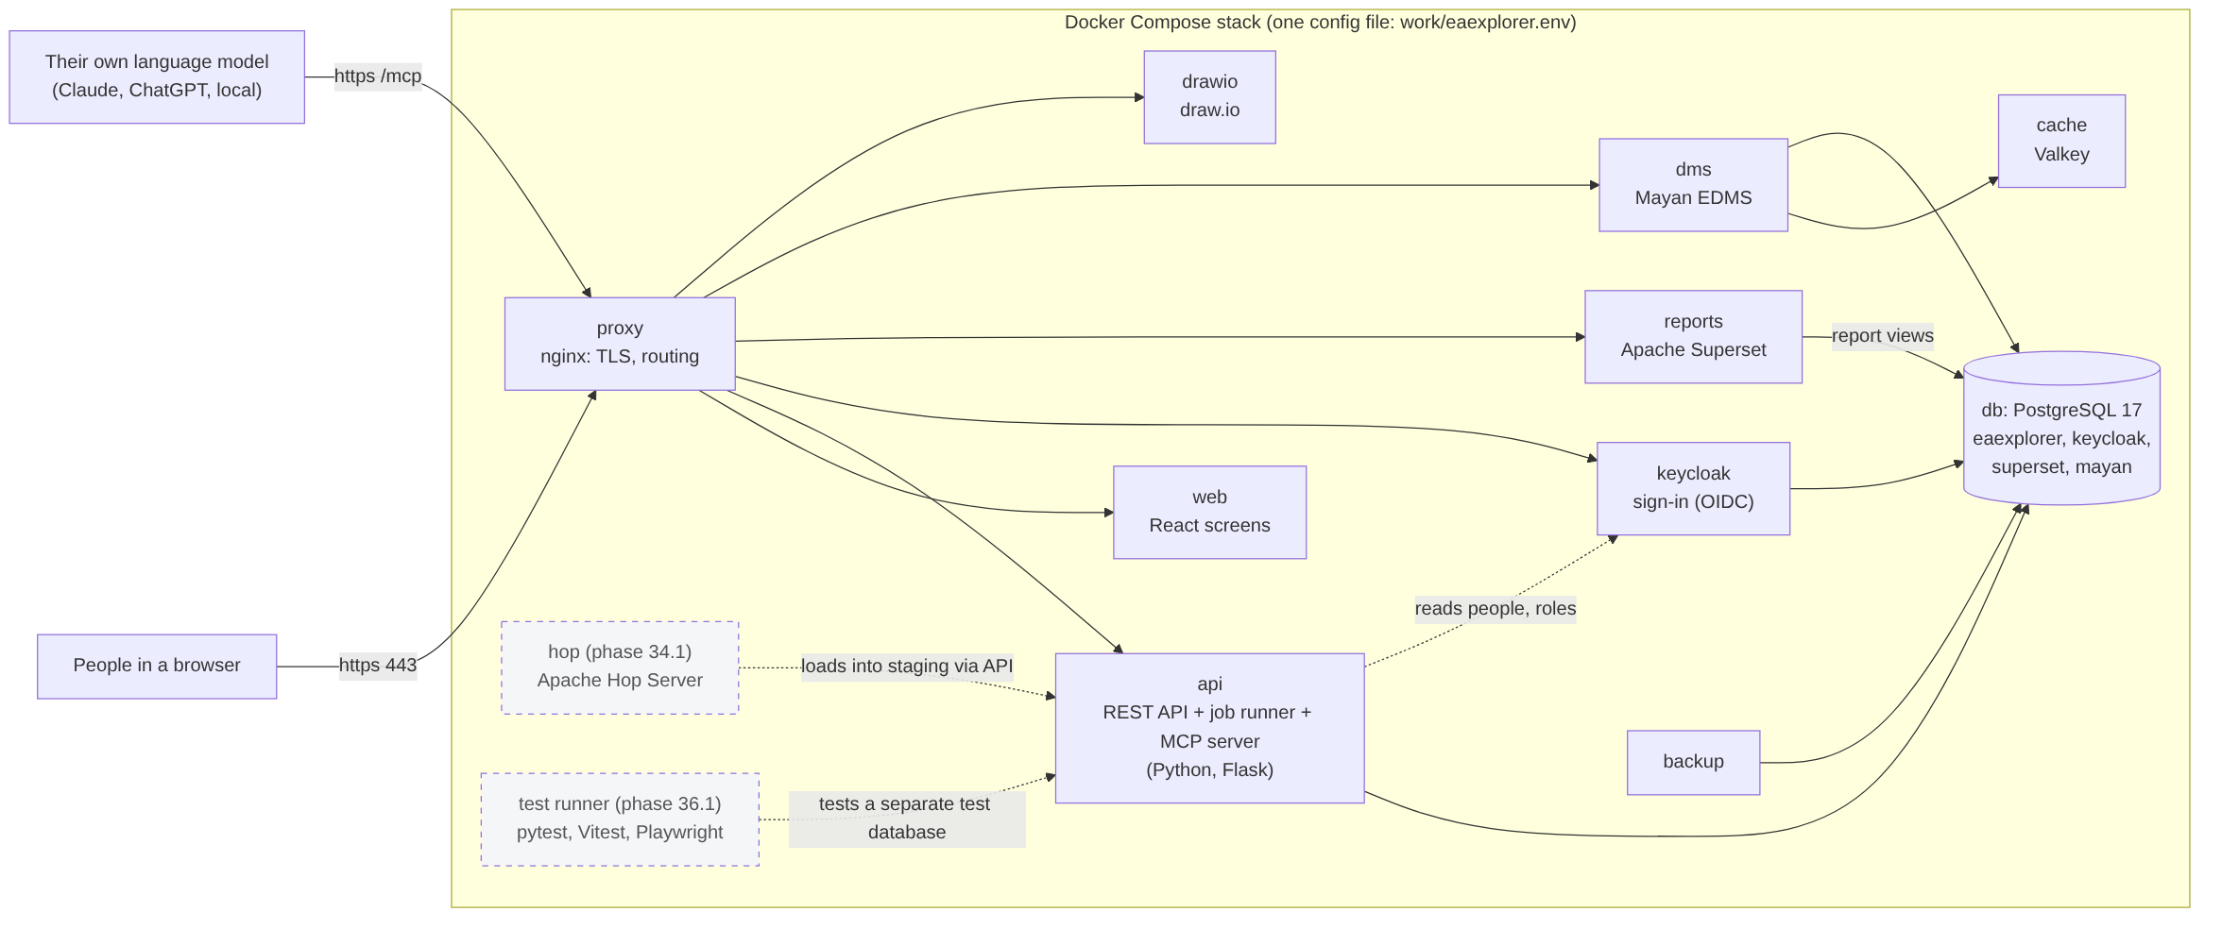
Figure 1. Containers and their connections
Container | Technology | Role
proxy | nginx 1.27 | TLS, one address, routing (/, /api, /mcp, /auth, /drawio; reports.* and docs.* hosts), upload limits
web | React 18, Vite, served by nginx | Our screens; signs in with keycloak-js; talks only to the API
api | Python 3.12, Flask, flask-smorest, SQLAlchemy, gunicorn; Procrastinate; MCP SDK on uvicorn | REST API, background jobs (for example model copies) and the MCP server, side by side in one image; runs migrations and the seed on start
db | PostgreSQL 17 | Databases eaexplorer (repository, jobs), keycloak, superset, mayan
keycloak | Keycloak 26 | Single sign-on (OIDC) for our screens, Superset and Mayan; directories and identity providers
reports | Apache Superset | Dashboards and reports on read-only report views
dms, cache | Mayan EDMS, Valkey | Documents, versions, OCR and search; broker and cache
drawio | draw.io (self-hosted) | Diagram editor; .drawio files carry entity ids
backup | PostgreSQL client tools + scheduler | Dumps of every database and Mayan's files; restore
setup | Our api image, run once | Certificates, Keycloak realm, Superset sample
hop (34.1) | Apache Hop Server | ETL pipelines into staging (D128)
test runner (36.1) | pytest, Vitest, Playwright | Unit, integration and UI suites on a separate test database (D127)

4. Application architecture

4.1 The API
The api container holds three processes built from one code base: the REST API (gunicorn), the job runner (Procrastinate, queue in PostgreSQL) and the MCP server (uvicorn, Streamable HTTP). They share the same modules, so a rule written once applies to every channel.
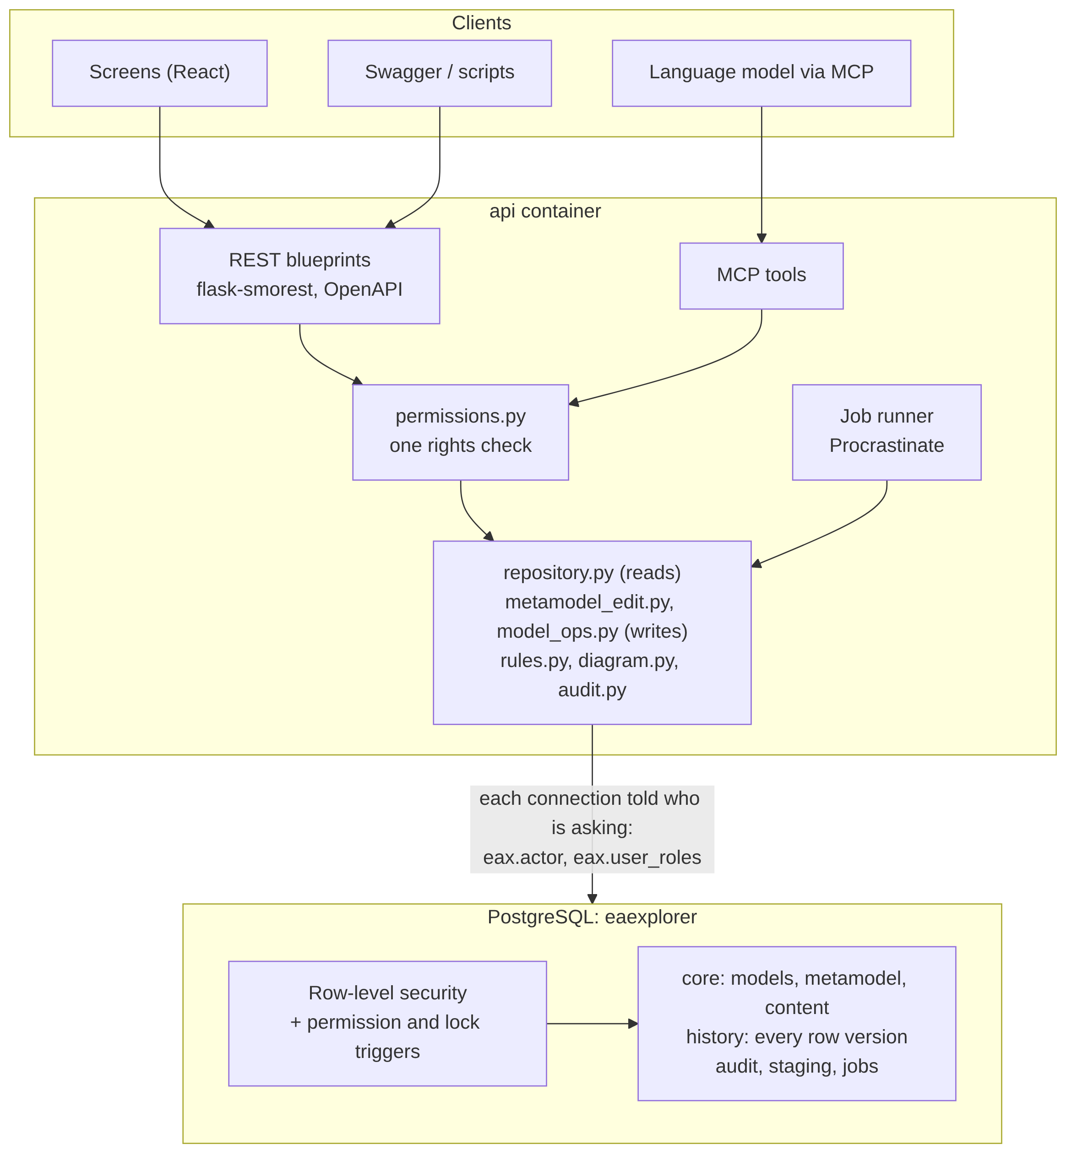
Figure 2. One code path, two layers of enforcement
- REST blueprints (flask-smorest) validate input with marshmallow schemas, publish OpenAPI, call the shared modules and turn refusals into clear 4xx messages.
- permissions.py is the one rights check for REST and MCP: global roles (from Keycloak) and roles per model.
- repository.py answers every read question once; metamodel_edit.py makes every metamodel change (with a dry run that shows the impact); model_ops.py creates, copies, packages, moves and retires models and handles metamodel drafts; rules.py evaluates validation rules (they warn, never block, D48).
- Writes run in one transaction: the person is set on the connection, the change is made, audited and committed, or rolled back for a dry run.
- Background jobs (Procrastinate) run long work such as copying a model's content, as the person who asked, so the database applies their rights.

4.2 The screens
A single-page React application built by Vite. The URL hash is the route (#/metamodel/<model>/<tab>/<item>); there is no router library. Screens load data through one fetch helper that adds the access token, cache answers briefly and refresh after a change. Diagrams are laid out in the browser with elkjs in a web worker and exported as SVG, PNG and .drawio. Every control carries a tooltip; what a role may not do is greyed out with the role it needs.

4.3 The MCP server
MCP tools are thin wrappers over the same repository and write functions: reading models, metamodels, entities, history, rules and graphs, and (phase 4) drafting metamodels step by step or as one document. A language model never changes a model directly: drafts wait for a person to review and apply them (D115, D120). Each call is signed in as a person and checked like the API.

5. Data architecture

5.1 Databases and schemas
One PostgreSQL server holds four databases. The repository database, eaexplorer, has these schemas:
Schema | Holds
core | Models and their roles, each model's metamodel (layers, entity types, attribute types, item attributes, pick lists, relationship types, allowed relationships, validation rules, metamodel versions) and content (entities, attribute values, relationships); metamodel drafts
history | row_versions: every version of every row, written by a trigger on each table, labelled per transaction
eax | Functions for SQL users and reports, for example eax.get_entity(type, name)
audit | Who did what through the API and MCP, with request ids
staging | Rows waiting for review before they load (imports, ETL, later phases)
rpt (phase 5) | Typed report views per published metamodel, read by Superset with a read-only login
Conventions: every table has a bigint id and a guid (what the API shows); housekeeping columns (status, is_deleted, created and modified by and at, row version); nothing is hard-deleted. Each model owns its metamodel and its content, so models evolve independently and a copy is complete in itself; core.copy_model copies a metamodel, and content with its display ids, faithfully.

5.2 The model hierarchy
Root sits at the top. Root metamodels (ArchiMate 4, or an organisation's own) hang under it; library (reference) models and project models are built on a root. A model created from a project model is either a child, linked to its parent for merges and updates, or an independent copy that can be compared (D122). Shipped library models are locked: nobody can change them, and a release adds a new version beside the old one.
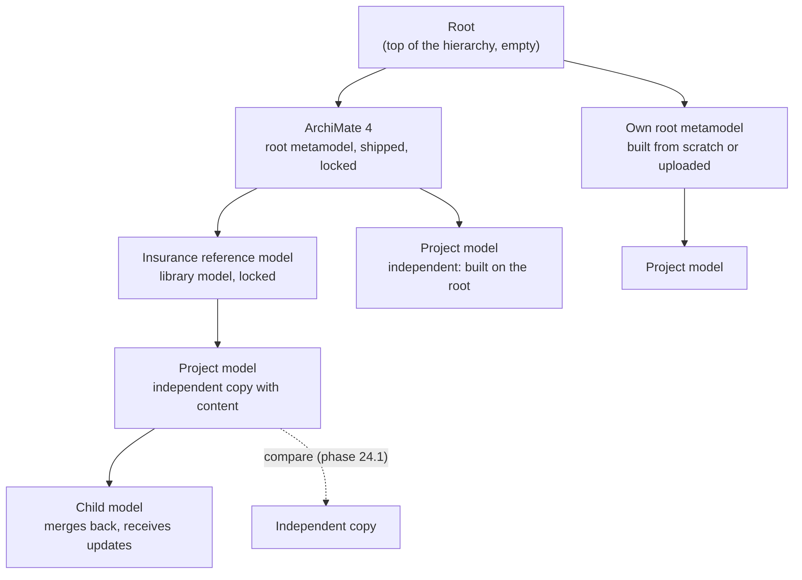
Figure 3. The model hierarchy

5.3 Packages and exchange formats
A model travels as one package (D116): a zip with manifest.json, the metamodel as JSON (eax-metamodel/1) and the content as CSV (one file per entity type, one for relationships), or one Excel workbook with the same content. An upload is analysed first and placed under a root metamodel it matches completely, or under Root as a root of its own (D108, D123). CSV and Excel sheets, the ArchiMate exchange format and .drawio files follow in later phases.

6. Security architecture
Concern | How it is handled
Sign-in | Keycloak (OIDC) for our screens, the API, MCP, Superset and Mayan; directories and identity providers are connected in Keycloak (D92, D93).
Global roles | Super Admin, IT Admin, User Admin, Keycloak Admin, Model Creator, Library Admin, User: given in Keycloak and mapped to ours by a User Admin (core.role_mappings).
Model roles | Model Admin, Model Sub Admin, Architect, Report Viewer: given per model on its People tab by its Model Admins (D96).
Enforcement in depth | 1) the screens grey out what is not allowed; 2) permissions.py refuses with 403; 3) the database applies row-level security and permission, lock and validity triggers to every connection, which is told who is asking (eax.actor, eax.user_roles).
Locks | Library models are locked permanently; Model Admins lock a metamodel, content or a whole model for maintenance; triggers enforce both.
Audit and history | Every API and MCP write is audited; every row change is versioned with who and when.
Transport | https everywhere through nginx; on a laptop a local CA (its key thrown away, limited to the installation's names) and optional eax trust; HSTS on servers only (D107).
Emergency access | A break-glass sign-in when Keycloak is down: audited, bannered, alerts the admins (D100).
Secrets | In the configuration file today; a key vault in the deployment phase (D99).
Language models | MCP tools act as the signed-in person; they read, or draft changes for a person to approve; nothing is applied without review.

7. Integration architecture
Interface | Direction | Notes
REST API (OpenAPI) | In and out | Everything the screens can do; Swagger at /api/docs; the base for scripts and integrations
MCP server | In and out | Language models read the repository and draft metamodels (phases 3.1, 4); proposals into staging in phase 27
Model packages (zip, Excel) | In and out | Move models between installations; edit in Excel and upload again (phase 4)
Report views and Superset | Out | Typed views per metamodel (phase 5) and standard reports (11, 24)
Mayan EDMS | Both | Documents linked to entities; library model packs (phase 13)
draw.io | Both | Draw with the model's entities; diagrams feed the repository (28 to 31)
CSV, Excel, ArchiMate exchange | Both | Sheets and exchange with other EA tools (32, 33)
Apache Hop (ETL) | In | Drag-and-drop pipelines from other APIs, databases and file dumps into staging through our API (34.1, D128)
Slides (PowerPoint) | Out | Views, diagrams and reports as slides (31, D112)

8. Technology architecture

8.1 Logical technology architecture
The logical view groups the technology services the product needs, independent of where they run. Each logical service is realised by one product; the physical views below show how they are deployed.
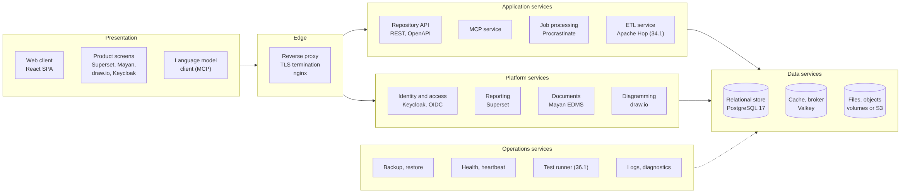
Figure 4. Logical technology services
Logical service | Realised by | Notes
Edge: reverse proxy, TLS | nginx | The only open ports; routes paths and host names; upload limits; HSTS on servers
Repository API, MCP service | api image (Flask, gunicorn; MCP SDK, uvicorn) | Stateless, so it can run as several replicas
Job processing | Procrastinate in the api image | Queue held in PostgreSQL; separate runners in scale-out
Identity and access | Keycloak | OIDC for every screen and API; federates the organisation's directory
Reporting | Apache Superset | Reads typed report views with a read-only login
Document management | Mayan EDMS with Valkey | Files, versions, OCR, search; cabinets per model (phase 13)
Diagramming | draw.io | Self-hosted; files carry entity ids
ETL | Apache Hop Server (34.1) | Pipelines into staging through the API
Relational store | PostgreSQL 17 | One server, four databases; row-level security
File and object storage | Docker volumes; S3-compatible storage in the cloud | Documents, imports, exports, backups, certificates
Operations | backup image, heartbeat, eax helper, test runner (36.1) | Backups and restore, health, logs and diagnostics, automated tests

8.2 Physical technology architecture
Today every installation is one Docker Compose stack on one host (laptop or single server). The proxy is the only container with published ports; the database, the broker and the backup container sit on an internal network with no outside access.
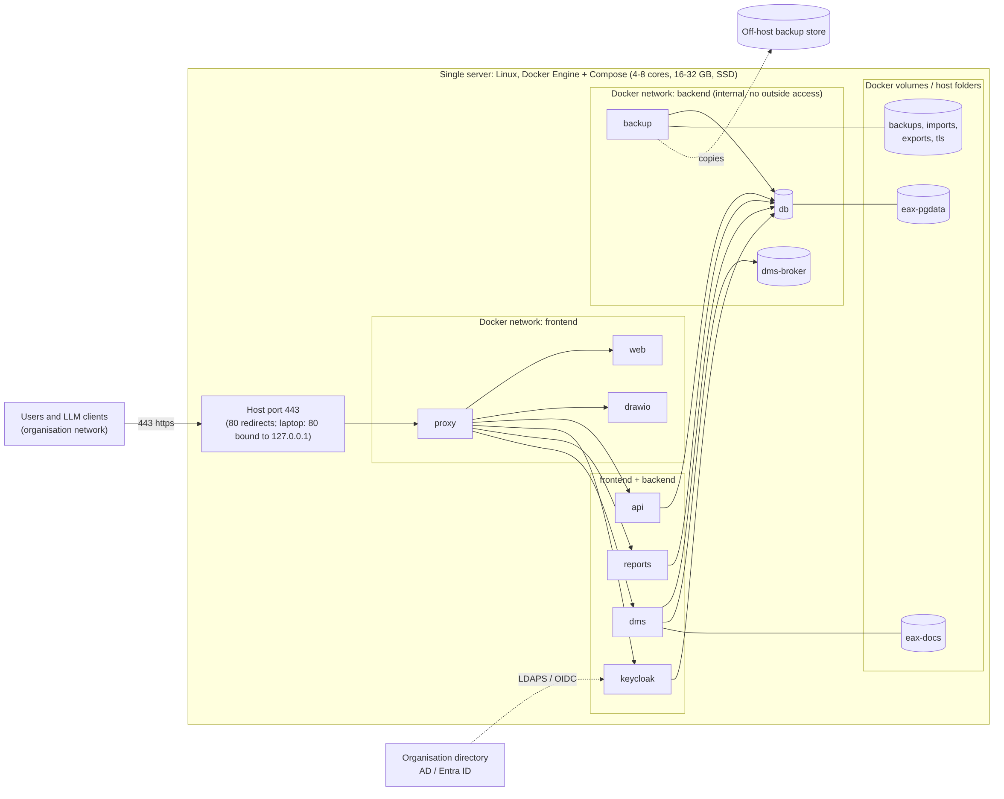
Figure 5. Physical view: single server (the laptop is the same on one machine)
Element | Physical detail
Host | Laptop: Windows (WSL2), macOS or Linux with Docker Desktop, 4 cores, 16 GB. Server: Linux with Docker Engine and Compose, 4 to 8 cores, 16 to 32 GB, SSD.
Ports | 443 (https) on the host. 80 redirects to https on servers; on a laptop 80 is bound to 127.0.0.1 and also serves the API and MCP over plain http (D107).
Networks | frontend: proxy, web, drawio, and the services the proxy reaches (api, keycloak, reports, dms). backend (internal): db, dms-broker, backup, plus api, keycloak, reports and dms.
Volumes | eax-pgdata (databases), eax-docs (documents), backups, imports, exports and tls (host folders under work/data on a laptop), plus Superset and Keycloak import volumes.
Configuration | One file, work/eaexplorer.env, from a template per deployment kind; the compose override per kind sets memory limits.
Outside connections | The organisation directory (AD, Entra ID) through Keycloak; an off-host backup store; nothing else is required.

Larger installations split the same containers across hosts (phase 36, D99). The API, MCP and web are stateless and run as replicas behind a load balancer; job runners and Apache Hop get their own host; PostgreSQL runs on its own host with a standby, or as a managed service; documents and backups go to object storage.
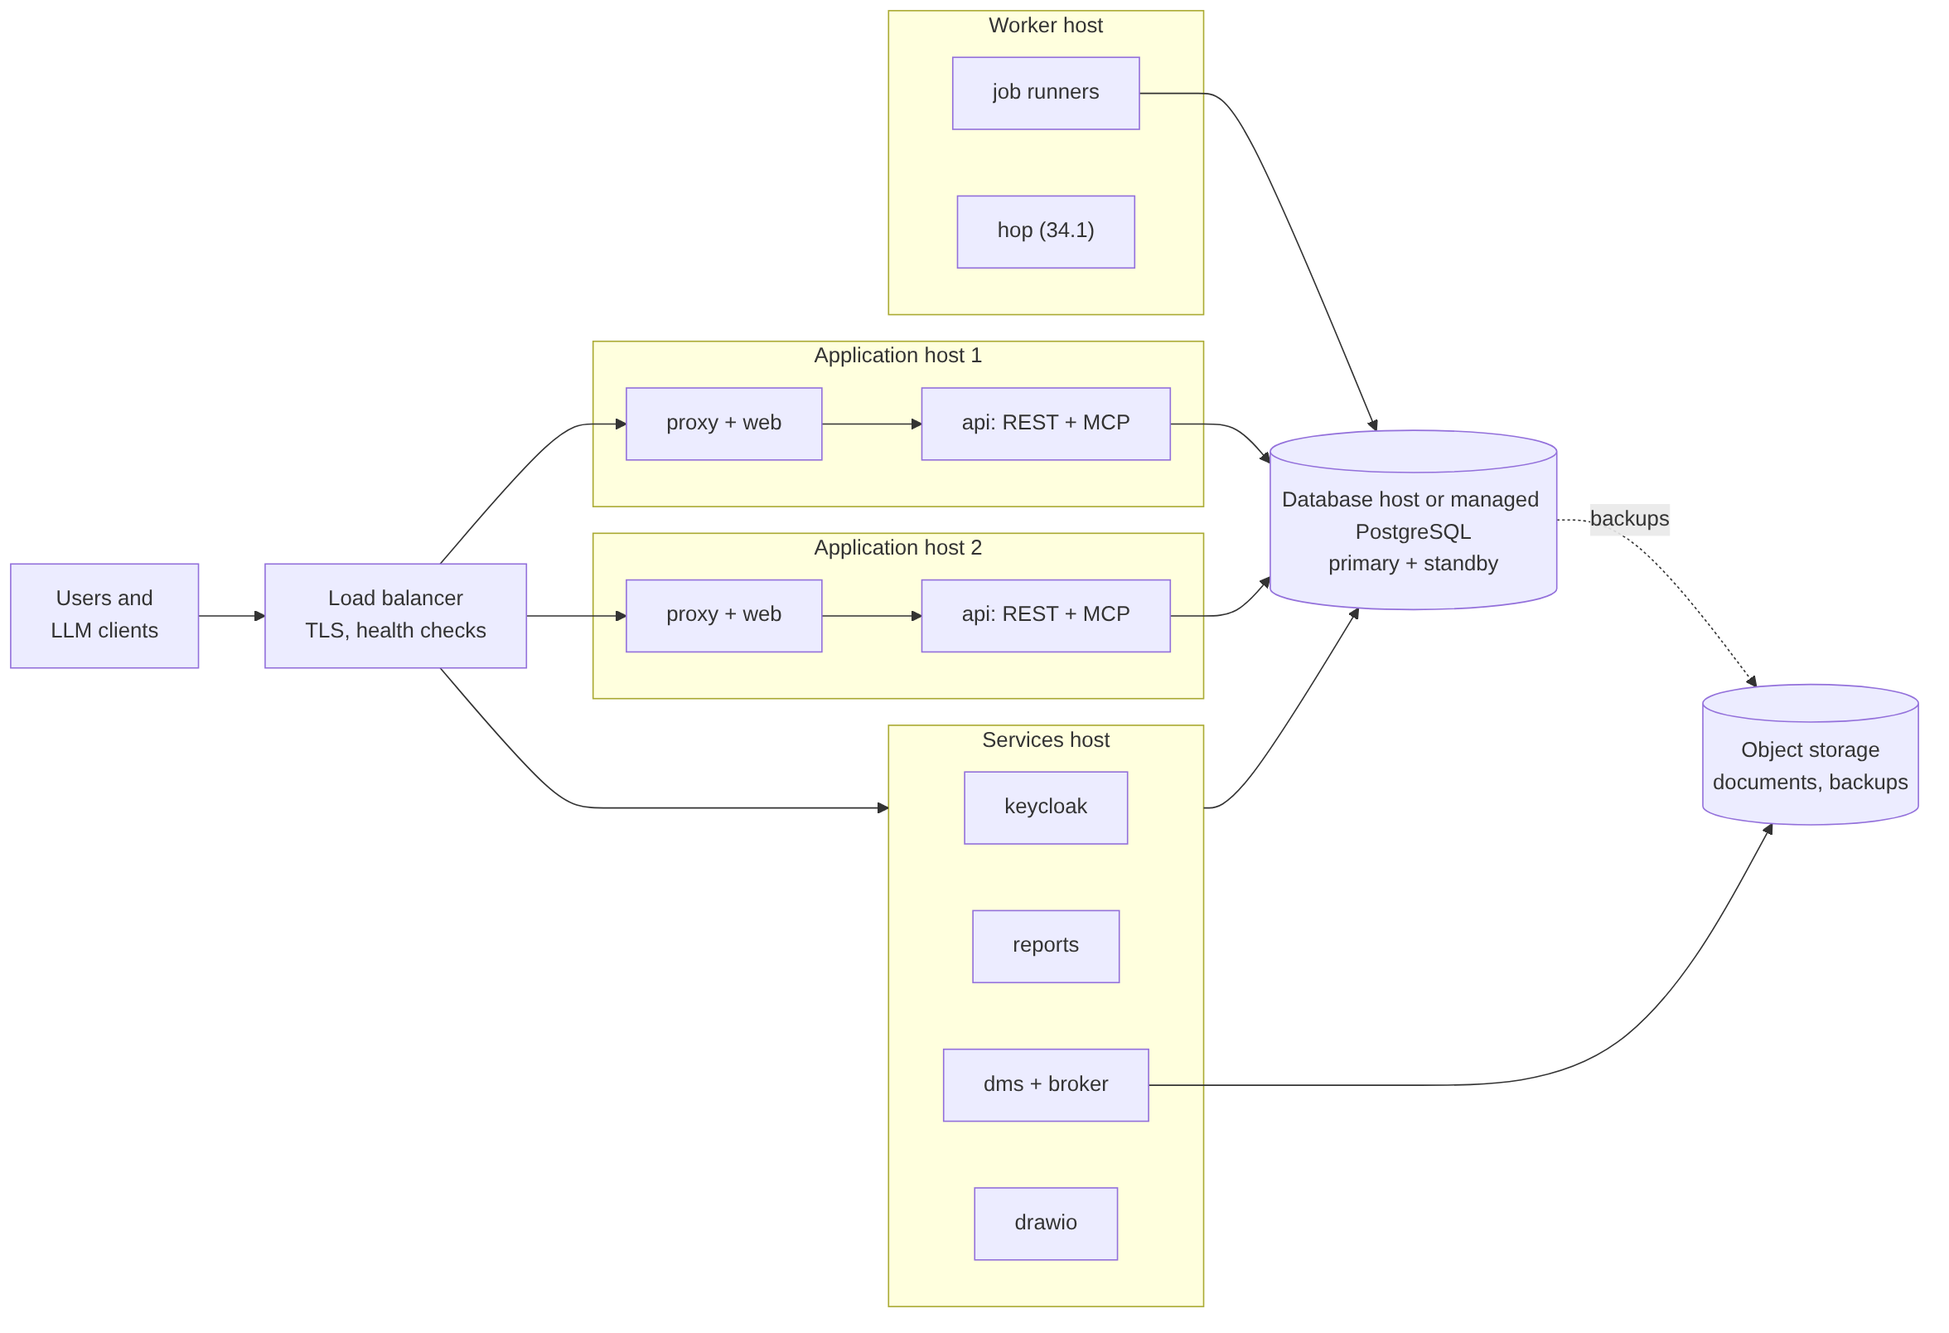
Figure 6. Physical view: scale-out and cloud
Kind | For | Shape
Laptop | Evaluation, training, one architect | All containers on one machine; local certificate; sample and test models
Single server | A team or small organisation | All containers on one Linux server; organisation certificate; directory sign-in; scheduled backups
Scale-out | Large organisations | API, MCP and web replicas behind a load balancer; separate job runners; PostgreSQL on its own host
Cloud | Public cloud | VMs or a container service; managed PostgreSQL; object storage; cloud load balancer and certificates

8.3 Operations
- The eax helper (eax.ps1 on Windows, eax.sh elsewhere): init, up/run, debug, diag, status, logs, down, backup, restore, trust, cleanup, clean-run, clean-restart. Every command writes a log; failures add a diagnostics report.
- Versions and migrations. Phase N is version 0.N.0. Each phase adds one Alembic migration that records its version in core.schema_versions; the API's version.toml must match, and the heartbeat warns if not.
- Health. The heartbeat checks every service (API, database, job queue, Keycloak, proxy, Superset, Mayan, draw.io, MCP, last backup) from inside the stack.
- Backups. Scheduled dumps of every database and Mayan's files, with retention; restore into the live databases or into a scratch database to inspect first.
- Testing. Today: pytest, ruff, SQL check scripts per phase run in a rolled-back transaction, and the phase demo. Phase 36.1 adds the test runner on the Health dashboard: unit, integration and UI suites on a separate test database, tests working only on copies of test models (D127).

9. Technology stack
Area | Choice | Licence
Our code | Python 3.12 (Flask, flask-smorest, SQLAlchemy, Alembic, Procrastinate, PyJWT, openpyxl); React 18, Vite, elkjs, keycloak-js | AGPL-3.0 (ours); libraries BSD, MIT, Apache, EPL
Database | PostgreSQL 17 | PostgreSQL Licence
Proxy | nginx | BSD-2-Clause
Identity | Keycloak | Apache-2.0
Reports | Apache Superset | Apache-2.0
Documents | Mayan EDMS, Valkey | GPL-2.0, BSD-3-Clause
Diagrams | draw.io | Apache-2.0
ETL (34.1) | Apache Hop | Apache-2.0
Testing (36.1) | pytest, Vitest, Playwright | MIT, MIT, Apache-2.0
Containers | Docker and Docker Compose | Apache-2.0

10. Roadmap and open questions
Next. Report views (5), data entry (6), grids and search (7), commits, publishing and workflows (8, 8.1), history and change log (9), standard reports (11, 24), Mayan (13), architecture projects and registers (15 to 16.2), work copies and merge (19, 20), versions and gap analysis (24.1), security hardening and MCP (25 to 27), draw.io and views (28 to 31), import, exchange and ETL (32 to 34.1), operations and deployment (35, 36), test automation (36.1), release candidate, pilot and 1.0 (37, 38), industries and documentation (39).
Open questions, settled in their phases' design sessions. Productionising (scale-out, another identity platform, AD sign-in, a key vault, D99); the kinds of notification and request (8.1); how a project's content behaves on close, merge or abandon (15); Apache Hop's connectors (34.1); the documentation tool and inline help (D126).

