DELHI ROUTE
A PROJECT REPORT
BACHELOR OF TECHNOLOGY IN
INFORMATION TECHNOLOGY
Submitted by:
Gaurav Raj (2K19/IT/052) &
Harshal Beniwal (2K19/IT/057)
Under the Supervision of
Mrs. Ritu Agarwal,
Asst.Prof


DEPARTMENT OF INFORMATION TECHNOLOGY
DELHI TECHNOLOGICAL UNIVERSITY
(Formerly Delhi College of
Engineering) Bawana Road, Delhi-
110042
DELHI TECHNOLOGICAL UNIVERSITY
(Formerly Delhi College of Engineering)
Bawana Road, Delhi-110042

CANDIDATES DECLARATION
We , Gaurav Raj, Roll No – 2K19/IT/052 and Harshal Beniwal , Roll No – 2K19/IT.057 ,students of B.Tech. (INFORMATION TECHNOLOGY), hereby declare that the project Dissertation titled “Delhi Route”
which is submitted by us to the Department of INFORMATION TECHNOLOGY, Delhi Technological University, Delhi in partial fulfillment of the requirement for the award of the degree of Bachelor of Technology, is original. This work has not previously formed the basis for the award of any Degree, Diploma Associateship, Fellowship or other similar title or recognition.
Place: Delhi
Date : 23/11/2020
Gaurav Raj
Harshal Beniwal

DEPARTMENT OF INFORMATION TECHNOLOGY
DELHI TECHNOLOGICAL UNIVERSITY
(Formerly Delhi College of Engineering)
Bawana Road, Delhi-110042

CERTIFICATE
We hereby certify that the Project Dissertation titled “Path Finding Visualizer” which is submitted by : Gaurav Raj – 2K19/IT/052 and Harshal Beniwal , Roll No – 2K19/IT/057; INFORMATION TECHNOLOGY, Delhi Technological University, Delhi in partial fulfilment

DEPARTMENT OF INFORMATION
TECHNOLOGY DELHI TECHNOLOGICAL
UNIVERSITY
(Formerly Delhi College of
Engineering) Bawana
Road, Delhi-110042

ACKNOWLEDGEMENT
I would like to convey our heartfelt thanks to our supervisor Mrs. Swati Sharda for her ingenious ideas, tremendous help and cooperation.
I am extremely grateful to my friends who gave valuable
suggestions and guidance for completion of my project. The
cooperation and healthy criticism came handy and useful with them.
Finally I would like to thank all the above mentioned people of the requirement for the award of the degree of Bachelor of Technology, is a record of the project work carried out by the students under my supervision. To the best of my knowledge this work has not been submitted in part or full for any Degree or Diploma to this University or elsewhere.
Place: Delhi
Date: 23-11-2020 Swati Sharda
SUPERVISOR

ABSTRACT

As a beginner’s step to algorithm and starting to understand how they work I decided to make this Delhi route finder that find the path from given source to destination using bfs. The understanding of this algorithm gives you the base idea of how navigation tools are implemented. . To make this path finder you need to be at least an intermediate level programming (Python) and a good understanding of the some path finding algorithm .

TABLE OF CONTENTS:
Abstract |  |  | 6
Table of Contents |  |  | 7
Chapter 1 : Introduction
 |  |  | 8
 | - Description
Chapter 2 : Tools and packages |  |  | 9
Chapter 3 : Result and analysis |  |  | 10
CODE LINK |  |  | 13

Introduction:

Breadth First Search:
The Breadth First Search (BFS) traversal is an algorithm, which is used to visit all of the nodes of a given graph. In this traversal algorithm one node is selected and then all of the adjacent nodes are visited one by one. After completing all of the adjacent vertices, it moves further to check another vertices and checks its adjacent vertices again.

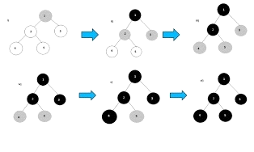
To implement this algorithm, we need to use the Queue data structure. All the adjacent vertices are added into the queue, when all adjacent vertices are completed, one item is removed from the queue and start traversing through that vertex again

Tools & Packages:

TKINTER

Tkinter, a module in the Python standard library which serves as an interface to Tk, a simple toolkit. There are many other toolkits available, but they often vary across platforms. If you learn the basics of Tkinter, you should see many similarities should you try to use a different toolkit.

Result & Analysis:

FINDING ROUTE

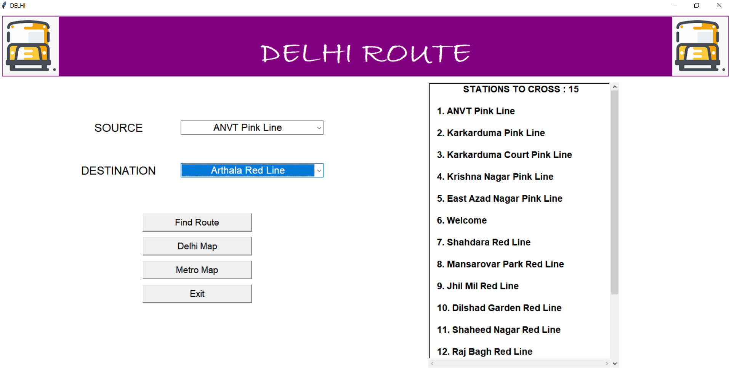

WHEN DELHI MAP BUTTON IS CLICKED

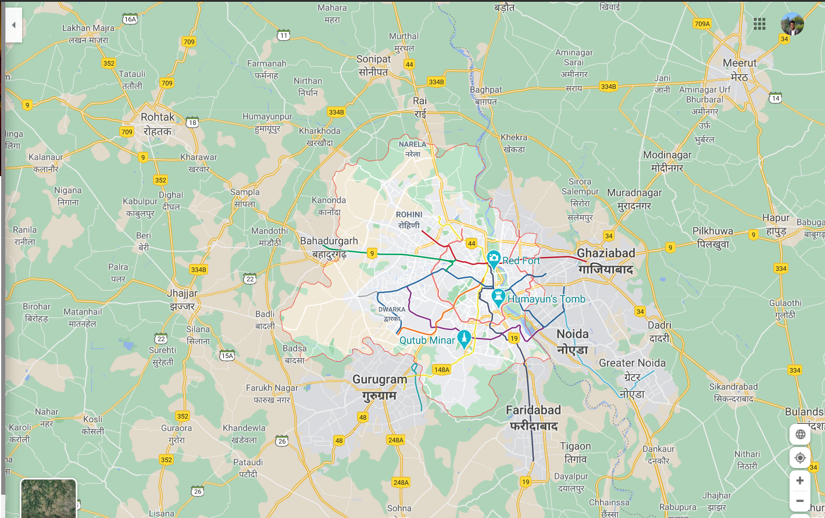

WHEN METRO MAP BUTTON IS CLICKED

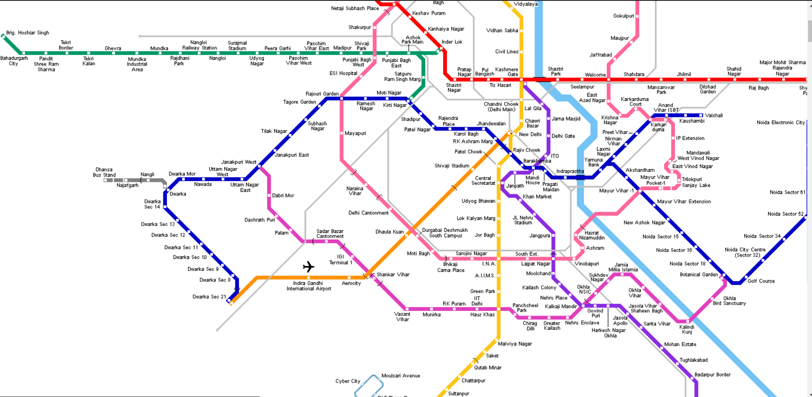

REFRENCE

GitHub - gauravvrajj/DELHI-ROUTE

