Assignment No. 1 – Setting Up a Cloud Account

Aim
To create an account on a cloud provider (AWS/Azure/GCP), explore the dashboard, set up billing alerts, and study regions & availability zones.

Objectives
- To understand the concept of cloud computing and its significance.
- To learn about the types of cloud computing and service models.
- To compare leading cloud platforms (AWS, Azure, GCP).
- To practically set up an AWS Free Tier account and configure billing alerts.
- To explore regions and availability zones in AWS.

Theory
1. What is Cloud?
Cloud computing refers to delivering computing services like servers, storage, databases, networking, software and analytics over the internet. It enables on-demand access to IT resources without investing in physical infrastructure.
Example: Gmail (SaaS), AWS EC2 (IaaS).

2. Why Cloud Computing?
- Cost Efficiency: No upfront infrastructure cost.
- Scalability: Resources scale automatically as per workload.
- Flexibility: Access from anywhere via internet.
- Reliability: High uptime and disaster recovery.
- Security: Advanced encryption, IAM, MFA, compliance with standards.

3. Types of Cloud Computing
Public Cloud – Services available to the general public (AWS, Azure, GCP).
- Private Cloud – Exclusive use by a single organization.
- Hybrid Cloud – Combination of public and private for flexibility.
- Community Cloud – Shared infrastructure for specific groups.

4. Services Provided by Cloud Computing
- IaaS (Infrastructure as a Service): Virtual machines, networks, storage.
  - Examples: AWS EC2, Azure VM, GCP Compute Engine.
- PaaS (Platform as a Service): Application hosting and development platforms.
  - Examples: AWS Elastic Beanstalk, Google App Engine.
- SaaS (Software as a Service): Ready-to-use applications.
  - Examples: Gmail, Office 365, Dropbox.
- FaaS (Function as a Service / Serverless): Event-driven execution without servers.
  - Examples: AWS Lambda, Azure Functions.

5. Different Cloud Computing Platforms
- AWS (Amazon Web Services): Largest provider with 200+ services.
- Microsoft Azure: Strong enterprise & Microsoft ecosystem integration.
- Google Cloud Platform (GCP): Best for data analytics, AI, ML.
- IBM Cloud & Oracle Cloud: Specialized in AI & enterprise databases.

Comparison of Cloud Platforms
Feature | AWS | Azure | GCP
Launched | 2006 | 2010 | 2011
Market Share | ~32% | ~23% | ~10%
Strengths | Wide service range, global reach | Microsoft integration, hybrid cloud | AI/ML, Big Data
Free Tier | 12 months + Always Free | 12 months + $200 credits | $300 credits (90 days)
Popular Services | EC2, S3, Lambda, RDS | VMs, Blob Storage, Azure Functions | Compute Engine, BigQuery
Regions | 30+ | 60+ | 35+

Steps
Task 1 – Sign up for a Free Tier AWS Account
- Visit https://aws.amazon.com.
- Click Create Free Account.
- Enter Email, Password, Account name.
- Provide Credit/Debit card details (for verification only).
- Verify identity with phone OTP.
- Select Free Tier plan.

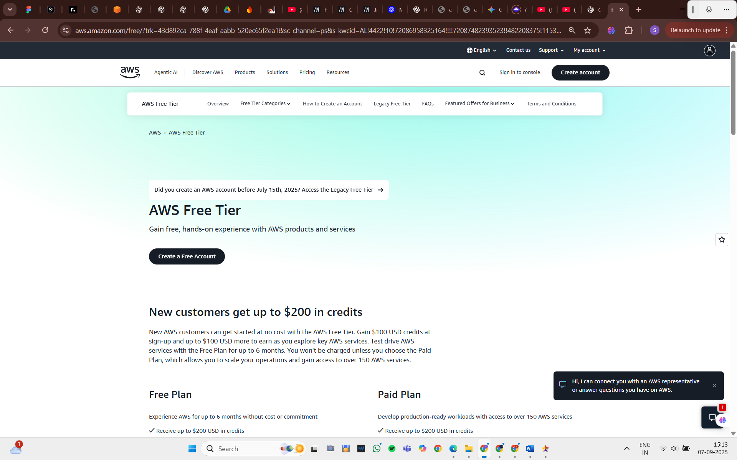

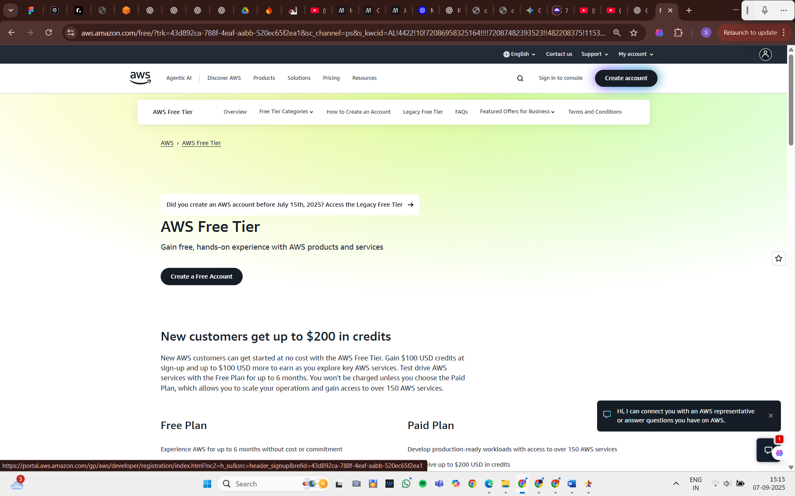

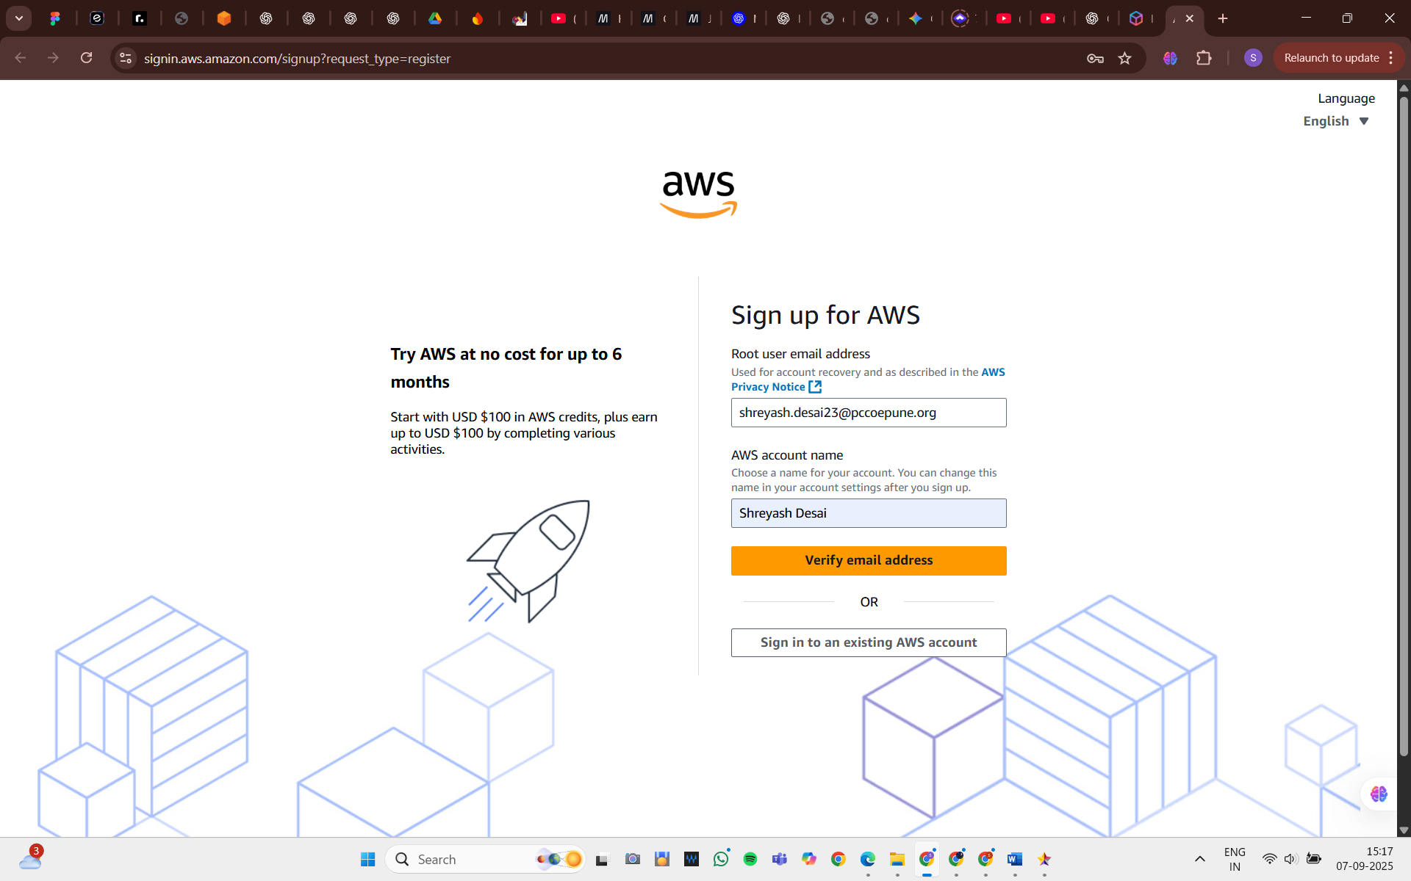

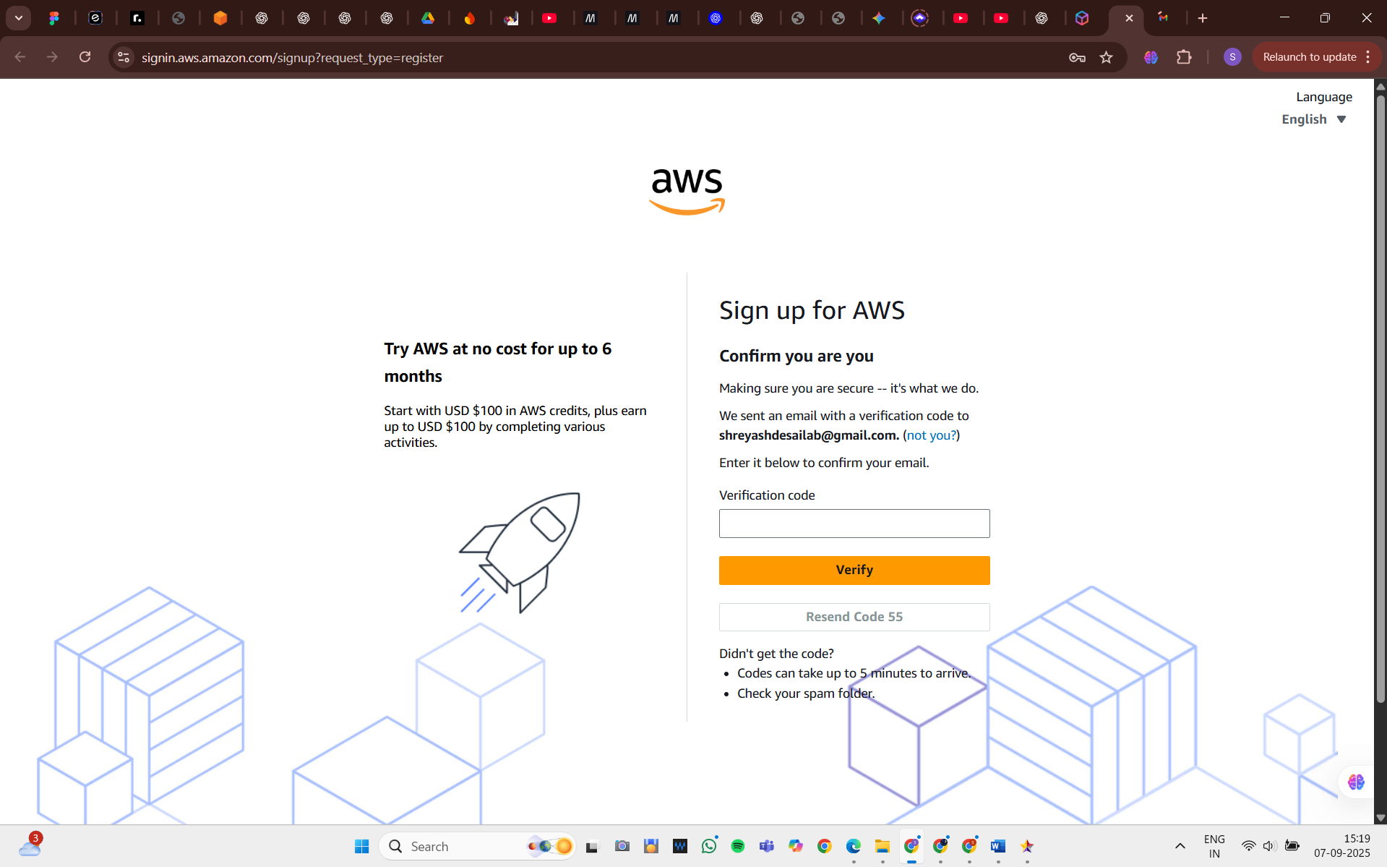

Task 2 – Navigate the AWS Dashboard
- Login to AWS Management Console.
- Explore services such as:
  - EC2 (Compute)
  - S3 (Storage)
  - RDS (Database)
  - IAM (Security)
- Use the search bar for quick service navigation.

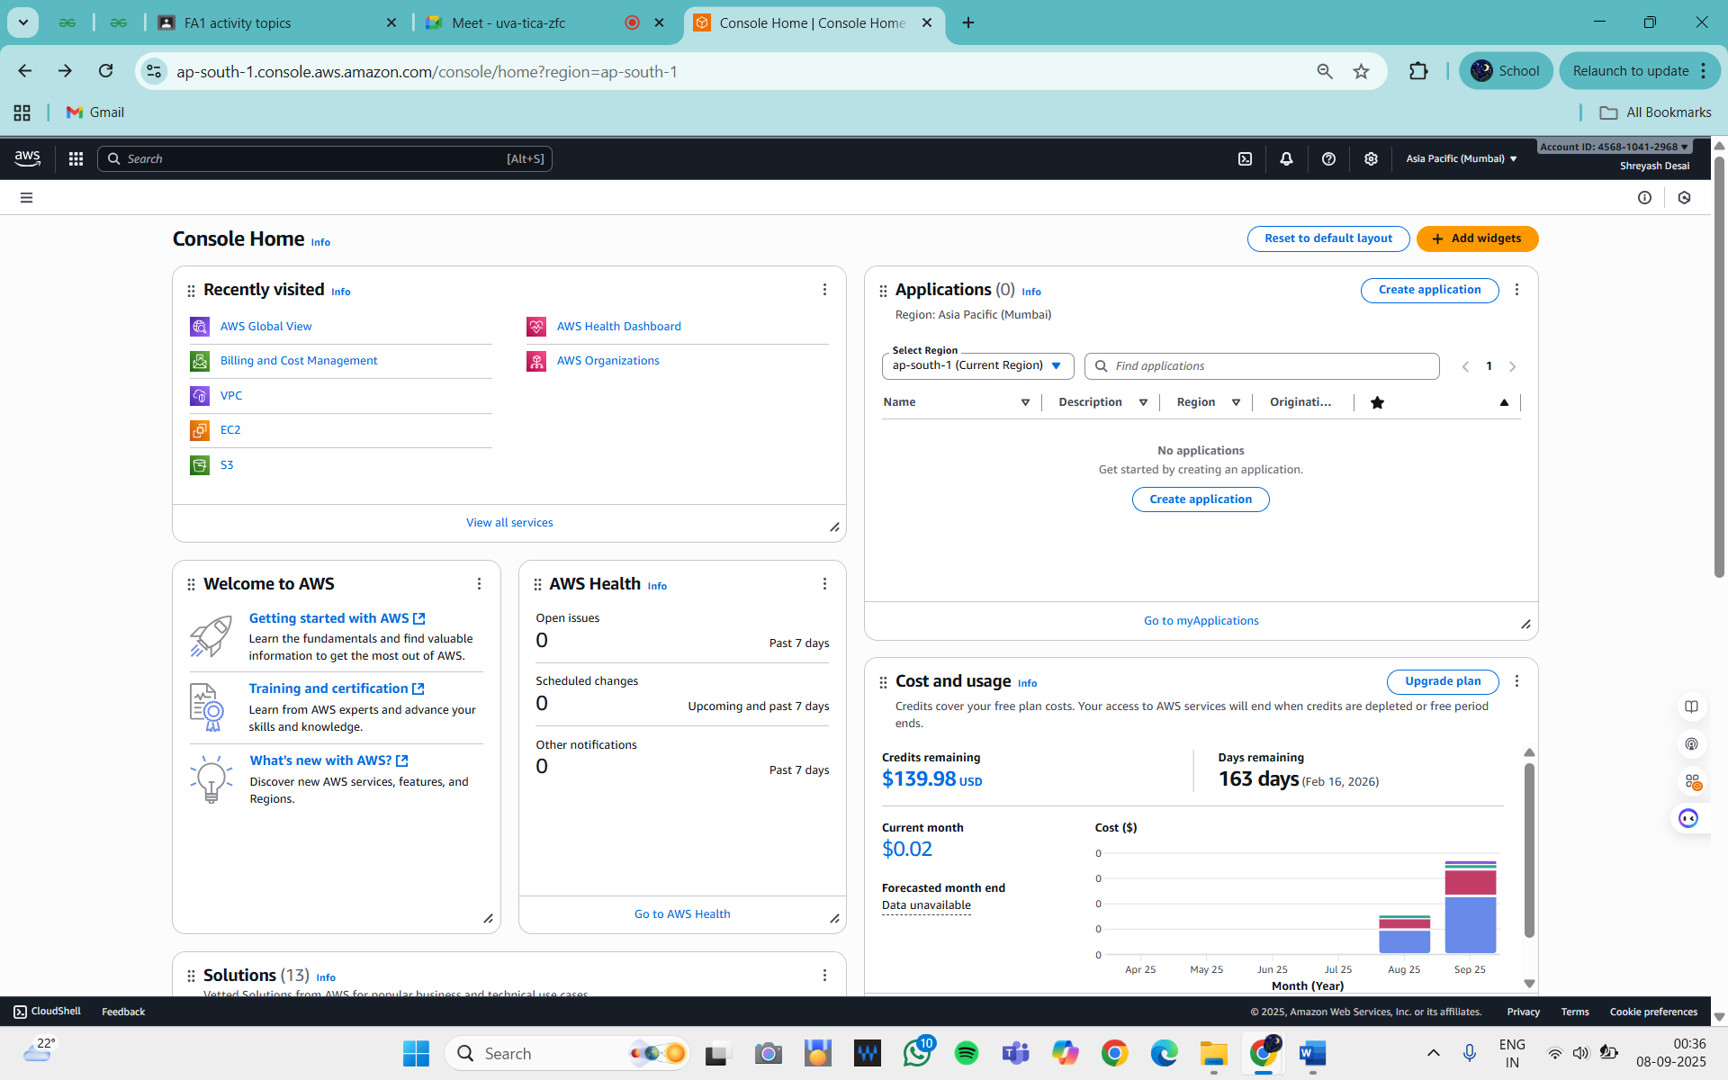
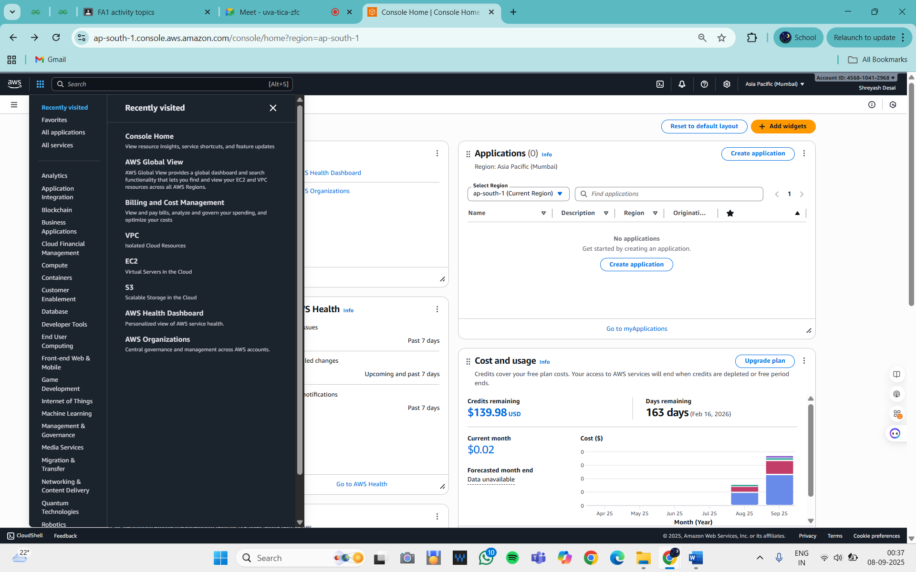

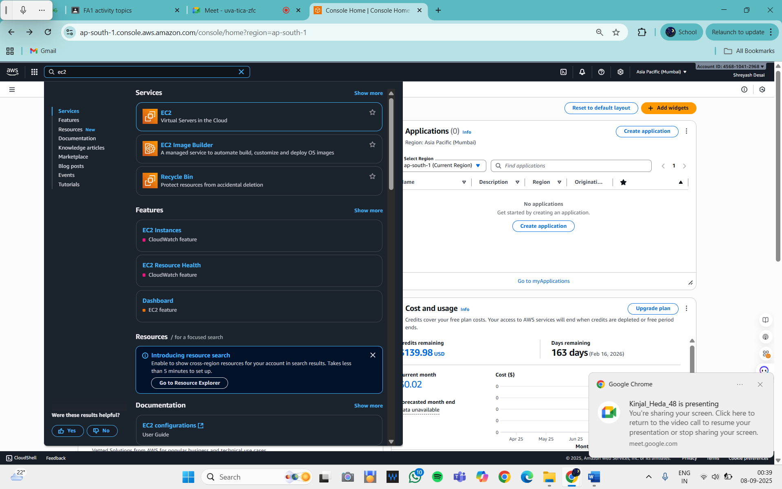

Task 3 – Set up Billing Alerts
- Go to Billing & Cost Management Dashboard.
- Enable Billing Alerts under Preferences.
- Create a Budget (e.g., $5/month).
- Configure CloudWatch Alarm to send email alerts when budget is exceeded.

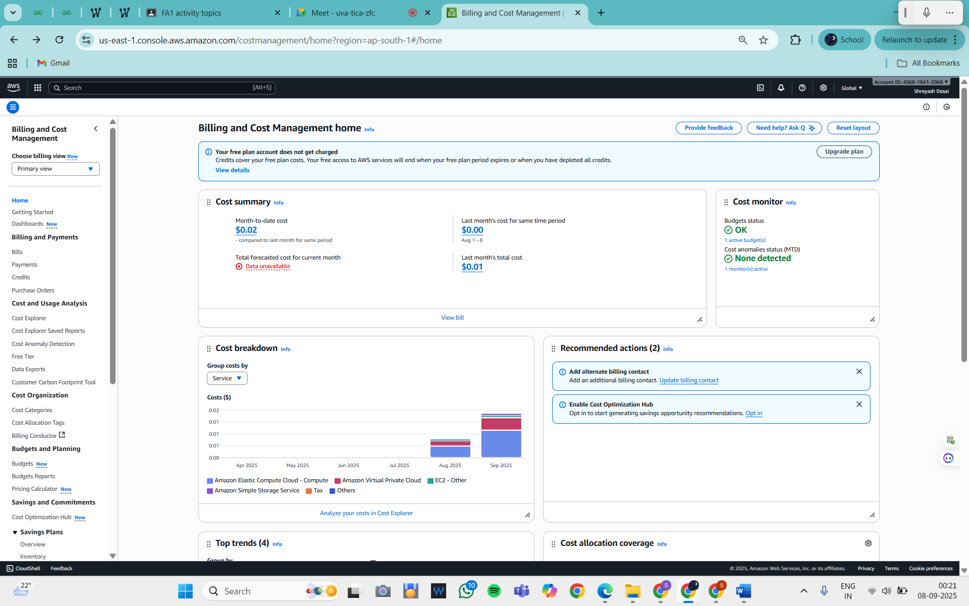

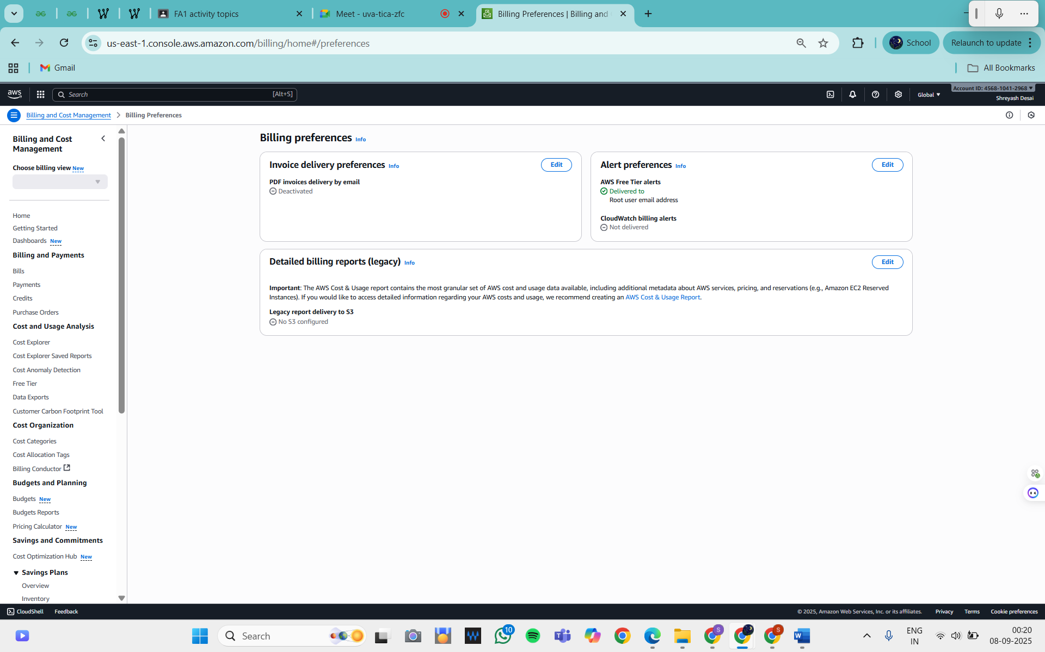

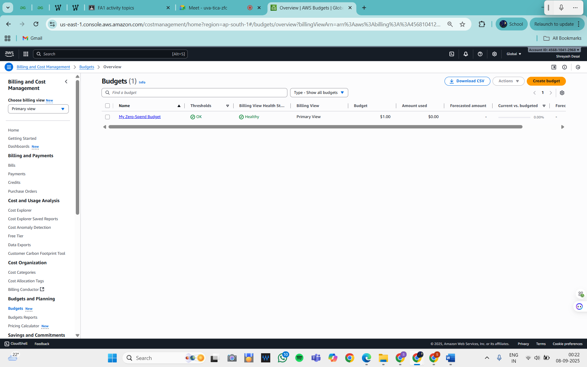

Task 4 – Explore Regions & Availability Zones
- In AWS Console, click on Region Dropdown (top right corner).
- Study global regions such as:
  - US East (N. Virginia)
  - Asia Pacific (Mumbai)
  - Europe (Frankfurt)
- Note that each region contains multiple Availability Zones (AZs) for redundancy.

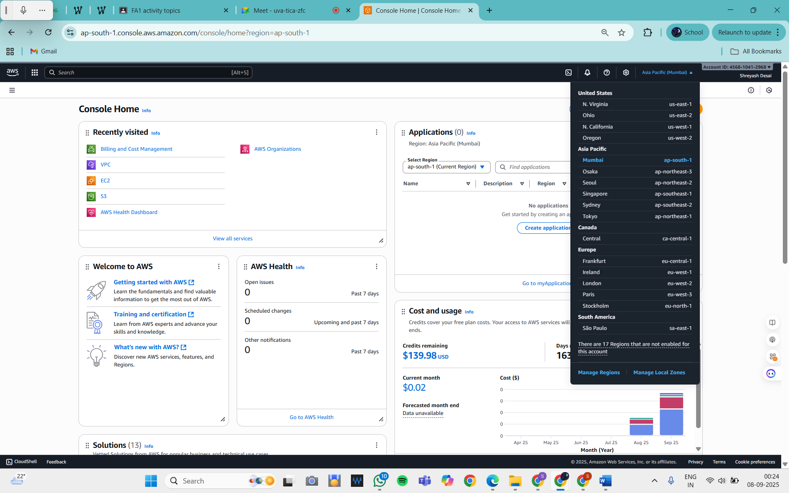
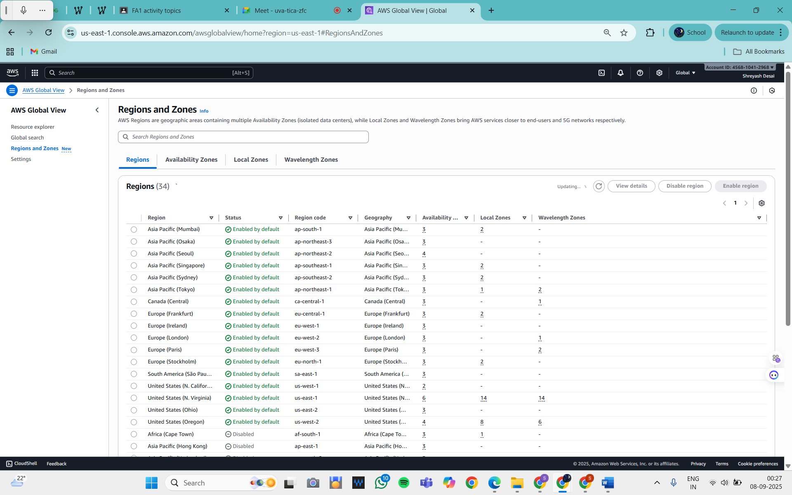

Conclusion
In this assignment, we successfully created a Free Tier AWS account, navigated the AWS dashboard,
set up billing alerts, and explored regions and availability zones. This provided hands-on exposure to cloud basics, helping us understand how organizations begin their cloud journey and manage resources effectively.

