**Online Examination System**

**Number of Roles**

1. **Student**
2. **Admin**

**A) Student Role :-**

**List of Student Modules**

**1)Log in**

**2)Student Registration**

**3)Forgot Password**

**4)Personal Details**

**5)View Result**

**6)Examination**

1. **Log in Page** This is First Page for Every User By Using this page user can enter into site. Here I am displaying Forgot password and Registration for new Student.
2. **Student Registration** . if the Student is coming for write Exam at first Time He can Register by giving his Personal details. Then He can get Username and Password.

Here Username and Email id should be unique (if Student entered already existing email or Username at that time it will shows Username is already existed try another.

1. **Forgot Password:** If the User forgot the password then he can retrieve by using His **Username** or **Email Id.** User name and Password is **Displaying at the time.** It will apply already registered students only.
2. **Personal Details** After logged in (Before that we are Checking where the User is appearing First time or Second time within the **Three Months** If the User is appearing Second time Then I am Not allowing in side the log in page . If First time I am allowing to **write the Exam)** This Personal Details useful for Confirming details and Updating if required. He Can **Update E-mail** also if mail id is already existed then giving message to Mail id is already (Existed email and with another username) try another.

C)**Admin**

**List of Admin Modules**

1. **Log in**
2. **Forgot Password**
3. **Set Timer**
4. **Questions**
5. **Set Exam Pattern**
6. **Student Exam Paper.**
7. **Student Details**
8. **Log in Page.** Log in Credentials given by Super admin(username and password)

This is First Page for Admin By Using this page Admin can enter into site.

1. **Forgot Password:**If the Student forgot the password, then can retrieve by using His **User name** or **Email Id.** User name and Password is **Sending to Corresponding mail id.**
2. **Admin can set Timer of Exam**.
3. **Questions:**All the Questions of Corresponding Department if The Admin belongs to C#(Admin) then C# Questions only he can Insert(new),Update and Delete. Here Super Admin can see all department Questions.
4. **Set Exam pattern:** He can set Exam pattern for His Department only. Here we can give **Exam Details** Like Time Duration for Exam, Pass marks and Number of Questions.(**Note :** Here If the User enter the minimum 10 Questions then Only he can view the Exam pattern for particular. ).

Minimum Number of Questions **at least: 10**

Minimum Time Duration for Writing Exam **At least :5**(Minutes)

Time Should not more then Double Number of Qustions(i.e if no. of questions 10

then Time Durations **not more** then 20(**2*NumberofQuestions**))

Pass marks should **Not Zero.**

1. **Student Exam Paper:** Here admin can see Particular student **Attempted Questions** Number of Questions has given and Student information. He can search by student name and Department wise Students too(Restrict to Admin department).

In Student Paper Details I am showing Questions,User answer Corresponding Options

User Details

1. **Students Details**: List of registered Students and complete details. He can choose Options like qualified or not qualified or Search by User name.

.

1. **Profile**: Admin can change or update his details and also change Password(Previous password never same as new password).

**User Execution Flow:**

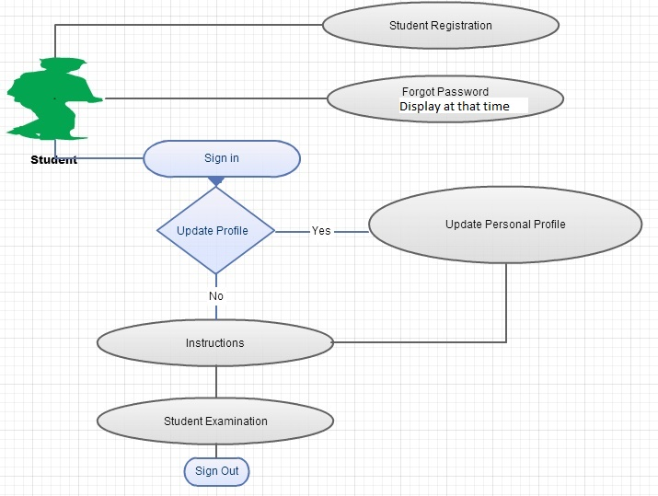

**Admin Execution Flow:**

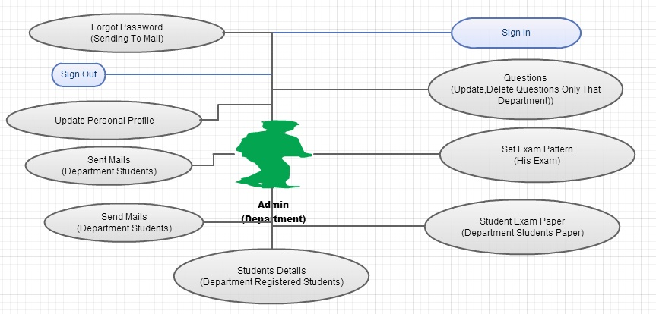

**Database :**

