**UNIT- II: The Linux File System, File and Directory management**

**Assignment 2.1**

Write a Linux command to perform the following task.

1. Create a directory <YourRollNo>. Make <YourRollNo> as the current working directory. Create the directory structure as shown below with a single command.

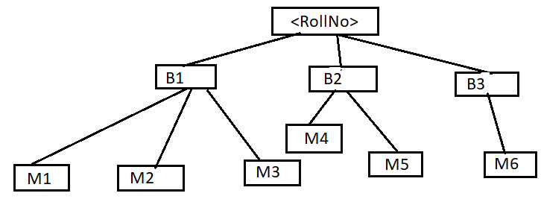

**#Create rollNumDir and create the directory structure given in the diagram**

**mkdir -p gau && cd gau || exit**

**mkdir -p b1/m1 b1/m2 b1/m3**

**mkdir -p b2/m4 b2/m5**

**mkdir -p b3/m6**

Now, make M6 your current working directory and solve the following questions

**cd b3/m6**

1. List the files in directory B1 without actually moving to the directory.

**ls ../../b1**

1. Delete the directory M1.

**rm -rf ../../b1/m1**

Now, make <YourRollNO> as your current working directory

**cd gau**

1. Display the entire hierarchy of your directories inside <YourRollNo>.

**tree**

1. Write a command to list the files in directory M1, where the filename starts with a digit.

**ls b1/m1/[0-9]\***

1. Write a command to move the files from directory M1 to M3 where the file name starts with the alphabet.

**mv b1/m1/[a-zA-Z]* b1/m3/**

1. List all the files present in M3 which are ending with “s”

**ls b1/m3/*s**

1. Move the files ending with the alphabet ‘a’ in your current working directory to subdirectory B3

**mv ./*a b3/**

1. Write a command to list the files in your current working directory where the file name satisfies the given condition.
2. file name starts with a vowel.

**ls [aeiou]\***

1. The file name does not start with a vowel.

**ls [!aeiou]\***

1. Only five characters in the file name.

**find . -maxdepth 1 -name "?????"**

1. Name which contains 5 characters, out of which, first and last should be either a or b.

**find . -maxdepth 1 -name "[ab]???[ab]"**

1. File where name contains 3rd letter as a digit.

**find . -maxdepth 1 -name "??[0-9]?*"**

1. The name with the first character should not be a, b or c.

**ls [!abc]\***

1. Names containing "seq" in the filename.

**ls ./*seq\***

1. The first three characters are only digits.

**find . -maxdepth 1 -name "[0-9][0-9][0-9]?*"**

1. Name that starts and ends with “a”.

**ls a*a**

1. Name with at least 2 characters in it.

**find . -maxdepth 1 -name "??*"**

1. Name with exactly 2 characters in it.

**find . -maxdepth 1 -name "??"**

1. Delete all the directory structures that you have created so far.

**#Coming to the parent directory of gau**

**cd ..**

**rm -rf gau**