PROJECT SPECIFICATION
AI-Powered Executive
Intelligence Platform
An agent-operated platform delivering AI trends, research insights, and personalized intelligence to technology leaders
Version 1.0
July 25,

1. Overview
This document specifies the requirements for an AI-Powered Executive Intelligence Platform: a web-based application whose day-to-day content operations are run by a set of coordinated, autonomous AI agents. The platform gives executives and technology leaders a single destination to track AI trends, understand influential research, and make informed strategic decisions in a fast-moving landscape.
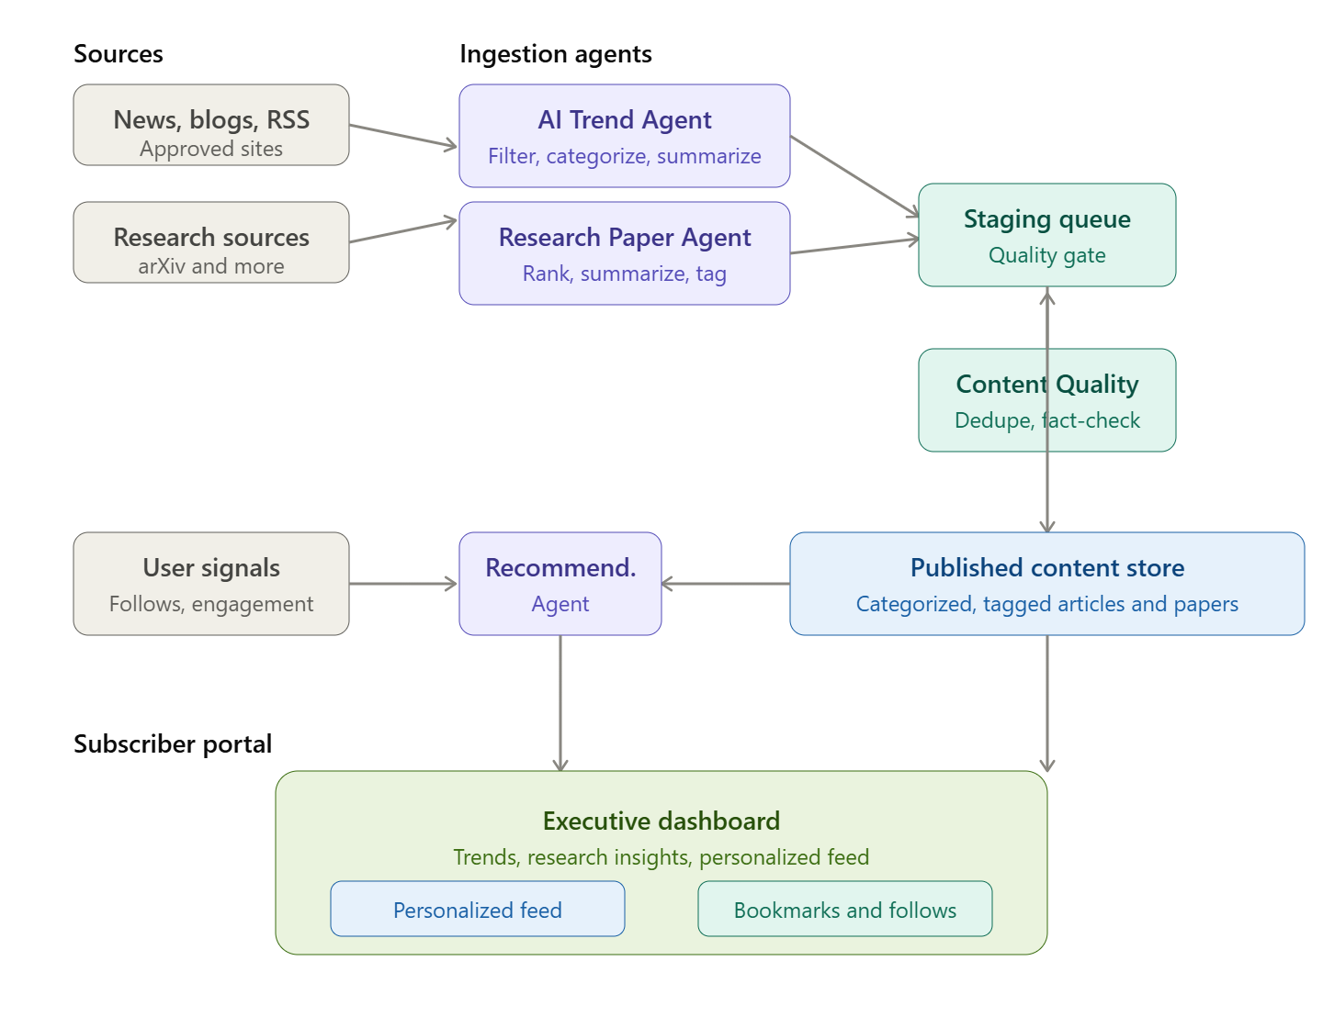

1.1 Objectives
- Aggregate and summarize the latest AI news, industry trends, and influential research in near real time.
- Automate content collection, categorization, quality control, and publication through specialized AI agents.
- Deliver personalized dashboards and recommendations aligned to each user's interests.
- Support tiered subscriptions and a separate administrative portal for platform governance.

1.2 Target Audience
The platform is designed for senior technology and business decision-makers, including CEOs, CTOs, and CIOs, engineering managers and team leads, product managers, innovation leaders, and technical architects.

1.3 Expected Business Value
- Stay current with AI developments from a single, curated source.
- Understand emerging technologies and research without deep technical reading.
- Identify opportunities and risks early.
- Make informed strategic decisions and guide teams with current industry knowledge.

2. Scope

2.1 In Scope
- AI Trends Dashboard with topic categorization.
- Research Paper Insights with AI-generated executive summaries.
- Personalized recommendations and topic/company/research-area following.
- Agent-based content pipeline (trend, research, quality, and recommendation agents).
- Real-time and batch content processing.
- Subscriber portal with authentication, preferences, and bookmarks.
- Administration portal with RBAC, moderation, source configuration, and monitoring.

2.2 Out of Scope (Phase 1)
Items listed in Section 10 (Future Enhancements) — including mobile applications, newsletters, a conversational assistant, multi-language support, and third-party chat integrations — are deferred beyond the initial release.

3. Core Features

3.1 AI Trends Dashboard
- Display the latest AI news and industry trends.
- Highlight significant developments from leading AI companies, research labs, and technology organizations.
- Categorize trends by topic — e.g. Generative AI, Agentic AI, Robotics, LLMs, and Computer Vision.

3.2 Research Paper Insights
- Showcase the latest AI research papers.
- Identify papers gaining significant attention within the AI community.
- Provide AI-generated summaries that are accessible to business leaders.
- Display key insights, practical applications, and business impact.

3.3 Personalized Recommendations
- Recommend relevant trends and research based on user interests.
- Allow users to follow specific topics, companies, or research areas.
- Generate personalized dashboards from engagement history.

4. Agent-Based Architecture
The platform is primarily operated by four specialized agents. Each agent runs autonomously, writes to a shared content store, and is observable through the administration portal.

Agent | Primary Responsibilities
AI Trend Agent | Monitor AI news sites and blogs; consume RSS feeds where available; crawl approved websites; filter, categorize, and summarize content; publish updates automatically.
Research Paper Agent | Monitor sources such as arXiv; identify trending papers via downloads, citations, social mentions, and community engagement; generate executive summaries and takeaways; categorize by domain.
Content Quality Agent | Validate quality and remove duplicates; fact-check summaries where possible; enforce consistent formatting and metadata tagging.
Recommendation Agent | Analyze user preferences and engagement; recommend articles, papers, and trends; generate personalized dashboards.

4.1 Agent Coordination
- Ingestion agents (Trend, Research) publish candidate content to a staging queue.
- The Content Quality Agent gates staged content before it becomes publicly visible.
- The Recommendation Agent operates on published content plus user engagement signals.
- All agent activity, errors, and throughput are surfaced in the AI Agent Monitoring view.

5. Content Processing

5.1 Real-Time Processing
- Continuously monitor RSS feeds and trusted AI news sources.
- Publish updates as they become available, subject to quality gating.

5.2 Batch Processing
- Scheduled jobs to analyze research papers.
- Trend analysis and ranking generation.
- Content enrichment and summarization.

6. User Management & Subscriptions

6.1 Subscriber Portal
Subscribers can create and manage accounts, log in securely, access premium content, save preferences and bookmarks, and receive personalized recommendations.

6.2 Subscription Plans

Plan | Intended For | Representative Entitlements
Individual | Single executive or practitioner | Full dashboard access, personalized recommendations, bookmarks.
Team | Small leadership or product teams | Multiple seats, shared following lists, team-level preferences.
Enterprise | Organizations | SSO/RBAC, admin controls, usage analytics, priority support.
Note: specific per-plan seat counts, pricing, and feature limits are to be finalized with the commercial team.

7. Administration Portal
A separate administrative portal is provided for platform management, with the following capabilities:
- User management and subscription management.
- Content approval and moderation.
- Source configuration — RSS feeds, websites, and research sources.
- AI agent monitoring and system health dashboard.
- Analytics and usage reporting.
- Role-Based Access Control (RBAC).

8. Non-Functional Requirements

Category | Requirement
Security | Secure authentication, encrypted data in transit and at rest, RBAC across portals, and audit logging of admin actions.
Scalability | Ingestion and processing must scale horizontally to handle growing source counts and user load.
Availability | Public dashboard and subscriber portal target high availability; degraded agent processing must not take the read experience offline.
Performance | Dashboard and content pages should load quickly under typical concurrent load; batch jobs must not block real-time publishing.
Observability | Centralized logging, agent metrics, and alerting on ingestion failures or quality-gate backlogs.
Compliance | Respect source terms of use and robots directives when crawling; attribute and link to original sources.

9. Assumptions & Constraints
- Crawling and RSS consumption are limited to approved and permitted sources.
- AI-generated summaries are advisory; source links are always retained for verification.
- Trend and attention signals depend on availability from third-party sources and may vary in coverage.
- Final pricing, plan limits, and source lists are defined during implementation planning.

10. Future Enhancements
- Daily and weekly AI digests, and executive email newsletters.
- AI trend prediction engine and competitor monitoring.
- Team collaboration features and a mobile application.
- Conversational AI assistant and multi-language support.
- Integrations with Microsoft Teams, Slack, and email.

