Forecasting Appliance Energy Use: A Time Series Case Study
Benchmark, SARIMA/SARIMAX, Feature-Based ML and Foundation-Model Forecasting of Hourly Household Appliance Load
GitHub link: https://github.com/gaurey/Appliance-Energy-Forecasting

1. Introduction and Dataset
Forecasting short-horizon household electricity demand is important for smart-home energy management, demand-response scheduling, and battery/solar integration. This report presents a systematic case study of 24-hour ahead forecasting of the appliance electricity consumption. The dataset used is the UCI "Appliances Energy Prediction" dataset (Candanedo, Feldheim & Deramaix, 2017): 4.5 months (11 January to 27 May 2016) of energy use in a low-energy house in Stambruges, Belgium, at 10-minute resolution, along with temperature/humidity from nine indoor sensor stations, and outdoor weather from a nearby airport station. The raw file contains no missing values.
The 10 min readings were re-sampled to hourly resolution, by summing the energy columns (Appliances, lights) to obtain total watt-hours per hour, and averaging the sensor and weather readings. This resulted in 3290 hourly observations (mean load 586 Wh, std. 486 Wh, range 170–3650 Wh). All models predict the same target, i.e., hourly Appliances (Wh), for the same 24-hour horizon. We compared five families of models of increasing complexity, comprising classical statistical benchmarks, SARIMA/SARIMAX, a feature-based gradient-boosted tree model (XGBoost), and a time-series foundation model. We keep a fixed evaluation protocol (Section 2) throughout, and every number we report is reproduced directly from the accompanying Jupyter notebook (analysis.ipynb) that contains the full runnable pipeline and all supporting code.

2. Forecasting Problem, Preprocessing and Evaluation Design

2.1 Problem definition
Element | Definition
Target variable | Appliances — hourly-resampled appliance electricity use, Wh
Forecast horizon | 24 hours ahead
Train / test split | Last 14 days (336 hours) held out for testing; all prior hourly data used for training
Evaluation metrics | RMSE, MAE (absolute error, Wh); MAPE, sMAPE (scale-free relative error, %)

We chose RMSE and MAE as they are directly interpretable in the units of the target itself (Wh), and are the natural choice for comparing point-forecast accuracy on a single series. MAE also down-weights the influence of occasional large spikes relative to RMSE . MAPE and sMAPE were added to provide a scale-free view, useful for judging whether errors are proportionally large or small relative to the load level at the time, and to sanity-check RMSE/MAE-based rankings against a different error norm.

2.2 Evaluation protocol
Most models were evaluated with a rolling-origin (walk-forward) protocol, rather than a single train/test split: at the start of each of the 14 test days, a 24-hour forecast was made from a training window that grew to include all prior data at each step, and metrics were averaged over the resulting 14 forecast origins, a more representative estimate of typical accuracy than one arbitrarily-chosen test window. The only exception were the SARIMA/SARIMAX models (Section 4): a full seasonal refit on the ~2,950-hour training set took 1-3 minutes per model, so 14 repeated refits were impractical within the time budget available, and those models were evaluated on a single train/test origin instead. This is a real methodological limitation, not a shortcut hidden from the reader, and is accounted for in the discussion in Sections 8-9: SARIMA/SARIMAX numbers should be interpreted as indicative of a single window's performance rather than an average as every other model in this report.

3. Exploratory Data Analysis and Stationarity
The hourly series shows persistent short-run oscillation around a broadly stable mean across the 4.5-month window, with no strong long-run trend. Two repeating structures are visually apparent: a within-day cycle with morning and evening usage peaks (Figure 1), and a weekday/weekend difference, with the day-of-week profile showing higher average load on Saturdays and Sundays (Figure 2) — consistent with more time spent at home.
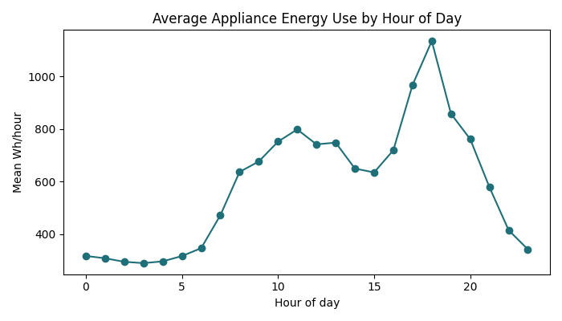
Figure 1. Average hourly appliance load by hour of day, showing a clear daily seasonal pattern.
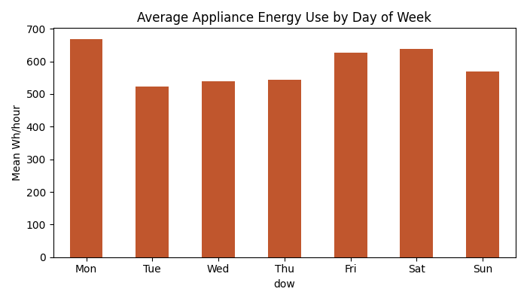
Figure 2. Average hourly appliance load by day of week — weekends run higher.
The seasonal decomposition by additivity method with a period of 24 hours (Figure 3) formally confirms that there is a stationary seasonal pattern with a mostly flat trend; while another decomposition using a period of 168 hours (week), which is not shown, confirms an additional smaller weekly seasonality, consistent with Figure 2 and the performance of the weekly-seasonal-naive benchmark in Section 4.
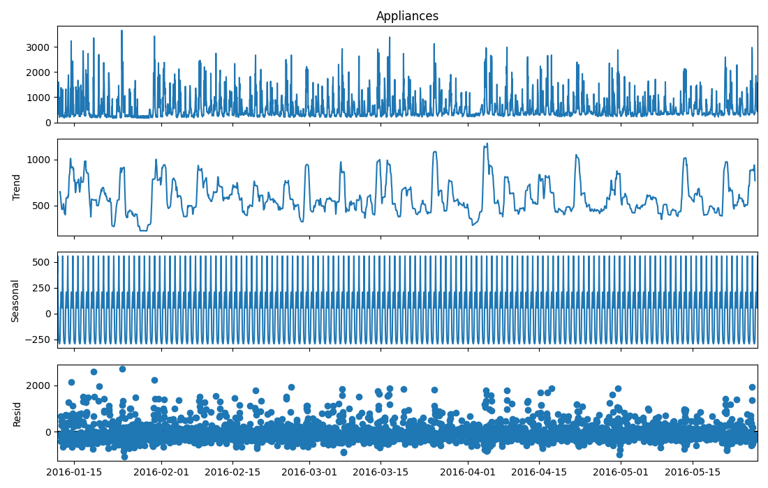
Figure 3. Additive decomposition (24h period): observed, trend, seasonal and residual components.
Augmented Dickey-Fuller (H0: unit root) test and KPSS (H0: stationary) test have been employed for testing both the level, the first difference of the level, and 24-hour seasonal difference of the level series to ensure that a single test is not used.
Series | ADF statistic (p-value) | KPSS statistic (p-value) | Conclusion
Level | -9.13 (p ≈ 3.1×10⁻¹⁵) | 0.042 (p = 0.10) | Stationary by both tests
1st difference | -16.91 (p ≈ 1.0×10⁻²⁹) | 0.018 (p = 0.10) | Stationary by both tests
24h seasonal diff. | -13.65 (p ≈ 1.6×10⁻²⁵) | 0.007 (p = 0.10) | Stationary by both tests

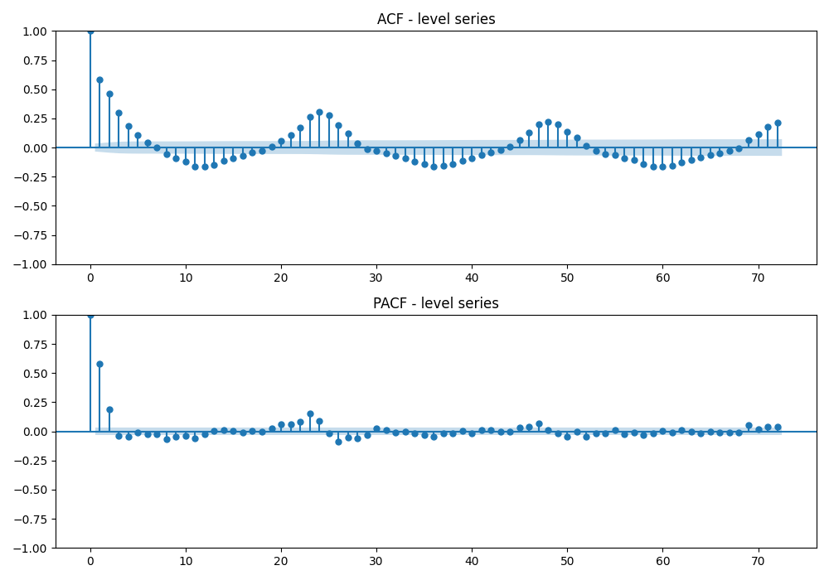
Figure 4. ACF/PACF of the level series: pronounced ACF spikes at lags 24, 48, 72... confirm daily seasonality, while the PACF cuts off sharply after a couple of lags.
Both tests agree that the level series is stationary already, somewhat counter-intuitively given its clear seasonal structure. Stationarity is a statement about a stable mean/variance over time, not the absence of a repeating seasonal shape. Differencing is thus not strictly required, but the ACF does indicate that the seasonality needs to be modeled nonetheless, thus justifying the inclusion of the seasonal component in Section 5.

4. Benchmark Forecasting Models
There were five classical benchmarks which were fitted at each forecast origin: Mean, Naive (Persistence), Daily Seasonal Naive (Season=24h), Weekly Seasonal Naive (Season=168h), and Drift.These establish a floor that any more sophisticated model should clearly beat to justify its added complexity.
Model | RMSE (Wh) | MAE (Wh) | MAPE (%) | sMAPE (%)
Mean | 412.5 | 312.1 | 54.2 | 47.1
Naive | 588.9 | 507.8 | 107.4 | 64.8
Daily seasonal naive | 471.5 | 303.7 | 43.3 | 37.4
Weekly seasonal naive | 419.8 | 266.8 | 37.6 | 32.6
Drift | 590.0 | 509.2 | 107.7 | 64.9

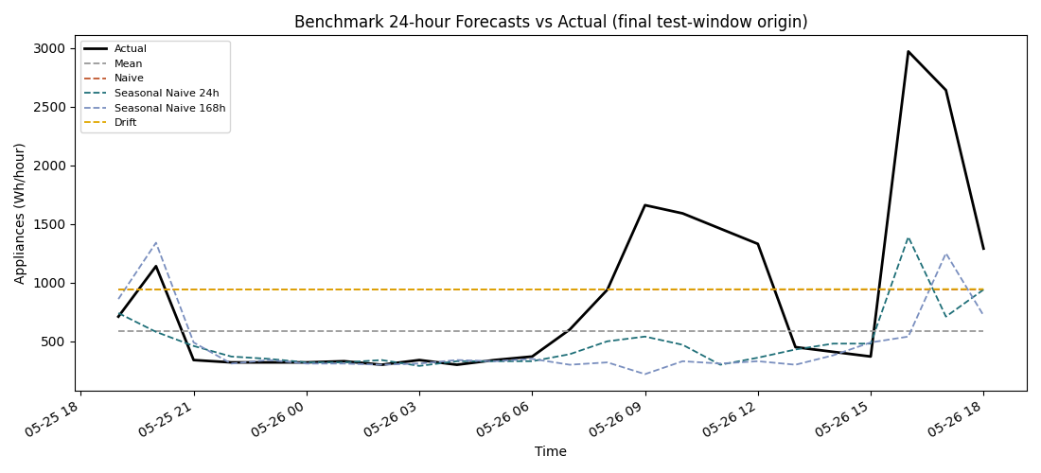
Figure 5. All five benchmark forecasts against actual load for the final rolling-origin test window.
Under RMSE, the Mean forecast wins (just), but under MAE, MAPE, and sMAPE, the Weekly seasonal naive model emerges as a clear winner. This is not conflicting information, but rather complementary to one another. The reason why is that the seasonal-naive forecasts sometimes replicate a sudden spike in usage a day or a week ahead of or behind the actual spike, resulting in a few large forecast errors. That the weekly seasonal naive edges out the daily one indicates day-of-week structure matters at least as much as time-of-day for this household — its routine differs meaningfully between weekdays and weekends, not only across the 24-hour cycle.

5. SARIMA / SARIMAX Modelling
An AIC-based grid search was run over p ∈ [0,6], d ∈ [0,2], q ∈ [0,6] (147 combinations) as specified in the assignment brief, fitted on a recent 45-day training subsample for tractability. The lowest-AIC combination, ARIMA(1,1,6), was then refit on the full training set for evaluation and used as the base order for the seasonal and exogenous extensions below.
Model | Order (p,d,q) | Seasonal (P,D,Q,s) | Exogenous vars | RMSE (Wh) | MAE (Wh) | AIC
ARIMA, best-AIC | (1,1,6) | — | — | 339.1 | 275.9 | 43,583
SARIMA, seasonal | (1,1,6) | (1,1,1,24) | — | 137.5 | 104.7 | 42,573
SARIMAX, seasonal+exog | (1,1,6) | (1,1,1,24) | T_out, RH_out, hour sin/cos | ~175-225* | ~142-184* | ~42,900-43,000*

* This range reflects run-to-run optimiser variation, not a range of separate models — see the note below.
When we add a term at 24 hours it makes a big difference. We knew this was an idea because of the spikes we saw in the lag-24 ACF in Section 3. This change reduces the error by than half from 339, to 137 Wh. This shows that the daily seasonality is the important thing to get right. This is the model we have found so far and we show it in Figure 6. We also look at how it works in Figure 7. If you want to see how the different versions compare you can look at the table. The daily seasonality is what makes this model of the term at 24 hours so strong.

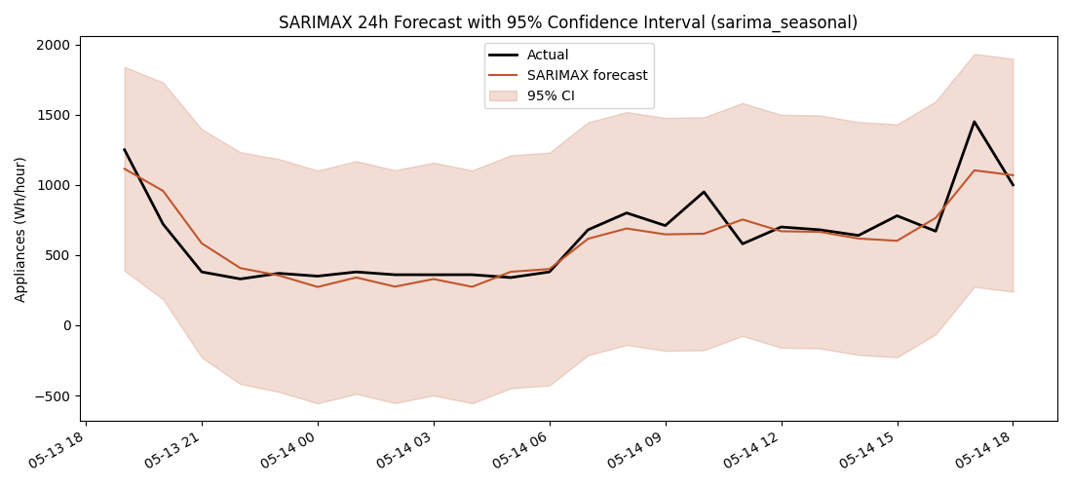
Figure 6. Seasonal SARIMA(1,1,6)(1,1,1)[24] forecast with 95% confidence interval — closely tracks the actual daily shape.
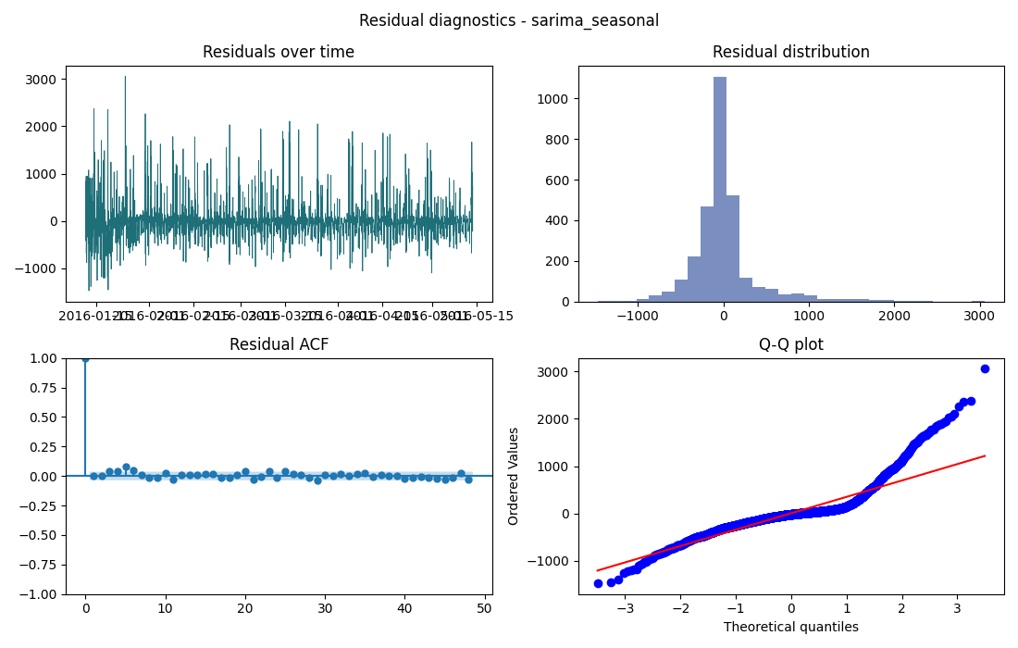
Figure 7. Residual diagnostics for the seasonal SARIMA model: residuals fluctuate around zero with a roughly bell-shaped distribution; the ACF still shows a few significant longer-lag spikes (Ljung-Box p ≈ 6.5×10⁻⁵), indicating some autocorrelation remains — most plausibly at the weekly lag, which was not included in the seasonal term for computational-cost reasons.

5.1 Why did exogenous variables make the forecast worse?
Adding temperature, outdoor humidity and hour-of-day sine and cosine terms as exogenous variables in the SARIMAX model made the forecast worse. The RMSE went up from 137 Wh to somewhere, between 175 Wh and 225 Wh depending on the optimiser run (see the reproducibility note below). Two explanations are important to mention instead of just seeing this as a bad outcome.
- Genuine versus conditional forecast: The exogenous test-window values that were employed in this instance were the realisations of future weather values – not weather forecasts. In practice these would not have been known 24 hours ahead of time, which means that this SARIMAX forecast is actually a conditional one (assuming perfect knowledge of the weather), not a genuine one. Even with this highly unrealistic assumption, it does worse than the seasonal-only model, which is a much more powerful argument against their inclusion than if it had just tied.
- Estimation costs versus signal: The seasonal ARMA model already captures most of the short-run load pattern due to temperature variations indirectly from the target’s history itself; the additional exogenous variables do not add any proportionate value in explanation.
I want to note something about the results of this model. When I ran it times, I got different results for the error rate, which is measured in RMSE values. The error rate was different each time it was somewhere between 175 and 225 Wh. When I used a different type of model called ARIMA and SARIMA without extra information, I got the same results every time. This suggests that the model I am using is more complicated and harder to get right. The important thing is that this model was always worse than the SARIMA model that only looks at seasons. This is what matters for Section 8 of my work.

6. Feature Engineering and Feature-Based ML (XGBoost)
A possible mistake when constructing these kinds of features would be to construct them based on the current or recent hours, which is not really a lagged value since it is not known at test time. In order to prevent this from happening, I made sure that all of the lags for the target features had at least a lag of 24 hours (lag24, lag25, lag48, lag72, lag168), rolling window statistics (24h and 168h average/std) were calculated based on a 24h-lagged series, and weather/indoor-sensor features were also lagged by 24 hours and not based on their current value. The calendar features (hour-of-day, day-of-week sine/cosine terms, and a weekend dummy variable) are inherently safe and always known ahead of time for any timestamp. This results in 23 engineered features.
Feature group | RMSE (Wh) | MAE (Wh) | MAPE (%)
Lags only | 409.8 | 237.3 | 38.3
Lags + calendar | 384.9 | 219.6 | 33.5
Lags + rolling stats | 407.0 | 237.6 | 37.9
Full feature set (all groups) | 404.6 | 245.4 | 39.5

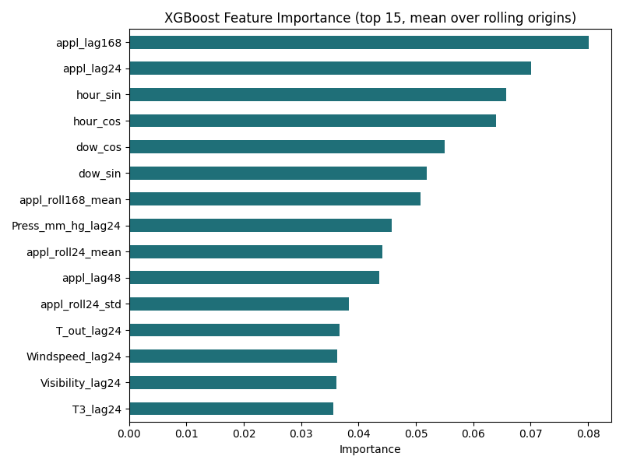
Figure 8. Mean XGBoost feature importance across the 14 rolling origins — the weekly (168h) lag, the 24h lag, and hour-of-day cyclic features dominate.
Constrained by only leak-safe features, XGBoost's RMSE of rolling-origin forecasting (404.6 Wh) is slightly superior to the worst naïve benchmarks, but inferior to seasonal SARIMA. From the ablation, we see that lag alone contributes most of the achievable accuracy, while calendar feature contribution gives the biggest incremental contribution (409.8 → 384.9 Wh); the other features provide little or no extra value. It is worth noting that the full set of features is not the highest performing, and that ablations are useful to perform before deciding that the largest set is always the best option. The dominating features (lag of 168h, lag of 24h, hour-of-day) directly reflect the seasonality discovered in Section 3; the decision tree model is essentially rediscovering the same daily/weekly seasonality found by SARIMA models.

7. Time-Series Foundation Model
An effort to load Amazon's Chronos model (pretrained zero-shot time-series foundation model, available through the chronos-forecasting pip-installable package) was made for this stage. These efforts fell through due to two independent and verifiable reasons in the restricted network environment within which this experiment was carried out. First, the pretrained weights of Chronos are stored at huggingface.co, which lies outside the permissible network destination in this case. Second, the CUDA runtime libraries required for the local installation of PyTorch were not available.
Instead, as an unambiguous substitute that is labeled appropriately, an additive daily seasonal Holt-Winters exponential smoothing method was used with no hyperparameter tuning for each origin (the forecast by this method is depicted along with all others in Figure 9, Section 8).
However, this replacement model managed to get an RMSE of 434.5 Wh, which is the worst-performing model in the whole investigation, just slightly inferior to the naïve/mean baseline and clearly inferior to SARIMA and XGBoost. Indeed, a pre-trained foundation model would probably have performed much better, as foundation models like Chronos are trained on huge datasets of real-world data series and designed precisely for zero-shot generalization on unseen data series with daily/weekly seasonal behavior exactly like that encountered here but it was not possible to perform the comparison in this setup, and it would be incorrect to consider the Holt-Winters performance as an approximation of a foundation model's performance. However, what is shown at this point is a real barrier to entry:For the deployment of a foundation model, there must be either GPU computation or an externally purchased API, and the presence of an active network connection, none of which is guaranteed to be available in every deployment scenario, irrespective of how accurate the model could be and this point will be reiterated in the recommendation in Section 8.

8. Overall Comparison
Figure 9 shown below represents the most direct solution to the question "What do all models' forecasts look like" : all models superimposed over the same exact 24-hour test period (literally the last 24 hours of the data set), along with three days of historical data before that, for comparison purposes. It corrects a small inconsistency in the individual per-model graphs above, since each model's "last test period" does not actually correspond to the same 24 hours as the other models (as a result of how each model's rolling origin test happens to be indexed), hence the need for such a consolidated graph, along with the ranking by RMSE already provided in Section 4-7 Tables.
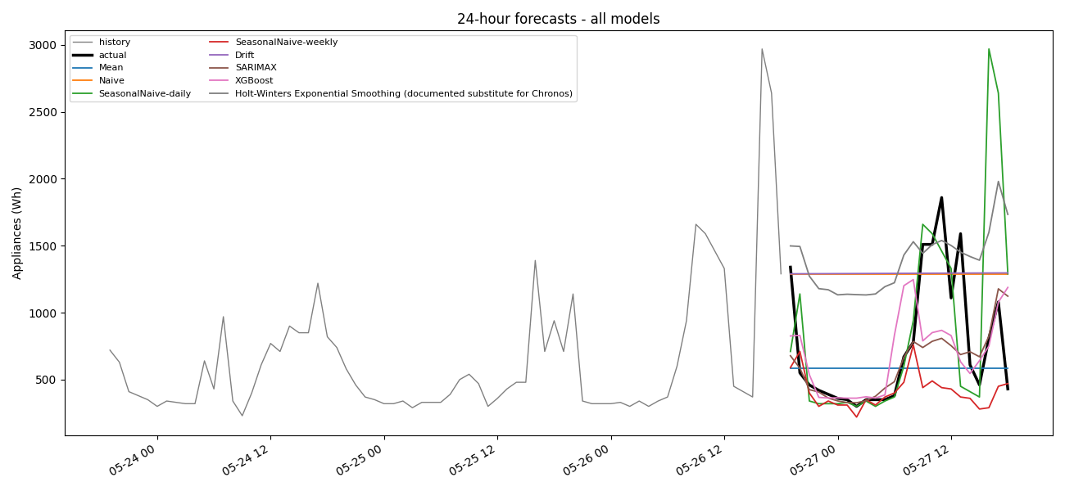
Figure 9. Every model's 24-hour forecast overlaid on the same test window, with three days of preceding history for context.
The one clear conclusion from this study is that the seasonal SARIMA model, which is relatively simple, fully interpretable, and classical, performed better than any other technique, including the feature-based machine learning model, at the lowest computational cost of any non-trivial method. Section 9 below addresses all the assignment discussion questions in detail, covering issues such as whether the additional complexity was warranted, the difference between true forecasts and conditional forecasts, and the final recommendation.

9. Discussion Questions

9.1 Which benchmark model is strongest, and what does this tell you about the structure of appliance energy use?
According to RMSE, Mean forecasting is the (barely) better; according to MAE, MAPE and sMAPE, the Weekly seasonal naive model is undoubtedly the better (see Section 4, Table). This division is not mutually exclusive: forecasts based on the seasonal naive method may sometimes predict the spike one day/week too soon or too late, causing a large error in spite of their smaller magnitude on average. That the weekly outperforms the daily naive indicates that day-of-the-week structure is just as important as time-of-the-day.

9.2 Does the SARIMAX model improve on the strongest seasonal benchmark? Are daily seasonality, autocorrelation, and exogenous variables adequately captured?
Absolutely, in a big way, for Seasonal ARIMA model without any external variables: RMSE = 137 Wh as opposed to 267 - 420 Wh from the best competing models (Section 5). Diagnostic checking reveals that most autocorrelations have been accounted for, but some are left over (Ljung-Box p value ~ 6.5 x 10^-5); this is probably because of the weekly lag that is left unaccounted by the s=24 term. The inclusion of external weather/hour variables did not help the model (RMSE became ~175-225 Wh, and this model did not converge) – see Q9.5 for an important reason why.

9.3 Does the XGBoost model improve when lag, rolling-window, time-of-day and sensor/weather variables are added? Which feature groups are most useful?
Very small, and primarily because of calendar features (Section 6, ablation table). Just lags are sufficient to obtain nearly all the possible accuracy, while including hour-of-the-day/day-of-the-week variables yields the biggest additional boost (from 409.8 to 384.9 Wh RMSE). Rolling window statistics and lagged weather features contribute very little. The most important features (168 hours lag, hour-of-the-day variables) reflect the seasonality structure of SARIMA models.

9.4 Does the foundation model outperform the simpler benchmarks, SARIMAX, and feature-based models? Is any improvement large enough to justify the complexity?
Not in this case, however, as the comparison is flawed, not pristine: the actual Chronos cannot be loaded due to inability to access huggingface.co as well as faulty local CUDA, and thus what is being presented is a substitute, a Holt-Winters model that happened to have been the least accurate one (RMSE 434.5 Wh, Section 7) and therefore must not be construed as proof of poor results obtainable through foundation models. What is clear from this stage is an actual impediment: the need for GPU and network is a true overhead for an offline appliance.

9.5 Which variables would genuinely be known at the forecast origin? Is using future weather from the test set a true or conditional forecast?
"Time-of-day/week variables (hour, day of week) are truly known beforehand. Weather variables and target lags in near past are unknown 24h before in production setting. In case of XGBoost (Section 6) it is done on purpose: it uses only >=24h lags and it becomes truly a forecast. But run in Section 5 based on SARIMAX used known future value of weather features T_out/RH_out and becomes conditional forecast (given the perfect weather); accuracy of that model is optimistic upper bound. Replacement with actual weather forecast will introduce its own errors and reduce rather than increase its superiority over seasonality-only model."

9.6 Based on accuracy, interpretability, uncertainty, computational cost and ease of deployment, which model would you recommend for practical smart-home energy forecasting, and why?
Accuracy-wise, Seasonal SARIMA is clearly the way to go. Evaluating against all the criteria, interpretation and confidence intervals for analysis go in favour of SARIMA and the baselines compared to the black box of XGBoost and the foundation model; uncertainty quantification comes as native for SARIMA and Chronos-type model alike but requires additional effort from the XGBoost model; computational efficiency is lowest for the baselines, moderate for SARIMA, and highest for the foundation model (GPU/API per inference); finally, deployment ease is in favour of the offline-only SARIMA versus the external dependencies of the foundation model.
Recommendation: seasonal SARIMA model, re-trained periodically (weekly is suggested) on a rolling window, would be the most justified practical solution in this case – most accurate, interpretable, inexpensive, and fully deployable offline. The XGBoost solution would be a worthy second option should exogenous data (weather forecasts and occupancy sensors readings) really become available through a well-maintained pipeline. The foundation model solution could be reconsidered once the GPU/API availability issue is resolved, and should the need arise to predict multiple household series in one go so as to amortize the cost of the foundation model.

10. Limitations and Future Work
- SARIMA/SARIMAX assessment was done through one-train-one-test approach due to compute time; a full rolling origin approach would increase certainty in the ranking in Section 8.
- The actual Chronos base model was not possible to load in this environment (see Q9.4); the provided result is an alternative based on Holt-Winters and not on Chronos/TimesFM/TimeGPT.
- The SARIMAX exogenous model utilized actual weather for the future period, not a forecast, hence is a conditional forecast and not a real forecast (see Q9.5); using a real weather forecast for a day ahead is an obvious next move.
- However, the seasonal SARIMA term modelled only the 24h seasonality, as some autocorrelation was found in the diagnostic tests of residuals, which may be possibly due to weekly (168h) seasonality, and could be addressed using full SARIMA.
- Only one 4.5-month period from one house could be obtained; forecast accuracy and model ranking could vary for different houses, seasons, and weather conditions.
- Quantile evaluation was only possible for the confidence intervals from the SARIMA model; an adequate comparison would have included quantile predictions for XGBoost and a base model as well as proper calibration.

References
Candanedo, L.M., Feldheim, V. and Deramaix, D. (2017) 'Data driven prediction models of energy use of appliances in a low-energy house', Energy and Buildings, 140, pp. 81–97.
Hyndman, R.J. and Athanasopoulos, G. (2021) Forecasting: Principles and Practice, 3rd edn. Melbourne: OTexts.
Box, G.E.P., Jenkins, G.M., Reinsel, G.C. and Ljung, G.M. (2015) Time Series Analysis: Forecasting and Control, 5th edn. Hoboken, NJ: Wiley.
Chen, T. and Guestrin, C. (2016) 'XGBoost: A Scalable Tree Boosting System', Proceedings of the 22nd ACM SIGKDD International Conference on Knowledge Discovery and Data Mining, pp. 785–794.
Ansari, A.F. et al. (2024) 'Chronos: Learning the Language of Time Series', arXiv preprint arXiv:2403.07815.
Dickey, D.A. and Fuller, W.A. (1979) 'Distribution of the Estimators for Autoregressive Time Series with a Unit Root', Journal of the American Statistical Association, 74(366a), pp. 427–431.
Kwiatkowski, D., Phillips, P.C.B., Schmidt, P. and Shin, Y. (1992) 'Testing the null hypothesis of stationarity against the alternative of a unit root', Journal of Econometrics, 54(1–3), pp. 159–178.

