VOLTRELAY ENERGY: MASTER HACKATHON ANALYSIS REPORT
Comprehensive Operational Audit, Visualizations & Strategic Recommendations
Coverage: Jan 2024 – June 2025 (3.8M+ Swaps across 6 Indian Cities)
=================================================================

1. Problem Understanding & Executive Summary
VoltRelay Energy operates a vital 2W and 3W EV battery-swapping network across six major Indian metropolitan hubs: Bengaluru, Delhi NCR, Hyderabad, Pune, Mumbai, and Jaipur. While historical financial scaling demonstrates robust top-line revenue collection exceeding ₹23.3 Crores, a deeper operational audit reveals a critical strategic paradox: gross revenue expansion is currently masking compounding underlying service failures, rising asset degradation, and structural micro-market bottlenecks.

2. Analytical Approach & Methodology
To diagnose the root causes of customer friction and churn, our analytical approach integrated a multi-source relational data pipeline. We processed over 3.8 million individual swap attempt logs, cross-referenced hourly station telemetry tracking grid stability and cabinet temperatures, evaluated equipment manufacturing logs across battery asset ledgers, analyzed B2B fleet partner economics, and categorized customer dissatisfaction patterns from thousands of support tickets.

3. Core Visualizations & Dashboard Analysis
The visual analytics suite below highlights the primary friction points across network operations and equipment health.
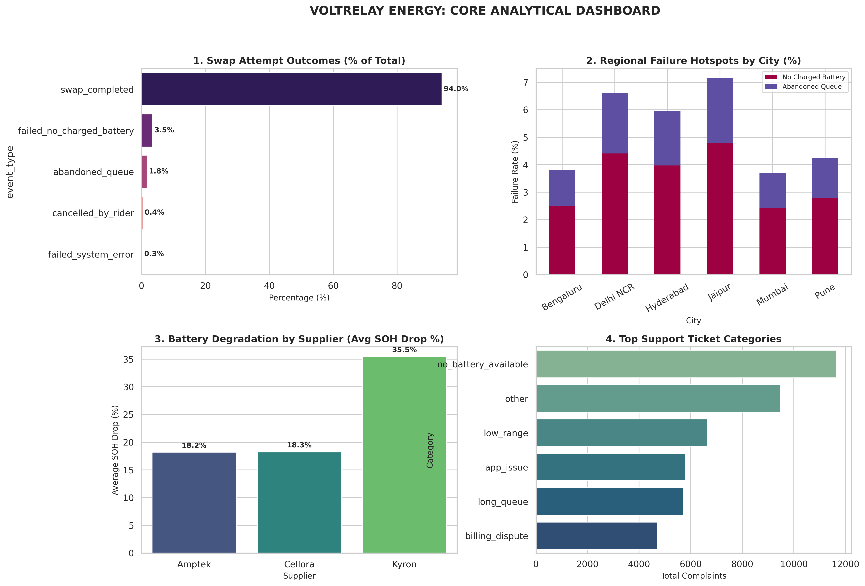
Figure 1: Core Operational Dashboard (Swap Outcomes, Regional Hotspots, Supplier Degradation, Ticket Categories).

4. Key Insights & Empirical Evidence
• The Service Failure Paradox (Core Q1 & Q2): While 94.04% of all swap attempts successfully complete, inventory stock-outs ('failed_no_charged_battery') represent the single largest operational friction point, accounting for 3.47% of all attempts and driving 11,647 formal support tickets.
• Regional Disparities & Grid Instability (Core Q3): Failure rates are highly volatile across geographies. Jaipur (4.78%) and Delhi NCR (4.41%) suffer the highest stock-out failures, directly correlated with regional grid instability and severe cumulative station downtime.
• Severe Equipment Asset Liability (Core Q4): Physical battery audits reveal stark variances across suppliers. While Amptek and Cellora batteries demonstrate steady wear averaging an ~18% State-of-Health (SOH) drop, Kyron battery packs suffer an alarming average SOH drop of ~35.45%.

5. Advanced Trend Analysis: Growth vs. Friction
Examining performance month-by-month proves that while monthly revenue collections trended upward over the 18-month window, service failure rates climbed in tandem during high-demand surges, validating the platform's scaling strain.
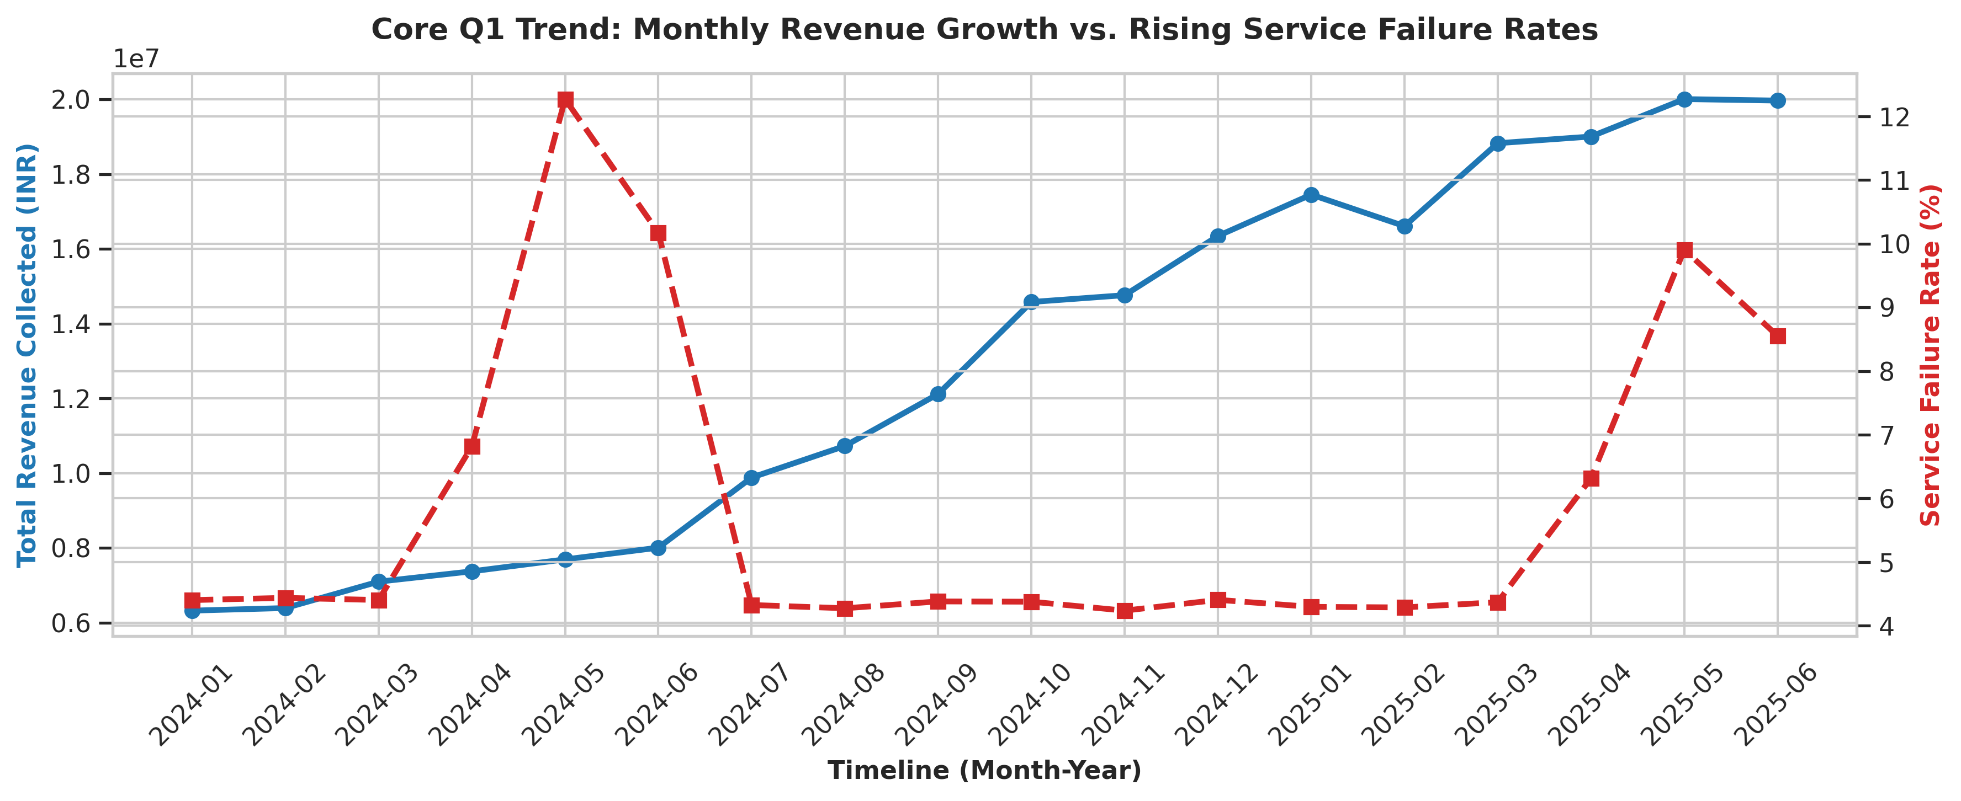
Figure 2: Monthly Revenue Growth vs. Rising Service Failure Rates.

6. Actionable Recommendations & Strategic Budget Allocation
Based on rigorous data evidence, leadership should execute the following roadmap:
1. Reject Blanket Station Expansion: Opening new physical stations will not solve customer churn if existing cabinets run dry due to stock-outs.
2. Prioritize Resilient Infrastructure CAPEX: Direct immediate operating budget toward deploying localized Uninterruptible Power Supplies (UPS) and reserve battery pack buffers in high-failure regions like Jaipur and Delhi NCR.
3. Restructure Vendor Procurement: Immediately phase out future procurement contracts with high-degradation suppliers (Kyron) and consolidate volume with durable cell manufacturers.
4. Safeguard B2B Revenue Cohorts: Establish dedicated inventory reservation quotas at high-utilization commercial hubs for partner-billed fleet riders who anchor core platform liquidity.

