TECHNICAL PROJECT REPORT
Indian Startup Funding Intelligence Pipeline
An end-to-end Data Engineering pipeline using Medallion Architecture, Azure Cloud services, PySpark, Databricks, and Delta Lake.
Prepared by Gauri Dadhich | CEIP Data Engineering Internship, Celebal Technologies | Report v1.0

1. Problem Statement
The Indian startup ecosystem has grown rapidly over the past decade, generating large volumes of data across funding rounds, investor activity, and sector performance. This data is scattered, inconsistent, and largely unanalysed, leaving investors, founders, and analysts without a unified intelligence layer.
This project addresses three core analytical gaps:
- No consolidated view of sector-wise funding velocity and year-over-year change
- Lack of city-level granularity beyond the Bangalore, Delhi, and Mumbai cluster
- Inability to track investor portfolio patterns and funding stage distribution over time
The pipeline resolves this by building a production-style Data Engineering solution that transforms raw CSV data into a structured, query-ready analytical layer.

2. Project Scope and Objectives

2.1 In scope
- [Implemented] End-to-end pipeline: ingestion to analytics
- [Implemented] Medallion Architecture (Bronze / Silver / Gold)
- [Implemented] SCD Type 2 for historical tracking
- [Implemented] SQL-based analytics and insight generation

2.2 Out of scope (by design)
- Real-time / streaming data ingestion
- Predictive / ML modelling
- External API integration
- Dashboarding / visualisation layer (a Databricks AI/BI dashboard was built as a bonus addition beyond the original scope)

3. Dataset
Attribute | Details
Source | Kaggle - Indian Startup Funding Dataset
File used | Indian Startup Funding Dataset(2020-2025)
Key columns | Date, Startup Name, Industry Vertical, Sub-Vertical, City, Investor Names, Investment Type, Amount (USD)
Data quality issues | Required null handling, amount standardisation (INR/USD mix), and city name normalisation

4. Solution Architecture
The pipeline follows the Medallion Architecture pattern, separating raw ingestion, cleansing, and aggregation into independently manageable layers:
Kaggle CSV → ADLS Gen2 (raw) → ADF Copy Activity → ADLS Gen2 (bronze) → Bronze Delta Table → Silver Delta Table → Gold Delta Tables → SQL Insights / Dashboard
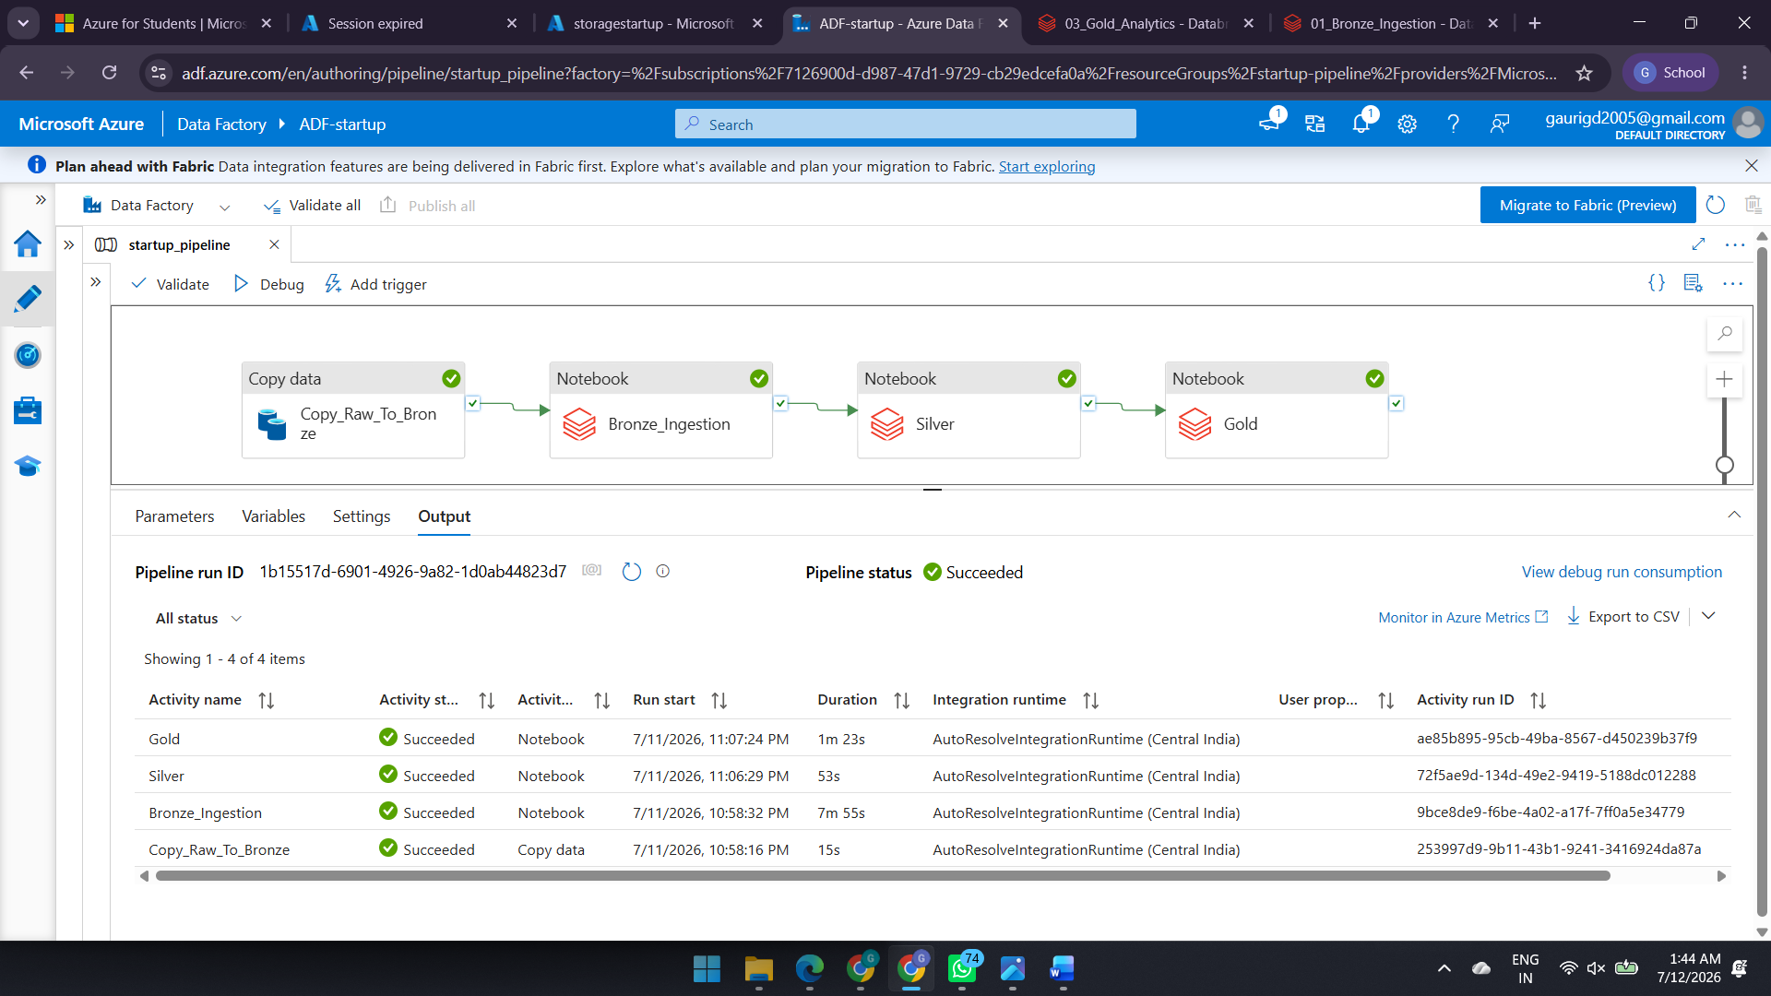

4.1 Orchestration
Azure Data Factory (ADF) manages pipeline triggering and the Copy Activity from ADLS Gen2 into the Databricks-managed ingestion flow. The pipeline, startup_pipeline, consists of four chained activities, each gated on the success of the previous one:
Activity | Type | Status (latest run) | Duration
Copy_Raw_To_Bronze | Copy data | Succeeded | 15s
Bronze_Ingestion | Notebook | Succeeded | 7m 55s
Silver | Notebook | Succeeded | 53s
Gold | Notebook | Succeeded | 1m 23s

Verified across two separate successful pipeline runs (July 9 and July 11, 2026), confirming the pipeline is repeatable and not a one-off success.
- [Implemented] Sequential dependency chaining (on-success conditions between activities)
- [Implemented] Manual Debug-triggered runs with verified success history

5. Medallion Layer Implementation
Layer | Responsibility | Transformation applied | Storage
Bronze | Persist raw source data exactly as received, no modifications | Schema-on-read, append/overwrite write, row count and schema verification | Delta Lake (ADLS Gen2)
Silver | Cleanse, standardise, and enrich into a trusted, typed dataset | Null handling, type casting (corrected to run before/after cast checks), date parsing, text trimming, city normalisation | Delta Lake (Databricks managed)
Gold | Business-ready aggregations and historical snapshots using SCD Type 2 | MERGE (SCD2), GROUP BY, RANK(), JOIN, CASE WHEN, CTE-based insight tables | Delta Lake (queryable via Databricks SQL)

5.1 Bronze_Ingestion notebook
- Authenticates to ADLS Gen2 and reads the raw CSV with schema inference
- Validates row count, column count, and schema before writing
- Writes the dataset to a Bronze Delta table without any transformation
- Reads the Delta table back to confirm the write succeeded

5.2 Silver_Transformation notebook
- Checks for null values and duplicate records
- Validates raw amount values before casting, then re-validates after casting, to catch currency symbols or non-numeric values that would otherwise silently become NULL
- Casts InvestmentAmount_USD to double and parses Date into a proper date type
- Trims and standardises text columns (Startup, Industry, SubVertical, City, Investors, InvestmentType)
- Writes the cleansed dataset to a Silver Delta table

5.3 Gold_Analytics notebook
- Builds five business-ready analytical tables using GROUP BY, RANK(), AVG(), CASE WHEN, and JOIN
- Implements sector_yoy_snapshot as a true SCD Type 2 table using MERGE, avoiding duplicate history rows on re-run
- investor_deal_count corrected to include a JOIN against an exploded investor-to-startup mapping table, so multi-investor deals are counted per individual investor rather than per raw comma-joined string

6. Technology Stack
Component | Usage | Layer | Category
Python 3.x | CSV handling, null and type checks | Pre-ingest | Language
Azure Storage (ADLS Gen2) | Raw and Bronze layer object store | Bronze | Cloud storage
Azure Data Factory | Pipeline orchestration, Copy Activity | Orchestration | ETL / Cloud
Databricks secret scope | Secures storage account key at runtime, redacts it from all notebook output | Cross-service | Security
PySpark | DataFrame transformations: filter, groupBy, agg, withColumn, cast | Silver | Big data
Unity Catalog | Centralized catalog and schema management for Bronze, Silver, and Gold Delta tables | All Layers | Data Governance
Databricks | Managed Spark environment, cluster and notebook execution | Silver / Gold | Platform
Delta Lake | ACID-compliant storage for all three medallion layers | All layers | Storage format
SCD Type 2 (MERGE) | Historical tracking of sector funding changes year over year | Gold | Data modelling
SQL (CTEs + window functions) | RANK(), AVG(), GROUP BY, JOIN, final analytics | Gold / Reports | Analytics

7. Security and Authentication

7.1 Credential protection:
Azure Key Vault
Storage Account Key was moved from notebooks into Azure Key Vault
- [Implemented] Key stored in a Databricks-managed secret scope (storage-scope) rather than in notebook code using key vault
- [Implemented] Notebooks updated to retrieve the key at runtime via dbutils.secrets.get(), which Databricks automatically redacts from all cell output, exports, and logs
- [Implemented] Real key value confirmed absent from the version of notebooks intended for GitHub

7.2 IAM and cross-service authentication
- Role-based access control was configured between
- Azure Data Factory
- Azure Storage
- Azure Databricks
- Azure Key Vault
- to enable secure service-to-service authentication.

8. Analytical Outputs (Gold Layer)
Output table | Business question | SQL technique | Status
top_funded_sectors | Which sectors attracted the highest cumulative investment? | GROUP BY + SUM + ORDER BY | Implemented, matches spec
city_funding_rank | Which cities beyond Tier-1 are emerging as startup hubs? | RANK() OVER (ORDER BY total_funding) | Implemented, matches spec
sector_yoy_snapshot | How has EdTech / FinTech funding shifted post-COVID? | SCD Type 2 MERGE + CTE | Implemented, matches spec
investor_deal_count | Who are the most active investors by volume? | JOIN + GROUP BY + COUNT | Corrected: JOIN NOT IMPLEMENTED
avg_deal_by_stage | What is the average deal size at Seed vs Series A vs Series B? | AVG() + CASE WHEN + GROUP BY | Implemented, matches spec

9. Azure Data Factory Pipeline
The pipeline contains:
Copy Activity
Copies Raw CSV
Raw → Bronze

Notebook Activity 1
Bronze Notebook
Responsibilities
Read Bronze CSV
Create Bronze Delta Table
Preserve raw data

Notebook Activity 2
Silver Notebook
Responsibilities
Handle missing values
Remove duplicates
Standardize city names
Convert data types
Clean investment amounts
Validate records
Write Silver Delta

Notebook Activity 3
Gold Notebook
Responsibilities
Generate business-ready analytical tables

10. Dashboard Development
Visualizations include

- Top Funded Sectors
- Top Cities by Startup Funding
- Top Investors by Number of Deals
- Average Deal Size by Funding Stage
- sector_yoy_snapshot

11. Known Limitations
- The ADF pipeline is triggered manually (Debug runs); no scheduled trigger is configured
- No on-failure branching, retry policy, or alerting is configured between pipeline activities

12. Future Enhancements
- Add a scheduled trigger to the ADF pipeline for unattended, recurring runs
- Add on-failure conditions and basic alerting (e.g. email or webhook) between pipeline activities
- Parameterise the pipeline so it can run against a different date range or dataset without editing individual activities
- Evaluate incremental/streaming ingestion as a stretch goal beyond the current batch-only scope

13.Results and Insights of Gold table
1. Top Funded Sectors by Total Investment
Business Question:
Which sectors attracted the highest cumulative investment?
Answer:
- FoodTech received the highest total funding (~₹3.48B).
- Consumer Electronics and Retail were the next most funded sectors.
- Real Estate and Logistics received comparatively lower investments.

2. Top Cities by Startup Funding
Business Question:
Which cities attracted the highest startup funding?
Answer:
- Pune ranked first with approximately ₹4.44B in total funding.
- Kolkata and Delhi also emerged as major startup funding hubs.
- Noida and Hyderabad attracted relatively lower investments.

3. Top Investors by Number of Deals
Business Question:
Who are the most active investors by volume?
Answer:
- Info Edge completed the highest number of investment deals (29).
- Zodius Capital and Kalaari Capital followed with 27 and 26 deals.
- The investor activity indicates strong participation from established venture capital firms.

4. Average Deal Size by Funding Stage
Business Question:
What is the average funding amount across investment stages?
Answer:
- Other funding stages recorded the highest average deal size (~₹57.53M).
- Series B had the second-highest average funding (~₹29.06M).
- Seed investments had the lowest average deal size c499.06K), reflecting the early-stage nature of funding.
- Seed A (~₹4.96M)

5. EdTech vs FinTech Funding Trend (2020–2025)
Business Question:
How has funding shifted between EdTech and FinTech over time?
Answer:
- FinTech experienced a funding peak in 2021.
- EdTech saw significant growth in 2024, surpassing FinTech.
- Funding patterns varied over the years, reflecting changing investor priorities across industries.

14. Conclusion
The project successfully demonstrates a production-inspired Azure Data Engineering pipeline that ingests, processes, secures, and analyzes startup funding data using Medallion Architecture. The implementation includes automated orchestration with Azure Data Factory, layered processing in Databricks, Delta Lake storage, secure credential management through Azure Key Vault, and interactive business dashboards built on Gold-layer analytical tables, aligning closely with the objectives outlined in the technical use case document.

