.
library(MASS)
head(faithful)
mydata<-faithful$eruption
stem(mydata)
png(file='boxplot.jpg')
boxplot(mydata, horizontal=TRUE)
dev.off()
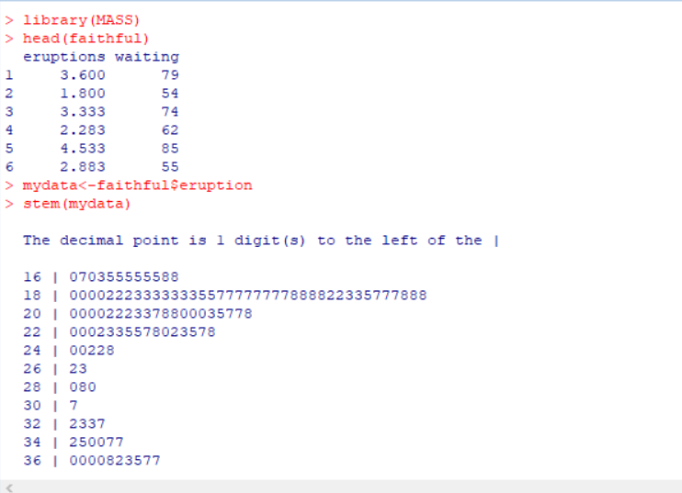
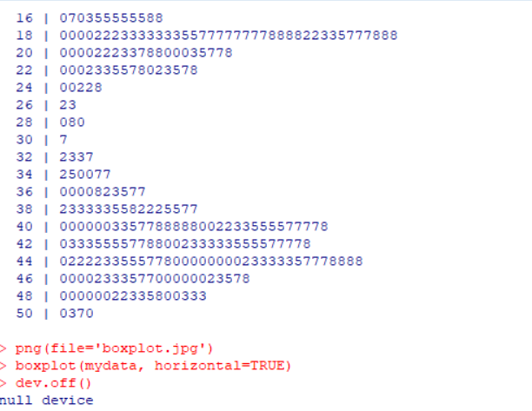
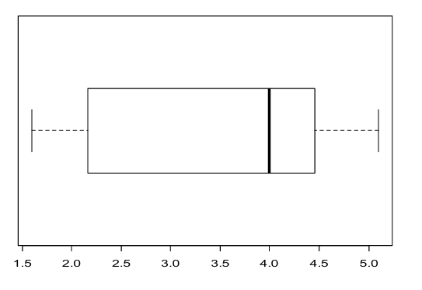

.
Objective: Descriptive Statistics.
- Find the arithmetic mean for the following data.
X: 9 8 7 6 5 4 3 2 1 0
f: 2 3 4 6 11 10 6 5 2 1
Ans:
x<-(9:0)
f<-c(2,3,4,6,11,10,6,5,2,1)
x
f
mydata<-data.frame(x,f)
A_M<-(sum(f*x))/(sum(f))
A_M
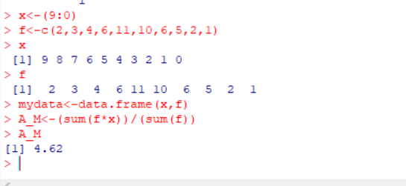

. Find the arithmetic mean for the following data:
Class: 60-63 f: 15 63-66 54 66-69 69-72 72-75 163 81 27 also find the cumulative frequency for the distribution and median.
Xi<-seq(61.5,73.5, by=3)
fi<-c(15,54,163,81,27)
A.M<-(sum(Xi * fi))/sum(fi)
A.M
cbind(cumsum(fi))
N=340 # total frequency
i=3 # difference between the lower limit and upper limit of the class interval
f=163 # frequency of the median class
c.f=69 # cumulative frequency just preceding the median class
l=66
# lower limit of the median class
Median<-(l+ ((i/f)*((N/2)-(c.f))))
Median
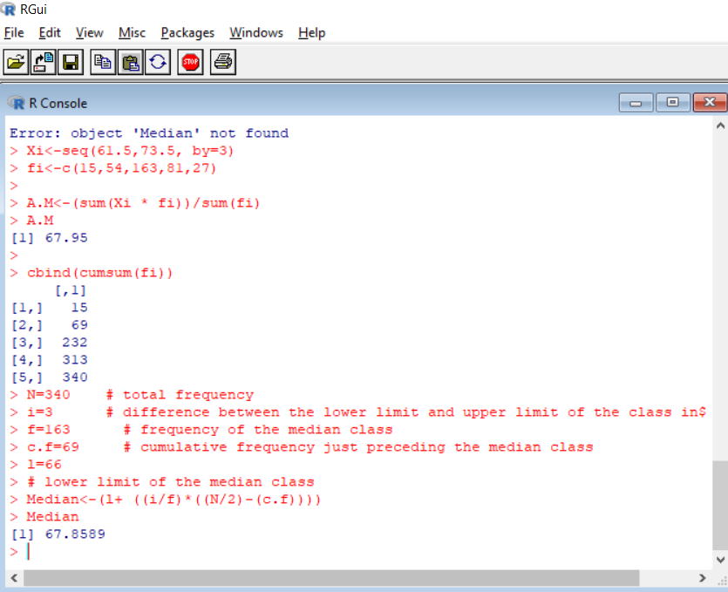

. Find the median, mean, quantile, 7th decile, 87th percentile.
Wages: 0-10 10-20 20-30 30-40 40-50
f: 22 38 46 35 20
Ans:
freq=c(22,38,46,35,20)
m_p<-seq(5,45,by=10)
m<-mean(sum(freq*m_p)/sum(f))
m
cf=cumsum(freq)
cf
l=20
h=10
f=46
c.f=60
N=sum(freq)
M<-l+(h/f)*((N/2)-c.f)
M
f1=38
c.f1=22
q1<-l1+(h/f1)*((N/4)-c.f1)
q1
l3=30
f3=35
c.f3=106
q3<-l3+(h/f3)*((3*N/4)-c.f3)
q3
7*N/10
l7=30
f7=35
c.f7=106
d7<-l7+(h/f7)*((7*N/10)-c.f7)
d7
87*N/100
l87=30
f87=35
c.f87=106
p87<-l87+(h/f87)*((87*N/100)-c.f87)
p87
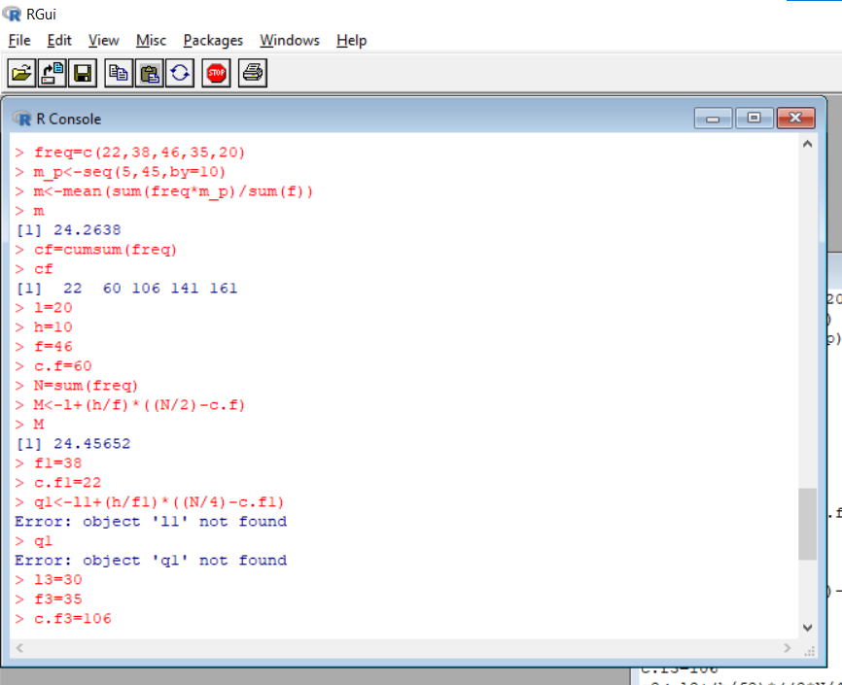
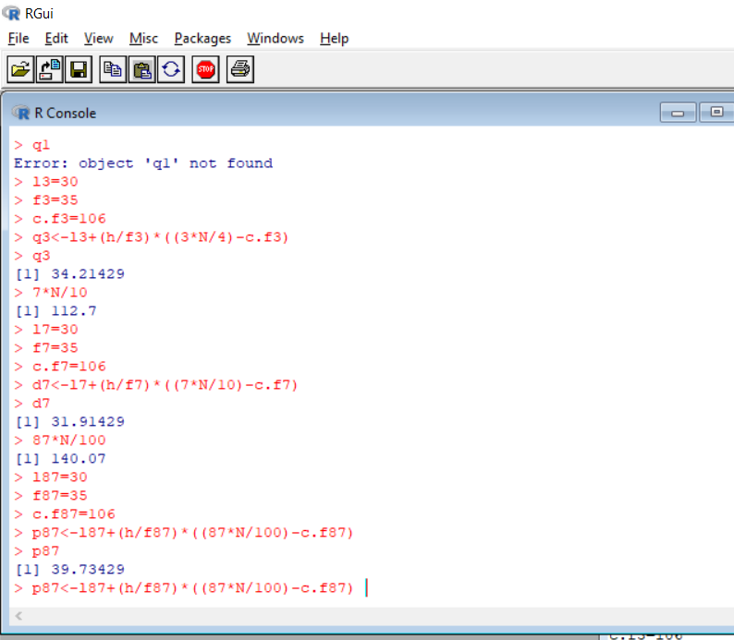
. Find the mean, median, variance, standard deviation, range, interquartile range, 19th, 58th, 89th quantile, moments, skewness and kurtosis of following data:
Marks: 25,30,17,45,27,30,48,42,37,39
Ans:
Marks<-c(25,30,17,45,27,30,48,42,37,39)
mean(Marks)
median(Marks)
var(Marks)
sd(Marks)
max(Marks)-min(Marks)#range
IQR(Marks)
quantile(Marks)
quantile(Marks,0.19,0.58,0.89)

quantile(Marks,0.19)
quantile(Marks,0.58)

quantile(Marks,0.89)

utils:::menuInstallPkgs() --- Please select a CRAN mirror for use in this session ---
library("e1071")
moment(Marks, order=3, center=TRUE)
skewness(Marks)
kurtosis(Marks)
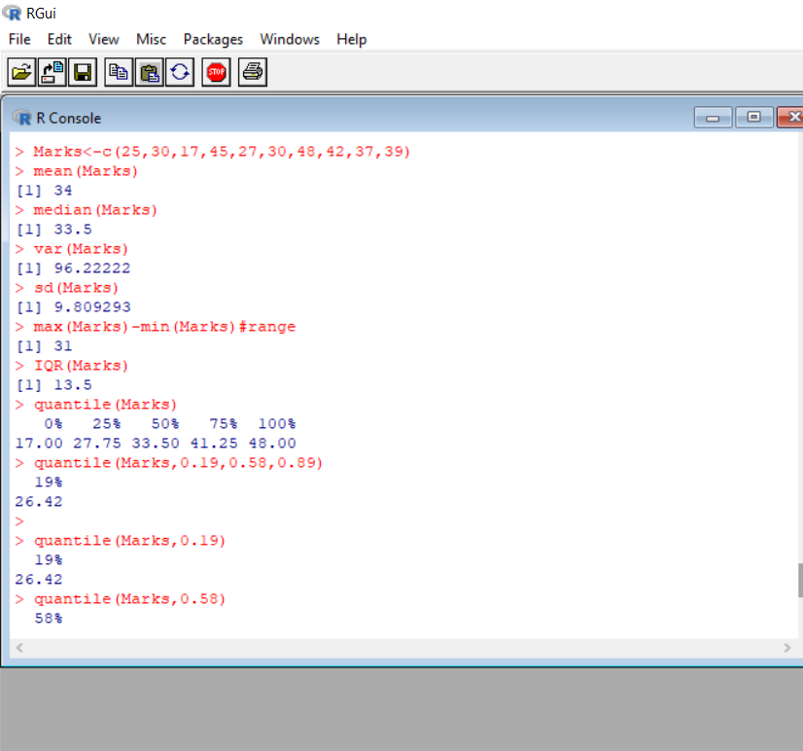
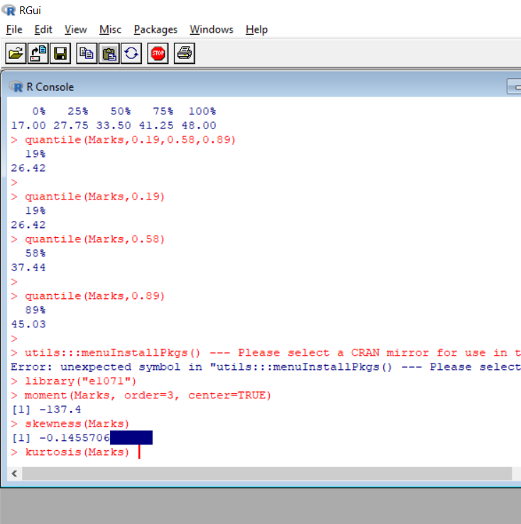

Objective: Correlation and Regression.
1.Calculate correlation coefficient for the following data:
X: 1 3 4 5 7 9 10
Y: 9 13 1 17 21 23 27
Ans:
x<-c(1,3,4,5,7,9,10)
x
y<-c(9,13,1,17,21,23,27)
y
cor(x,y)
x_bar=sum(x)/length(x)
x_bar
y_bar=sum(y)/length(y)
y_bar
A=(x-x_bar)
A
B=(y-y_bar)
B
C=sum(A*B)
C
r=sum(A*B)/sqrt(sum(A^2)*sum(B^2))
r
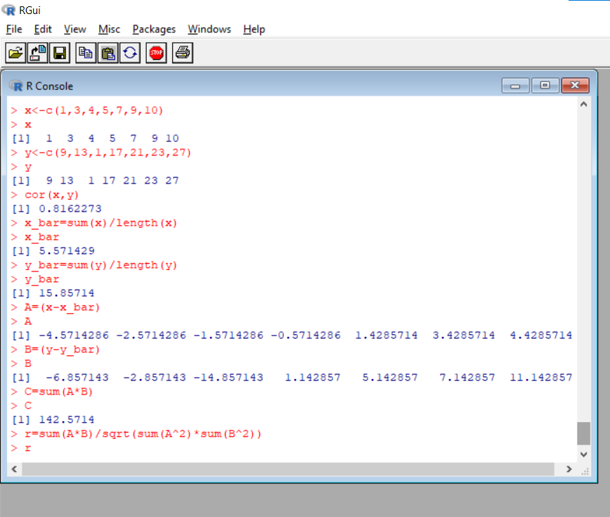

Missing value case:
- Calculate correlation coefficient from the following data
X: 60 34 40 ? 45 41 22 43
Y: 75 32 34 40 45 33 12 30
Ans:
x<-c(60,34,40,NA,45,41,22,43)
x
y<-c(75,32,34,40,45,33,12,30)
y
cor(x,y,use = "complete.obs")

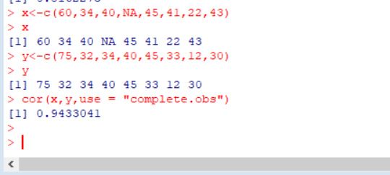

Rank Correlation:
.Find the rank correlation coefficient between x and y.
X: 86 83 91 77 68 85 52 82 57 37
Y: 89 92 87 86 83 77 71 63 50 53
Ans:
X<-c(86,83,91,77,68,85,52,82,57,37)
X
Y<-c(89,92,87,86,83,77,71,63,50,53)
Y
cor.test(X,Y,method="spearman")
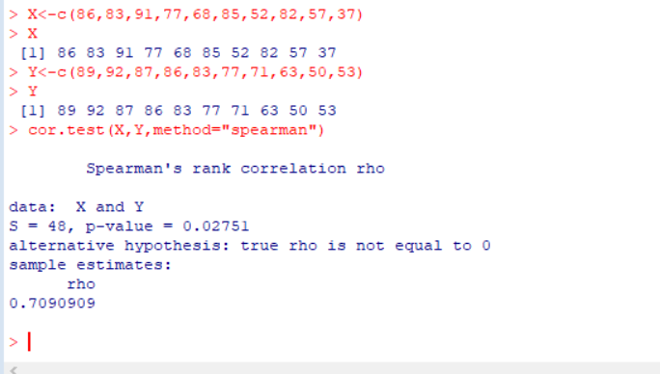

Regression:
.Obtain two regression line from the following data:
X: 9 8 20 2 7 1 9 7 9 8
Y: 6 3 7 8 8 9 10 1 3 5
Ans:
a<-c(9,8,20,2,7,1,9,7,9,8)
a
b<-c(6,3,7,8,8,9,10,1,3,5)
b
model=lm(a~b); # a on b
model
model=lm(b~a); # b on a
model
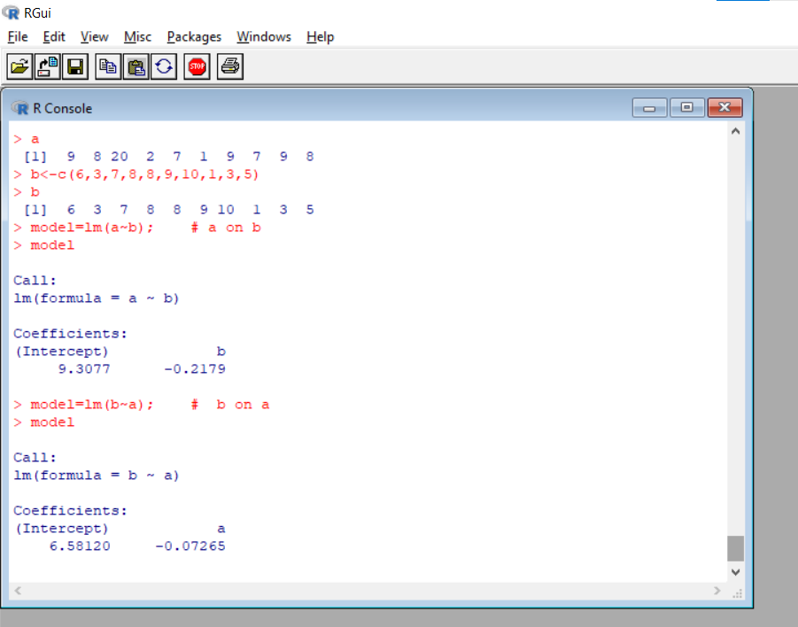
1.Regression Diagnostics
Ans:
input <- mtcars[,c("mpg","disp","hp","wt")]
print(head(input))
model <- lm(mpg~disp+hp+wt, data = input)
print(model)
betastar<-coef(model)
betastar
Vbetastar<-vcov(model)
Vbetastar
sqrt(diag(Vbetastar))
input_resid<-residuals(model)
input_resid
input_fitted<-fitted(model)
input_fitted
plot(input_fitted,input_resid,xlab="Fitted values", ylab="Residuals",ylim=max(abs(input_resid))*c(1,1),type="n")
abline(h=0,lty=2)
text(input_fitted,input_resid,lebels=rownames(input))

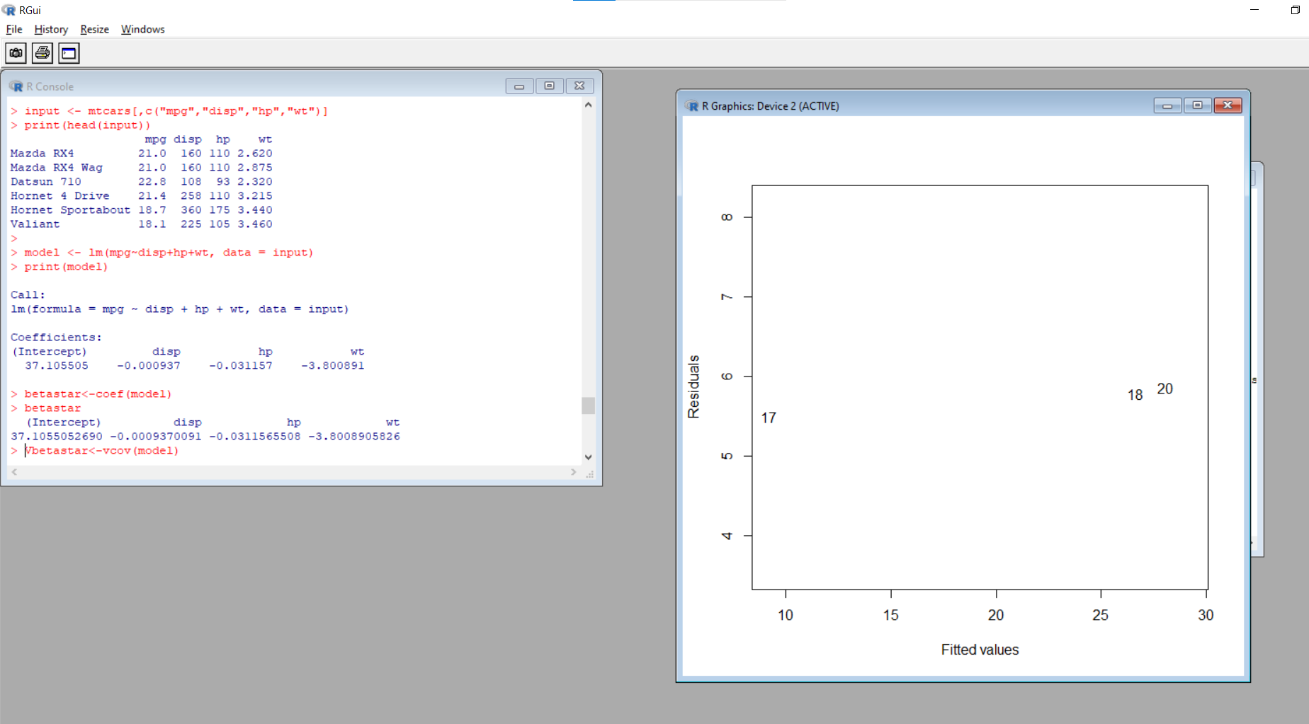
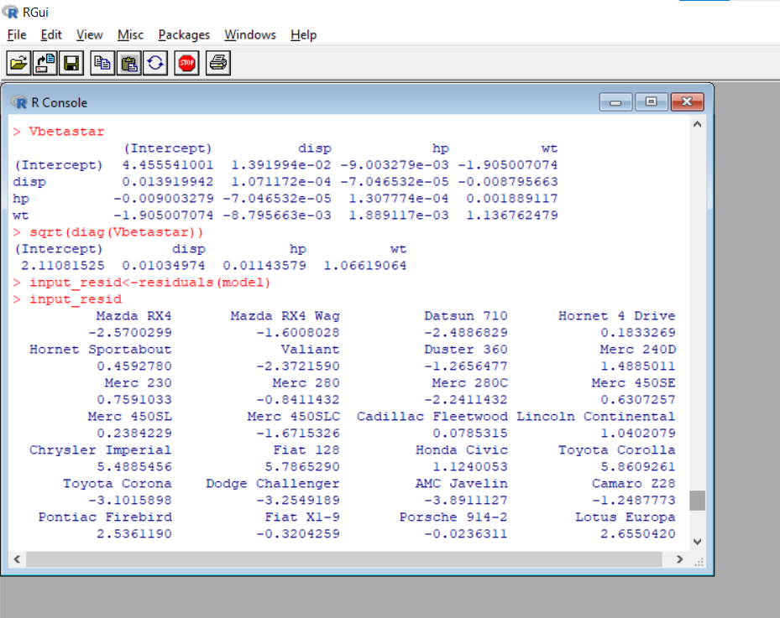
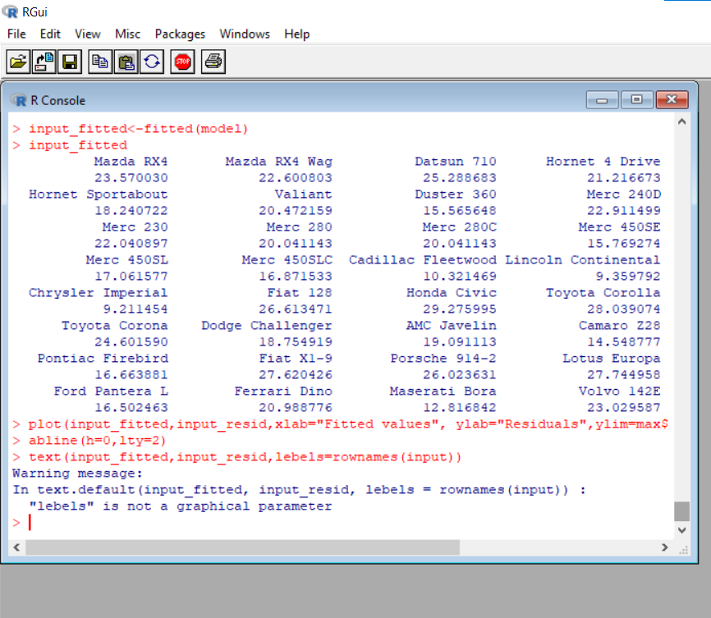

Ans:
plot(Menarche/Total ~ Age, data=menarche)
lines(menarche$Age, glm.out$fitted, type="l", col="red")
title(main="Menarche Data with Fitted Logistic Regression Line")
summary(glm.out)
glm.out$coef
glm.out$fitted
glm.out$resid
glm.out$effects
anova(glm.out)
