**AWS OVERVIEW**

(Gauri Gupta, 8181)

1) List out the types of instance base on the pricing model and write a brief about your understanding about it.

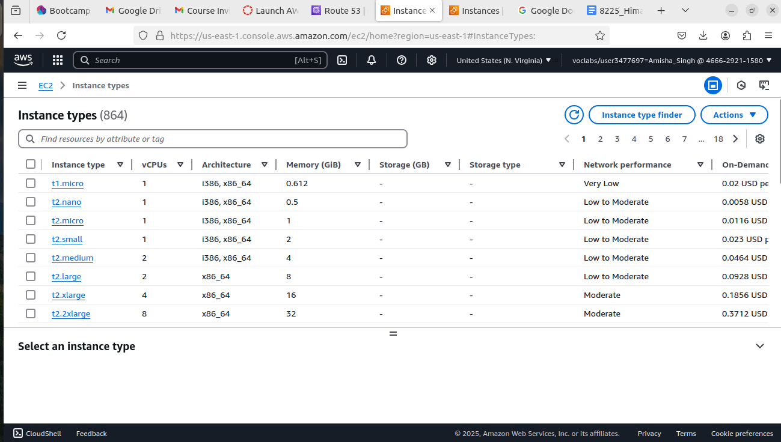

**t1.micro**: Old, very small instance for basic tasks with minimal CPU and memory.

**t2.nano**: The smallest T2 instance, perfect for super lightweight tasks and low traffic.

**t2.micro**: Slightly more power than **t2.nano**, good for small websites or low-traffic apps.

**t2.small**: More memory than **t2.micro**, ideal for small databases or basic apps.

**t2.medium**: Balanced CPU and memory for moderate workloads or small to medium web apps.

**t2.large**: More memory and power, suitable for medium-sized apps and moderate traffic.

**t2.xlarge**: Powerful instance with 4 vCPUs, great for high-traffic websites or larger apps.

**t2.2xlarge**: High-performance instance with 8 vCPUs, perfect for large apps, databases, or heavy workloads.

2)Host a static website in S3.

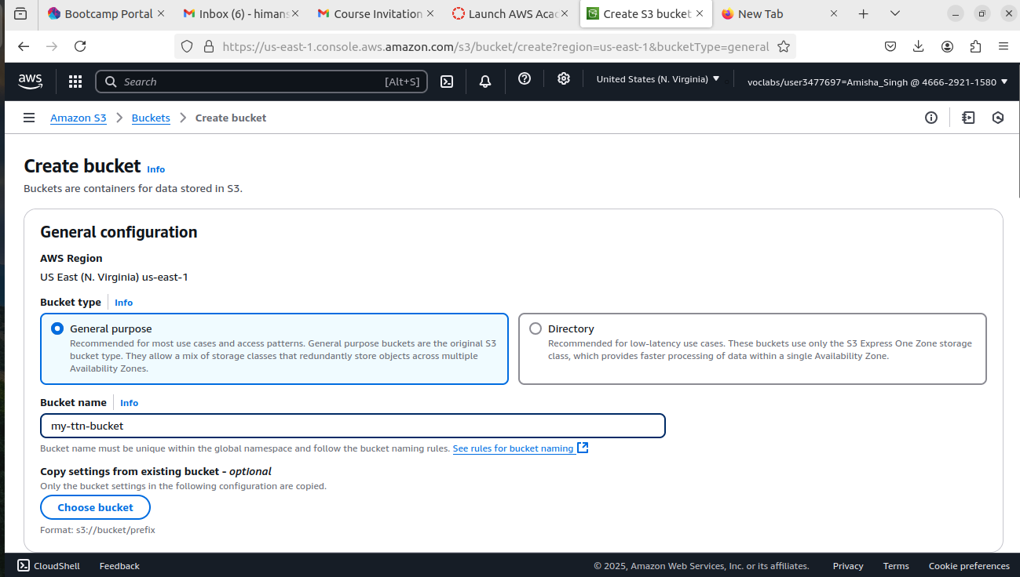

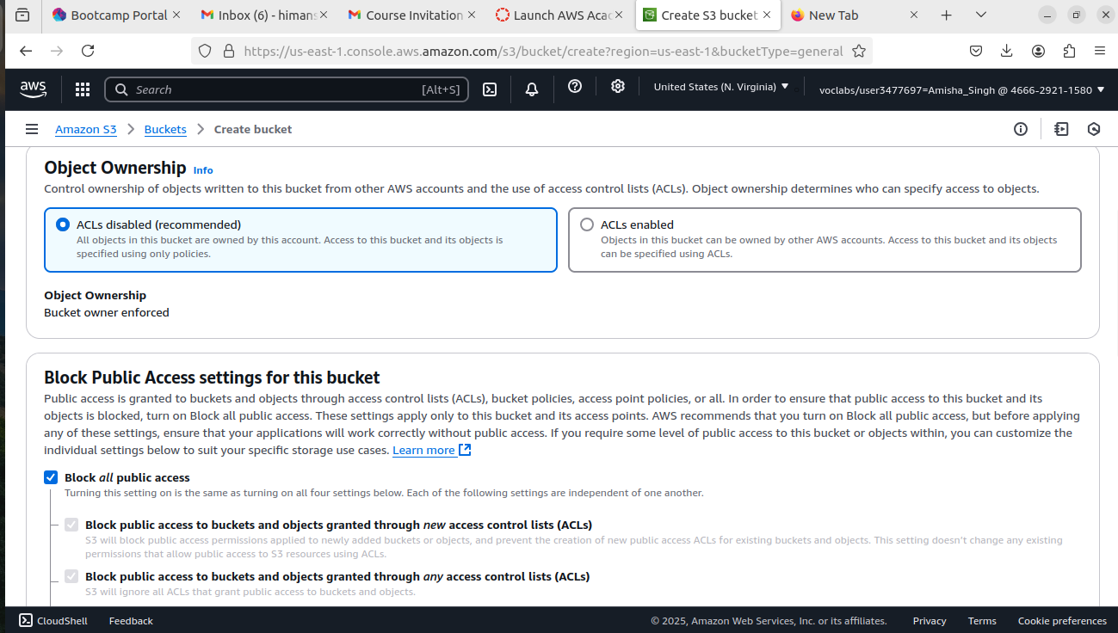

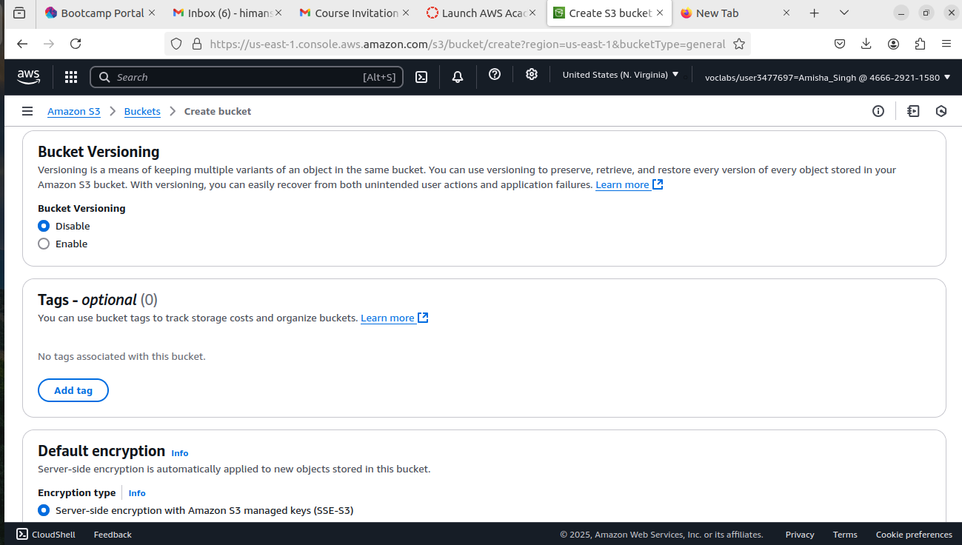

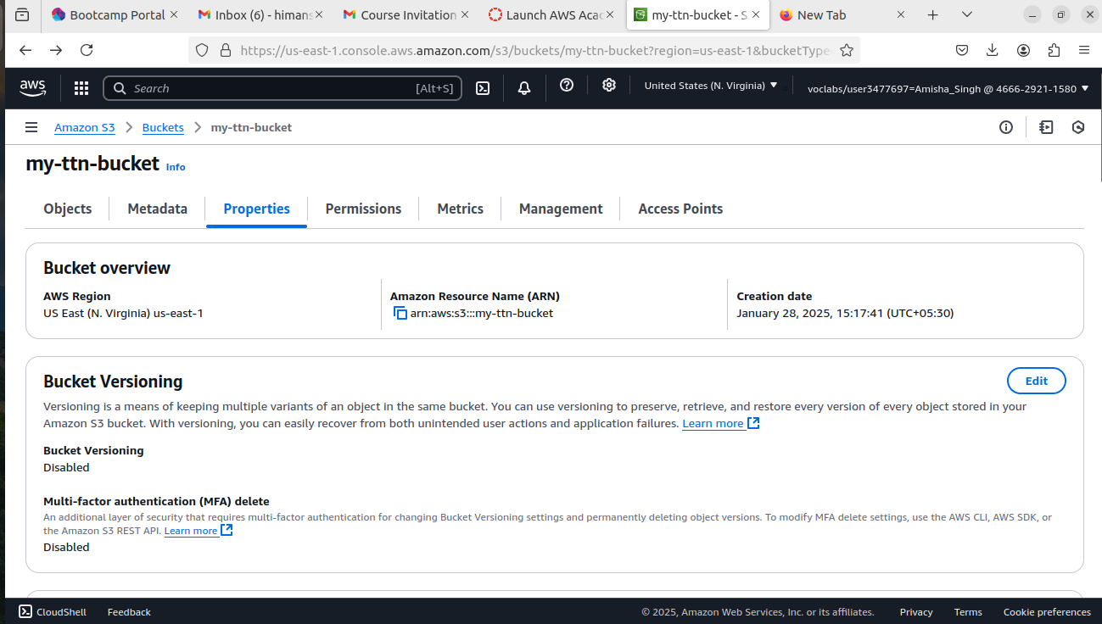

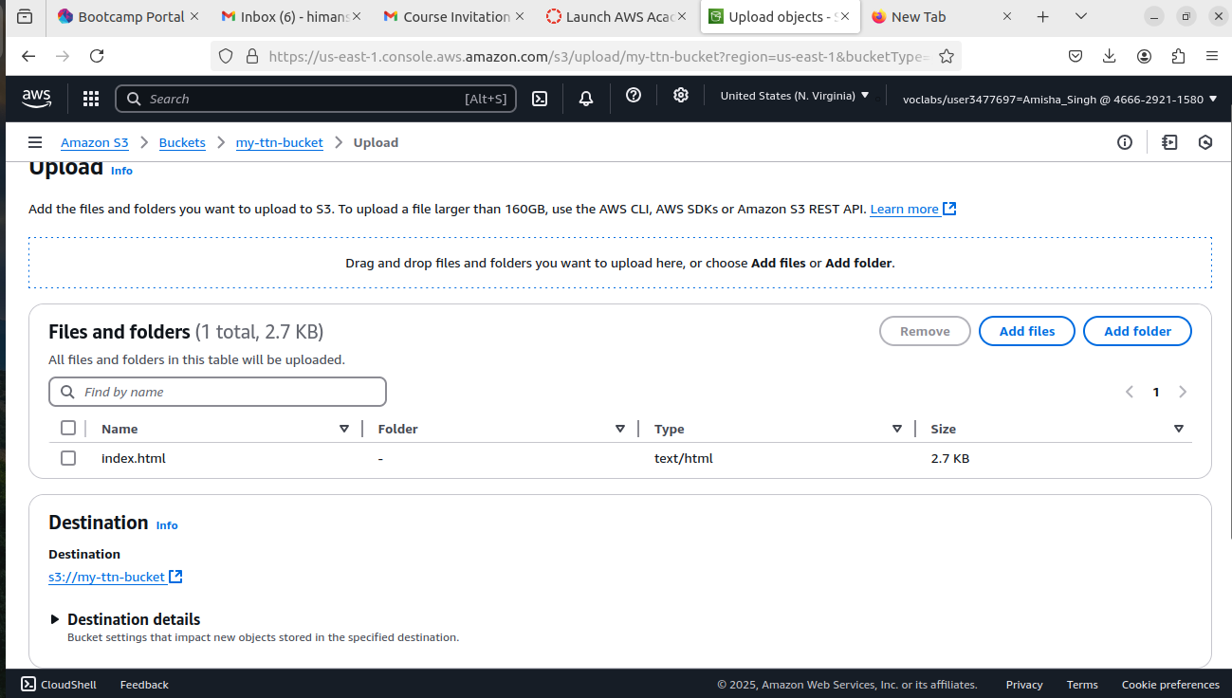

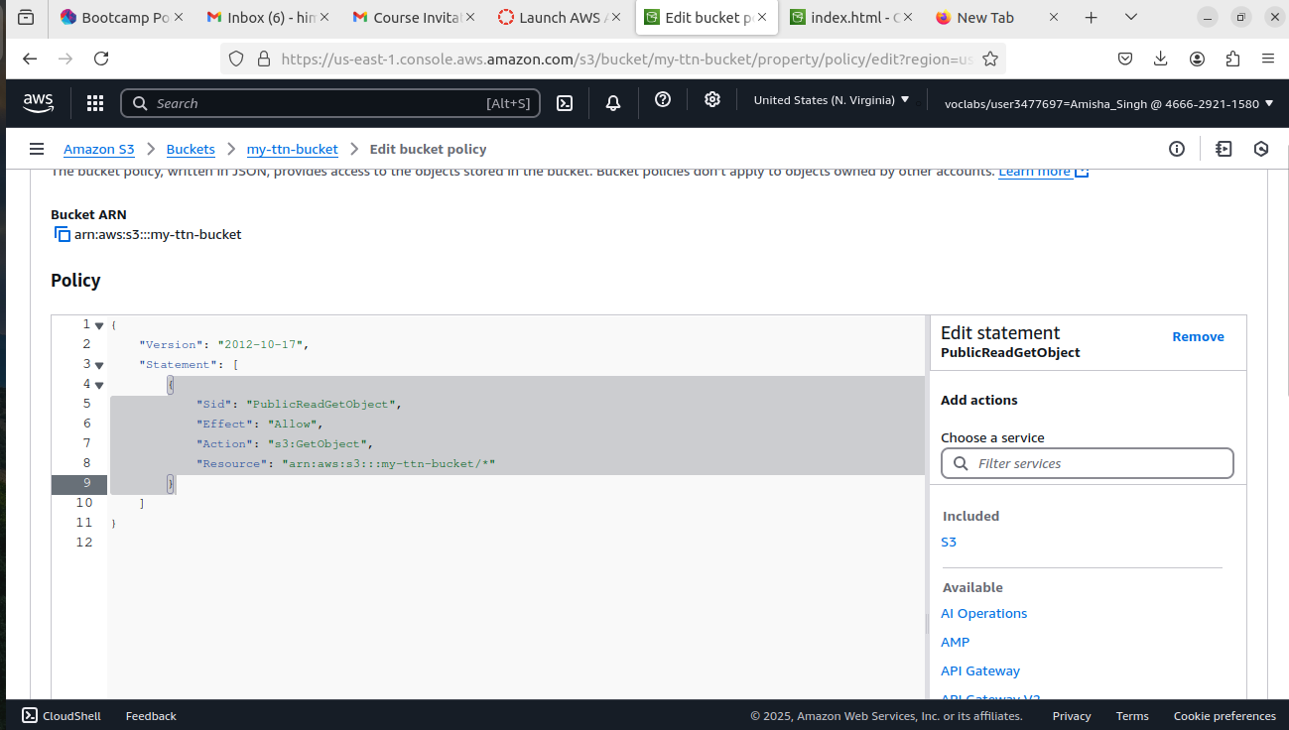

3) Launch an Ubuntu EC2 instance on AWS, with 10GB root volume, and SSH from your local machine using the private key.

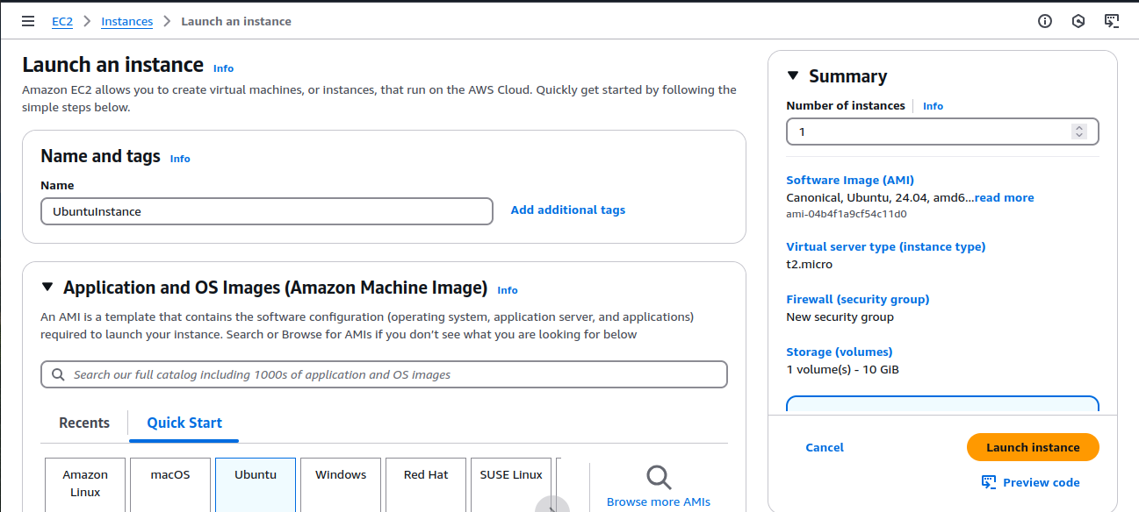

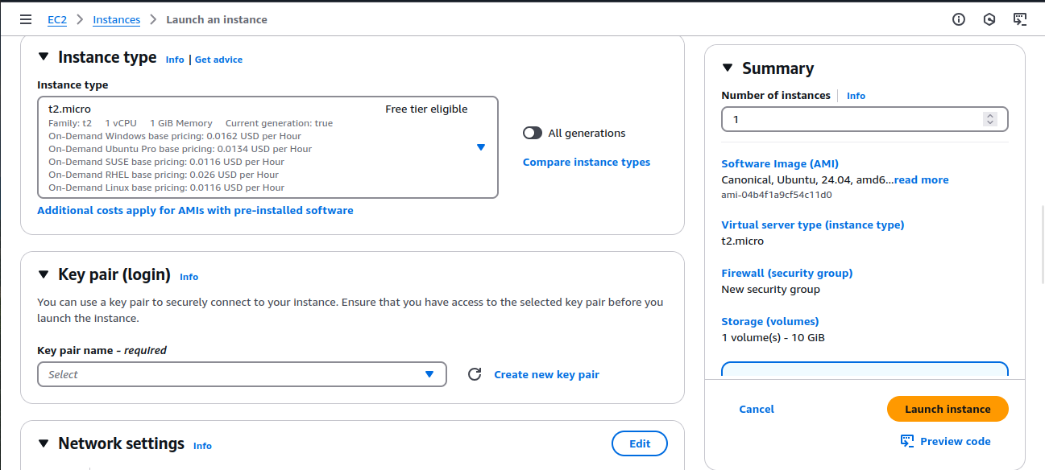

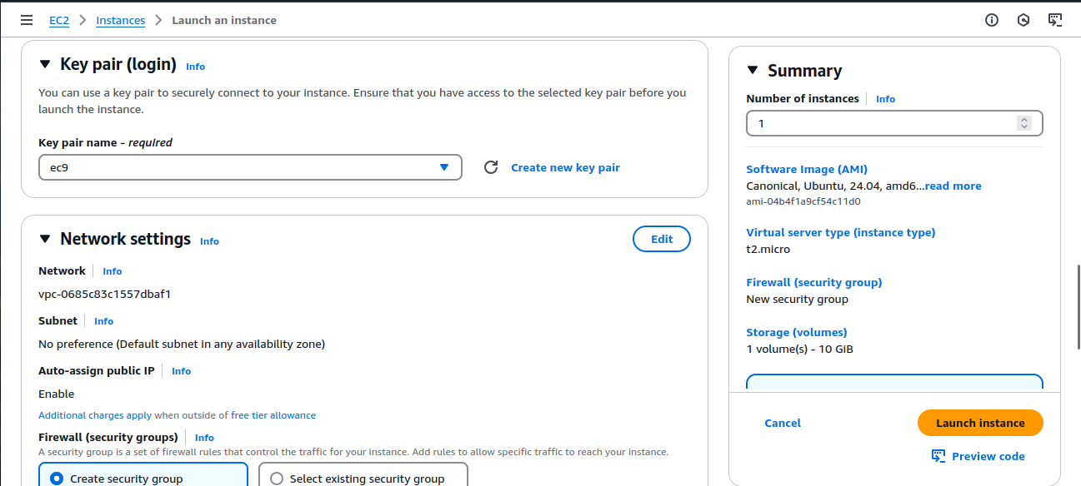

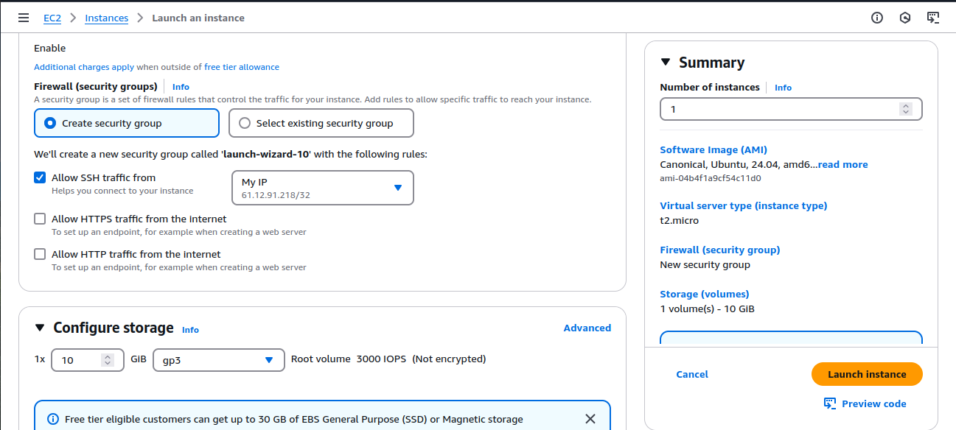

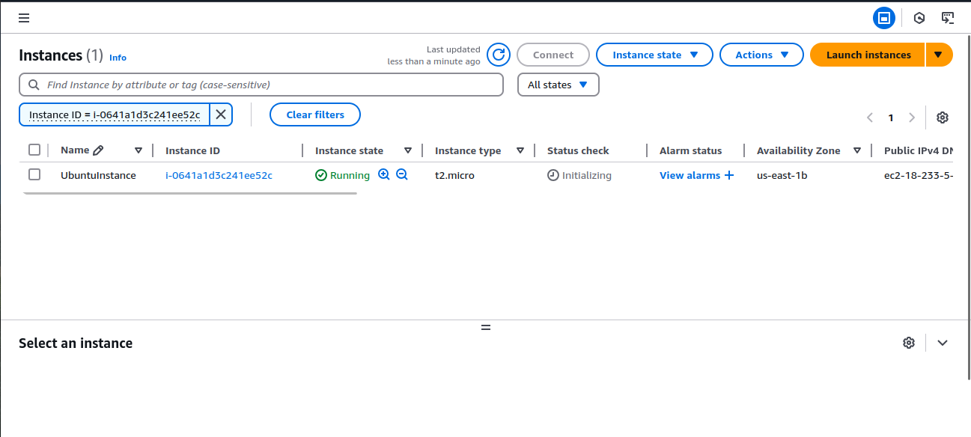



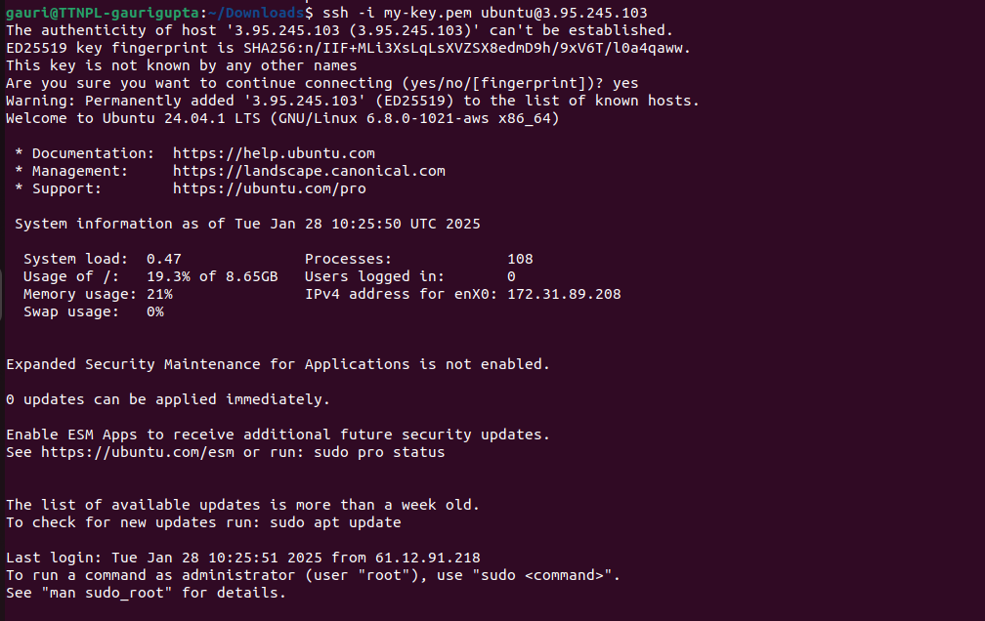

4) Install nginx package in the above server and access this page from your local browser using a domain name instead of IP address of the server.

