**INTRODUCTION TO DATABASES**

*(Gauri Gupta - 8181)*

Question1)Problem Statement: There can be multiple customers, who can place multiple orders on the site. Now a sales person can handle these orders will distribute into multiple sales persons (One order will be assign to one salesperson only). So a sales person can have multiple orders of multiple customers Create Database.

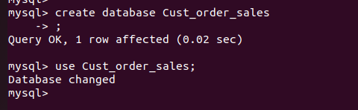

Question2)Design Schema

We will create 3 tables CUSTOMER(c_id , c_name , c_add, c_mobno, c_mail) , ORDERS(o_id, amt,ord_date,s_id, c_id )& SALESPERSON (s_id,s_name,s_mobno). In this CUSTOMER & ORDER have 1 to many relationship , so we will use CUSTOMER’S primary key , c_id as foreign key in ORDERS table . Similarly , in SALESPERSON & ORDER also have 1 to many relationship , so we will use SALESPERSON’S primary key , s_id as foreign key in ORDERS table .

Question3)Create tables

CUSTOMER Table

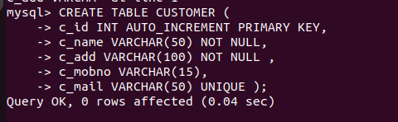

SALESPERSON Table

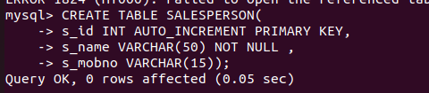

ORDERS Table

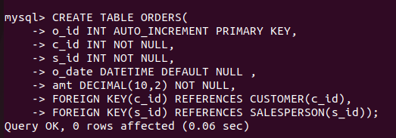

Question 4)

Insert sample data

CUSTOMER Table

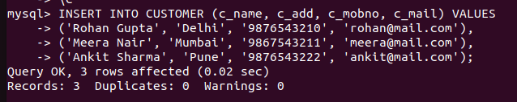

SALESPERSON Table



ORDERS Table

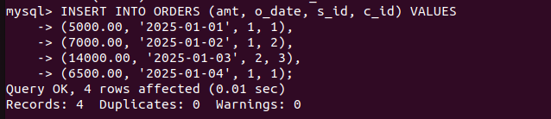

Question5)Find the sales person have multiple orders.

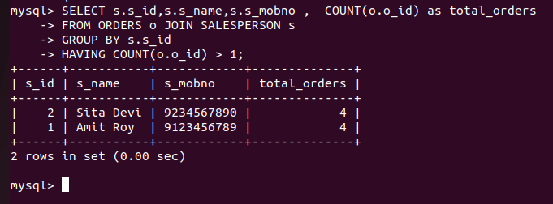

Question6)Find the all sales person details along with order details.

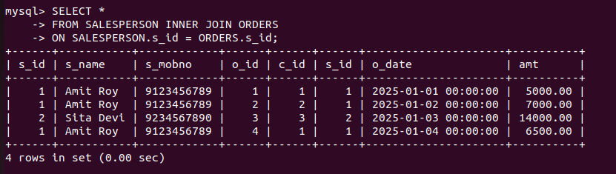

Question 7)Create index.

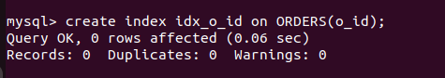

Question 8)How to show index on a table

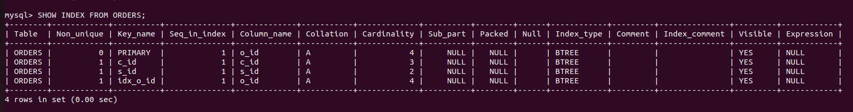

Question 9) Find the order number, sale person name, along with the customer to whom that order belongs to

