SUPPLY CHAIN
ANALYTICS REPORT
Delivery Performance & Profitability Analysis
An exploratory data analysis of delivery delays across shipping modes, markets, regions and time, with an additional examination of order profitability.

PROJECT TYPE | DOMAIN | TOOLS
Exploratory Data Analysis | Supply Chain & Operations | Python · Pandas · NumPy · Matplotlib · Seaborn

1. Executive Summary
This project examines delivery performance in the DataCo Global Supply Chain dataset, focusing on where late deliveries are concentrated and how profitability differs across delivery-performance groups. The supplied shipping-mode summary covers 62,897 unique orders. The order counts in the profitability summary also total 62,897, matching the shipping-mode total.
Orders analysed | Weighted late rate* | First Class late rate | Standard Class late rate
62,897 | 57.32% | 100.00% | 39.85%

*Weighted late rate is reconstructed from shipping-mode order counts and rounded late rates, so it is approximate.

Headline observations
- First Class has a reported late delivery rate of 100.00%, while Standard Class has the lowest rate at 39.85%.
- Pacific Asia has the highest market-level late rate (57.68%), although market differences are relatively small.
- Central Africa has the highest regional late rate (60.04%); its order volume is comparatively low (533), so the rate should be interpreted cautiously.
- Monthly late rates fluctuate within a fairly narrow band, from 55.04% (2017-04) to 59.86% (2016-06).
- Late orders show the lowest average profit (59.37) and average profit margin (11.88%) among the three delivery groups, but the differences are modest and do not establish causation.
Overall interpretation: late delivery is widespread across the analysed orders, but the available summaries suggest that shipping-mode definitions and scheduling expectations deserve close examination before operational conclusions are drawn.

2. Business Problem & Objectives
Delivery delays can affect customer experience, service reliability and operational planning. An overall late-delivery percentage indicates the scale of the issue, but does not show where the issue is concentrated. This analysis compares delivery performance across operational and geographical segments and explores whether profitability metrics differ by delivery outcome.

Objectives
- Classify orders as Early, On Time or Late using actual versus scheduled shipping days.
- Compare late delivery rates across shipping modes, markets and regions.
- Examine monthly changes in late delivery rates.
- Compare order value, profit and profit margin across delivery-performance groups.
- Translate descriptive results into areas for further operational investigation.

3. Dataset & Analytical Method
Dataset: DataCo Global Supply Chain Dataset (DataCoSupplyChainDataset.csv). The dataset includes order identifiers, order and shipping dates, actual and scheduled shipping durations, delivery status, shipping mode, market, region, product category, order value and profit-related fields.

Data preparation performed
- Reviewed dataset dimensions, data types, descriptive statistics, missing values and duplicate records.
- Counted unique orders and order-item identifiers to understand the dataset's grain.
- Converted order and shipping date fields to datetime format.
- Calculated calendar shipping duration and compared it with recorded actual shipping days.
- Excluded rows marked as Shipping canceled and records with negative actual or scheduled shipping durations.
- Created delay days and delivery-performance classifications.

Core calculation
Delay Days = Actual Shipping Days − Scheduled Shipping Days
Classification | Rule
Late | Delay Days > 0
On Time | Delay Days = 0
Early | Delay Days < 0

Unit of analysis
Delivery summaries were aggregated to one record per Order Id using the first row's order-level shipping attributes. This is important because the source contains multiple order-item records for some orders. Profitability metrics were also grouped by Order Id in the supplied analysis.

Important validation note
The notebook compares calendar-day differences with recorded actual shipping days. The number of mismatches was calculated in the notebook, but that result was not included in the supplied outputs. It should be reviewed before final submission. This report does not claim that date validation passed without discrepancies.

4. Overall Delivery Performance
The supplied shipping-mode counts total 62,897 orders. Using those counts and their reported late rates gives an approximate weighted late-delivery rate of 57.32%. This indicates that more than half of the analysed orders were late, based on the supplied segment summaries.
The delay severity distribution and exact Early / On Time / Late order counts were not supplied separately. They are therefore not reconstructed in this report.

5. Shipping Mode Analysis
Shipping mode shows the largest differences among the supplied segment summaries. Standard Class has the lowest late rate, while First Class has the highest.
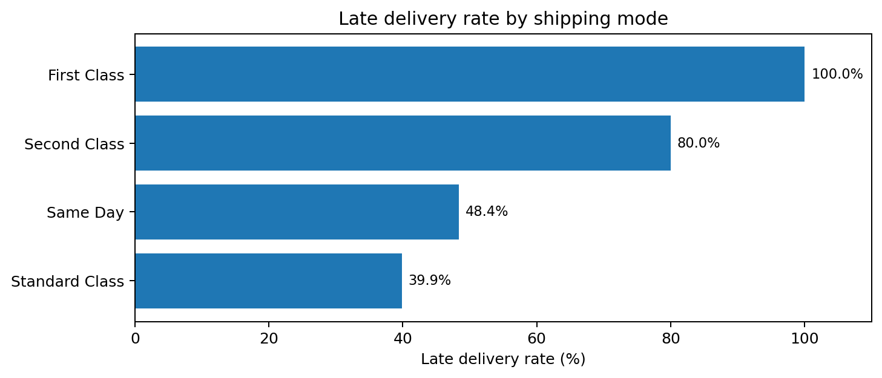
Shipping mode | Orders | Actual days | Scheduled days | Avg. delay | Late rate
First Class | 9,602 | 2.00 | 1.00 | 1.00 | 100.00%
Same Day | 3,407 | 0.48 | 0.00 | 0.48 | 48.37%
Second Class | 12,256 | 4.00 | 2.00 | 2.00 | 79.99%
Standard Class | 37,632 | 3.99 | 4.00 | -0.01 | 39.85%

Interpretation
Standard Class accounts for the largest order volume (37,632) and has a 39.85% late rate, the lowest among the four modes. Second Class has a 79.99% late rate, and First Class is reported at 100.00%. Same Day has a 48.37% late rate despite an average actual shipping duration below half a day.
Critical business caveat: First Class and Second Class have scheduled durations of one and two days respectively, while Same Day has a scheduled duration of zero days. A strict comparison of actual versus scheduled days may classify an order as late even when the actual delay is less than one full calendar day. The 100% First Class result should trigger a review of service-level definitions, timestamp precision and the meaning of scheduled shipping days before it is interpreted as a complete service failure.

6. Market & Regional Analysis
Market-level late rates are tightly grouped, ranging from 56.55% to 57.68%. Pacific Asia records the highest rate, while Africa records the lowest. This narrow range suggests the late-delivery issue is not isolated to one market.
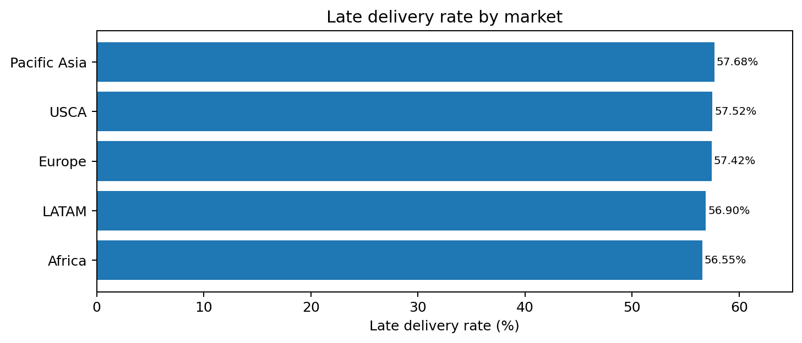
Market | Orders | Late rate | Average delay (days)
Pacific Asia | 16,853 | 57.68% | 0.58
USCA | 8,178 | 57.52% | 0.58
Europe | 17,763 | 57.42% | 0.56
LATAM | 16,414 | 56.90% | 0.55
Africa | 3,689 | 56.55% | 0.55

Regional comparison
Regional rates vary more than market rates. Central Africa has the highest reported rate (60.04%), followed by East Africa (59.08%) and South of USA (58.83%). Canada has the lowest rate (52.58%), but only 291 orders. Central Asia's average delay is 0.64 days, the highest reported average delay, despite its late rate being 56.67%.
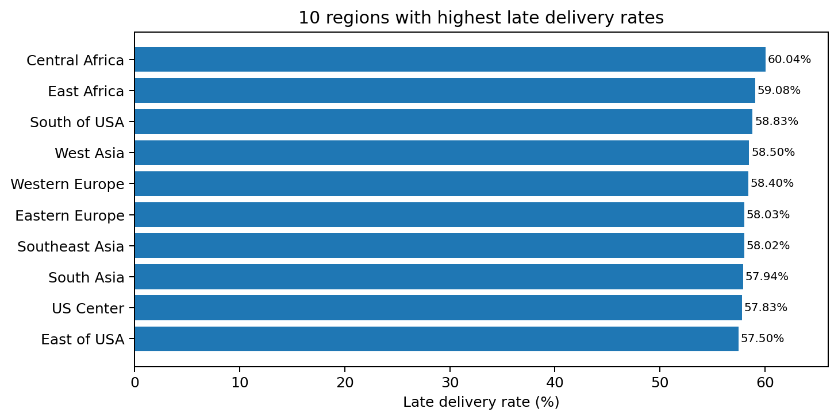
The regional ranking should be interpreted alongside order volume. Smaller samples can produce less stable rates than high-volume regions. Further investigation should prioritize both the size of the late rate and the number of orders affected.

7. Monthly Delivery Trend
The monthly analysis covers January 2015 through January 2018. Across this period, the late delivery rate fluctuates but remains broadly within the mid-to-high 50% range.
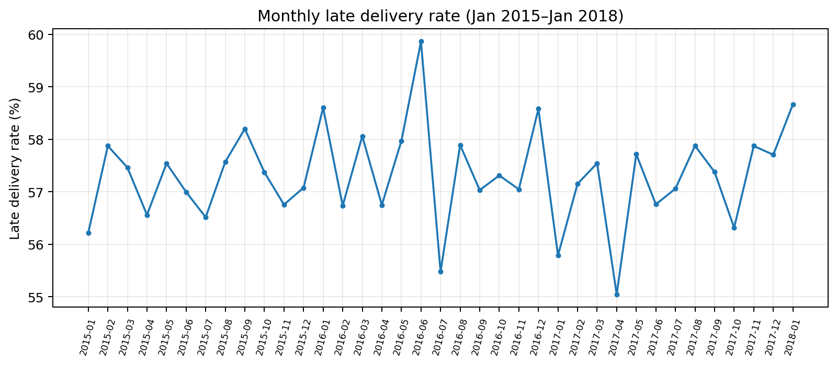
Measure | Month | Late rate | Orders
Lowest monthly rate | 2017-04 | 55.04% | 1,666
Highest monthly rate | 2016-06 | 59.86% | 1,617

The lowest monthly late rate is 55.04% in 2017-04; the highest is 59.86% in 2016-06. The difference is approximately 4.82 percentage points. No sustained improvement or deterioration is evident from the supplied monthly rates alone.
A useful next step would be to compare monthly rates with order volumes, shipping-mode mix and market mix. That would help determine whether changes in the overall monthly rate reflect operational performance or changes in the composition of orders.

8. Profitability Analysis
Profitability was compared across Early, On Time and Late orders using average order value, average profit, median profit and profit margin.
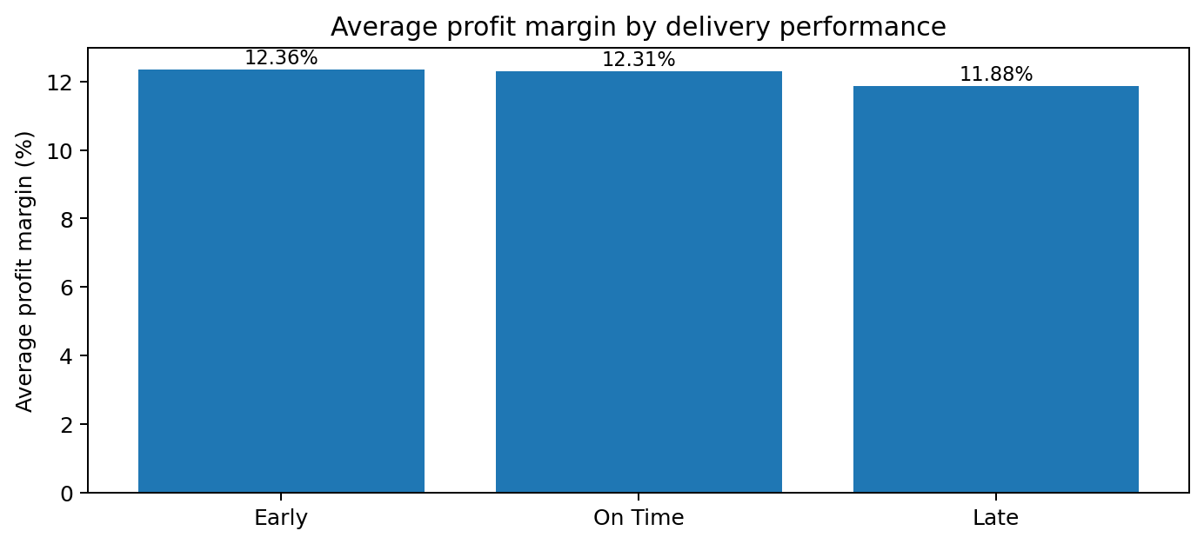
Delivery group | Orders | Avg. order value | Avg. profit | Median profit | Avg. margin | Median margin
Early | 15,127 | 506.14 | 61.82 | 72.44 | 12.36% | 22.73%
Late | 36,048 | 501.62 | 59.37 | 72.60 | 11.88% | 22.77%
On Time | 11,722 | 503.82 | 62.37 | 73.28 | 12.31% | 23.11%

Interpretation
Late orders have the lowest average order value (501.62), average profit (59.37) and average profit margin (11.88%). On-time orders have the highest average profit (62.37) and median profit (73.28). Early orders have the highest average profit margin (12.36%), while on-time orders have the highest median margin (23.11%).
The differences in average profit margin are relatively small: 11.88% for Late, 12.31% for On Time and 12.36% for Early. These results show an association between delivery group and the supplied profitability metrics, not proof that late delivery causes lower profitability.

Metric validation to complete
The notebook calculates item-level profit as Order Item Total multiplied by Order Item Profit Ratio and compares it with Order Profit Per Order. Before publishing, verify whether Order Profit Per Order is repeated across line items. If it is repeated, summing it across an order can overstate total profit. Also confirm the currency and precise definition of the source profit fields.

9. Correlation Analysis
The notebook calculates a correlation matrix for Total Profit, Order Value, Profit Margin and Delay Days and visualizes it as a heatmap. The numerical correlation matrix was not included in the supplied results, so this report does not assign correlation coefficients or claim specific relationships from that analysis.
Correlation measures the strength and direction of a linear association between numerical variables. It does not establish causation, and a correlation involving delay days should be interpreted with attention to how the variables are calculated.

10. Key Findings
- Late delivery is common: the approximate weighted late rate reconstructed from shipping-mode summaries is 57.32% across 62,897 orders.
- Shipping-mode performance differs substantially: First Class is reported at 100.00% late, while Standard Class is at 39.85%.
- Market differences are modest: market late rates fall between 56.55% and 57.68%.
- Some regions warrant review: Central Africa, East Africa and South of USA have the highest regional rates in the supplied table.
- Monthly rates are relatively stable: the observed range is 55.04%–59.86%.
- Late orders have lower average profitability metrics: the late group has the lowest average profit and average profit margin, though the differences are not large.

11. Business Recommendations
- Audit shipping service definitions. Review scheduled-day targets and timestamp rules for First Class, Second Class and Same Day before changing carrier or fulfillment processes.
- Investigate high-volume problem areas. Prioritize regions and markets using both late rate and order volume, rather than ranking by percentage alone.
- Monitor delivery KPIs monthly. Track late rate, average delay and order volume together to distinguish meaningful changes from fluctuations.
- Review the Standard Class operating model. Its lower late rate and high order volume may provide useful comparison points for understanding scheduling and fulfillment practices.
- Validate profitability calculations. Confirm order-level aggregation and currency definitions before using the profitability comparison for commercial decisions.
- Extend the analysis. Examine category-level performance, carrier/region combinations and other available operational variables to identify more specific delay patterns.

12. Limitations
- This report is based on aggregated summary tables supplied from the notebook, not a fresh re-run of the raw dataset.
- Product-category summary results and correlation coefficients were not supplied and are therefore not reported.
- The weighted overall late rate is reconstructed from rounded shipping-mode rates and is approximate.
- The supplied results are observational; they do not establish the causes of delivery delays or profitability differences.
- Some regions have relatively low order counts, which can make their rates less stable.
- The profit aggregation and date-validation mismatch count should be verified before the report is treated as a final operational assessment.

13. Conclusion
This exploratory analysis identifies delivery performance as an area requiring further operational attention. Late delivery rates are elevated across all five markets, with meaningful variation by shipping mode and some regional differences. Monthly rates fluctuate within a comparatively narrow range, suggesting that the issue persists across the observed period rather than appearing only in one isolated month.
The profitability comparison shows that late orders have somewhat lower average profit and margin than early and on-time orders. This is a useful signal for further investigation, but it should not be interpreted as evidence that delays directly reduce profit. Before making operational decisions, the business should validate service-level definitions, confirm the profit calculation and examine more detailed combinations of shipping mode, geography and order characteristics.
Project classification: Exploratory Data Analysis (EDA) | Domain: Supply Chain & Operations Analytics | Tools: Python, Pandas, NumPy, Matplotlib and Seaborn

