1

counter = 100
miles = 1000.0
name = "Mihir"
print(counter,miles,name)

100 1000.0 Mihir

2

a = b = c = 1
a,b,c = 1,2,"john"

a = 5
b = 4.56
print(5*a)
print(a/2)
print(a**2)

25
2.5
25

3

import numpy as np

str = 'Hello World!'
print (str)
print (str[0])
print (str[2:5])
print (str[2:])
print (str * 2)
print (str + "TEST")

Hello World!
H
llo
llo World!
Hello World!Hello World!
Hello World!TEST

4

var1 = 'Hello World!'
print ("Updated String :", var1[:6] + 'Python')
print( "My name is %s and weight is %d kg!" % ('Abay', 55))
str = "this is string example wow!!!";
print (str.capitalize())
str = "this is string example ... wow!!!";
str.count('s')
str.find('example')
str = "this is string example ... wow!!! this is really string";
print (str.replace("is", "was"))
str = "this is string example ... wow!!!";
print (str.swapcase())
str = "this is string example ... wow!!!";
print (str.title())

Updated String : Hello Python
My name is Abay and weight is 55 kg!
This is string example wow!!!
thwas was string example ... wow!!! thwas was really string
THIS IS STRING EXAMPLE ... WOW!!!
This Is String Example ... Wow!!!

5

list = [ 'abcd', 786 , 2.23, 'john', 70.2 ]
tinylist = [123, 'john']
print (list)
print (list[0])
print (list[1:3])
print (list[2:])
print (tinylist * 2)
print (list + tinylist)
list = ['physics', 'chemistry', 1997, 2000];
list.append('maths')
del list[2]
len(list)
list.count('physics')
list.pop()
print(list)
list.insert(2, 'maths')
print(list)
list.remove('chemistry')
print(list)
list.reverse()
print(list)

['abcd', 786, 2.23, 'john', 70.2]
abcd
[786, 2.23]
[2.23, 'john', 70.2]
[123, 'john', 123, 'john']
['abcd', 786, 2.23, 'john', 70.2, 123, 'john']
['physics', 'chemistry', 2000]
['physics', 'chemistry', 'maths', 2000]
['physics', 'maths', 2000]
[2000, 'maths', 'physics']

6

tuple = ( 'abcd', 786 , 2.23, 'john', 70.2 )
list = [ 'abcd', 786 , 2.23, 'john', 70.2 ]
tuple[2] = 1000
list[2] = 1000

Traceback (most recent call last):
File "sample.py", line 112, in <module>
tuple[2] = 1000
TypeError: 'tuple' object does not support item assignment

7

num=float(input('Enter a number:'))
if num>0:
print('pos number')
elif num==0:
print('zero')
else:
print('Neg number')

Enter a number:5
pos number

8

x=42
if x>1:
print('above one')
if x<100:
print('less than 100')
print('All done')

above one
less than 100
All done

9

age=15
b=('kid' if age<18 else 'adult')
print(b)

kid

10

stud=['Ram','Vijay','Nithya','Anu','Ramesh','suja']
for k in stud:
print('Hello:', k)
print('done')

Hello: Ram
Hello: Vijay
Hello: Nithya
Hello: Anu
Hello: Ramesh
Hello: suja
done

210905346_gauri@prg:~/Desktop/210905346$ python3 sample.py
Enter Length : 4
Enter Breadth : 2
Area : 8
Enter Number 1 : 3
Enter Number 2 : 4
a : 4 b: 3
Enter a Number : 3
Odd
Enter Number 1 : 3
Enter Number 2 : 4
Enter Number 3 : 1
4 is greater
Enter Number : 3
Enter Number : 4
Enter Number : 5
Enter Number : 1
[3, 4, 5, 1]
[3, 4, 5]
[5, 4, 3]
(1, 3, 5, 7, 9)
(2, 4, 6, 8, 10)
(12, 38, 56, 78)
-21
-93
Even Count : 2 Odd Count : 4
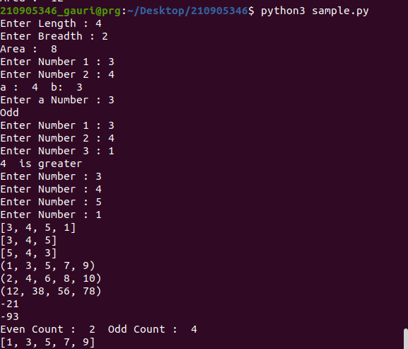
[1, 3, 5, 7, 9]

