LAB-4
SOCKET PROGRAMMING USING PYTHON

SOLVED1)

SERVER.PY
import socket
# Import socket module
host = socket.gethostname() # Get local machine name
port = 1112import socket
# Import socket module
host = socket.gethostname() # Get local machine name
port = 1112
# Reserve a port for your service.
s = socket.socket() # Create a socket object
s.bind((host, port)) # Bind to the port
s.listen(5)
# Now wait for client connection.
conn, addr = s.accept()
# Establish connection with client.
print('Got connection from', addr[0], '(', addr[1], ')')
print('Thank you for connecting')
while True:
data = conn.recv(1024)
if not data: break
conn.sendall(data)
print('Received message is sent back to client')
conn.close()
# Reserve a port for your service.
s = socket.socket() # Create a socket object
s.bind((host, port)) # Bind to the port
s.listen(5)
# Now wait for client connection.
conn, addr = s.accept()
# Establish connection with client.
print('Got connection from', addr[0], '(', addr[1], ')')
print('Thank you for connecting')
while True:
data = conn.recv(1024)
if not data: break
conn.sendall(data)
print('Received message is sent back to client')
conn.close()

CLIEN.PY
import socket
# Importimport socket
# Import socket module
host = socket.gethostname() # Get local machine name
port = 1112
# Reserve a port for your service.
s = socket.socket()
# Create a socket object
s.connect((host, port))
s.sendall(b'Welcome user!')
print('Client is connected to server and it has sent the message to server')
data = s.recv(1024)
print('This is printing the message received back by the server')
print(repr(data))
s.close()
# Close the socket when done socket module
host = socket.gethostname() # Get local machine name
port = 1112
# Reserve a port for your service.
s = socket.socket()
# Create a socket object
s.connect((host, port))
s.sendall(b'Welcome user!')
print('Client is connected to server and it has sent the message to server')
data = s.recv(1024)
print('This is printing the message received back by the server')
print(repr(data))
s.close()
# Close the socket when done

SAMPLE2)
server.py
import socket
sock = socket.socket(socket.AF_INET,socket.SOCK_DGRAM)
udp_host = socket.gethostname()
udp_port = 12345
# For UDP
# Host IP
# specified port to connect
sock.bind((udp_host, udp_port))
while True:
print('Waiting for client...')
data,addr = sock.recvfrom(1024)
#receive data from client
print('Received Messages:',data.decode(),'from',addr)
sock.close()

client.py
import socket
# Import socket module
sock = socket.socket(socket.AF_INET,socket.SOCK_DGRAM)
udp_host = socket.gethostname() # Host IP
udp_port = 12345
# specified port to connect
msg = "UDP Program third time!"
print('UDP target IP:', udp_host)
print('UDP target Port:', udp_port)
sock.sendto(msg.encode(),(udp_host,udp_port))
sock.sendto(msg.encode(),(udp_host,udp_port))
sock.close()

SAMPLE3)
server.py
import socket
HOST = '127.0.0.1' # Standard loopback interface address (localhost)
PORT = 2053 # Port to listen on (non-privileged ports are > 1023)
with socket.socket(socket.AF_INET, socket.SOCK_STREAM) as s:
s.bind((HOST, PORT))
s.listen()
conn, addr = s.accept()
with conn:
print('Connected by', addr)
while True:
data = conn.recv(1024)
if data:
print("Client: ",data.decode())
data = input("Enter message to client:");
if not data:
break;
# sending message as bytes to client.
conn.sendall(bytearray(data,'utf-8'));
conn.close()

client.py
import socket
HOST = '127.0.0.1' # The server's hostname or IP address
PORT = 2053
# The port used by the server
with socket.socket(socket.AF_INET, socket.SOCK_STREAM) as s:
s.connect((HOST, PORT))
s.sendall(b'Hello, world')
data = s.recv(1024)
print('Received Connection')
print('Server:', data.decode())

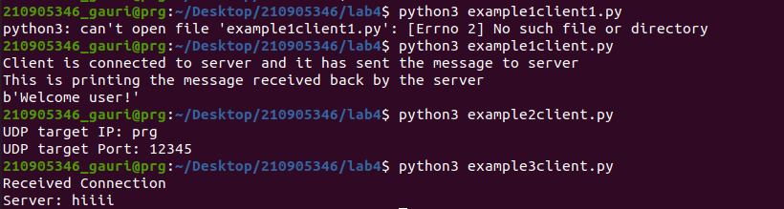

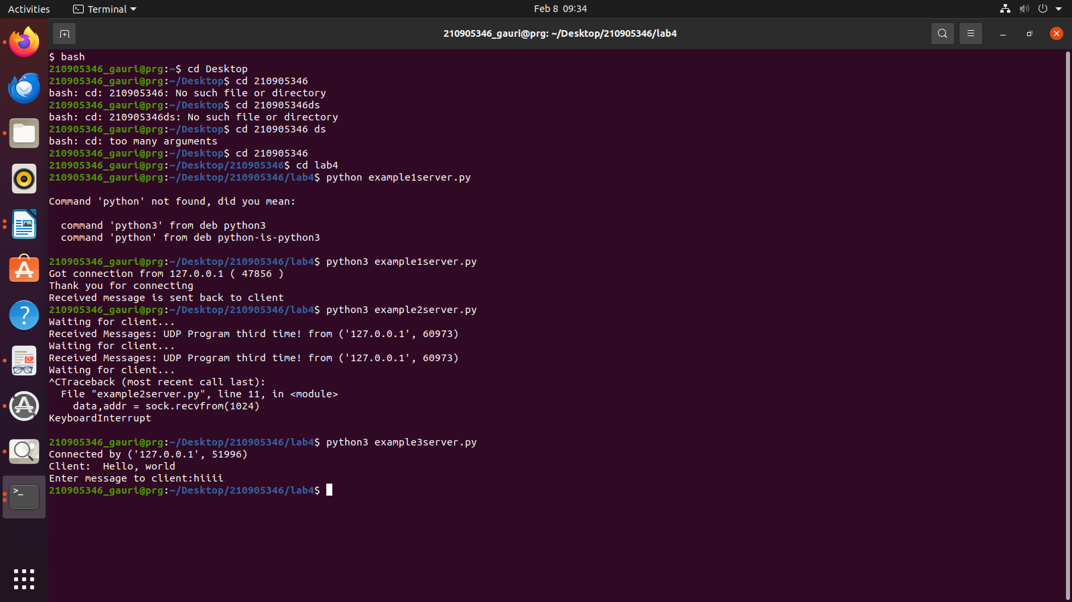

EXAMPLE4)
client.py
# Client program: Time client
#client.py
import socket
# create a socket object
s = socket.socket(socket.AF_INET, socket.SOCK_STREAM)
# get local machine name
host = socket.gethostname()
port = 9991
# connection to hostname on the port.
s.connect((host, port))
# Receive no more than 1024 bytes
tm = s.recv(1024)
print(' Current time from Sever :', tm.decode())
s.close()

server.py

# Server program: Time server
import socket
import time
# create a socket object
serversocket = socket.socket(socket.AF_INET, socket.SOCK_STREAM)
# get local machine name
host = socket.gethostname()
port = 9991
# bind to the port
serversocket.bind((host, port))
# queue up to 5 requests
serversocket.listen(5)
while True:
# establish a connection
clientsocket,addr = serversocket.accept()
print("Got a connection from %s" % str(addr))
urrentTime = time.ctime(time.time()) + "\r\n"
clientsocket.send(currentTime.encode('ascii'))
clientsocket.close()

EXAMPLE5)
client.py

import socket
HOST = '127.0.0.1' # Standard loopback interface address (localhost)
PORT = 31621 # Port to listen on (non-privileged ports are > 1023)
s = socket.socket()
name = input(str("\nEnter your name: "))
print("\nTrying to connect to ", HOST, "(", PORT, ")\n")
s.connect((HOST, PORT))
print("Connected...\n")
s.send(name.encode())
s_name = s.recv(1024)
s_name = s_name.decode()
print(s_name, "has joined the chat room\nEnter [e] to exit chat room\n")
while True:
message = s.recv(1024)
message = message.decode()
print(s_name, ":", message)
message = input(str("Me : "))
if message == "[e]":
message = "Left chat room!"
s.send(message.encode())
print("\n")
break
s.send(message.encode())

server.py

import socket
HOST = '127.0.0.1' # Standard loopback interface address (localhost)
PORT = 31621 # Port to listen on (non-privileged ports are > 1023)
s = socket.socket()
s.bind((HOST, PORT))
s.listen()
print("\nWaiting for incoming connections...\n")
conn, addr = s.accept()
print("Received connection from ", addr[0], "(", addr[1], ")\n")
s_name = conn.recv(1024)
s_name = s_name.decode()
print(s_name, "has connected to the chat room\nEnter [e] to exit chat room\n")
name = input(str("Enter your name: "))
conn.send(name.encode())
while True:
message = input(str("Me : "))
if message == "[e]":
message = "Left chat room!"
conn.send(message.encode())
print("\n")
break
conn.send(message.encode())
message = conn.recv(1024)
message = message.decode()
print(s_name, ":", message)

EXAMPLE6)
client.py

import socket
ClientSocket=socket.socket()
host='127.0.0.1'
port=1233
print('waiting for connection..')
try:
ClientSocket.connect((host,port))
except socket.error as e:
print(str(e))
Response=ClientSocket.recv(1024)
while True:
Input=input('say something')
ClientSocket.send(str.encode(Input))
Response=ClientSocket.recv(1024)
print(Response.decode('utf-8'))

ClientSocket.close()

server.py

import socket
import os
from _thread import*

ServerSocket= socket.socket()
host='127.0.0.1'
port= 1233
ThreadCount=0
try:
ServerSocket.bind((host,port))
except socket.error as e:
print(str(e))
print('waiting for a connection...')
ServerSocket.listen(5)

def threaded_client(connection):
connection.send(str.encode('Welcome to servern'))
while True:
data=connection.recv(2048)
reply='Server Says:'+ data.decode('utf-8')
if not data:
break
connection.sendall(str.encode(reply))

connection.close()
while True:
Client,address=ServerSocket.accept()
print('connected to:'+ address[0]+':'+str(address[1]))
start_new_thread(threaded_client,(Client,))
ThreadCount +=1
print('Thread Number:' + str(ThreadCount))
ServerSocket.close()

output example 4,5,6
