Using the captured information, answer the following questions in your lab report.
A.
In the packet list pane, select the first DNS packet. In the packet detail pane, select the
User Datagram Protocol. The UDP hexdump will be highlighted in the packet byte lane.
Using the hexdump, Answer the following:
a. the source port number. 50475
b. the destination port number.53
c. the total length of the user datagram.51
d. the length of the data.(Subtract the length of the UDP header (8 bytes) from the total length of the UDP packet to obtain the length of the data payload.)35
e. whether the packet is directed from a client to a server or vice versa.client to server
f. the application-layer protocol.UDP
g. whether a checksum is calculated for this packet or not.yes it is calculated(0xa749)

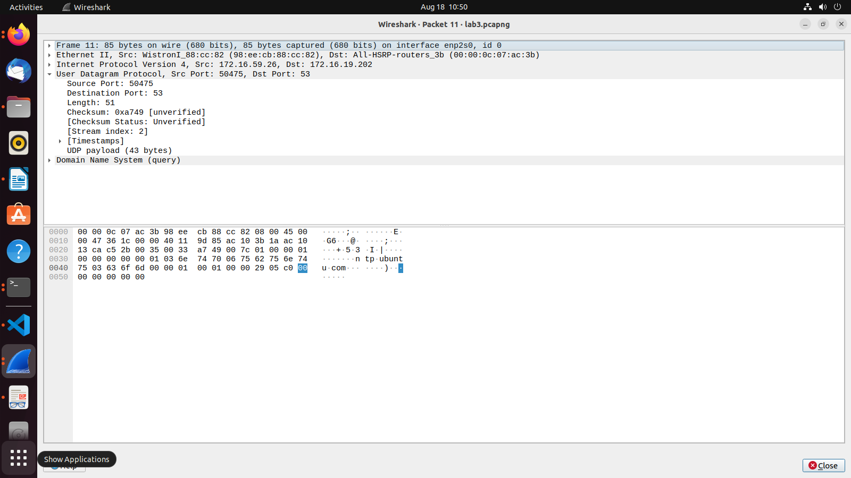
B. What are the source and destination IP addresses in the DNS query message? What are those
addresses in the response message? What is the relationship between the two?

ans) source IP addresses- 172.16.59.26
destination IP addresses-172.16.19.202

response source IP addresses- 172.16.19.202
response destination IP addresses-172.16.59.26
The relationship between the source and destination IP addresses in DNS communication is that the source of the response is the destination of the query, and vice versa.

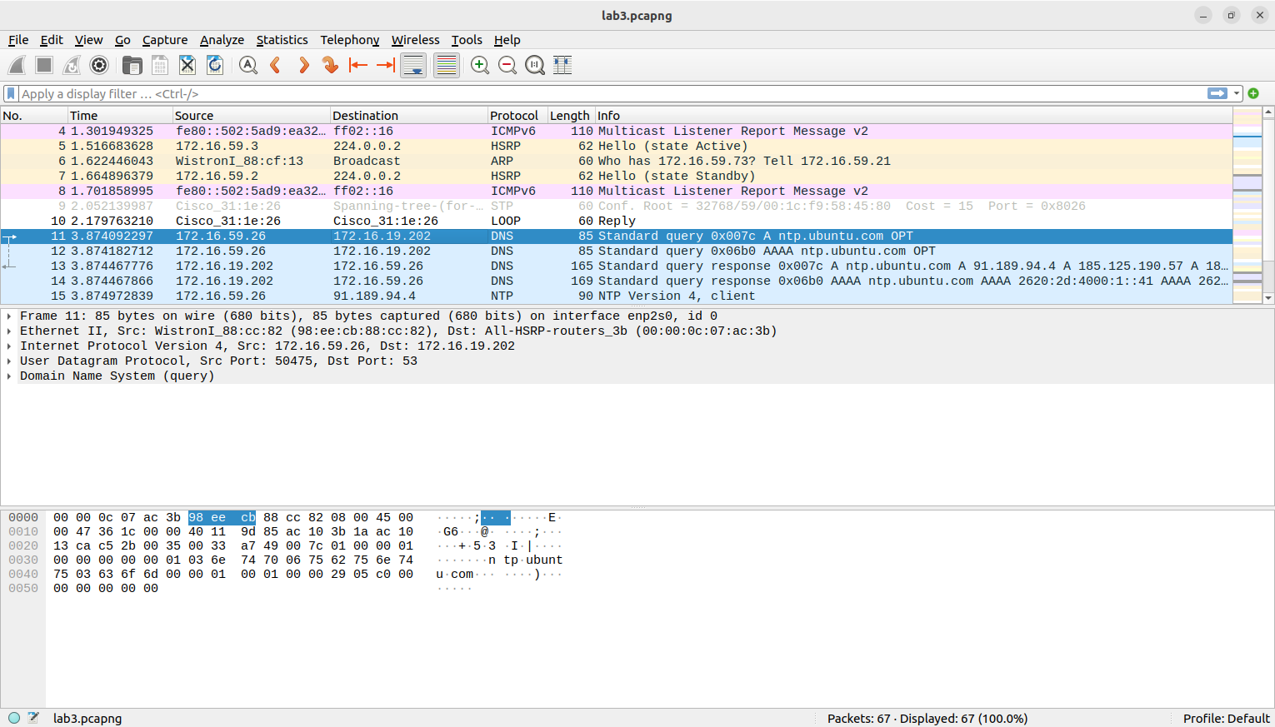
C. What are the source and destination port numbers in the query message? What are those
addresses in the response message? What is the relationship between the two? Which port
number is a well-known port number?

for dns query message
source port-50475
destination port-53
for response message
source port-53
destination port-50475
53 is a well-known port number

D. What is the length of the first packet? How many bytes of payload are carried by the first
packet?

length of the first packet-85 bytes
bytes of payload-Payload Length = Total Frame Length - (Ethernet Header Length + IP Header Length + UDP Header Length + DNS Header Length)
Payload Length = 85 - (14 + 20 + 8 + 12) = 31 bytes

