STUDENT PERFORMANCE PREDICTION
USING MACHINE LEARNING

Predictive Analytics Mini Project Report

Submitted for Predictive Analytics — Semester V

Submitted by: Gauri
Roll Number: 2427030543
Section: F

Abstract
Predictive analytics involves the application of historical data and statistical or machine-learning methods in order to estimate an unknown result. This project creates a binary classification process with the aim of spotting students who might be at risk of having poor academic performance by making use of student-related characteristics. The dataset employed is the Student Performance dataset available from the UCI Machine Learning Repository. The final grade, G3, is turned into a target label, being classified as 'at risk' if G3 is less than 10 and 'not at risk' if G3 is 10 or higher. Logistic Regression is the main model while Random Forest is used as a point of comparison. The workflow consists of carrying out data inspection, conducting exploratory data analysis, preparing the features, carrying out a train-test split, training the model, and evaluating it using accuracy, precision, recall, the F1-score and confusion matrices. The report has to include the actual results obtained from the submitted program. Since the dataset is rather small and originates from Portuguese secondary schools, the purpose of this work is to serve as an academic example rather than as a validated tool for actual decisions in institutions.
Keywords: predictive analytics, student performance, machine learning, Logistic Regression, Random Forest, classification, model evaluation.

1. Introduction

Educational institutions gather information on students, for example details about their studying, their family and school background, the number of absences and their academic results. By analysing this type of information researchers are able to identify patterns linked to academic performance. Predictive analytics uses statistical methods and machine-learning algorithms on historical data in order to estimate the outcome for a new record.

The project presents the task in the form of binary classification. Rather than predicting the student's exact final grade, the model determines if the student falls into an academic-risk group as defined in this experiment. If a grade is below 10 on the dataset's 0-to-20 scale, it is marked as 'at risk'; if the grade is 10 or above, it is labelled 'not at risk'. This threshold is specific to the project and is not a general definition of student success.

1.1 Problem Statement

We need to develop and assess a machine-learning model which uses certain student-related features to classify students as being at risk or not at risk, incorporating data preprocessing, exploratory data analysis, and appropriate evaluation methods.

1.2 Objectives

Take the public student-performance dataset and check it.

Look at the grade distributions and the selected attributes using visualisation.

Form a binary target variable based on the final grade.

Build classifiers using Logistic Regression and Random Forest.

Evaluate the models in terms of their accuracy, precision, recall, F1-score, and confusion matrices.

We should discuss the limitations and the ethical considerations associated with academic-risk prediction.

1.3 Scope

The project makes use of Python libraries such as Pandas, Matplotlib, Seaborn and Scikit-learn. It shows the key stages involved in predictive modelling and does not attempt to identify the reasons why an individual student's performance is what it is, nor does it seek to establish causal relationships or assert that the predictions are appropriate for use in important decisions.

2. Dataset Description

The project draws its data from student-mat.csv, which is part of the Student Performance dataset available on the UCI Machine Learning Repository. The Mathematics dataset has 395 records and 33 attributes; these attributes cover demographic information, family background, school details, information regarding study habits and social factors, as well as the grades obtained over various periods. Since the CSV file uses a semicolon as its separator, it is loaded using pandas.read_csv(..., sep=';').

The value of at_risk is set to 1 if G3 is less than 10 and to 0 in all other cases. In order to turn this into an early-warning-type experiment, G1, G2 and G3 are left out of the input features since G3 is the one that determines the target and G1 and G2 are earlier grades that are closely related to the final outcome. The other attributes are then the potential predictors. The dataset does not include a direct figure for attendance; instead it records the number of absences.

3. Methodology

3.1 Data Loading and Inspection

The student-mat.csv file is loaded into a Pandas DataFrame and the shape along with the first few records are shown in order to verify that the data has been loaded properly. Before modelling takes place, the number of missing values and some basic summary statistics are examined; this stage aids in spotting incorrect file paths, the use of the wrong separator, unexpected data types and data-quality problems.

3.2 Exploratory Data Analysis
Exploratory Data Analysis (EDA) is useful for gaining an understanding of the data prior to training a model. The histogram for G3 illustrates the distribution of the final grades. The count plot for studytime shows how many records there are in each study-time category. These visualisations describe the dataset and might indicate patterns that are worth investigating. Neither does an association between variables prove that one causes the other.
Here is the histogram of the final grades produced by your program.
The graph showing the amount of time spent on studies generated by our program is as follows..
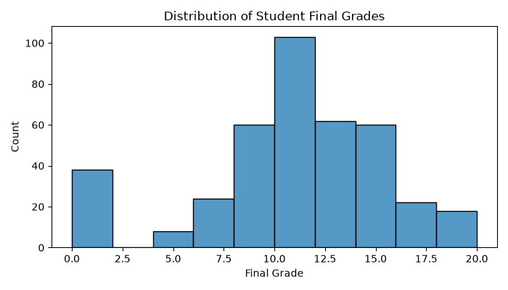
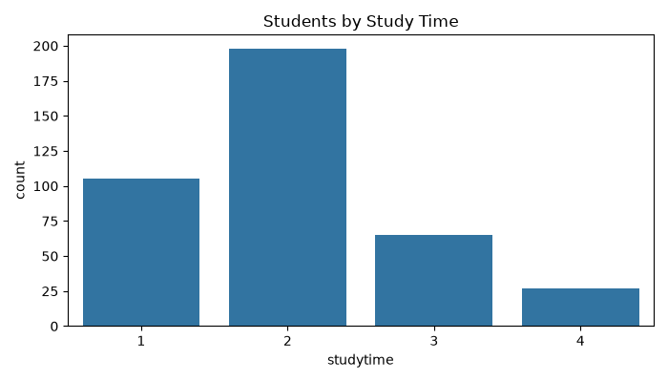

3.3 Target Creation and Feature Preparation

The target label is obtained from G3 by applying the specified threshold, the input matrix X includes the other student attributes and y consists of the binary target, and the categorical variables are transformed into numeric indicator columns by means of pandas.get_dummies(..., drop_first=True) so that the classifiers can deal with them.

3.4 Training and Testing

The dataset is split into training and testing subsets in an 80:20 ratio. The training subset is used to fit the models, whereas the testing subset is used to evaluate the predictions for records that have not been used in the fitting process. A fixed random state ensures that the split can be reproduced. Stratification is employed so that the proportions of the two target classes remain approximately the same in both subsets

3.5 Logistic Regression

Logistic Regression is a supervised classification method which estimates the probability of a binary result. It takes a linear combination of the input variables and applies the logistic function to this combination, thus obtaining a probability value between zero and one. A decision threshold is used to determine the predicted class. It serves as a useful baseline since the method is fairly simple and its coefficients can be interpreted if one is careful. In the program, max_iter is raised in order to achieve convergence and class_weight='balanced' is used to take into account the different frequencies of the classes.

3.6 Random Forest
Random Forest is an ensemble technique which combines the predictions of a number of decision trees. These trees are trained using samples of the records and subsets of the features, and then their predictions are averaged. It is capable of capturing nonlinear relationships and interactions which a simple linear decision boundary might not be able to represent. Its performance is evaluated by comparing it with that of Logistic Regression on the same test set.

4. Evaluation Measures

Several evaluation measures are given since relying solely on accuracy can mask poor performance with respect to the less frequent class. The positive class is defined as 'at risk' (label 1).

4.1 Accuracy
Accuracy refers to the proportion of test items that are correctly classified; although it provides an overall summary, it should not be used by itself in the case of imbalanced classes..
Accuracy = (True Positives + True Negatives) / Total Predictions

4.2 Precision
Precision refers to the fraction of students who were predicted to be at risk and who in fact were in the at-risk group. When precision is low, it means there are more false alarms.
Precision = True Positives / (True Positives + False Positives)

4.3 Recall
The recall figure shows the proportion of students who actually were at risk and were properly identified. In the case of an early-warning system, recall is important since a false negative indicates that a student who met the project's risk criteria was overlooked
Recall = True Positives / (True Positives + False Negatives)

4.4 F1-score
The F1-score is the harmonic mean of the precision and recall; it is useful in those situations where both missed at-risk cases and false alarms have to be taken into account.
F1 = 2 × (Precision × Recall) / (Precision + Recall)

4.5 Confusion Matrix

A confusion matrix shows the number of true positives, true negatives, false positives and false negatives; it is useful for identifying the kinds of errors committed by each model, and the program produces a separate confusion matrix for Logistic Regression and Random Forest.

5. Results and Discussion

Model | Accuracy | F1-score | Observation
Logistic Regression | 0.671 | 0.581 | Moderate performance in identifying at-risk students.
Random Forest | 0.734 | 0.533 | Higher accuracy, but lower F1-score than Logistic Regression

6. Implementation Details

The project is carried out using Python; Pandas is used to load the CSV file and to prepare the features, while Matplotlib and Seaborn are responsible for producing the visualisations, and Scikit-learn carries out the train-test split, trains the classifiers and computes the evaluation metrics.

6.1 Program Workflow

Import required libraries.

Read in the file student-mat.csv using the semicolon as the separator.

Look at the dataset and verify the missing values.

Imagine the final grades and the different categories of study time.

Form the at_risk target using G3.

Take the input features and remove G1, G2 and G3 then encode the categorical variables.

Divide the data into training and testing sets.

Carry out logistic regression and random forest.

Work out the accuracy, F1-score and the classification reports.

Show the confusion matrices and compare the models

.6.2 How to Run the Program

Put the file miniproject.py and the file student-mat.csv into the same project folder. Open the folder in Visual Studio Code and then select Terminal → New Terminal. Use the following command to install the packages: python -m pip install pandas matplotlib seaborn scikit-learn. After that, execute: python miniproject.py. However, if a FileNotFoundError message appears, make sure that the name of the dataset file is exactly student-mat.csv and that it is located in the same folder as the Python script.

7. Ethical Considerations

Academic data is sensitive since a model might copy the patterns or biases it has picked up from its training data, and wrong predictions could result in unfair assumptions being made about students. A prediction must never be considered a definite judgment of a student's abilities. If the method is to be put into real practice it will need appropriate data protection, evaluation using data that is relevant to the local area, fairness checks, human supervision and a means of correcting errors. The purpose of the predictions should be to provide constructive help rather than to impose punishment

.8. Limitations
- The dataset is fairly small and was obtained from Portuguese secondary schools, so it might not be representative of other education systems.
- The criterion that G3 < 10 is a choice made for a particular project rather than a universal standard.
- The results vary according to the split chosen and the features that are available.
- The analysis finds only predictive associations and not causal effects.
- The fact that a test has been successful does not mean that the model will perform just as well in an actual institution.

9. Conclusion and Future Scope

The mini project presents a basic workflow for predictive analytics involving binary classification. It begins by loading and examining a public student dataset, creates a risk label based on the final grade, and then trains and compares two supervised learning methods—Logistic Regression and Random Forest. The project shows the importance of data preparation, the use of a separate test set, and multiple evaluation measures.

Finish drawing the final conclusion once the program has been run. Give the actual scores that were obtained, state which model did better on the criteria selected, and note any compromise between precision and recall. Since the dataset is small and specific to a certain geography, the findings should be regarded as showing the possibility rather than as proof that the model can be used in another institution.

9.1 Future Scope

Assess the approach using a larger dataset that has been ethically gathered from an appropriate education setting.

Where appropriate and permitted, look into the differences in fairness and performance among various groups.

Assess the stability of the model by using cross-validation and carrying out controlled hyperparameter tuning.

Look into the calibrated probabilities and decision thresholds that apply to the intended support process.

The interface should not be developed until the model has been validated and its limitations have been understood.

References

[1] The Student Performance dataset is available from the UCI Machine Learning Repository at https://archive.ics.uci.edu/dataset/320/student%2Bperformance (access date: 15 October 2026).

[2] P. Cortez and A. Silva, in their paper "Using Data Mining to Predict Secondary School Student Performance," published in 2008, for full citation details please consult the UCI dataset page.

[3] The scikit-learn developers, in their book 'scikit-learn: Machine Learning in Python', can be found at https://scikit-learn.org/ (access date: 15 October 2026).

