14. Record and Execute a Test Case for Finding and Playing a Selenium Tutorial Video.

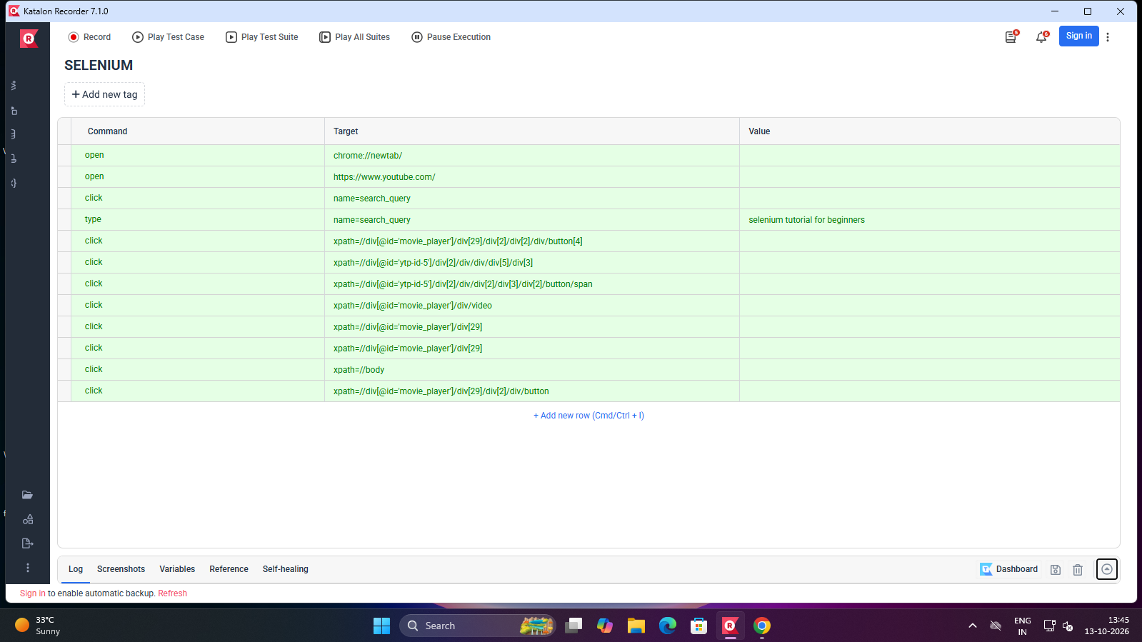

Output :

[info] Playing test case Software Testing / SELENIUM

[info] Time: Tue Oct 13 2026 13:40:40 GMT+0530 (India Standard Time) Timestamp: 1791879040695

[info] OS: Windows Version: 10

[info] Browser: Chrome Version: 155.0

[info] If the test cannot start, please refresh the active browser tab

[info] Executing: | open | chrome://newtab/ | |

[info] Executing: | open | https://www.youtube.com/ | |

[info] Executing: | click | name=search_query | |

[info] Executing: | type | name=search_query | selenium tutorial for beginners |

[info] Executing: | click | xpath=//div[@id='movie_player']/div[29]/div[2]/div[2]/div/button[4] | |

[info] Wait until the element is found

[info] Cannot find element xpath=//div[@id='ytp-id-5']/div[2]/div/div/div[5]/div…

[info] Executing: | click | xpath=//div[@id='ytp-id-5']/div[2]/div/div/div[5]/div[3] | |

[info] Wait until the element is found

[info] Cannot find element xpath=//div[@id='ytp-id-5']/div[2]/div/div/div…

[info] Executing: | click | xpath=(.//*[normalize-space(text()) and normalize-space(.)='Playback speed'])[1]/following::div[1] | |

[info] Executing: | click | xpath=//div[@id='ytp-id-5']/div[2]/div/div[2]/div[3]/div[2]

[info] Wait until the element is found

[info] Cannot find element xpath=//div[@id='ytp-id-5']/div[2]/div/div[2]/div[3]/div..

[info] Executing: | click | xpath=//div[@id='ytp-id-5']/div[2]/div/div[2]/div[3]/div[2

[info] Wait until the element is found

[info] Cannot find element xpath=//div[@id='ytp-id-5']/div[2]/div/div[2]

[info] Wait until the element is found

[info] Cannot find element xpath=//div[@id='movie_player']/div[29] after 1000ms switch to xpath=//div[@id='movie_player']/div[29]

[info] Executing: | click | xpath=//div[@id='movie_player']/div[29] | |

[info] Wait until the element is found

[info] Cannot find element xpath=//div[@id='movie_player']/div[29] after 1000ms switch to xpath=(.//*[normalize-space(text()) and normalize-space(.)='(720p60)'])[1]/following…

[info] Wait until the element is found

[info] Cannot find element xpath=//div[@id='movie_player']/div[29] after 1000ms switch to xpath=//div[@id='movie_player']/div[29]

[info] Executing: | click | xpath=//div[@id='movie_player']/div[29] | |

[info] Wait until the element is found

[info] Cannot find element xpath=//div[@id='movie_player']/div[29] after 1000ms switch to xpath=(.//*[normalize-space(text()) and normalize-space(.)='(720p60)']….

[info] Executing: | click | xpath=//body | |

[info] Executing: | click | xpath=//div[@id='movie_player']/div[29]/div[2]/div/button |

[info] Executing: | click | xpath=(.//*[normalize-space(text()) and normalize-space

[info] Time: Tue Oct 13 2026 13:41:26 GMT+0530 (India Standard Time) Timestamp: 1791879086276

[info] Test case passed

