Weather application AngularJS

**Submitted by:**

Gauri Dengare

B-Number: B00692537

[gdengar1@binghamton.edu](mailto:gdengar1@binghamton.edu)

**Under the Guidance of:**

Prof. Leslie Lander

Department of computer Science

Thomas J. Watson School of Engineering and Applied Science

**Table of Contents:**

|  |  |
| --- | --- |
| **Sr. No.** | **Page Title** |
| 1 | Project Overview |
| 2 | Introduction |
| 3 | Technologies Used |
| 4 | Implementation |
| 5 | Future Scope |
| 6 | Bibliography |

**1.Project Overview**

This weather app is a Single Page Application built for the users who wants to take a look at the weather condition of a particular city.

**The app displays the following weather features:**

* Current Temperature
* Minimum Temperature
* Maximum Temperature
* Wind Speed
* Humidity
* Pressure
* Image

**External APIs Used:**

* Google API to get the geolocation of the city
* OpenWeatherMap API to get the weather features of the geolocation provided.

**2.Introduction**

In this app, the user must enter the city of their interest to check the weather. Then geolocation (Latitude and Longitude) of the city will be extracted using google API and using this geolocation, OpenWeatherMap API will get the weather information of that particular city.

**3.Technologies Used**

* AngularJS 1.5.8
* jQuery 3.3.1
* Bootstrap 3.4.0

**AngularJS:**

* AngularJS is a JavaScript framework based on Model-View-Controller (MVC) programming pattern which isolates application logic from user interface. It extends HTML with ng-directives.
* Ng-directives used in this project:

Ng-click, Ng-model, Ng-app, Ng-value,

Ng-controller.

* Model: The model manages application data.
* View: view presents data to the user in particular format.
* Controller: Controller validates user data and perform operations on the data model objects.
* Factory/Service: Using factory/service we can create our own service that can be used by multiple controllers.

**4. Implementation**

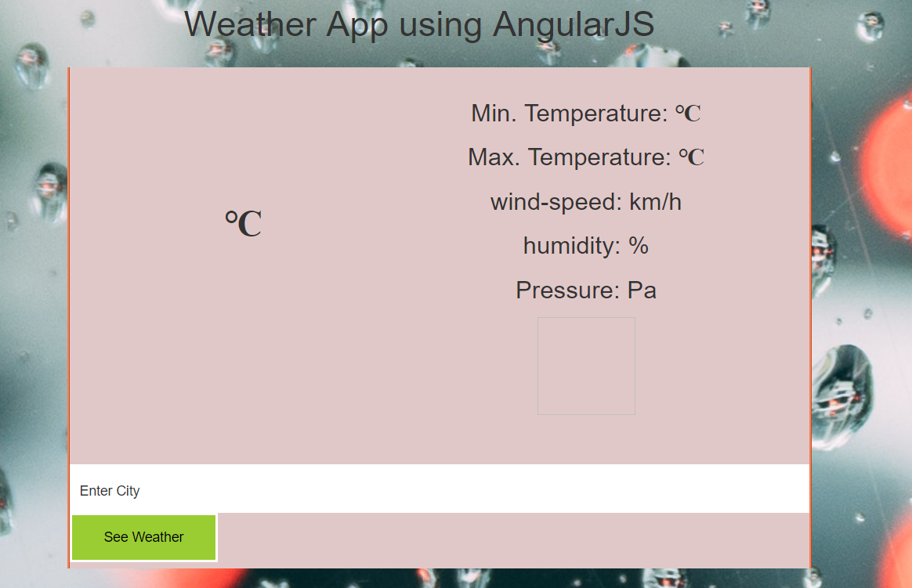

* After entering city and hitting button:

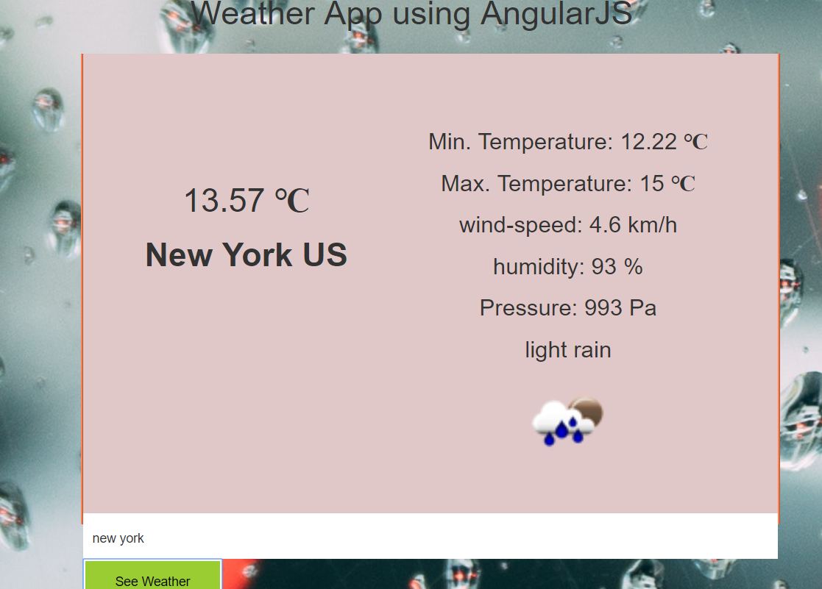

**Code:**

1.HTML file:

<html>

<!-- Latest compiled and minified CSS -->

<link rel="stylesheet" href="https://maxcdn.bootstrapcdn.com/bootstrap/3.4.0/css/bootstrap.min.css">

<!-- jQuery library -->

<script src="https://ajax.googleapis.com/ajax/libs/jquery/3.3.1/jquery.min.js"></script>

<link rel="stylesheet" type="text/css" href="app.css">

<body>

<h1>Weather App using AngularJS</h1>

<div ng-app = "App" ng-controller = "WeatherCtrl" id="MainBlock">

<div id="temp">

<h1> {{temp}} <strong>&#8451;</strong></h1>

<h1><strong>{{city}} {{country}}</strong></h1>

</div>

<div id="data">

<p>Min. Temperature: {{min}} <strong>&#8451;</strong></p>

<p>Max. Temperature: {{max}} <strong>&#8451;</strong></p>

<p>wind-speed: {{wind}} km/h</p>

<p>humidity: {{hum}} %</p>

<p>Pressure: {{press}} Pa</p>

<p>{{code}}</p>

<img ng-src="{{myImg}}" height="100" width="100">

</div>

<div id="search">

<input ng-model = "cityName" style="width: 30%; float:inherit" input type="text" ng-value="message"/>

<br>

</div>

<button ng-click = "output()" style="width: 20%; float:inherit">See Weather</button>

</div>

<script src="https://cdnjs.cloudflare.com/ajax/libs/angular.js/1.5.8/angular.min.js"></script>

<script type="text/javascript" src = "app.js"></script>

</body>

</html>

2.CSS file:

body {

font-family: Arial, Helvetica, sans-serif;

background: url("blur-cars-dew-125510.jpg") no-repeat center center fixed;

padding-top: 10%;

text-align: center;

}

#MainBlock {

border-left-style: ridge;

border-left-color: coral;

border-right-style: ridge;

border-right-color: coral;

margin: 25px 50px 25px 400px;

background-color: rgba(225, 200, 200, 1);

display: block;

height: 85%;

width: 50%;

top:-50px;

}

#temp {

overflow: hidden;

font-size: 400px;

position: relative;

left: -200px;

bottom: -120px;

}

#data {

overflow: hidden;

font-size: 25px;

position: relative;

right: -150px;

top: -50px;

}

#search {

display: block;

background-color: white;

min-height: 50px;

width: 100%;

overflow: hidden;

height: 50px;

padding-left:10px;

}

button {

color: black;

display: block;

background: yellowgreen;

border: 2px solid white;

float: right;

width: 30%;

min-height: 50px;

}

button:hover {

opacity: 0.5;

color:#4341f4;

border-color:#ebf441;

}

input {

display: block;

float: left;

background: transparent;

border-style: none;

min-height: 55px;

width: 72%;

}

3.JS file:

var App = angular.module("App", []);

App.value("defaultCity", "Enter City");

App.service('locationService', function ($http) {

this.getLocation = function () {

return $http.post('https://www.googleapis.com/geolocation/v1/geolocate?key=AlzaSyAQysYpEWqEZkg4bvm1SicYh7NhvAlHwvs');

}

});

App.service('GetWeatherByCityService', function (WeatherApi) {

this.getWeatherByCity = function (City) {

return WeatherApi.requestWeatherByCity(City);

}

});

App.factory('WeatherApi', function ($http) {

var factory = {};

factory.requestWeatherByCity = function (City) {

var URL = 'https://api.openweathermap.org/data/2.5/weather?';

var request = {

url: URL,

method: 'GET',

params: {

q: City,

units: 'metric',

appid: 'ce786550f7097ef314ec01eb7b3349f3'

}

};

return $http(request);

}

return factory;

});

App.controller('WeatherCtrl', function ($scope, GetWeatherByCityService, locationService, defaultCity) {

$scope.cityName = defaultCity;

$scope.output = function () {

GetWeatherByCityService.getWeatherByCity($scope.cityName).then(function (response) {

$scope.city = response.data.name;

$scope.temp = response.data.main.temp;

$scope.wind = response.data.wind.speed;

$scope.myImg = "https://openweathermap.org/img/w/" + response.data.weather[0].icon + ".png";

$scope.code = response.data.weather[0].description;

$scope.hum = response.data.main.humidity;

$scope.press = response.data.main.pressure;

$scope.min = response.data.main.temp_min;

$scope.max = response.data.main.temp_max;

$scope.country = response.data.sys.country;

});

}

});

**5. Future Scope:**

* Specifying country along with the city name to avoid confusion between cities with same name.
* Hourly data for the entire day

**6. Bibliography:**

* <https://gist.github.com/andrejikonikov/abcf097a4f24bea5ec0a8f56d2e20886>
* <https://codepen.io/Ikonikov/pen/yaZNQj>
* <https://tylermcginnis.com/angularjs-factory-vs-service-vs-provider/>
* <https://www.tutorialspoint.com/angularjs/angularjs_mvc_architecture.htm>
* <https://www.w3schools.com/angular/>