**Project Title- Gun Violence in US**

-Project By, Gauri Dharkar, Chinmay Naphade, Kumar Saket

**Project Visualization Outputs :**

**1 : Heat map depicting type of gun-violence most prevalent in the states across USA.**

**2 : Distribution of number of gun-violence incidents across USA.**

Texas has maximum number of gun violence incidents and states located in central USA exhibit lower number of gun violence incidents.

**3 : Word-cloud showing gun-violence incident characteristics.**

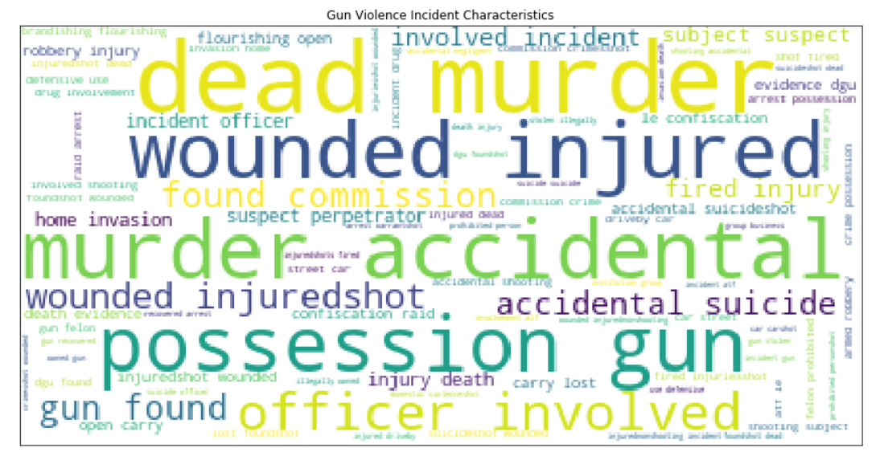

**4 : Comparison between political parties according to the number of gun-violence incidents.**

Surprisingly, after analysis of the visualization it is observed that democratic constituency is more prone to gun-violence crimes than republican which is reverse of the common-knowledge.

**5 : Predictive multiple linear regression model finding the parameters best depicting the number of people killed in a gun-violence incident.**

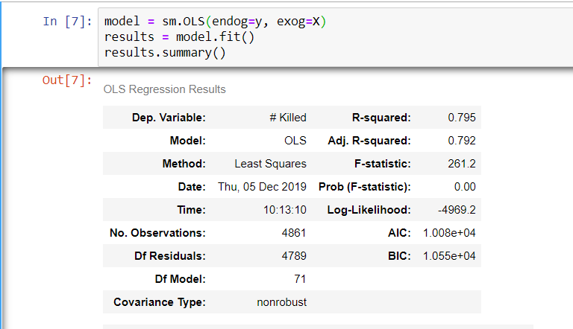

R- Squared value of the model is 0.795 which shows model is a good fit for the prediction.

The parameters taken into consideration were number of injured, state and type of incident.

These three factors play an important role in predicting the number of deaths in a gun-violence crime.

