A11yPreserve Alternative Text Fixture
Enrollment is reported across three academic years in the chart below.
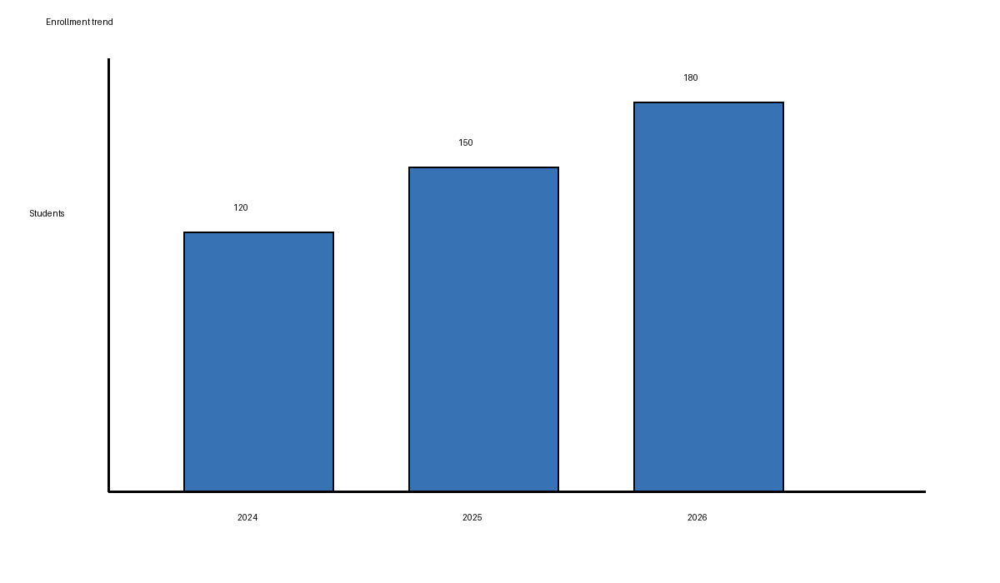
The visual summarizes the reported trend without repeating its complete alternative text.

