WOOD BASED LICENSING SYSTEM

## UI & UX Specialist Project Report

**Submitted by:**

**(102003720) GAURI KADYAN**

**(102003529) SPARSH CHHETRI**

**BE Third Year, CoE**

## ABSTRACT

We have had the task to create and develop customized software for the procedures related to issuing new licenses, registration, renewal and to design and develop software application for management of database related to existing wood- based industries in Punjab . We have also created the software architecture for the department server's apps and procedures.

## DECLARATION

We hereby declare that the design principles and working prototype model of the project entitled Wood based Licensing System is an authentic record of our own work carried out in the Computer Science and Engineering Department, TIET, Patiala, during 5th semester (2022).

Date: 17th September , 2022

|  |  |  |
| --- | --- | --- |
| **Roll No.** | **Name** | **Signature** |
| 102003720 | Gauri Kadyan | ***GAURI*** |
| 102003529 | Sparsh Chhetri | ***SPARSH*** |

ii

## LIST OF FIGURES

**Figure No. Caption Page No.**

|  |  |
| --- | --- |
| Figure 1 | METHODOLOGY |
| Figure 2 | Breakdown of the website |
| Figure 3 | MVC DIAGRAM |
| Figure 4 | Design level diagram |
| Figure 5 | User-Interface Diagram |

## TABLE OF CONTENTS

ABSTRACT… i

DECLARATION… ii

LIST OF FIGURES iv

LIST OF TABLES v

LIST OF ABBREVIATIONS vi

**CH APTER… Page No.**

|  |  |  |
| --- | --- | --- |
| **1. Introduction** | | **1** |
| 1.1 | Project Overview |  |
| 1.2 | Problem Definition and Scope |  |
| 1.3 | Assumptions and Constraints |  |
| 1.4 | Methodology |  |
| 1.5 | Project Outcomes and Deliverables |  |

1. **Methodology Adopted**
   1. Proposed Solution
   2. Work Breakdown Structure
   3. Tools and Technology
2. **Design Specifications** (Sub-sections may vary according to the applicability of diagrams for student projects)
   1. System Architecture (Eg: Block Diagram / MVC/ Tier architecture whichever suits the project)
   2. Design Level Diagrams
   3. User Interface Diagrams
3. **Conclusions**
   1. Work Accomplished
   2. Environmental / Economic/ Social Benefits
   3. Future Work Plan

*Note: Diagrams should have a detailed explanation. Do refer figure/table numbers in the running text also.

1. **INTRODUCTION:-**

**PROJECT OVERVIEW-**

* + To design and develop software application for management of database related to existing wood-based industries in Punjab
  + To design and develop customized application for the processes related to issuing New Licenses/ Registration, Expansion, Renewal, Relocation and change of ownership of the existing licenses/Units
  + To develop this software architecture for the above-mentioned applications/processes on the department server

P**ROBLEM DEFINATION AND SCOPE-**

The management of the whole system was done in offline mode i.e., manually which was proven to be a time consuming and an error prone task. This project helps getting rid of both the main issues (time consumption and error prone)by centrally managing the whole data with the help of a database.

**The services the software will provide are as follows**-

* + - New License
    - Renewal of License
    - Change of Ownership
    - Relocation of Unit

**Why is it needed?**

1. Ease out the Current Manual Mechanism
2. Data Analysis of activities done over a period of time
3. Improved Efficiency
4. Role Based Access
5. Transparency in the process

## METHODOLOGY

Fig.1 Methodology

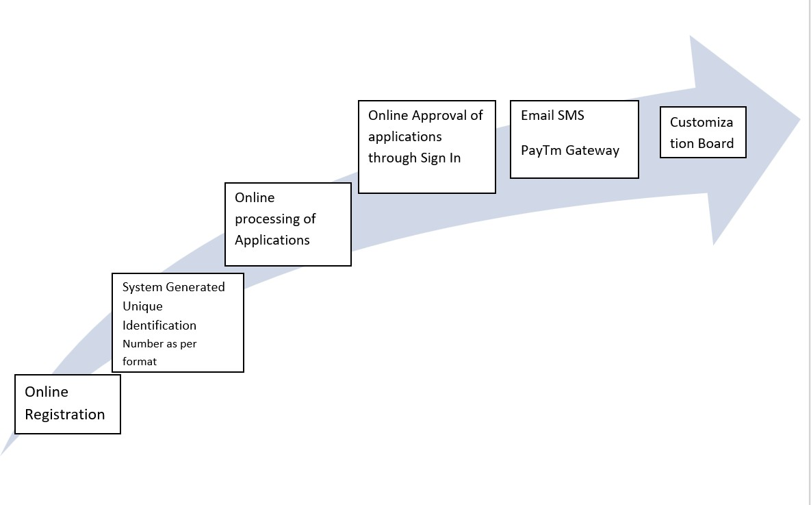

# Methodology Adopted-

**Proposed Solution-**

* 1. It will ease out the Current Manual Mechanism
  2. Data Analysis of activities will be done over a regular period of time
  3. An improved efficiency will be provided
  4. Role Based Access would be followed
  5. Transparency in the process will be introduced
  6. Service of New License will be provided
  7. Renewal of License would also be applicable
  8. Change of Ownership would be introduced
  9. Relocation of Unit will be available

**Work Breakdown Structure-**

Fig.2 Breakdown of the website

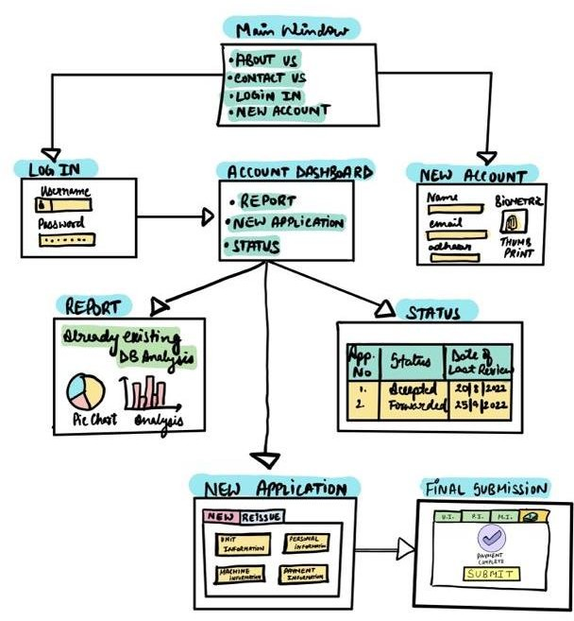

**Tools and Technology Used-**

The web technologies used in the project are HTML, CSS and JavaScript while the tool/platform we used to make our project was Visual Studio Code.

# SYSTEM ARCHITECTURE

**MVC DIAGRAM**

Fig.4 Model-View-Controller Diagram

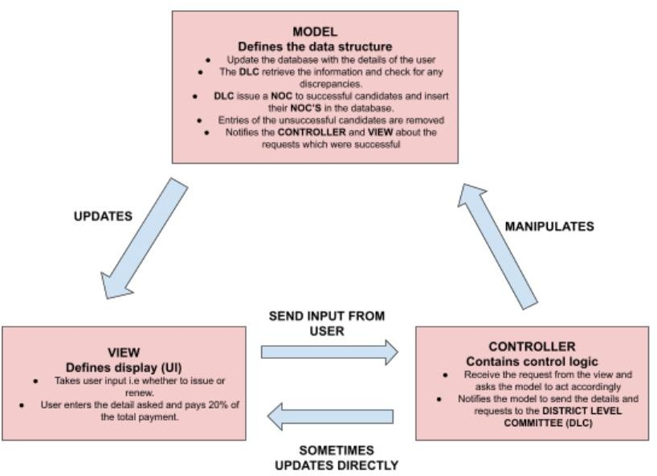

**DESIGN LEVEL DIAGRAM**

Fig.4 design level diagram

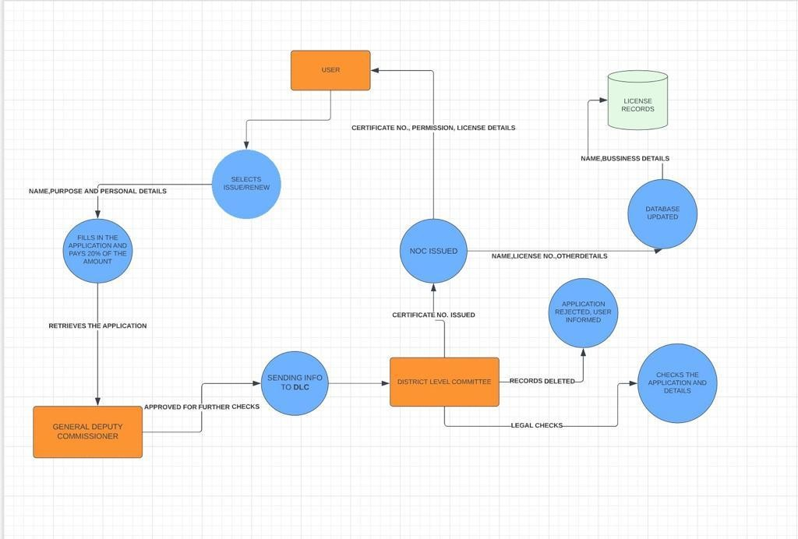

**USER INTERFACE DIAGRAM**

Fig.5 User interface Diagram

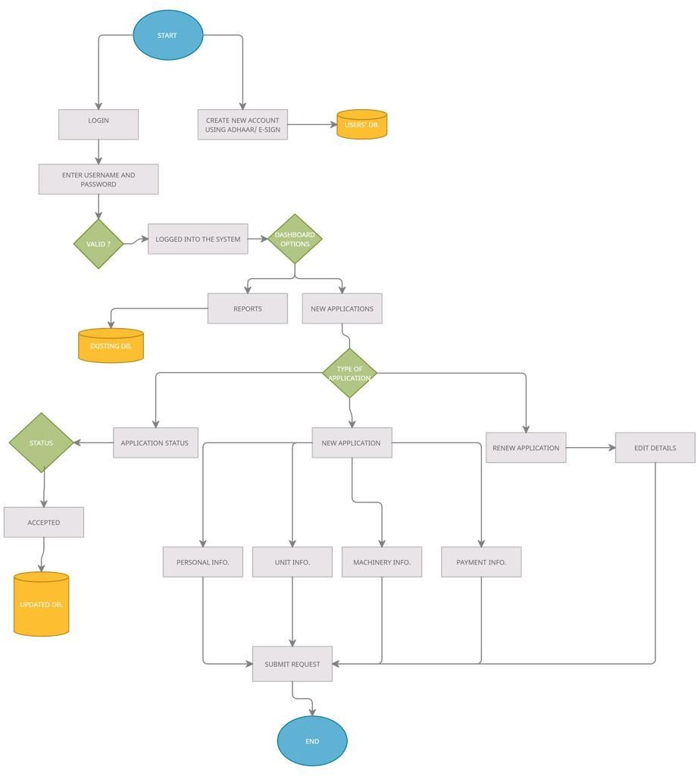

* + 1. **Conclusions**

## Work Accomplished

* + - 1. Developed a software application for management of database related to existing wood-based industries in Punjab.
      2. Developed a customized application for the processes related to issuing New Licenses/ Registration and renewal of license.

## Environmental / Economic/ Social Benefits

1. Enhanced performance – Performance is enhancing by this system or we can say that processes become more easy.
2. Data transparency - Easily access and work with data no matter where they are located or what application created them and the assurance that data being reported are accurate and are coming from the official source.
3. Avoid redundancy - Data redundancy is storing the same data in more than one place. This happens in nearly every business/industry that doesn’t use a central database for all its data storage needs. So this can be avoided by this system.
4. Process portability – Processes becomes portable by this system.
5. Increased productivity - Productivity is the crying need of the modern business world. And this system helps to increase productivity. The results of increased productivity would be beneficial to all in terms of increasing the standard of living of people. This means that everyone employed in gainful employment should contribute to increased productivity to increase his standard of living and build a powerful nation.
6. Digital report processing Report processing becomes easier as we can now do it digitally.
7. Improved efficiency – Efficiency of New license issuing, renewal of license, change of ownership and Relocation of unit has improved by this system.

## Future Work Plan

In future we aim to make this system more efficient in issuing license and in renewal of license. We will work to enhance the performance and productivity of system. And there will be more Data Transparency in the future. And in future our vision is to install this system in most of the Wood based industries in our country.