Practical

Installation of Google App Engine & Creating Hello World Application using Python

Step by Step implementation:

1. Create Google Cloud Account
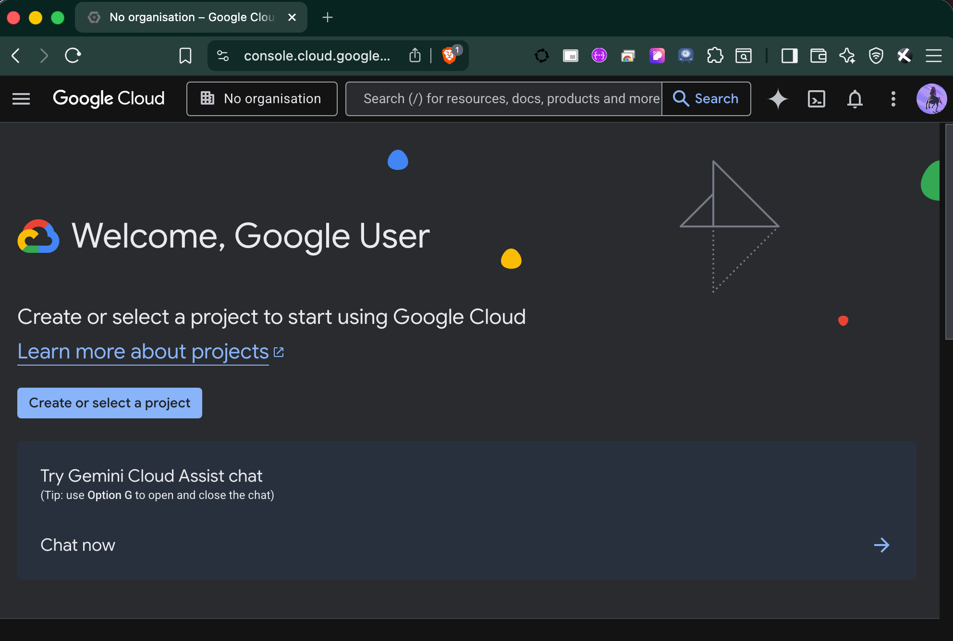
- Go to: https://cloud.google.com
- Click Get Started / Free Trial
- Login using your Google account
- Enable billing (free trial credits available)
- After login, open Google Cloud Console

2. Create New Project

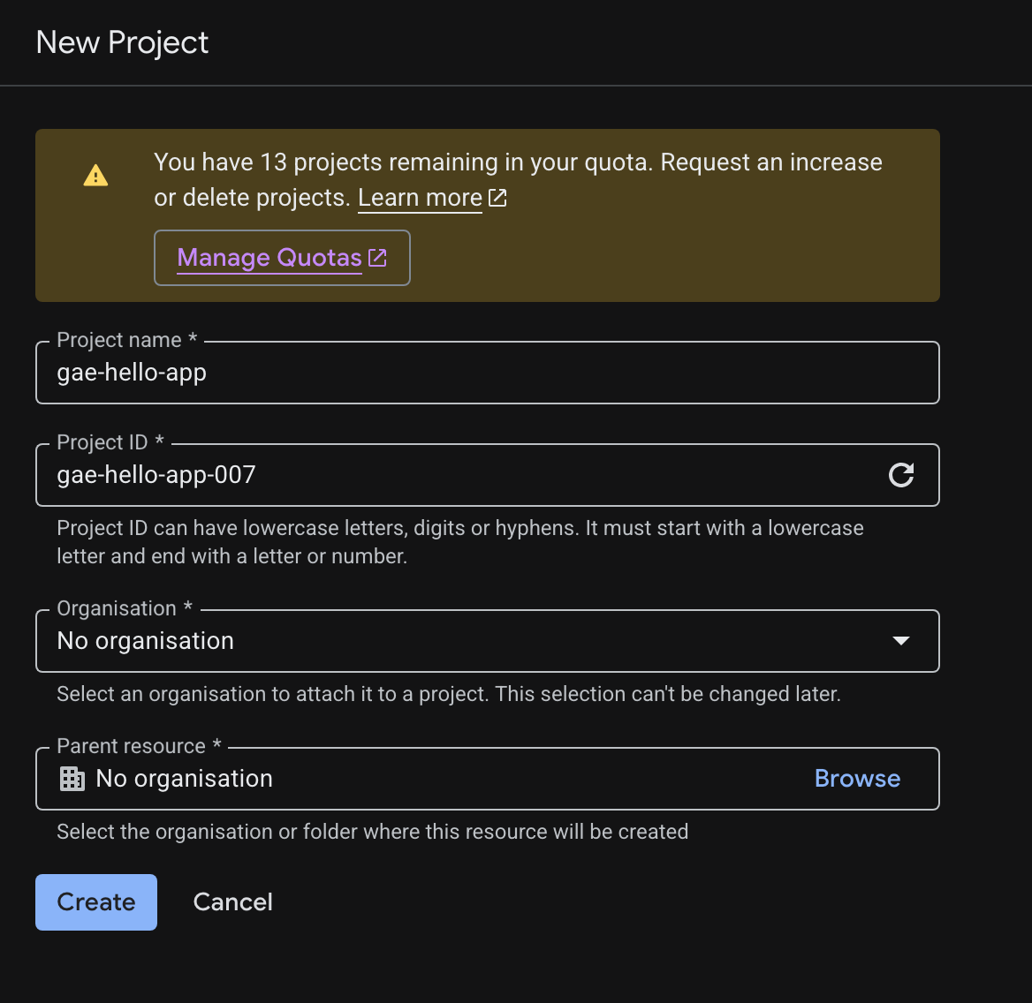

- Click Project Selector (top bar)
- Click New Project
- Enter:
  - Project Name → gae-hello-app
- Click Create
Wait a few seconds for project to be ready

3. Local machine setup/prerequisites

1. Install Python

Download from: Python
Install version 3.10+
During install → check Add Python to PATH
Verify: python --version

2. Google Cloud CLI on Windows

Install Google Cloud CLI on Windows
Step 1: Download Installer

Go to the official page:
https://cloud.google.com/sdk/docs/install

Download: GoogleCloudSDKInstaller.exe
Step 2: Run Installer
Double-click the .exe file
Click Next
Keep default options:
Add to PATH
Install bundled Python
Click Install

3. Verify Installation
Run:
gcloud --version
You should see version info like:
Google Cloud SDK (latest version)

4. Initialize CLI
After install, open:
Command Prompt OR PowerShell
Run:
gcloud init
This will:
Open browser login
Select your Google account
Choose or create a project
Set default region
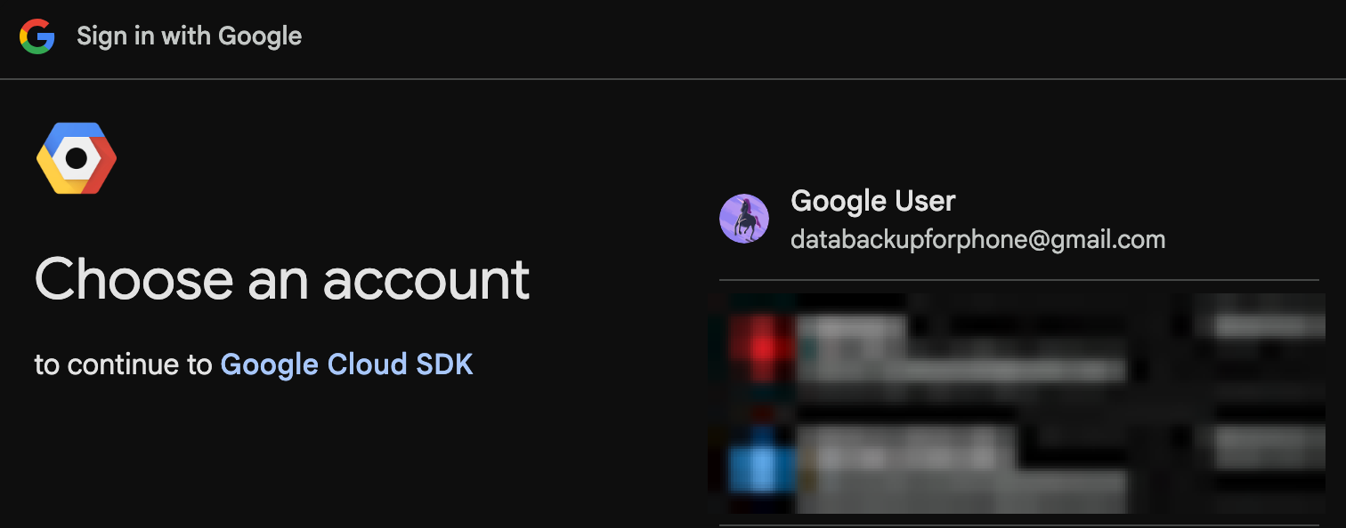


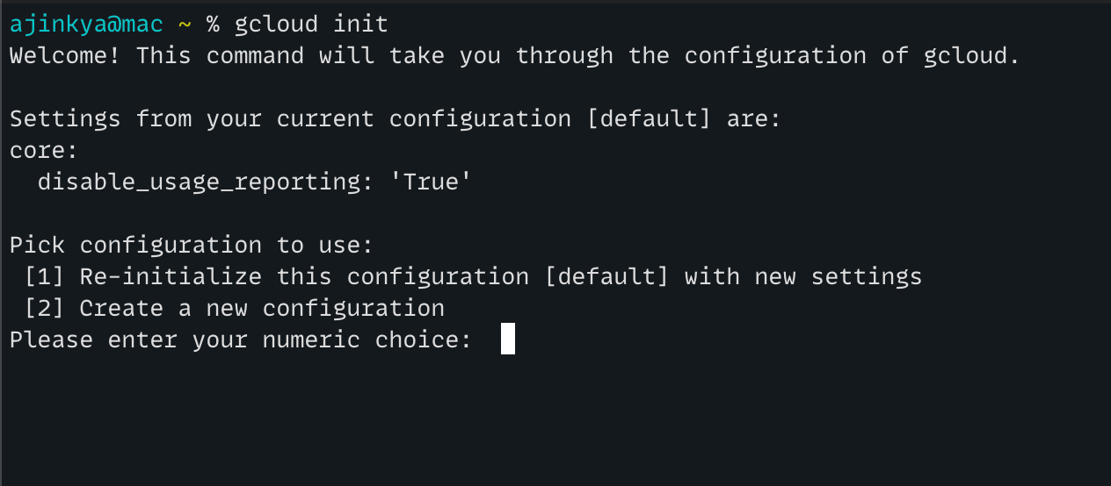
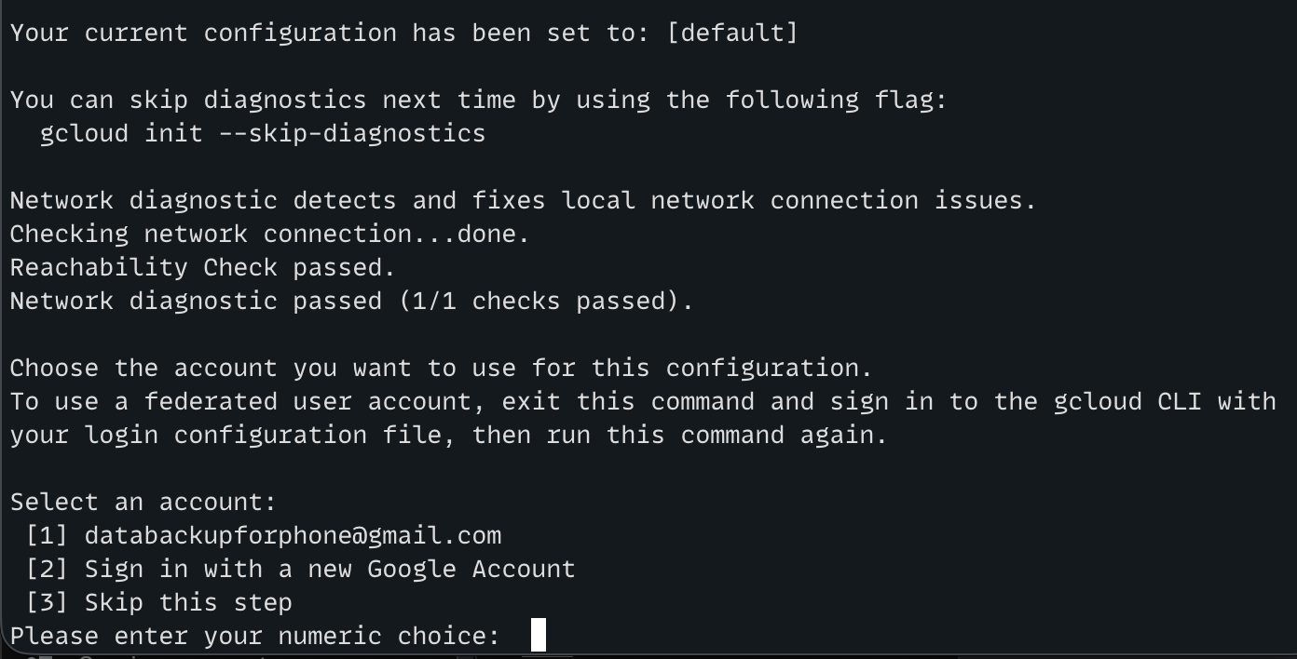
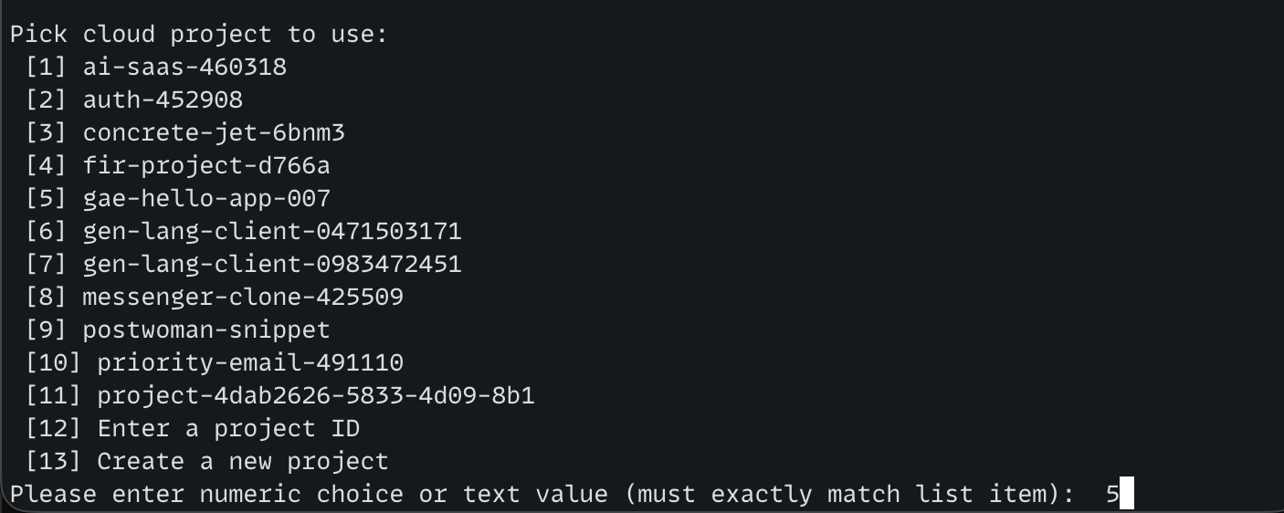
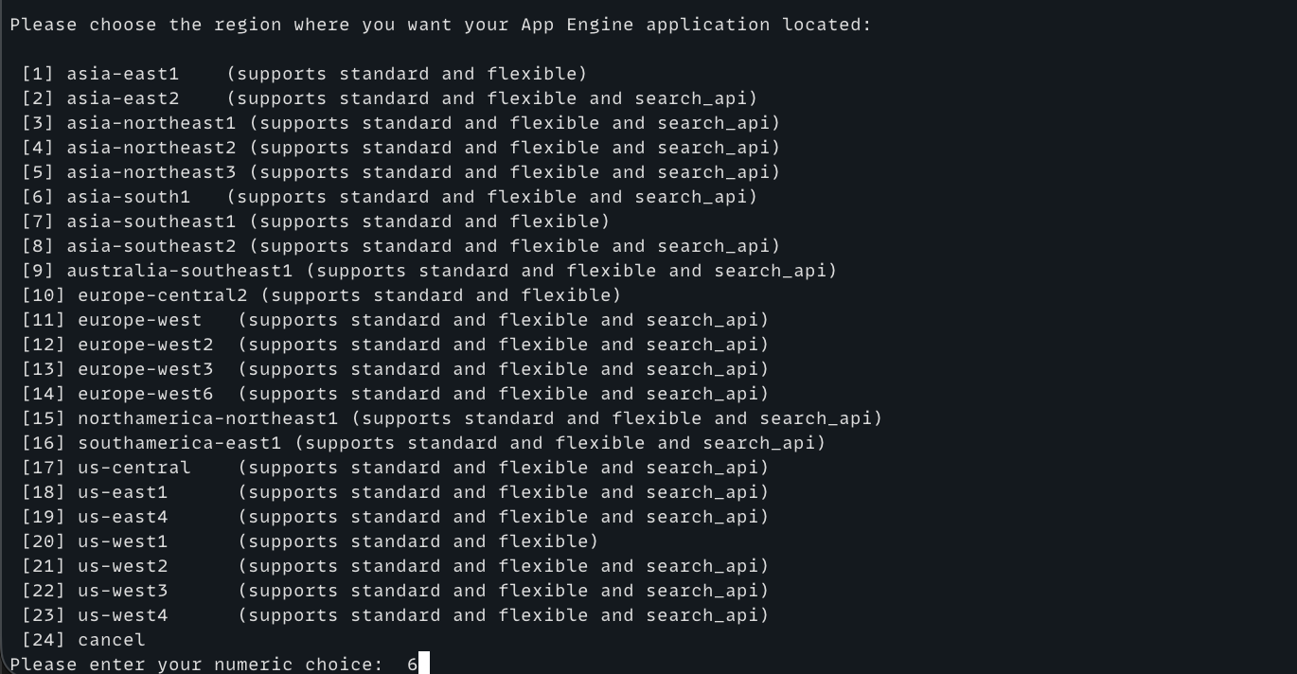
4. Create a new project

In terminal:
mkdir gae-py-app
cd gae-py-app
Activate Virtual Environment:
source ./myenv/bin/activate

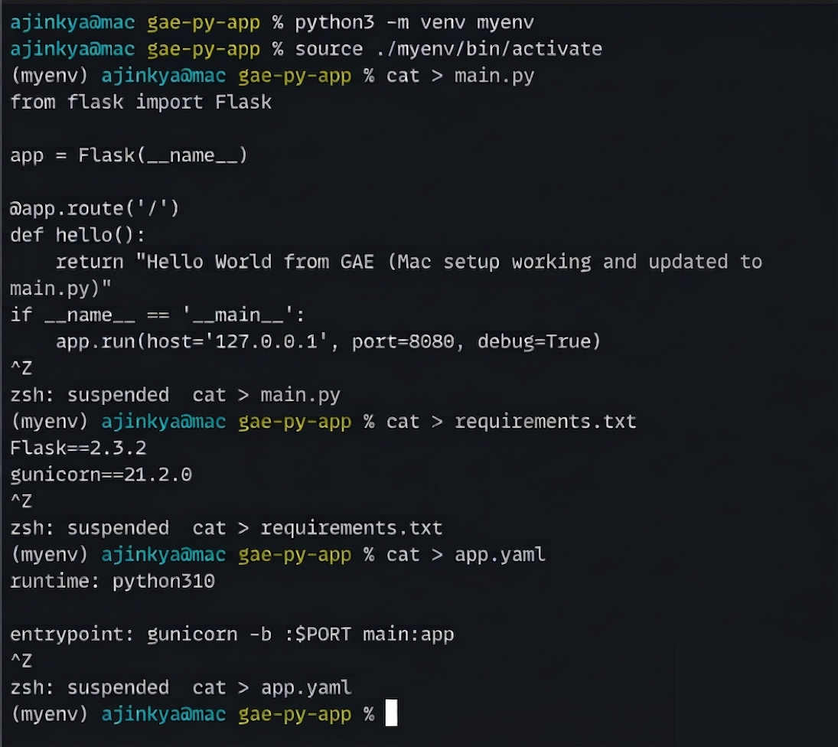

In terminal:
gcloud app deploy
Then:
gcloud app browse

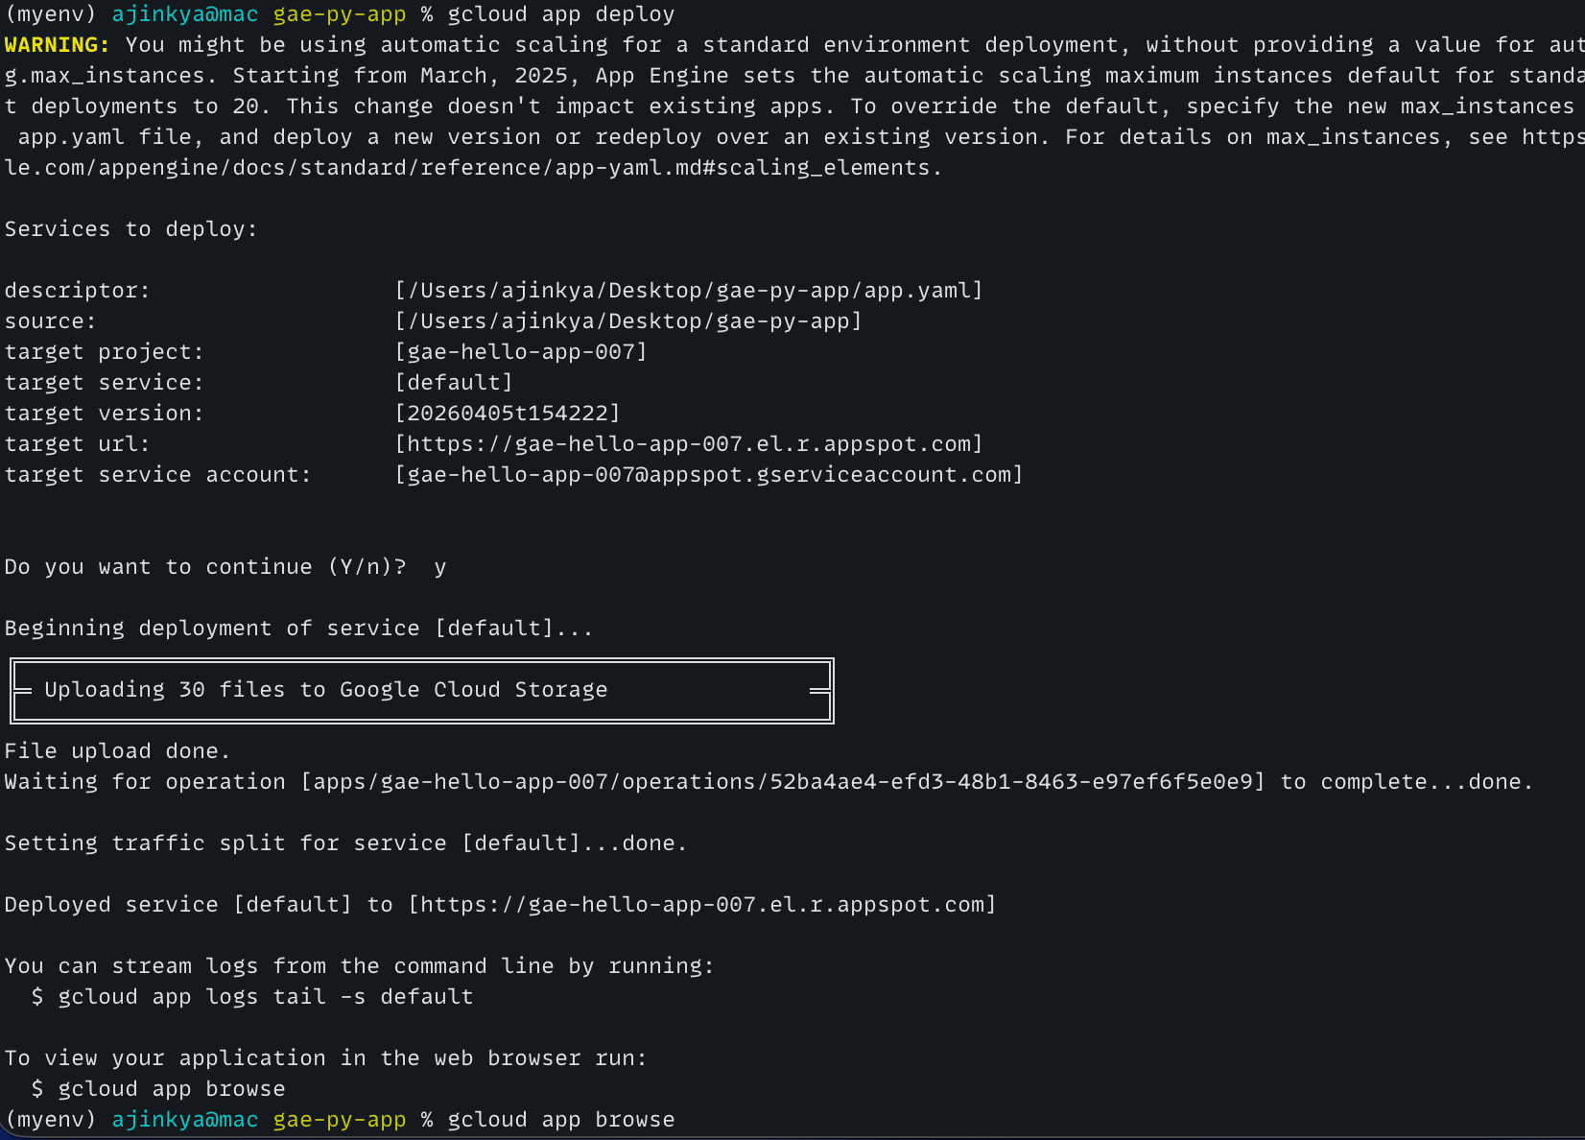
Deployed service url:

https://gae-hello-app-007.el.r.appspot.com
