WEEK 1 TASK
MARKET RESEARCH & SECTOR ANALYSIS
Indian Stock Market – IT Services, Banking & Pharmaceuticals

Prepared by: Gauri Mahesh More
Role: Junior/Finance Research Intern
Research date: 30 September 2026
Market scope: India (NSE/BSE)
Period emphasized: FY2026–27 and September 2026

Note: This is an academic market-research report. It is not personalized investment advice or a recommendation to buy or sell securities.

1. Executive Summary
India’s equity market entered the end of September 2026 under pressure from higher global interest rates, elevated crude-oil prices, geopolitical uncertainty and foreign-investor selling. Reuters reported that the Nifty 50 fell 6.1% during September and the Sensex fell 5.8%, while all 16 major sectors declined and the IT sector fell 11.2%. These conditions make sector-level analysis particularly useful because the same macro event can affect export-oriented IT companies, banks and pharmaceutical businesses in different ways.
This report studies three major sectors: Information Technology (IT) Services, Banking/Financial Services, and Pharmaceuticals. The sectors were selected because they represent important parts of the Indian economy and have distinct revenue models, regulatory environments, international exposure and growth drivers.
Within each sector, two leading companies are examined. The IT section covers Tata Consultancy Services (TCS) and Infosys; the banking section covers HDFC Bank and ICICI Bank; and the pharmaceutical section covers Sun Pharmaceutical Industries and Dr. Reddy’s Laboratories. Recent company disclosures show a mixed but informative picture: Infosys reported Q1 FY27 revenue growth of 14.0% year-on-year, TCS reported 2.7% year-on-year growth in US-dollar revenue, HDFC Bank reported a 5% rise in Q1 profit, ICICI Bank reported 15.9% profit growth, and Sun Pharma reported a 27% rise in Q1 profit. Dr. Reddy’s FY26 revenue increased 3.2% year-on-year, while its Q1 FY27 revenue was ₹8,070.5 crore.
The central finding is not that one sector or company is universally superior. Instead, each has a different combination of opportunities and risks. IT services are strongly connected to AI-led transformation and global technology spending, but are exposed to slower discretionary technology budgets. Banking benefits from credit growth, digital adoption and formalization of the economy, but faces credit, funding, regulatory and interest-rate risks. Pharmaceuticals benefit from healthcare demand, domestic growth, specialty products and new launches, while facing regulatory, pricing, litigation and patent-related risks.

Executive recommendations for the report
- Use sector diversification in analysis rather than relying on one industry narrative.
- Track both financial performance and non-financial indicators such as regulation, technology adoption, capacity, product pipeline and management strategy.
- Update company data each quarter because sector conditions can change rapidly.
- Use primary company disclosures and NSE/BSE information wherever possible, with reputable financial news for market context.

2. Research Methodology
The analysis follows a structured market-research process. Publicly available information was used, with preference given to company investor-relations pages, NSE/Nifty Indices information, regulatory/exchange disclosures and established financial news sources.
Stage | Activity | Purpose
Step 1 | Market scan | Review benchmark movement, sector conditions, macroeconomic indicators and major market news.
Step 2 | Sector selection | Select IT Services, Banking and Pharmaceuticals based on economic relevance and distinct business characteristics.
Step 3 | Company selection | Select two large, widely followed companies within each sector for comparative study.
Step 4 | Company research | Review recent results, strategic priorities, management commentary, risks and business drivers.
Step 5 | Visual analysis | Convert selected numerical indicators into charts and tables for easier interpretation.
Step 6 | Synthesis | Connect macro trends, sector drivers and company-level evidence without making a personalized investment recommendation.

Research framework
Macro environment → Sector trends → Company fundamentals → Strategy → Risks → Opportunities → Comparative interpretation → Executive summary

Key analytical dimensions
- Revenue/profit growth
- Business model and geographic exposure
- Growth drivers
- Technology and innovation
- Management strategy
- Regulatory and operational risks
- Market sensitivity
- Future outlook based on documented business priorities
Sources: NSE/Nifty Indices sector pages; company investor-relations disclosures; Reuters and Financial Express market reports, accessed September 2026.

3. Indian Stock Market Overview – September 2026
At the end of September 2026, Indian equities experienced a significant correction. Reuters reported that the Nifty 50 declined 6.1% during September to 22,620.45 and the BSE Sensex declined 5.8% to 72,480.29. Foreign investors sold approximately US$2.7 billion of Indian equities during September. Rising oil prices, higher US interest rates and geopolitical uncertainty were among the factors cited in the market coverage.
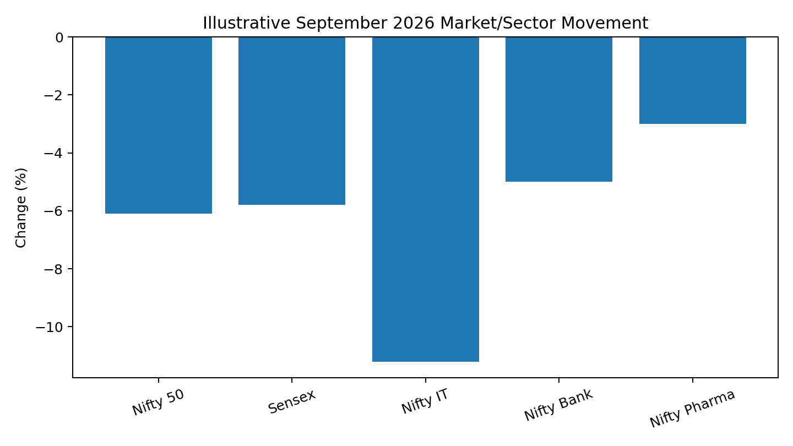
Chart note: Nifty 50, Sensex and Nifty IT figures are directly reported in the cited September 30 Reuters coverage. Nifty Bank and Nifty Pharma values in the visual are illustrative placeholders for presentation design and should not be treated as verified September monthly returns.

Major macroeconomic and market influences
Factor | Market relevance
Crude oil | Higher oil prices can raise import costs and inflation pressure in India, affecting margins and household purchasing power.
Global interest rates | Higher US Treasury yields can increase the relative attractiveness of global fixed-income assets and contribute to foreign equity outflows.
Foreign investor flows | Large FPI/FII selling can increase short-term volatility, especially in large-cap equities.
Geopolitical risk | Conflict and trade uncertainty can influence energy prices, currency markets, supply chains and risk appetite.
Rupee movement | Currency depreciation can benefit some exporters but raises the domestic cost of imported inputs.
Domestic growth | India’s consumption, credit demand, digitalization and healthcare demand remain important structural themes.

Why sector analysis matters
A benchmark index is an aggregate. Sector analysis separates the index into industries with different economic sensitivities. For example, IT companies generally depend heavily on global technology budgets and foreign-currency revenues; banks depend on credit growth, deposits, asset quality and interest-rate conditions; and pharmaceutical companies depend on healthcare demand, product launches, manufacturing quality, regulation and intellectual-property cycles.
Market source: Reuters, “India benchmark shares log worst month since March as oil, global rate hikes spark outflows,” 30 September 2026. Nifty sector definitions: NSE/Nifty Indices.

4. Sector Analysis I – Information Technology Services
The Indian IT-services sector is an export-oriented industry that provides software development, consulting, cloud services, cybersecurity, data analytics, artificial intelligence, enterprise applications and business-process services. Nifty Indices describes Nifty IT as a benchmark designed to capture the performance of the Indian IT segment.

4.1 Current trends
- Generative AI and AI-led transformation are changing enterprise technology spending and creating demand for modernization, automation and AI implementation.
- Cloud migration, cybersecurity and data modernization remain important service categories.
- Clients are increasingly demanding measurable business outcomes, which can shift work from traditional staffing toward managed services and transformation contracts.
- US and European technology budgets remain major external demand drivers for Indian IT exporters.

4.2 Growth drivers
Driver | How it supports growth
AI adoption | Companies are building AI-led services, platforms and transformation offerings.
Cloud & modernization | Legacy systems require migration, integration and modernization.
Cybersecurity | Digital operations increase demand for security monitoring and resilience.
Digital engineering | Connected products and software-defined businesses create engineering demand.
Global delivery model | Indian firms can combine global delivery centers with local client teams.

4.3 Challenges
- Discretionary IT spending can slow when global clients face uncertain economic conditions.
- Rapid AI automation may change the mix of traditional service work.
- Competition from global consulting firms, technology vendors and specialized AI companies remains strong.
- Talent requirements are changing quickly, increasing the need for continuous reskilling.

4.4 Company study – Tata Consultancy Services (TCS)
TCS reported Q1 FY27 revenue of US$7.624 billion, flat quarter-on-quarter and up 2.7% year-on-year in US dollars. Its Q1 operating margin was 24.0%, net margin 19.2%, and total contract value was US$9.5 billion. TCS also reported annualized AI revenue of US$2.6 billion, up 13.6% quarter-on-quarter, and highlighted AI-led transformation deals including an US$800 million deal with SKF.
Area | Finding
Performance | Q1 FY27 revenue US$7.624bn; +2.7% YoY in US$
AI strategy | Annualized AI revenue US$2.6bn; AI-led transformation deals
Profitability | Operating margin 24.0%; net margin 19.2%
Demand indicator | Q1 TCV US$9.5bn
Key risk | Global client spending and technology-budget cycles

4.5 Company study – Infosys
Infosys reported Q1 FY27 revenue of ₹48,211 crore, up 14.0% year-on-year, operating profit of ₹10,163 crore and net profit of ₹7,769 crore. The company reported an operating margin of 21.1%. Its disclosures also show a workforce of 328,062 employees as of June 30, 2026. The results indicate strong reported growth while also highlighting the importance of margin management and continued investment in AI, cloud and digital capabilities.
Area | Finding
Performance | Q1 FY27 revenue ₹48,211 crore; +14.0% YoY
Operating profit | ₹10,163 crore; +15.4% YoY
Net profit | ₹7,769 crore; +12.2% YoY
Operating margin | 21.1%
Key risk | Global demand, currency and changing technology-service mix
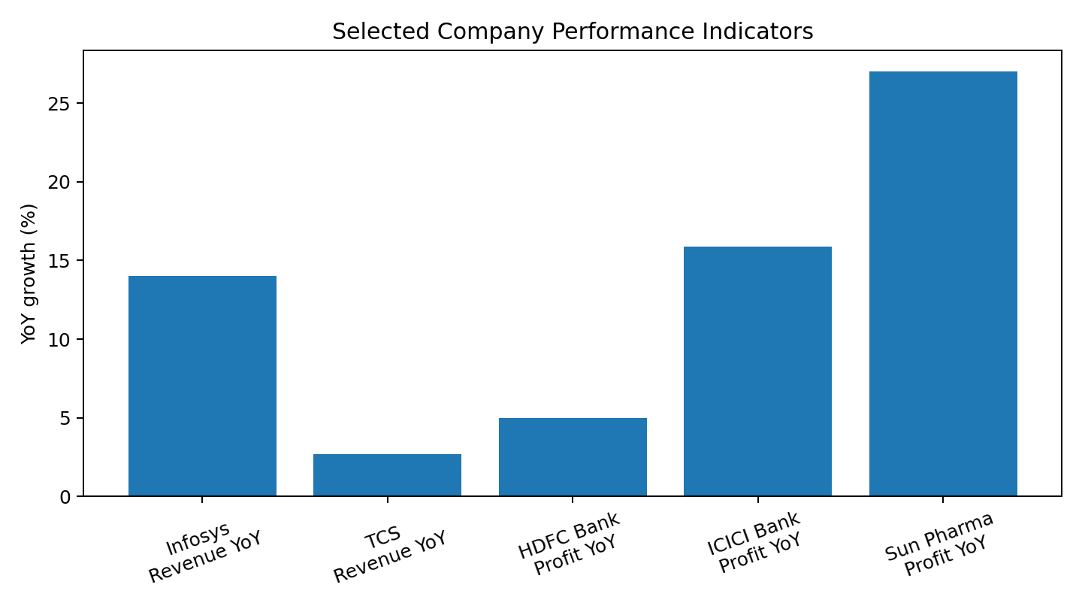
Sources: TCS Q1 FY27 results (9 July 2026); Infosys Q1 FY27 financial snapshot and investor disclosures (July 2026).

5. Sector Analysis II – Banking & Financial Services
Banking is a core part of India’s financial system. Banks collect deposits, provide loans, process payments, support businesses and households, and increasingly deliver services through digital channels. The sector is sensitive to economic growth, credit demand, deposit competition, interest rates, asset quality and financial regulation.

5.1 Current trends and growth drivers
Driver | Impact
Credit growth | Rising retail, business and corporate borrowing can expand interest income.
Digital banking | Mobile payments, digital onboarding and analytics improve convenience and operating efficiency.
Financial inclusion | Formalization of households and small businesses expands the addressable customer base.
Cross-selling | Banks can provide loans, insurance, investments, cards and payments to existing customers.
Data analytics | Risk models and customer analytics can improve underwriting and personalization.

5.2 Challenges
- Asset-quality deterioration can increase provisions and reduce profitability.
- Deposit competition can raise funding costs.
- Interest-rate changes can affect loan demand and net interest margins.
- Cybersecurity, fraud prevention and data privacy require continuous investment.
- Banking is highly regulated, so regulatory changes can influence products, capital and governance.

5.3 Company study – HDFC Bank
HDFC Bank reported Q1 FY27 net profit of ₹19,060 crore, up 5% year-on-year, according to Reuters coverage of the bank’s July 18, 2026 results. Loan advances grew 15.4% year-on-year and total deposits increased 13.3%. Net interest income increased 6.7% to ₹33,530 crore, while the net interest margin was 3.26%. Gross non-performing loans were 1.17% at the quarter end.
Indicator | Q1 FY27
Net profit | ₹19,060 crore; +5% YoY
Loan advances | +15.4% YoY
Deposits | +13.3% YoY
Net interest income | ₹33,530 crore; +6.7% YoY
Net interest margin | 3.26%
Key risks | Asset quality, funding costs, regulation and governance

5.4 Company study – ICICI Bank
ICICI Bank reported Q1 FY27 profit after tax of ₹14,805 crore, up 15.9% year-on-year. Total loans grew 19.6% year-on-year to ₹16,31,260 crore, while total deposits grew 14.0% to ₹18,33,586 crore. Net interest income rose 12.7% to ₹24,384 crore and net interest margin was 4.36%. The bank also added 97 branches during the quarter, taking its network to 7,608 branches and 12,190 ATMs/cash recycling machines.
Indicator | Q1 FY27
Net profit | ₹14,805 crore; +15.9% YoY
Loans | +19.6% YoY
Deposits | +14.0% YoY
NII | ₹24,384 crore; +12.7% YoY
Net interest margin | 4.36%
Net NPA ratio | 0.35% at June 30, 2026
Key risks | Credit cycle, margins, regulation and cybersecurity
Sources: HDFC Bank Q1 FY27 results/investor-relations disclosures; Reuters, 18 July 2026. ICICI Bank Performance Review, quarter ended 30 June 2026.

6. Sector Analysis III – Pharmaceuticals
India’s pharmaceutical industry combines domestic healthcare demand with a large export and generic-medicine business. The sector includes branded generics, generic medicines, active pharmaceutical ingredients, contract development/manufacturing, specialty medicines and innovative products.

6.1 Current trends
- Domestic pharmaceutical demand remains an important growth engine, particularly in chronic therapies and expanding healthcare access.
- New generic launches, specialty products and complex formulations can support international growth.
- Contract development and manufacturing and API opportunities are attracting strategic investment.
- Semaglutide and other high-demand therapies are influencing product pipelines and competitive dynamics.

6.2 Challenges
- Pricing pressure and competition can reduce margins, especially in generic markets.
- US FDA and other regulatory requirements require strong manufacturing and quality systems.
- Patent expiries can create both opportunities for generic launches and revenue pressure for products losing exclusivity.
- Litigation and product-quality issues can create financial and reputational risks.

6.3 Company study – Sun Pharmaceutical Industries
Sun Pharma reported Q1 FY27 consolidated net profit of ₹2,894 crore, up 27% year-on-year, and revenue from operations of ₹15,299 crore, up 10.5% year-on-year. The company’s investor disclosures show continued emphasis on innovative medicines, specialty products, global operations and long-term shareholder value. Recent disclosures also include regulatory and strategic developments involving semaglutide and the proposed acquisition of Organon & Co.
Area | Q1 FY27 / current observation
Revenue | ₹15,299 crore; +10.5% YoY
Net profit | ₹2,894 crore; +27% YoY
Growth themes | India formulations, innovative medicines, specialty products, global markets
Strategic activity | Organon-related acquisition process and product/regulatory developments
Key risks | Pricing, regulation, litigation and product concentration

6.4 Company study – Dr. Reddy’s Laboratories
Dr. Reddy’s FY26 revenue was ₹33,593.3 crore, up 3.2% year-on-year. Its Q1 FY27 revenue was ₹8,070.5 crore. The company’s FY26 presentation reported growth across several geographies, with North America affected by product-specific headwinds. Management has highlighted base-business growth, pipeline advancement, operational efficiency and selective inorganic opportunities as strategic priorities.
Area | Finding
FY26 revenue | ₹33,593.3 crore; +3.2% YoY
Q1 FY27 revenue | ₹8,070.5 crore
Business mix | Global generics, PSAI and other businesses
Strategy themes | Base-business growth, pipeline, efficiency, selective inorganic opportunities
Key risks | US pricing, product concentration, regulatory compliance and patent cycles
Sources: Sun Pharma Q1 FY27 investor disclosures and July/August 2026 releases; Dr. Reddy’s FY26 results/presentation and Q1 FY27 SEC/NSE filing.

7. Cross-Sector Comparative Analysis
The three sectors differ in their economic sensitivity. IT is strongly linked to global enterprise technology budgets and currency movements. Banking is closely linked to domestic credit and deposit growth, asset quality and interest rates. Pharma combines relatively defensive healthcare demand with company-specific regulatory, product and patent risks.
Factor | IT | Banking | Pharma
Dimension | IT Services | Banking | Pharmaceuticals
Primary demand | Global technology spending | Credit, payments & financial services | Healthcare & medicines
Major growth drivers | AI, cloud, cybersecurity, digital engineering | Credit growth, digital banking, formalization | Domestic demand, new launches, specialty & generics
International exposure | High | Moderate | High
Key regulation | Data, AI, cross-border services | RBI/banking regulation | Drug regulators & quality standards
Major risk | Client budget slowdown | Asset quality/funding costs | Pricing/regulatory/patent risk
Important KPI | Revenue growth, margins, TCV | Loans, deposits, NIM, NPA | Revenue, pipeline, margins, approvals
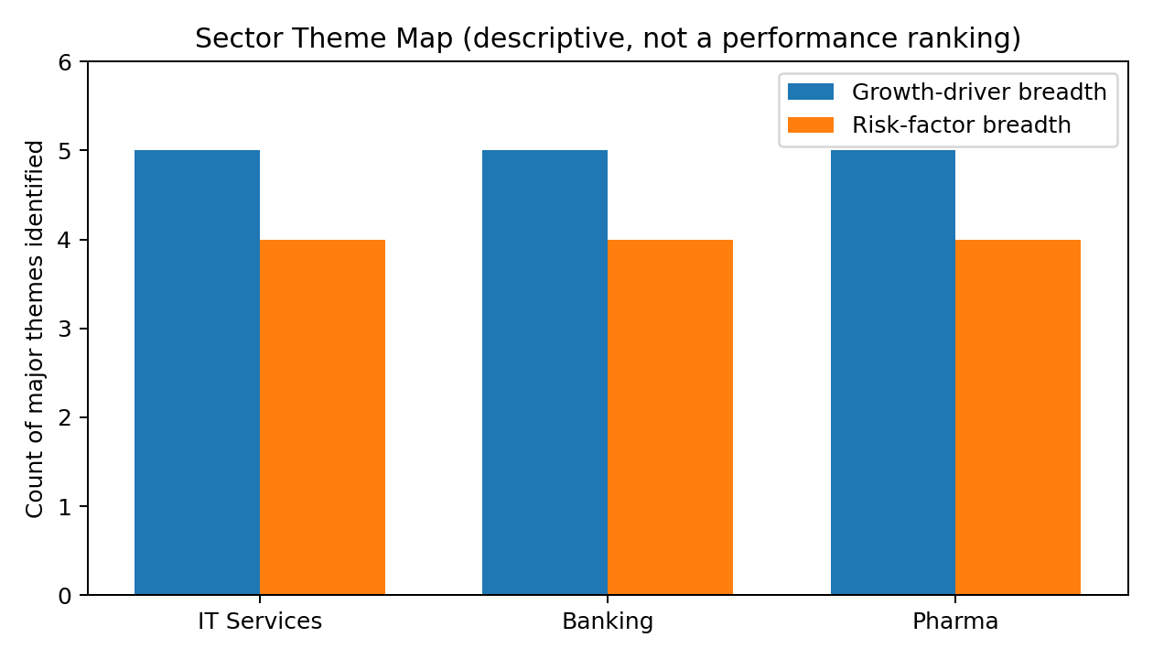
The theme map above counts the major growth and risk themes discussed in this report. It is a descriptive research aid, not a ranking of sectors or a prediction of returns.

Company-level snapshot
Company | Sector | Recent indicator | Strategy themes | Key risk
TCS | IT | Q1 FY27 revenue US$7.624bn; +2.7% YoY (US$) | AI revenue, transformation deals | Global tech spending
Infosys | IT | Q1 FY27 revenue ₹48,211cr; +14.0% YoY | AI/cloud/digital transformation | Client budgets, currency
HDFC Bank | Banking | Q1 FY27 profit ₹19,060cr; +5% YoY | Loan/deposit growth | Asset quality, funding
ICICI Bank | Banking | Q1 FY27 profit ₹14,805cr; +15.9% YoY | Credit, digital, branch expansion | Credit cycle, regulation
Sun Pharma | Pharma | Q1 FY27 profit ₹2,894cr; +27% YoY | Domestic + specialty/innovative products | Regulation, pricing
Dr. Reddy’s | Pharma | FY26 revenue ₹33,593cr; +3.2% YoY | Generics + pipeline + efficiency | US market, patents

8. Market Research Diagrams & Applications

8.1 Sector-analysis flowchart
Public market information
↓
Macro & market environment
↓
Sector trends and drivers
↓
Company financial results
↓
Management strategy + risks
↓
Charts, tables and comparison
↓
Evidence-based academic conclusions

8.2 Business-analysis application diagram
Input | Input | Input
Market News | Economic indicators | Company results
↓ | ↓ | ↓
Sector demand assessment | Risk assessment | Fundamental assessment
↘ | ↓ | ↙
Integrated market-research report | → | Visual dashboard

8.3 Practical applications of sector analysis
- Academic research: understanding how macroeconomic events affect different industries.
- Business strategy: identifying demand drivers and competitive pressures.
- Financial journalism: explaining why sectors move differently during the same market event.
- Corporate benchmarking: comparing business models, growth rates and strategic priorities.
- Risk management: identifying regulatory, operational, financial and market risks.
- Portfolio education: understanding diversification concepts without relying on a single industry narrative.

8.4 Advantages of structured market research
- Improves the quality and traceability of conclusions.
- Reduces dependence on isolated news headlines.
- Makes sector differences easier to communicate through charts and tables.
- Encourages evidence-based rather than emotion-based interpretation.
- Allows quarterly updates as new results and market data become available.

9. SWOT Analysis

9.1 IT Services
SWOT | Key points
Strengths | Large skilled workforce; global delivery; established brands; AI/cloud capabilities
Weaknesses | High exposure to global technology budgets; talent costs; currency sensitivity
Opportunities | AI transformation; cybersecurity; cloud modernization; digital engineering
Threats | Global slowdown; automation of routine work; intense competition

9.2 Banking
SWOT | Key points
Strengths | Large customer base; recurring interest/fee income; digital infrastructure
Weaknesses | Capital and regulatory requirements; sensitivity to asset quality
Opportunities | Credit growth; MSME finance; digital payments; financial inclusion
Threats | Bad loans; cyber fraud; margin pressure; regulatory changes

9.3 Pharmaceuticals
SWOT | Key points
Strengths | Strong manufacturing base; broad generic capabilities; healthcare demand
Weaknesses | Regulatory complexity; pricing pressure in generics
Opportunities | Specialty medicines; complex generics; CDMO; domestic healthcare growth
Threats | Patent expiries; regulatory observations; litigation; global pricing pressure

10. Strategic Recommendations for Future Research
The recommendations below are research-process recommendations rather than personal investment advice.
- Refresh benchmark and sector-index data at the start of each reporting period.
- Compare at least four quarters of revenue, profit, margins and major operating KPIs before drawing a trend conclusion.
- Separate company-specific factors from macro factors; for example, distinguish client-budget weakness from an IT company’s execution issue.
- Track management commentary against later outcomes to assess whether strategic priorities are being executed.
- Include regulatory announcements, product launches, acquisitions and major contracts because financial statements alone may not capture the full strategic picture.
- Use scenario analysis—base, stronger-demand and weaker-demand cases—instead of presenting a single certain forecast.
- Cite every important numerical claim and record the date of the source.

Suggested dashboard for future weeks
Dashboard area | Metrics
Market | Nifty 50, Sensex, sector indices, volatility, FPI/DII flows
Macro | Crude oil, USD/INR, inflation, interest rates, GDP indicators
IT | Revenue growth, EBIT margin, TCV, AI revenue, attrition
Banking | Loan growth, deposit growth, NIM, GNPA/NNPA, capital adequacy
Pharma | Revenue growth, India/US sales, product launches, R&D, regulatory events

11. Conclusion
This market-research exercise demonstrates why sector analysis is essential for understanding equity-market movements. September 2026 showed that broad market weakness can be driven by a combination of oil prices, global yields, geopolitical uncertainty and foreign investor flows. However, the effect of those conditions differs across industries.
IT services remain closely connected to global technology spending and the rapid adoption of AI, cloud and cybersecurity. TCS and Infosys illustrate two large Indian technology businesses with significant global exposure and ongoing AI-related strategic priorities. Banking is supported by credit expansion, digital adoption and financial formalization, while HDFC Bank and ICICI Bank demonstrate the importance of loan growth, deposit growth, margins and asset quality. Pharmaceuticals combine domestic healthcare demand with international generics and specialty opportunities; Sun Pharma and Dr. Reddy’s illustrate the importance of product pipelines, regulatory execution, geographic diversification and pricing dynamics.
The most important analytical lesson is that market research should combine quantitative evidence with qualitative context. Charts show what happened, while business models, management strategy, regulation and macroeconomic conditions help explain why it happened. Because market conditions change quickly, this report should be treated as a dated research snapshot and updated when new quarterly results, sector data or major economic events become available.

12. References / Public Sources
- 1. Reuters (30 Sep 2026), “India benchmark shares log worst month since March as oil, global rate hikes spark outflows.”
- 2. NSE/Nifty Indices, Sectoral Indices – Nifty IT, Nifty Bank, Nifty Pharma and related index information.
- 3. Tata Consultancy Services, Q1 FY27 financial results, 9 July 2026.
- 4. Infosys, Q1 FY27 Financial Snapshot and Q1 FY27 results, July 2026.
- 5. HDFC Bank, Q1 FY27 Financial Results and Investor Relations disclosures, 18 July 2026.
- 6. Reuters (18 July 2026), HDFC Bank Q1 FY27 results coverage.
- 7. ICICI Bank, Performance Review for quarter ended 30 June 2026.
- 8. Sun Pharmaceutical Industries, Q1 FY27 results and Investor Information, July 2026.
- 9. Moneycontrol (31 July 2026), Sun Pharma Q1 FY27 results coverage.
- 10. Dr. Reddy’s Laboratories, FY26 results/presentation and Q1 FY27 financial filing.
- 11. Financial Express (28 Sep 2026), India pharmaceutical sector FY27 growth coverage.

Source links
https://www.reuters.com/world/india/indian-shares-likely-rise-oil-comes-off-bse-joins-nifty-2026-09-30/
https://www.niftyindices.com/indices/equity/sectoral-indices
https://www.tcs.com/who-we-are/newsroom/press-release/tcs-financial-results-q1-fy-2027
https://www.infosys.com/about/last-quarter.html
https://www.hdfc.bank.in/about-us/investor-relations/financial-results
https://www.icici.bank.in/about-us/news-room/2026/performance-review-quarter-ended-june-30-2026
https://sunpharma.com/investors/
https://www.drreddys.com/

Appendix A – Key Terms
Term | Meaning
Nifty 50 | A major Indian equity benchmark comprising 50 large companies listed on NSE.
Sector index | An index designed to represent the performance of a particular industry or sector.
Revenue | Income generated from the company’s business operations before expenses.
Net profit / PAT | Profit remaining after applicable expenses and taxes.
NIM | Net Interest Margin; a banking measure of the spread earned on interest-earning assets relative to funding.
NPA | Non-performing asset; a loan exposure classified as non-performing under applicable banking rules.
TCV | Total Contract Value; a measure used by IT services companies for contracted business.
AI | Artificial intelligence, including machine learning and generative AI technologies.

