Graph1:

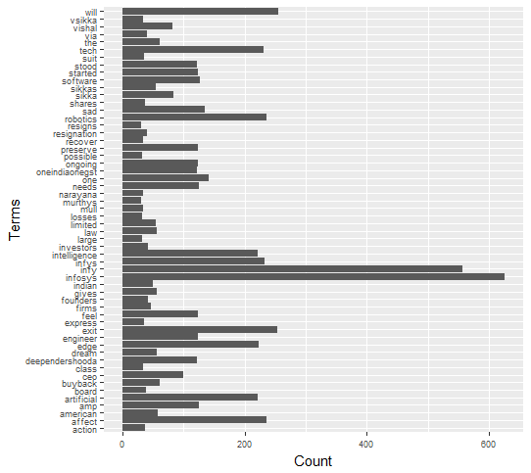

Graph2:



Sentiments:

negative neutral positive

170 772 58

Sentiment Score:

result

date score

1 2017-08-18 -4

2 2017-08-19 -96

3 2017-08-20 -12

Graphh3 (sentiments Score Vs Date)

