MAHATMA JYOTIBA PHULE ROHILKHAND UNIVERSITY, BAREILLY



PROJECT REPORT
ON
“SALARY MANAGEMENT SYSTEM”

DEPARTMENT OF COMPUTER SCIENCE AND INFORMATION TECHNOLOGY

SUBMITTED TO : SUBMITTED BY :
Ms. Nikhat Praveen Deepak Gangwar (24CS25)
Dhruv Kumar (24CS26)
Divya Gupta (24CS27)
Gauri Saxena (24CS28)

ACKNOWLEDGEMENT

I would like to express my sincere gratitude to all those who have supported and guided me throughout the development of this project on the Salary Management System.
Firstly, I would like to thank my project guide and faculty members for their valuable guidance, encouragement, and continuous support during the course of this project. Their insights and suggestions helped me in understanding the concepts clearly and completing the project successfully.
I am also thankful to my college for providing me with the necessary resources and environment to work on this project. The infrastructure and academic support played an important role in the completion of this work.
I would like to extend my appreciation to my friends and classmates who helped me with their suggestions and support whenever required.
Lastly, I am grateful to my family for their constant motivation and encouragement throughout the project.
This project has been a great learning experience, and I am thankful to everyone who contributed directly or indirectly to its completion.

SALARY MANAGEMENT SYSTEM

INTRODUCTION

The Salary Management System is a software application designed to simplify and automate the process of managing employee salary details within an organization. In many organizations, handling payroll manually or through basic tools can be time-consuming, error-prone, and difficult to maintain. This project aims to provide an efficient and structured solution for managing employee records, departments, and salary-related information.
The system allows the user (admin or authorized personnel) to perform operations such as adding new employees, updating employee details, managing departments, and calculating salaries. It ensures that all the data is stored systematically and can be accessed easily whenever required.
This project is developed using programming concepts and database connectivity (such as Python with database modules), making it user-friendly and efficient. The application provides a menu-driven interface where users can navigate through different functionalities without difficulty.
Overall, the Salary Management System reduces manual workload, improves accuracy, and ensures better organization of employee and salary data. It serves as a basic model that can be further expanded into a full-scale payroll system with advanced features.

Problems With The Current System
The existing system (manual or semi-manual methods) for managing employee salaries has several limitations:
1. Time-Consuming Process
Manual calculation of salaries, maintaining records, and updating employee details require a significant amount of time, especially in organizations with many employees.
2. High Chances of Errors
Human errors such as incorrect salary calculation, wrong data entry, or misplacement of records are very common in manual systems.
3. Poor Data Management
Storing employee and salary data in files or spreadsheets can lead to:
- Data redundancy
- Difficulty in searching records
- Lack of proper organization
4. Lack of Security
Manual records or basic systems do not provide proper data security. Sensitive employee information can be easily accessed, modified, or lost.
5. Difficulty in Updating Records
Updating employee information such as salary, department, or contact details is not efficient and may lead to inconsistencies.
6. No Centralized System
Data is often scattered across multiple files or registers, making it difficult to maintain a single reliable source of information.
7. Limited Scalability
As the organization grows, the existing system becomes harder to manage and inefficient.

OBJECTIVES OF THE PROJECT
The main objectives of the Salary Management System are:
1. Automate Salary Management
To reduce manual effort by automating the process of storing, updating, and managing employee salary details.
2. Improve Accuracy
To minimize human errors in salary calculation and data handling by using a computerized system.
3. Efficient Data Storage
To store employee and salary information in a structured and organized manner using a database.
4. Easy Data Retrieval
To allow users to quickly search, view, and access employee and department details whenever needed.
5. Simplify Record Management
To provide functionalities like:
- Adding employees
- Updating employee details
- Managing departments
- Viewing salary records
6. Enhance Security
To ensure that sensitive employee data is stored safely and accessed only by authorized users.
7. User-Friendly Interface
To design a simple and easy-to-use menu-driven interface that can be operated without advanced technical knowledge.
8. Scalability and Flexibility
To create a system that can be easily expanded in the future by adding more features.
ER DIAGRAM
ENTITY-RELATIONSHIP(ER) DIAGRAM DESCRIPTION

The Entity-Relationship (ER) Diagram of the Salary Management System represents the structure of the database, including entities, their attributes, and relationships. In this system, specialization is used to divide employees into different categories based on their employment type.

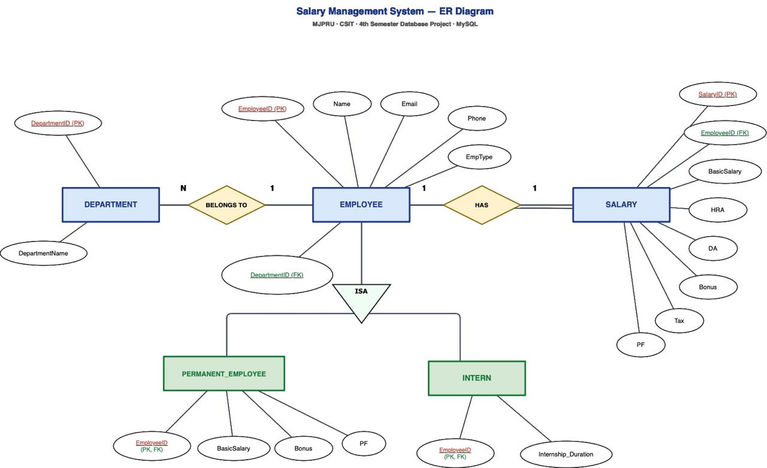

Entities And Their Attributes
1. Employee
The Employee entity is the main entity that stores common details of all employees.
Attributes:
- EmployeeID (Primary Key)
- Name
- Email
- Phone_Number
- EmpType
- DepartmentID (Foreign Key)
This entity contains attributes that are common to all types of employees.

2. Permanent Employee
This is a specialized entity derived from the Employee entity.
Attributes:
- EmployeeID (Primary Key & Foreign Key)
- Basic_Salary
- Bonus
- PF
Explanation:
Permanent employees receive a fixed salary along with allowances and deductions.

3. Intern
This is another specialized entity derived from the Employee entity.
Attributes:
- Employee_ID (Primary Key & Foreign Key)
- Internship_Duration
Explanation:
Interns are hired for a specific time duration.

4. Department
The Department entity stores details of different departments.
Attributes:
- Department_ID (Primary Key)
- Department_Name

5. Salary
Attributes:
- Salary_ID (Primary Key)
- Employee_ID (Foreign Key)
- Basic_Salary
- HRA
- DA
- Bonus
- Tax
- PF
Explanation:
The Salary entity stores the final salary paid to employees. It helps in maintaining salary records separately and can also support salary history.

2. Specialization (Generalization Concept)
- The Employee entity is divided into:
  - Permanent Employee
  - Intern
- This is called specialization, where a higher-level entity (Employee) is broken down into lower-level entities based on specific characteristics.

3. Relationships
1. Employee – Department
- Type: Many-to-One (M:1)
- Many employees belong to one department.

2. Employee – Sub Entities
- The relationship between Employee and its sub-entities is “IS-A” relationship:
  - Permanent Employee IS-A Employee
  - Intern IS-A Employee

4. Keys Used
Primary Keys
- Employee_ID (Employee)
- Department_ID (Department)
- Salary_ID (Salary)
Foreign Keys
- Department_ID in Employee
- Employee_ID in Permanent and Intern (links to Employee)

5. Working of the ER Diagram
- When a new employee is added, their general details are stored in the Employee entity.
- Based on their type:
  - If permanent → details go into Permanent Employee
  - If intern → details go into Intern
- This avoids redundancy and keeps data well organized.

Queries
CREATING DATABASE :
create database Salary_Management;

CREATING TABLES:
CREATING TABLE : DEPARTMENT ->
CREATE TABLE DEPARTMENT (
DepartmentID INT PRIMARY KEY,
DepartmentName VARCHAR(20) NOT NULL
);
CREATING TABLE: EMPLOYEE->
CREATE TABLE EMPLOYEE (
EmployeeID INT PRIMARY KEY,
Name VARCHAR(100) NOT NULL,
Email VARCHAR(100) UNIQUE,
Phone VARCHAR(15),
EmpType VARCHAR(20) CHECK (EmpType IN ('Permanent', 'Intern')),
DepartmentID INT,
FOREIGN KEY (DepartmentID) REFERENCES DEPARTMENT(DepartmentID)
);

CREATING TABLE : PERMANENT EMPLOYEE->
CREATE TABLE PERMANENT_EMPLOYEE (
EmployeeID INT PRIMARY KEY,
BasicSalary DECIMAL(10,2) CHECK (BasicSalary >= 0),
Bonus DECIMAL(10,2) CHECK (Bonus >= 0),
PF DECIMAL(10,2) CHECK (PF >= 0),
FOREIGN KEY (EmployeeID)
REFERENCES EMPLOYEE(EmployeeID)
ON DELETE CASCADE
);
CREATING TABLE : INTERN->
CREATE TABLE INTERN (
EmployeeID INT PRIMARY KEY,
Internship_Duration INT CHECK (Internship_Duration > 0),
FOREIGN KEY (EmployeeID)
REFERENCES EMPLOYEE(EmployeeID)
ON DELETE CASCADE
);
CREATING TABLE : SALARY->
CREATE TABLE SALARY (
SalaryID INT PRIMARY KEY,
EmployeeID INT UNIQUE,
BasicSalary DECIMAL(10,2) CHECK (BasicSalary >= 0),
HRA DECIMAL(10,2) CHECK (HRA >= 0),
DA DECIMAL(10,2) CHECK (DA >= 0),
Bonus DECIMAL(10,2) CHECK (Bonus >= 0),
Tax DECIMAL(10,2) CHECK (Tax >= 0),
PF DECIMAL(10,2) CHECK (PF >= 0),
FOREIGN KEY (EmployeeID)
REFERENCES EMPLOYEE(EmployeeID)
ON DELETE CASCADE
);

INSERTING DATA:
INSERTING DATA IN TABLE : DEPARTMENT->
INSERT INTO DEPARTMENT VALUES
(1, 'HR'),
(2, 'IT'),
(3, 'Finance'),
(4, 'Marketing'),
(5, 'Production');
INSERTING DATA IN TABLE: EMPLOYEE->
INSERT INTO EMPLOYEE VALUES
(101,'Aarav Sharma','aarav101@gmail.com','9000000001',
'Permanent',3),
(102,'Riya Verma','riya102@gmail.com','9000000002','Intern',1),
(103,'Kabir Singh','kabir103@gmail.com','9000000003',
'Permanent',5),
(104,'Ananya Gupta','ananya104@gmail.com','9000000004',
'Intern',2),
(105,'Vivaan Mehta','vivaan105@gmail.com','9000000005',
'Permanent',4),
(106,'Diya Kapoor','diya106@gmail.com','9000000006','Intern',3),
(107,'Arjun Nair','arjun107@gmail.com','9000000007',
'Permanent',1),
(108,'Meera Iyer','meera108@gmail.com','9000000008','Intern',5),
(109,'Rohan Das','rohan109@gmail.com','9000000009',
'Permanent',2),
(110,'Sneha Joshi','sneha110@gmail.com','9000000010','Intern',4);

INSERTING DATA IN TABLE: PERMANENT_EMPLOYEE->
INSERT INTO PERMANENT_EMPLOYEE VALUES
(101,50000,5000,2000),
(103,60000,6000,2500),
(105,55000,5500,2200),
(107,52000,4000,2000),
(109,58000,5000,2500);

INSERTING DATA IN TABLE: INTERN->
INSERT INTO INTERN VALUES
(102,6),(104,6),(106,6),(108,6),(110,6);
INSERTING DATA IN TABLE: SALARY->
INSERT INTO SALARY VALUES
(1,101,50000,10000,5000,5000,3000,2000),
(2,102,30000,5000,2000,1000,500,0),
(3,103,60000,12000,6000,6000,3500,2500),
(4,104,32000,6000,2500,1000,800,0),
(5,105,55000,11000,5500,5500,3200,2200),
(6,106,31000,5000,2000,1000,500,0),
(7,107,52000,10000,5000,4000,3000,2000),
(8,108,30000,5000,2000,1000,500,0),
(9,109,58000,11000,5000,5000,3000,2500),
(10,110,31000,5000,2000,1000,500,0);

VIEWING DATA OF TABLES

VIEW DEPARTMENT TABLE->
SELECT* from department;

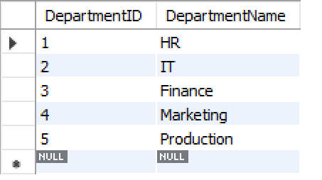

VIEW EMPLOYEE TABLE->
SELECT* from employee;
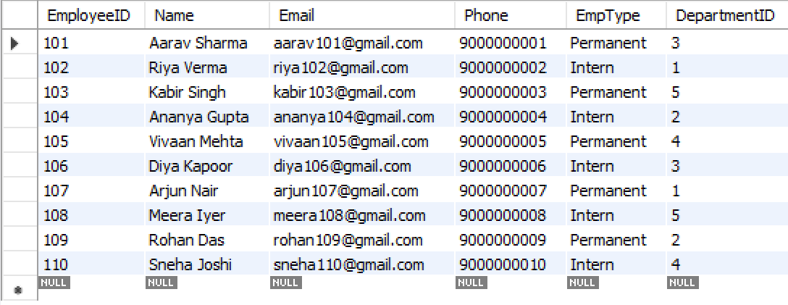

VIEW PERMANENT EMPLOYEE->
SELECT* FROM permanent_employee;
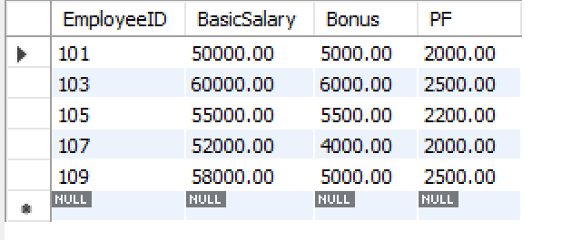

VIEW INTERN ->
SELECT* from intern;
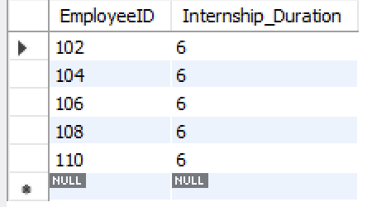

VIEW SALARY->
SELECT* from salary;
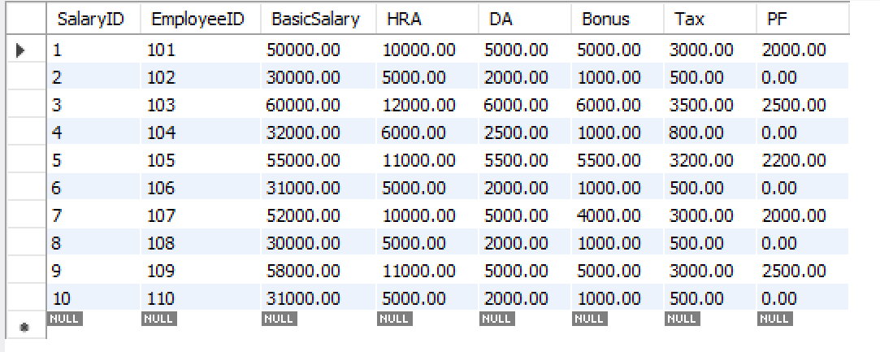

CALCULATE NET SALARY REPORT->
SELECT e.EmployeeID, e.Name, s.BasicSalary, s.HRA, s.DA, s.Bonus, s.Tax, s.PF,
(s.basicSalary + s.HRA + s.DA + s.Bonus - s.tax - s.pf) AS NET_SALARY
FROM Salary s
LEFT JOIN Employee e on s.employeeID=e.EmployeeID;
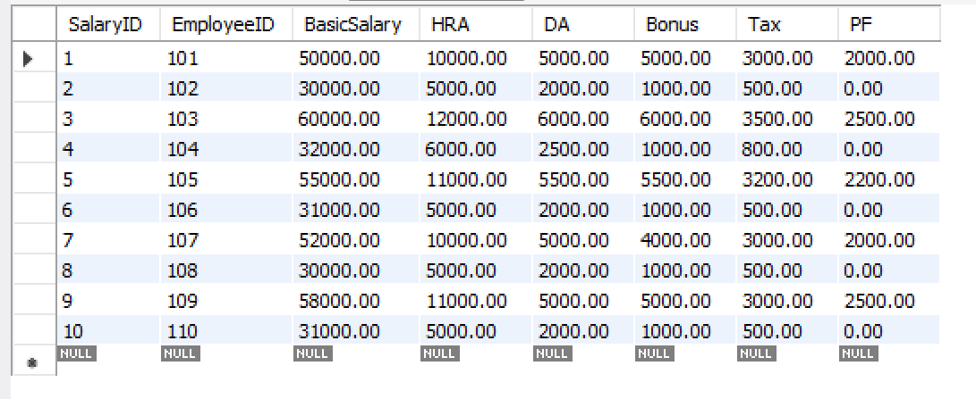

VIEW HIGHEST PAID EMPLOYEE->
SELECT e.EmployeeID, e.Name,
(s.BasicSalary + s.HRA + s.DA + s.Bonus - s.Tax - s.PF) AS NetSalary
FROM EMPLOYEE e
JOIN SALARY s ON e.EmployeeID = s.EmployeeID
ORDER BY NetSalary DESC
LIMIT 1;

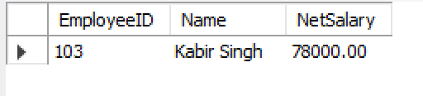

EMPLOYEE IN SPECIFIC DEPARTMENT->
SELECT e.EmployeeID, e.Name, d.DepartmentName
FROM EMPLOYEE e
JOIN DEPARTMENT d ON e.DepartmentID = d.DepartmentID
WHERE d.DepartmentName = 'IT';

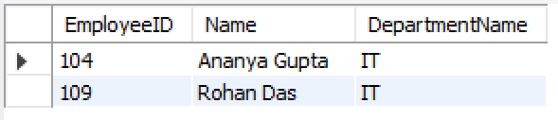

DEPARTMENT WISE SALARY REPORT->

SELECT d.DepartmentName,
SUM(s.BasicSalary + s.HRA + s.DA + s.Bonus - s.Tax - s.PF) AS TotalSalary,
ROUND( AVG(s.BasicSalary + s.HRA + s.DA + s.Bonus - s.Tax - s.PF)) AS AvgSalary
FROM EMPLOYEE e
JOIN DEPARTMENT d ON e.DepartmentID = d.DepartmentID
JOIN SALARY s ON e.EmployeeID = s.EmployeeID
GROUP BY d.DepartmentName;

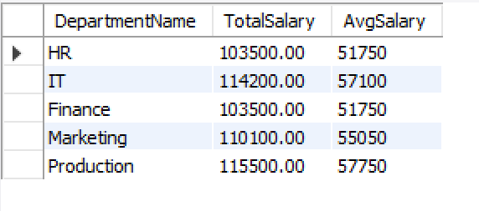

FUTURE ADVANCEMENTS:
Future Advancements in Salary Management Systems
1. AI & Machine Learning
Automates salary calculations
Detects errors or fraud
Predicts salary trends
2. Cloud-Based Systems
Access data anytime, anywhere
Real-time updates
Secure storage with backups
3. Blockchain Technology
Tamper-proof salary records
High transparency and security
4. Employee Self-Service Portals
View payslips anytime
Apply leave & update details
Reduces HR workload
5. System Integration
Connects with attendance, tax, performance systems
Ensures accurate salary processing
6. Data Analytics
Helps in salary planning and budgeting
Improves decision-making

