**EXPERIMENT -1** GAURISH ANAND (2K18 / IT / 055 )

**PARAMETERS INITIALIZATION**

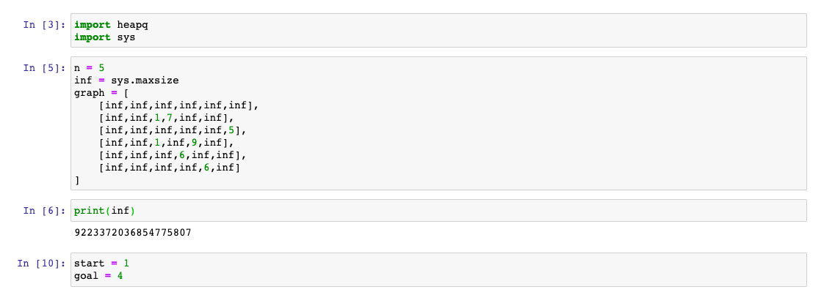

**3 ALGOS USED ARE –**

1. **DEPTH FIRST SEARCH (DFS)**
2. **BREADTH FIRST SEARCH (BFS)**
3. **UNIFORM COST SEARCH (UCS)**
4. DFS

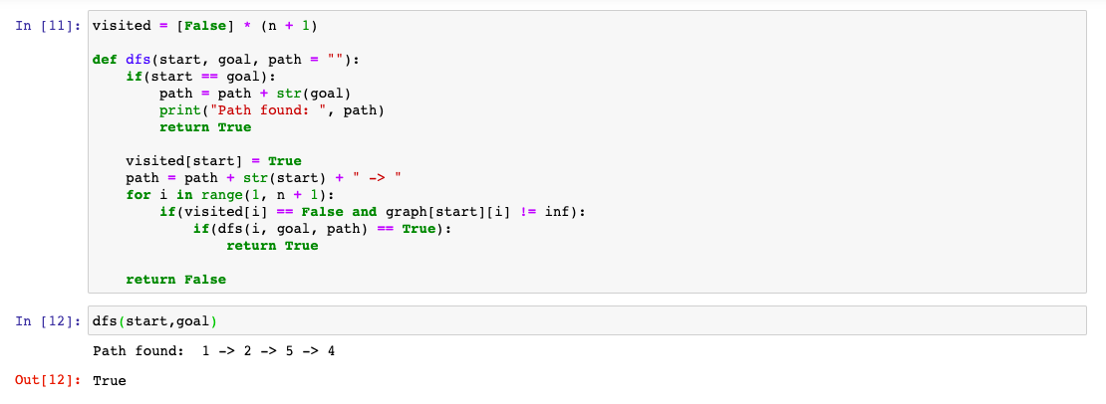

1. BFS

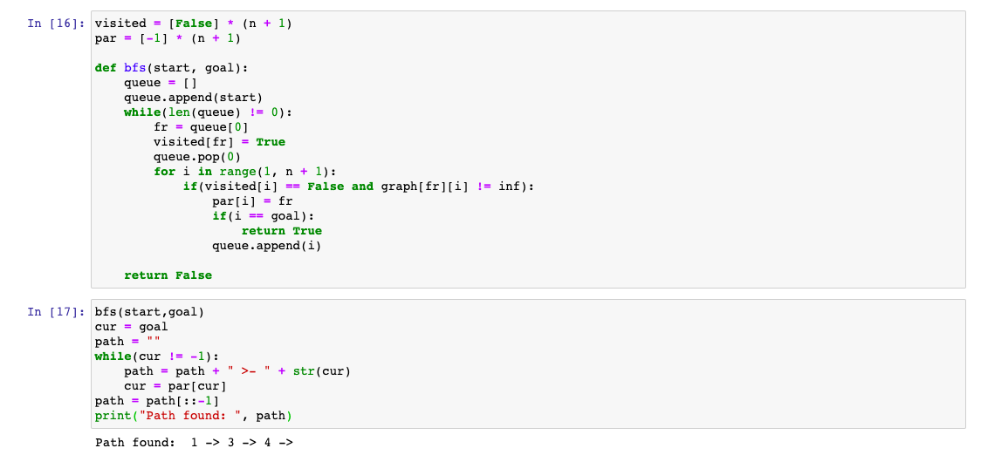

1. UCS

