**EXPERIMENT -2** GAURISH ANAND (2K18 / IT / 055 )

**PARAMETERS INITIALIZATION --- [CODE_LINK](https://github.com/gaurishanand13/AI-LAB/blob/main/GaurishAnand_Expreriment2.ipynb) (PLEASE REFRESH IF CODE IS NOT LOADED IN ONE TIME)**

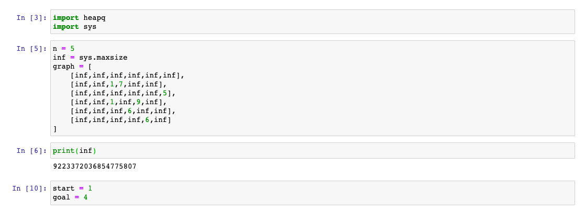

**3 ALGOS USED ARE –**

1. **DEPTH FIRST SEARCH (DFS)**
2. **BREADTH FIRST SEARCH (BFS)**
3. **UNIFORM COST SEARCH (UCS)**
4. DFS

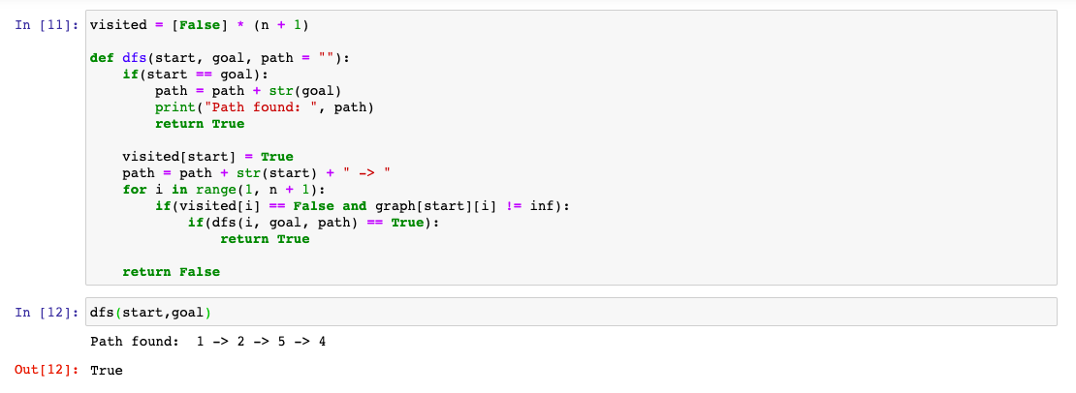

1. BFS

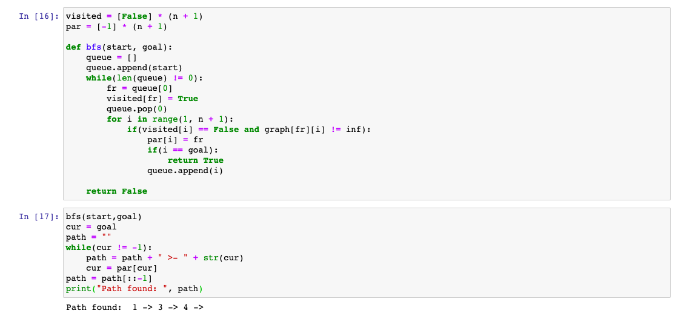

1. UCS

