**Module:**

STW121COM – **Introduction to Computing**

**Assignment Title:**

Coursework- Individual Project

**Intake:**

SEPTMEBER/NOVEMBER 2019

**Submitted By:**

**Gauri Shankar Sharma**

**Submitted To:**

**Shyam Sunder Khatiwada**

**Softwarica College in collaboration with**

**Coventry University**

Assessment Submission and Declaration Form

PLEASE COMPLETE SECTIONS IN BLOCK CAPITALS

|  |  |  |  |
| --- | --- | --- | --- |
| **Group work**  If group work ALL student names and IDs must be added below- on behalf of all members; Name................................................... ID......................  Name................................................... ID......................  Name................................................... ID......................  Name................................................... ID......................  Name................................................... ID...................... | | **Surname:** SHARMA | |
| **First Name:** GAURI SHANKAR | |
| **Word Count:** | |
| **Student number (ID):** 10173183 | | **Attempt:**  FIRST: RESIT: | |
| **Assignment Due Date:** 21 /02/2020 | | **Module Code:** STW121COM | |
| **Programme Title:** BSC (HONS) COMPUTING | | | |
| **Module Title:** INTRODUCTION TO COMPUTING | | | |
| **Name of Supervisor or Tutor (if applicable):**  SHYAM SUNDER KHATIWADA | | **Individual Work:** | **Group Work:** |
| **Assessment Title and Type (i.e. essay, journal, CD,**  **Dissertation)** | | INDIVIDUAL PROJECT |  |
| *I have read the Softwarica College rules and regulations on the submission of academic work and in particular the sections concerning misconduct in assessment, including plagiarism, collusion and cheating. I certify that this assignment is the result of my own (or group) work and contains no unreferenced material from another source and does not contravene any part of the College’s rules and regulations.*  *I acknowledge that in submitting this work I am declaring that I (or my group) are fit to be assessed and that a deferral may not be requested following hand in.*  *I confirm that an electronic version of the item to be assessed where appropriate) is available and will be made available to the College by the specified deadline via Moodle.*  *In respect of group assignments, the submission of this work is made on the basis that all group members are jointly and severally responsible for the work presented for assessment and that by handing in this item for assessment, all group members acknowledge and confirm the statements above and that ALL student names and ID numbers for the group are listed.* | | | |
|  | | | |
| **Student(s) Signature:** | **College Stamp:** | | |

**Table of Contents**

**Introduction** 1

**Screenshots** 3

**User Interfaces** 3

**Codes** 10

**Class Diagram** 19

**Conclusion** 20

**References** 21

# **Introduction**

In this project, an employee management system has been made for an organization using Python 3.7.4 (32 bit) in PyCharm 2019.3.3 (Community Edition). Python is an object oriented, interpreted and high-level programming language. It is simple and easy to learn. It supports modules and packages which makes program modularity and code reuse (Python, n.d.). PyCharm is an integrated development environment used in computer programming, especially for Python with complete set of tools for python development. It provides various features like Intelligence Coding Assistance and Code Editor, Smart Code Navigation, Fast and Safe Refactoring, Debugging, Testing and Profiling etc. (ComponetntSource, n.d.).

The employee management system has got mainly two interfaces. The first interface is related to the user management which has got registration and login interfaces where users can register and login. The second interface is related to the employee management which has got employees and departments details and registration interfaces where new employees and departments can be added in required condition. The users are given access to login using their email and password and their full details will be shown in their login page only if they have been already registered in the admin department otherwise their full details won’t be shown. The available employees and departments details will be only seen and controlled by the administrator. For this, a specific email and password will be recognized as the administrator and the employee and department management page will be open when the administrator logs in.

This employee management system also offers some other functionality which are given below

* Direct access button to register page from sign in page and vice-versa without going back to home page,
* Email format will be checked while registering,
* Password length will be checked,
* registration won’t work using the same email twice,
* Direct access button to employee details page from department details page and vice-versa without going back to administrator page,
* Details of only related employee will be shown in the login page even if two employees have same name
* same department and employee having same contact no., email cannot be added twice,
* error messages will popup according to the mistakes and incorrect behaviors made while registering, logging in, adding departments and employees like registering without filling up the form completely,
* Successful messages will appear after successful login and registering, successfully adding employees and departments.

But this system has some limitation also which are given below

* same employee can register and login using different email,
* the added departments and the employees cannot be deleted,
* no full details of the administrator like the employees,
* space cannot be given while registering the employee details otherwise the system will not work properly,
* more than one department cannot be chosen for an employee etc.

This employee management system can be made more effective by removing and improving above mentioned limitations and adding more features like editing employee and department details, adding more administrator to control the employees and departments details etc.

# **Screenshots**

## **User Interfaces**

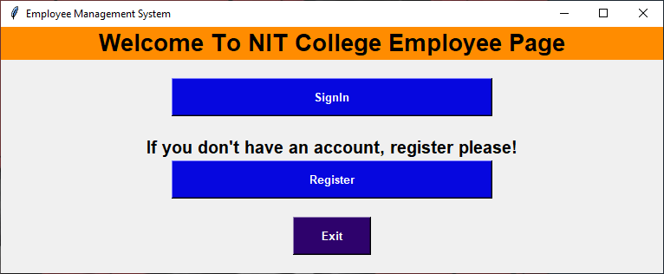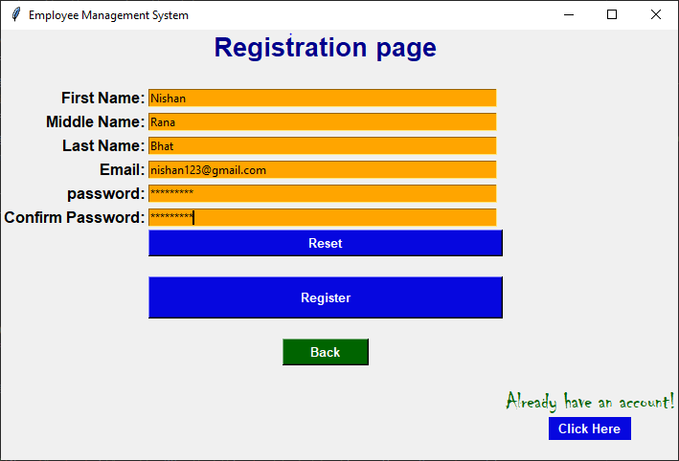

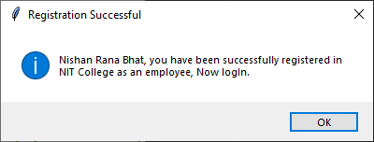

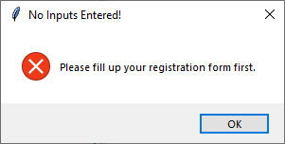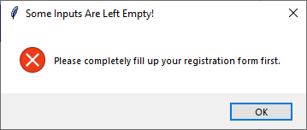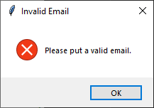

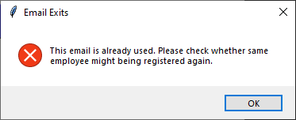

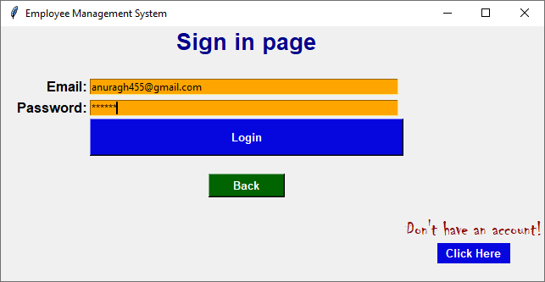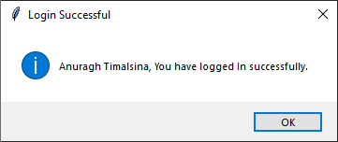

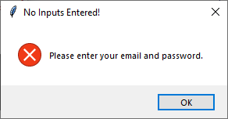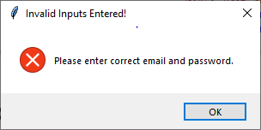

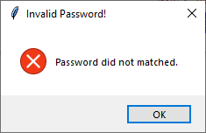

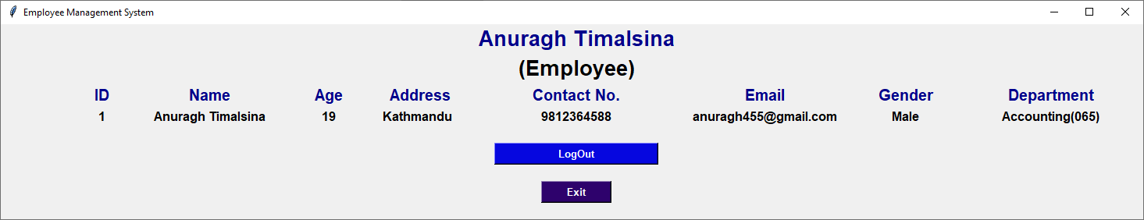

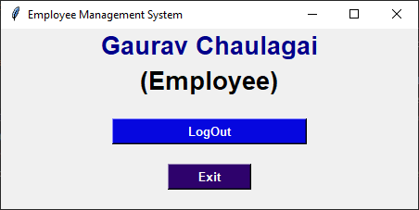

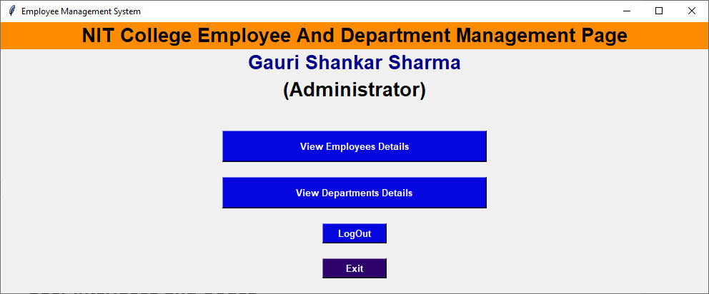

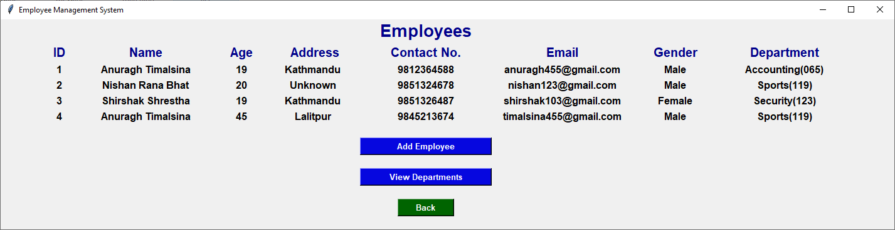

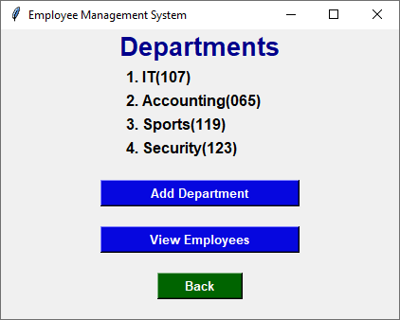

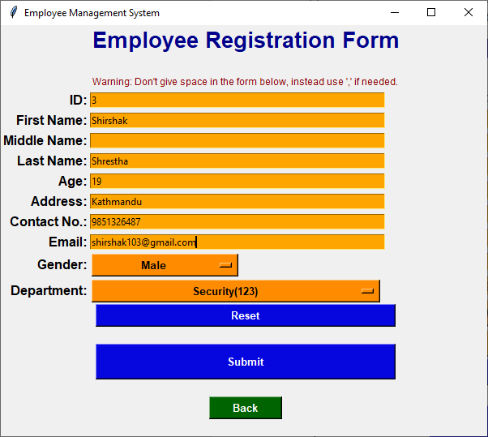

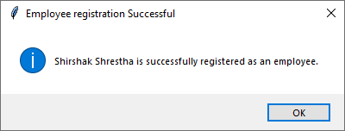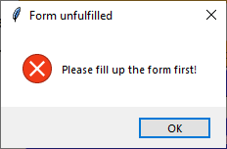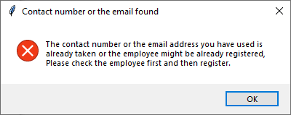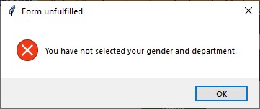

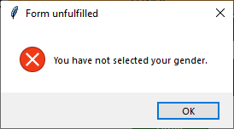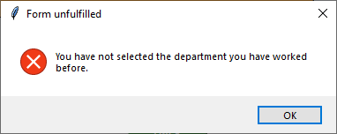

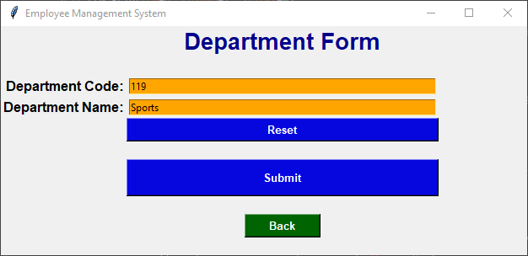

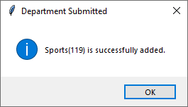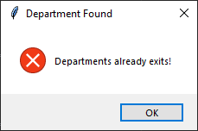

## **Codes**

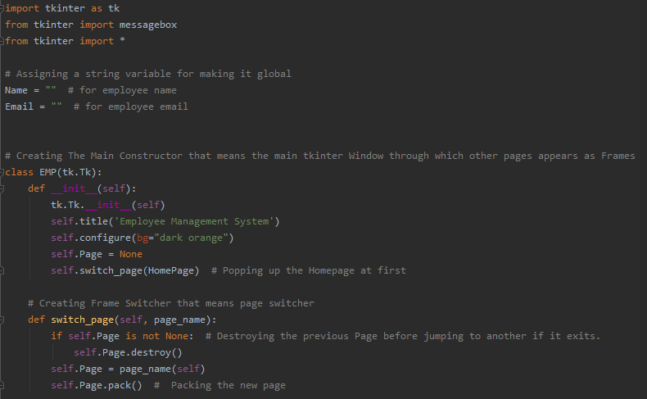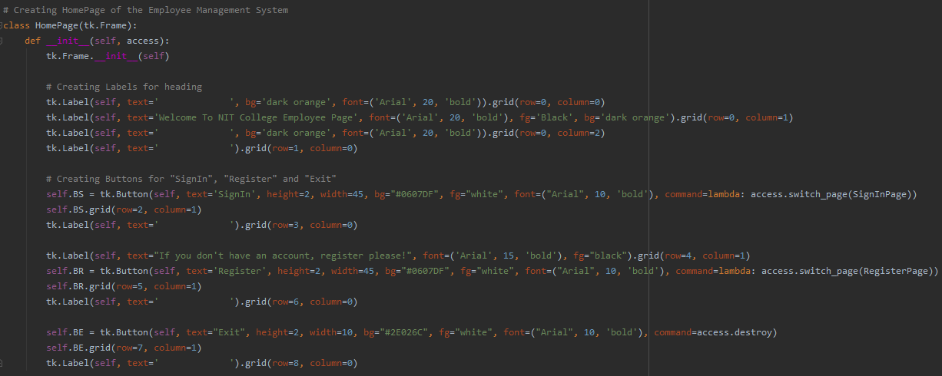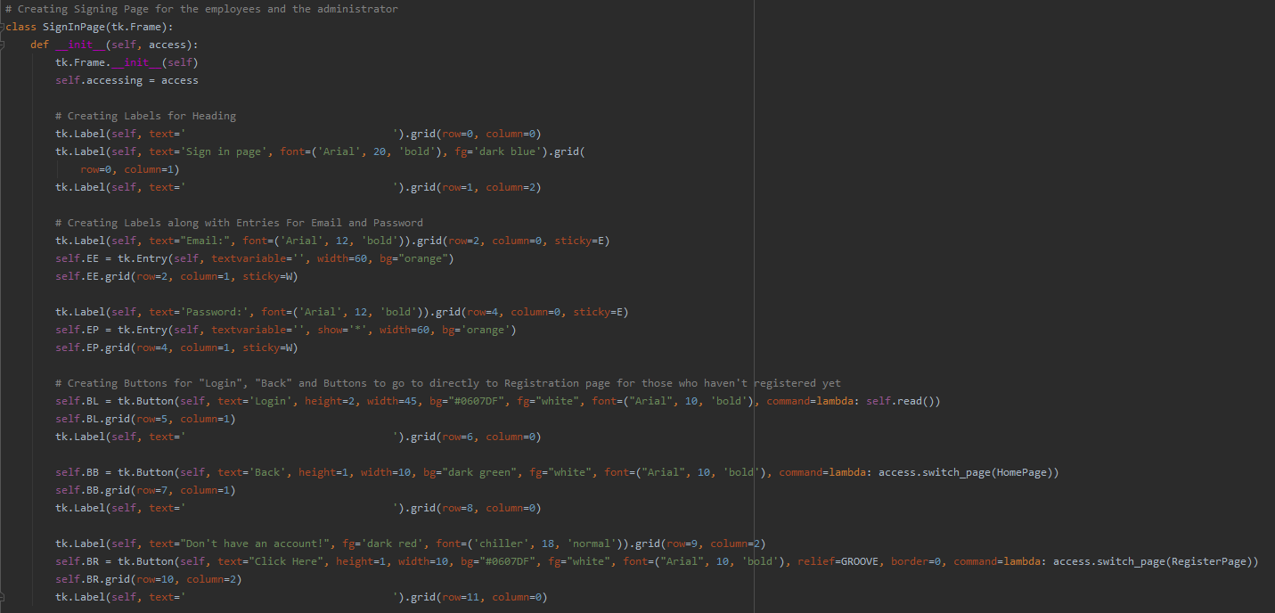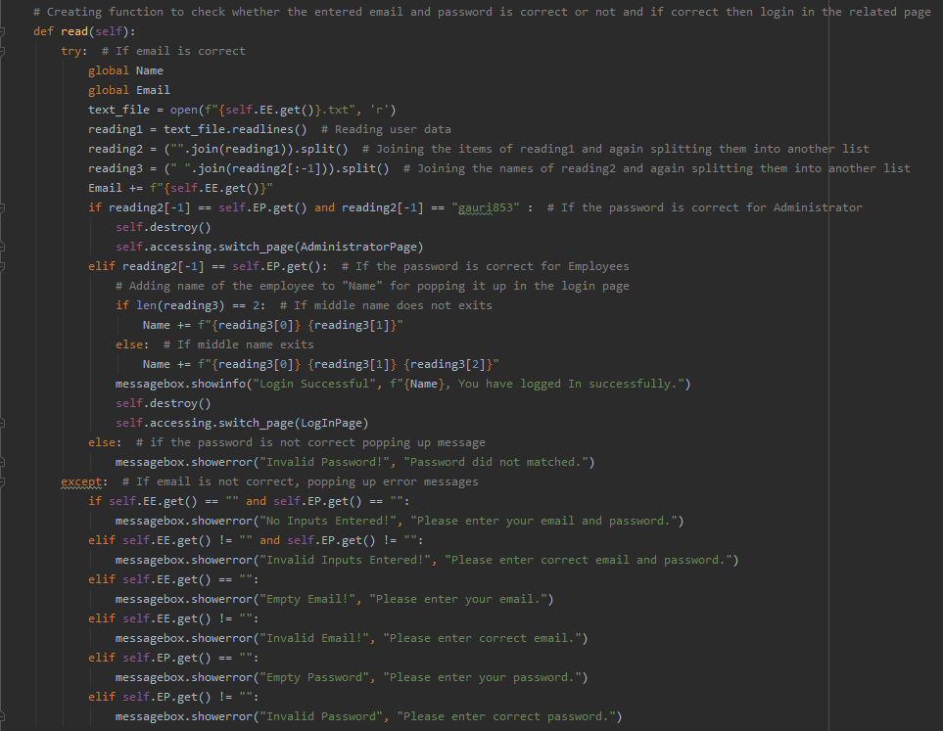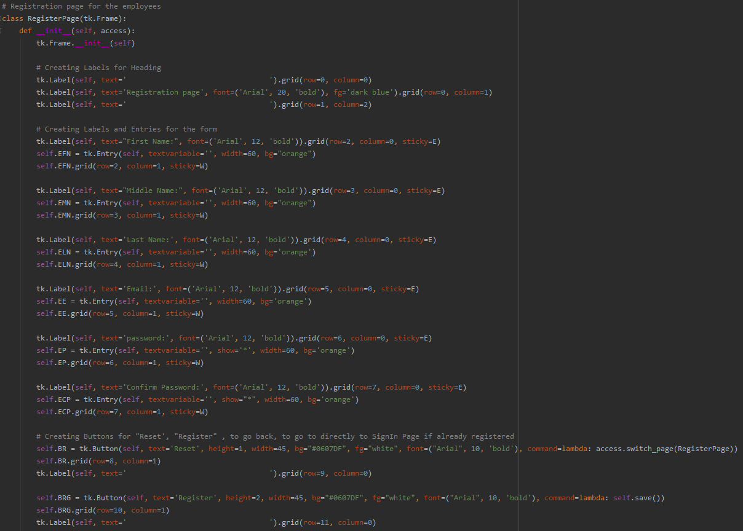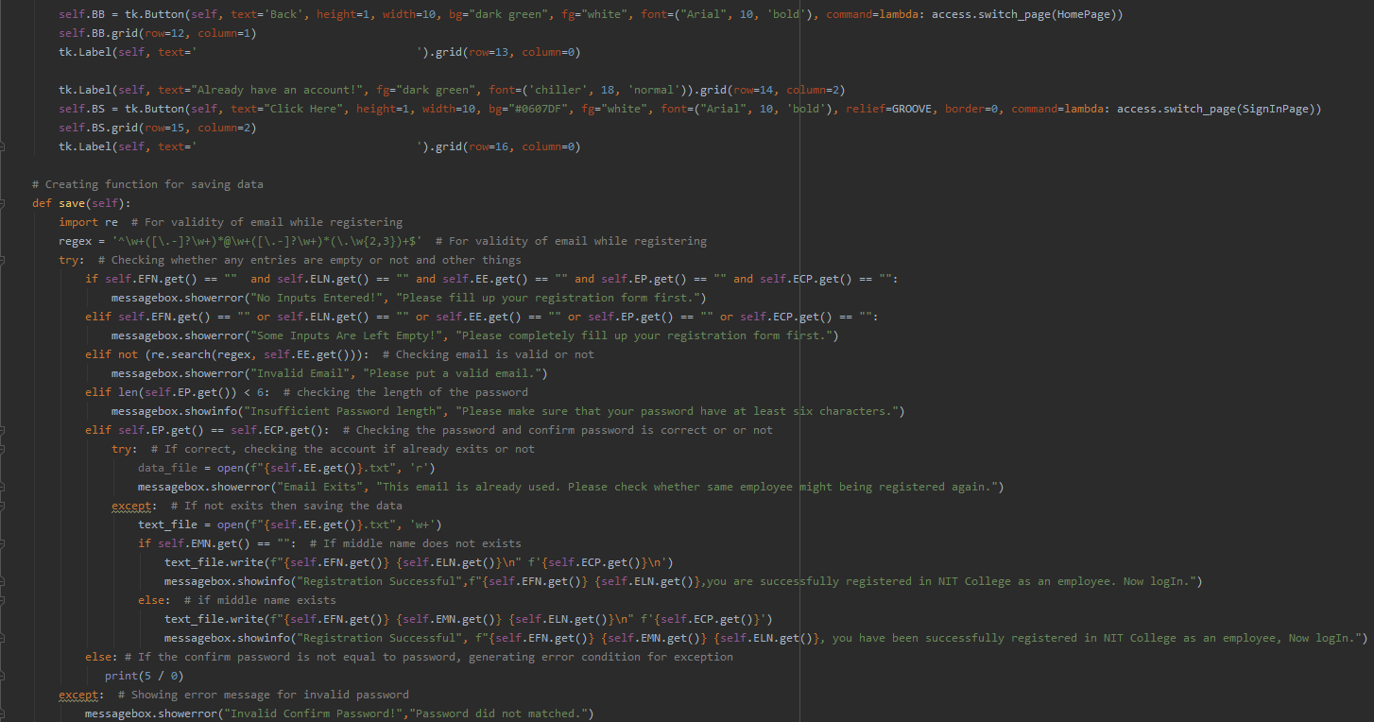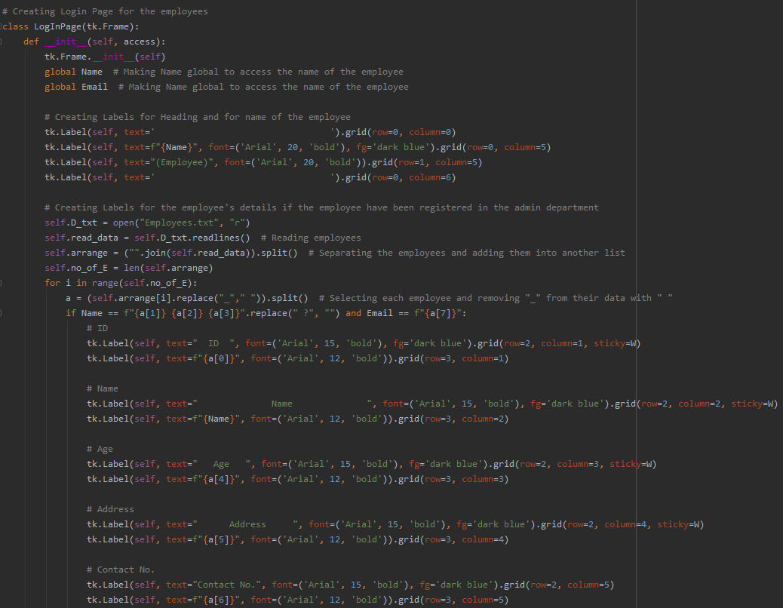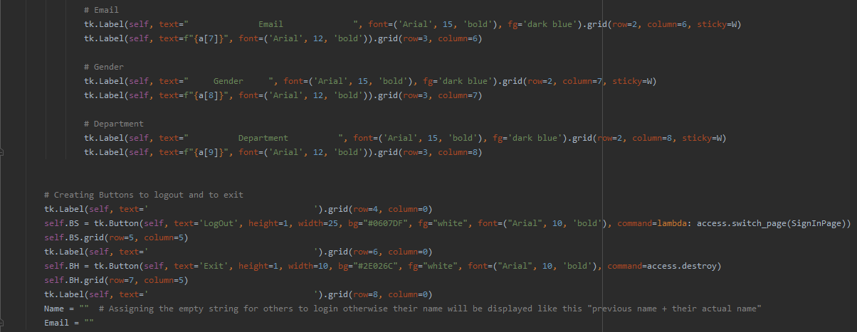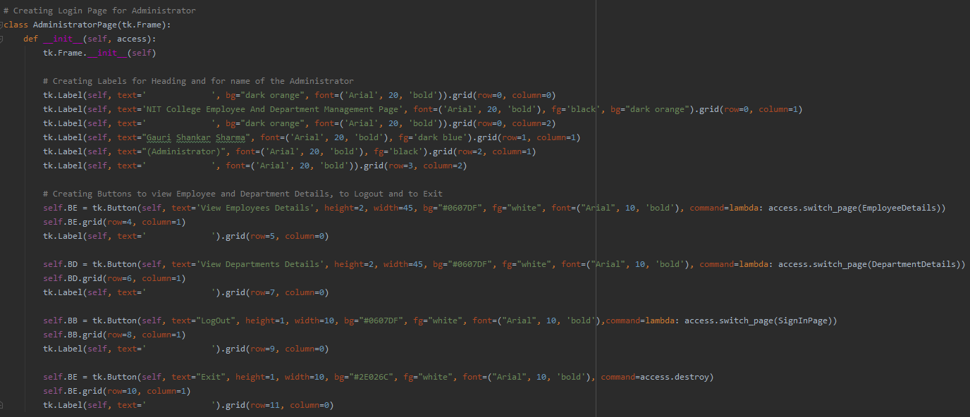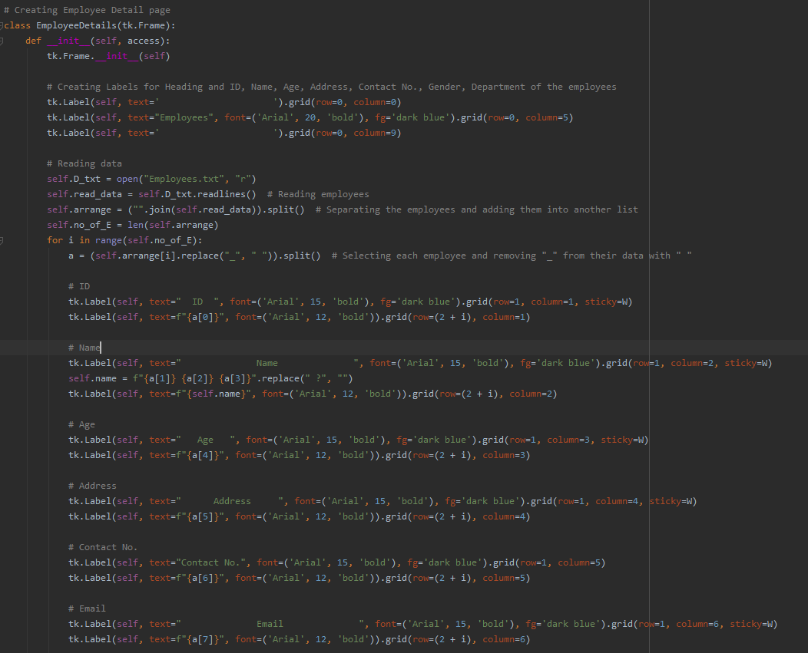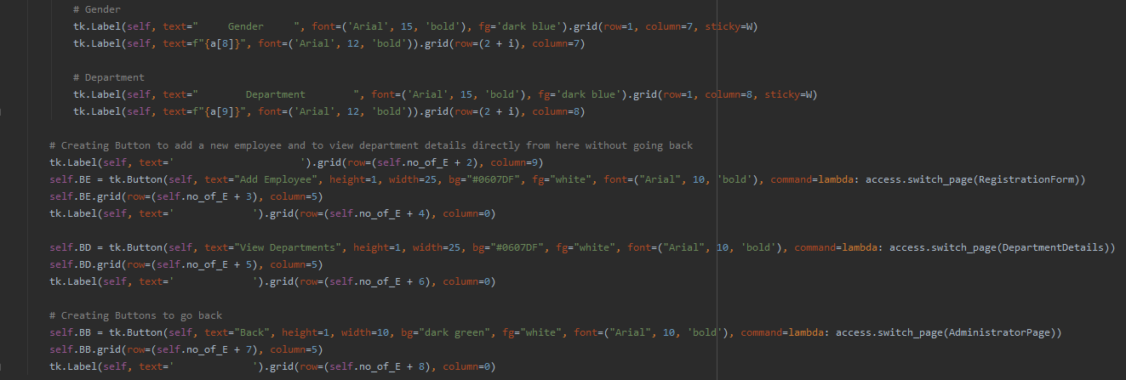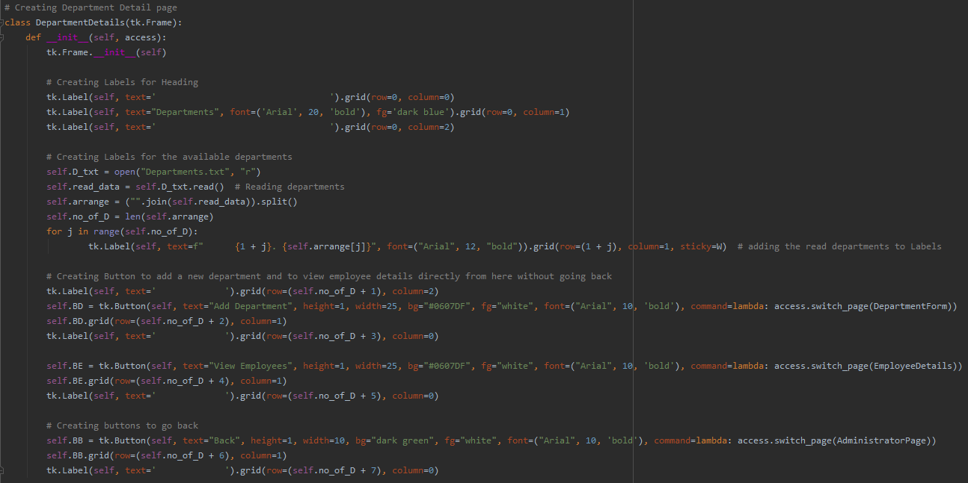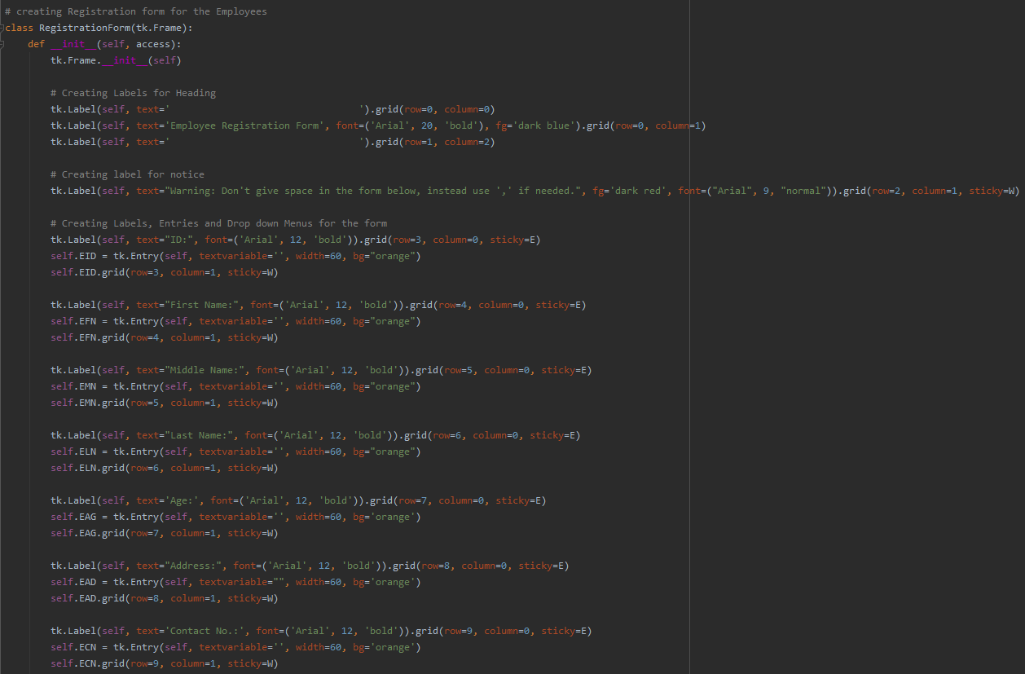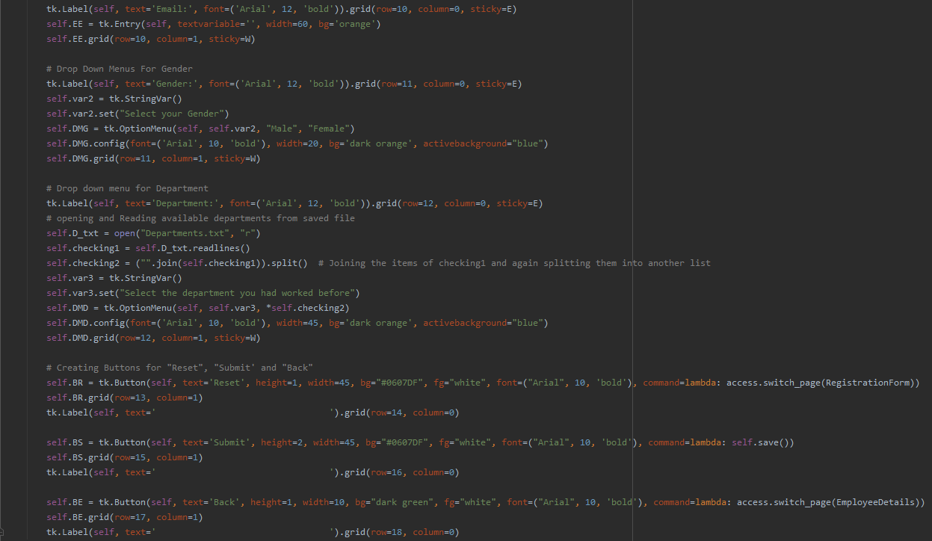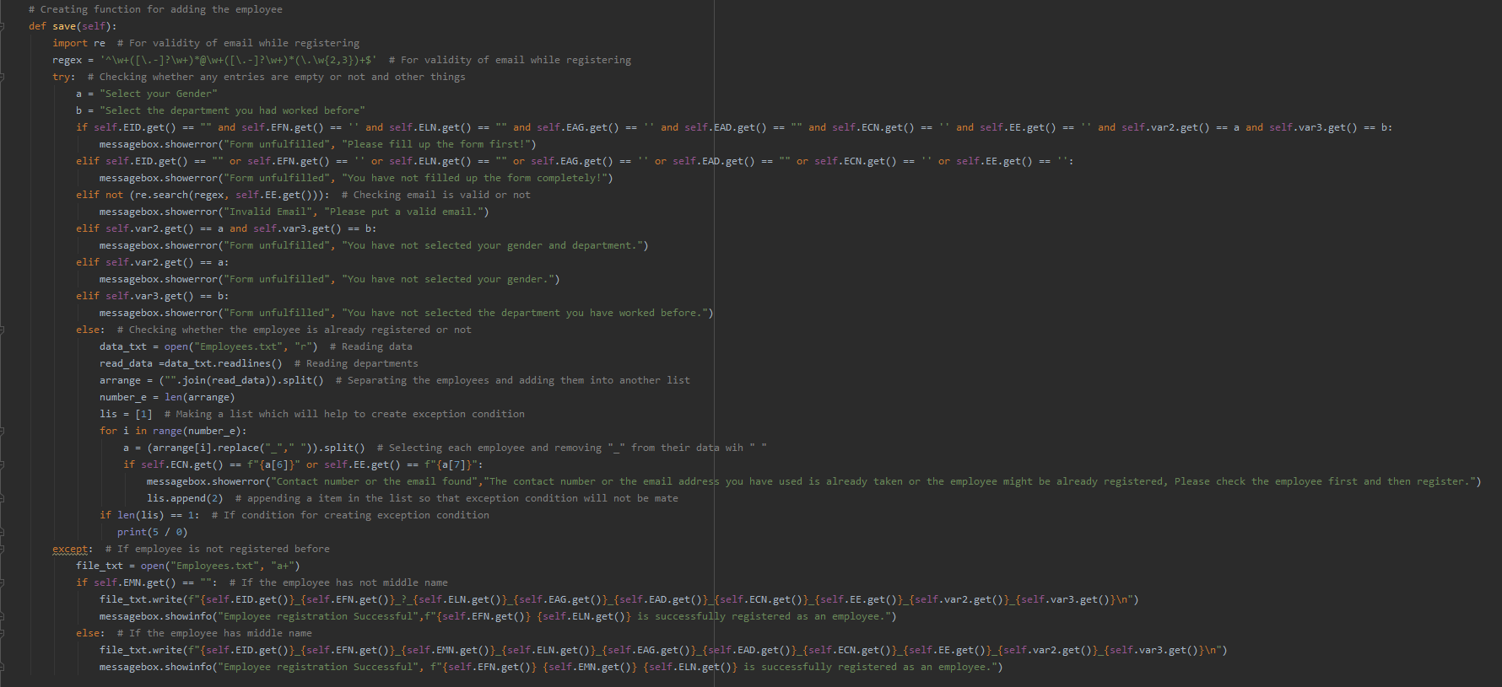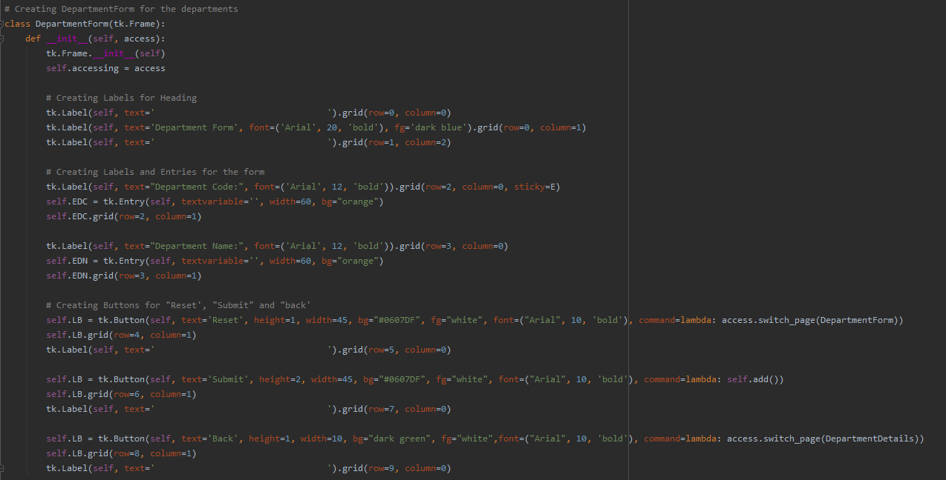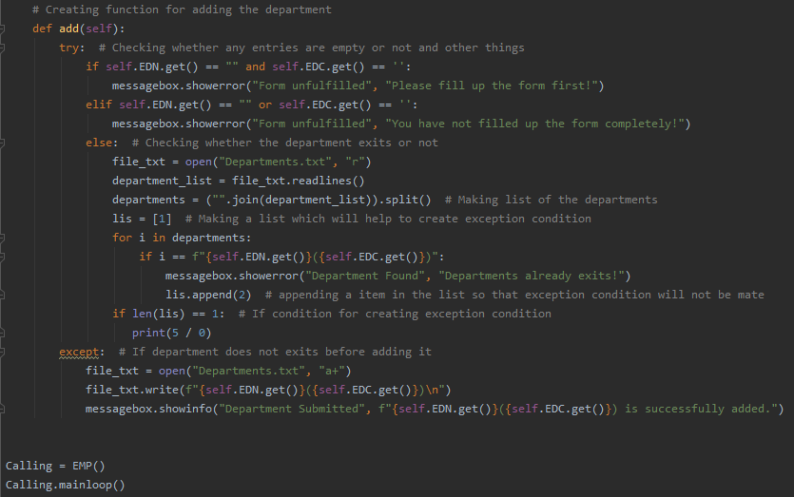

# **Class Diagram**

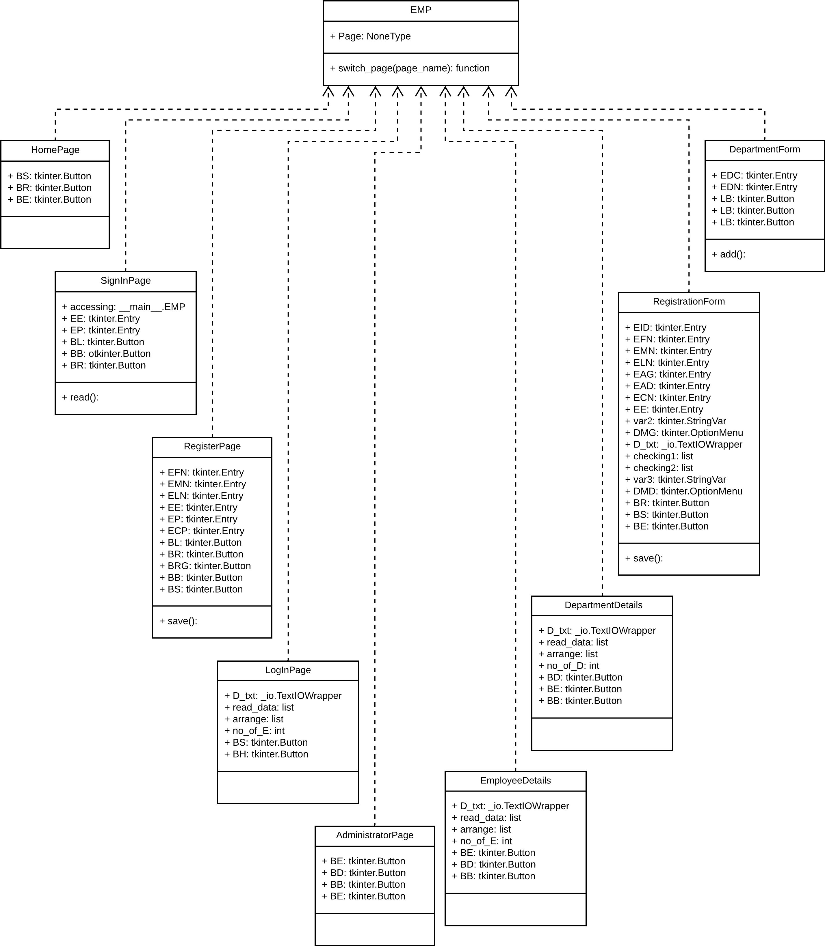

# **Conclusion**

An employee management system has been made using Python 3.7.4 (32 bit) in PyCharm 2019.3.3 (Community Edition) successfully. In this system, employee can login in their account using their email and password after they have registered and can be able see their full details only if they also have been registered by the admin department otherwise their full details will not be shown. The access to the employee and department management page will be given to the administrator only that means employee will not able to see and control employees and departments details after they have logged in. For this, a specific email and password will be recognized as the administrator. The administrator can add new employees and departments if needed. But this system can be made more efficient by adding some more features like features to edit the employee and department details, features to delete the employees and departments, features to add more administrator and their full details like the employees.

# **References**

ComponetntSource, n.d.. *Componentsource.com.* [Online]   
Available at: https://www.componentsource.com/product/pycharm/about  
[Accessed 16 February 2020].

Python, n.d.. *Python.org.* [Online]   
Available at: https://www.python.org/doc/essays/blurb/n  
[Accessed 16 February 2020].