# Part 1

## A

NoSQL queries are a better and effective choice because they can handle the large volume of B2B website data more smoothly than SQL queries. Its flexibility, scalability, and low cost over SQL queries will benefit the B2B website. The backend solution will be done with MongoDB.

## B

The results should be shown fast enough so that the users of the website will not be irritated because of slow performance. The use of the Hadoop framework will drastically enhance its performance.

## C

Customers will be linked with the order document and the order document will be linked with the with Order Product document which will give the products that the customers had bought.

## D

The fields that keep records of the thought of the customers towards the products like review text, rating, product review, shopping cart etc. will be used for recommendations.

## E

The documents which will keep records of the activies done between the customers and business will required which are Business, Customer, Product, Order, Order Prodcut, Payment, Shipping Address, Review, Shopping Cart etc.

## F

The documents are atomic and can not be splitted further more. The documents are splitted more and more to keep good records of activities done in B2B portal.

## G

The whole database will not be available for real time quering because all of them will not be used at the same time. Therefore, the database which are needed at the current time of using of B2B portal will be available for real time querying.

# Part 2

## A

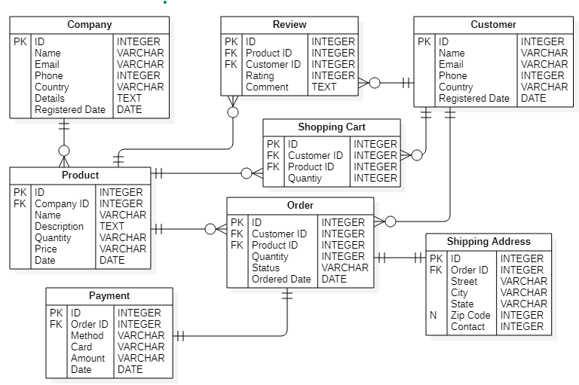

Figure 1: Diagram explaining the B2B solutions

Customers will order the products that the company had added. Customers can give a review of the products and add them to the shopping cart. The order table will keep records of the product ordered, payment, and shipping address for the product.

## B

## Data insert

Figure 2: Data insert

Link of js file of data insert: - <https://l.messenger.com/l.php?u=https%3A%2F%2Fdrive.google.com%2Fdrive%2Ffolders%2F1QxAPU1cbqYJRqAJinB26E0L4qhO8Id3K%3Fusp%3Dsharing&h=AT1SR2hVUtdfVA25zSwj6CAySr9mzmfGg9Rudf4H6BkBLAG3G4YdG0xA0r3UJBskcvbymXKUSU9lg2so4aUEiXyuEc0OobKO53-rYRkr8AEtgxHosD6JL7Yz6DnQZhiR7xEwXA>

### Required quries

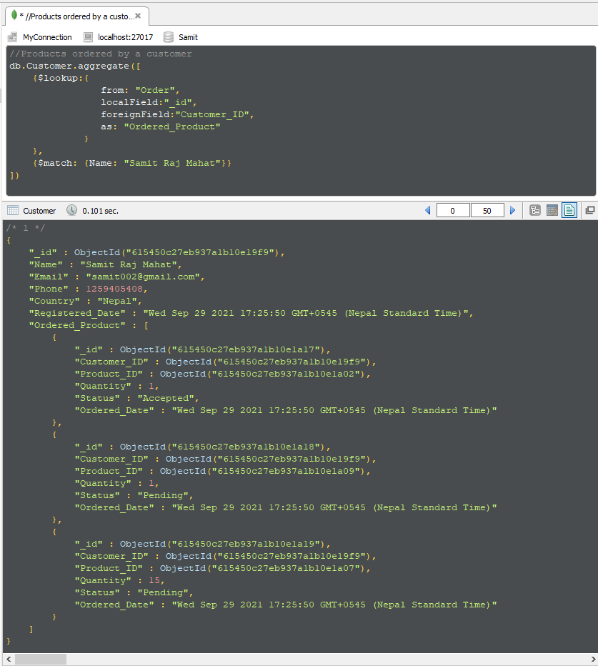

Figure : products orderd by a customer

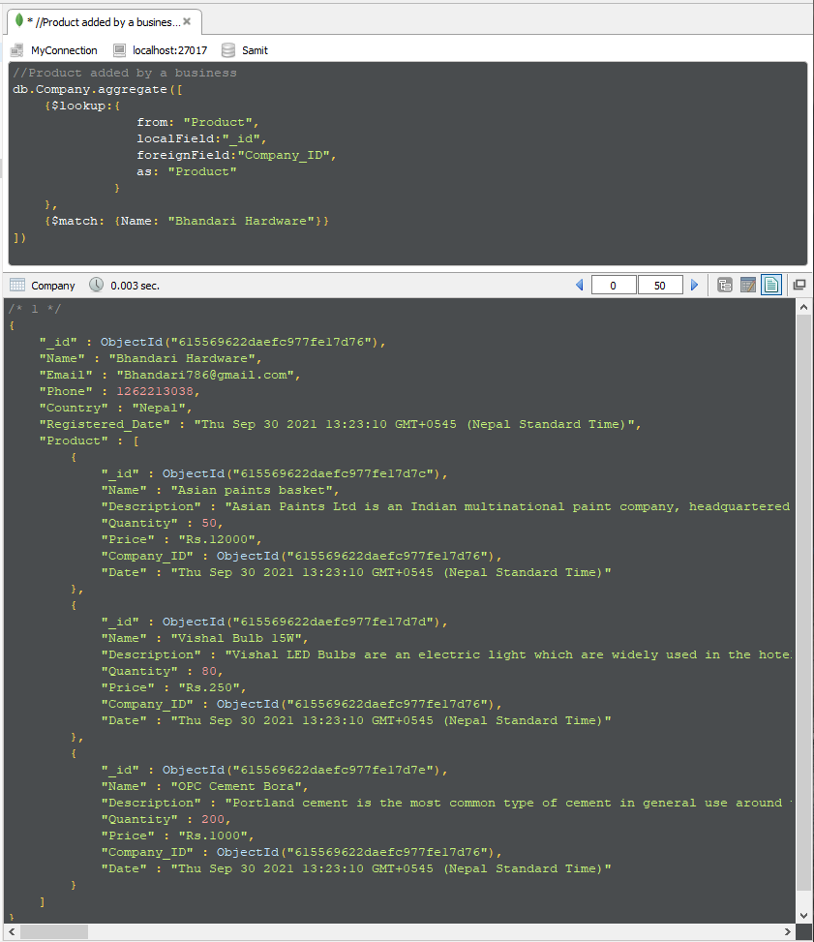

Figure : Products of a company

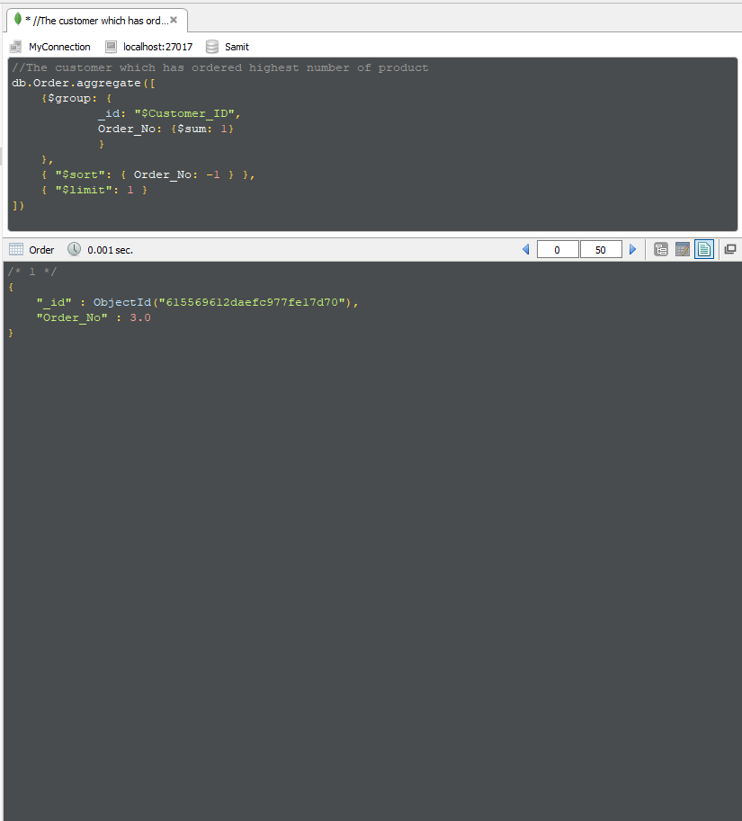

Figure : Customer with highest order

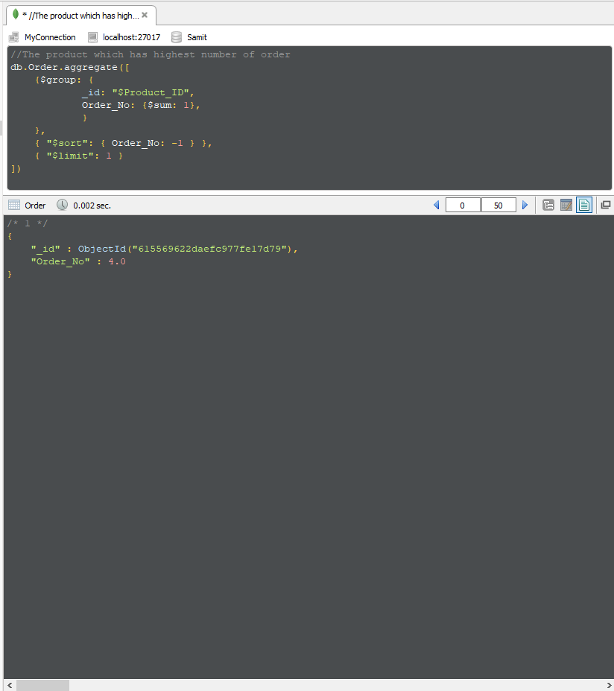

Figure : Product with highest order

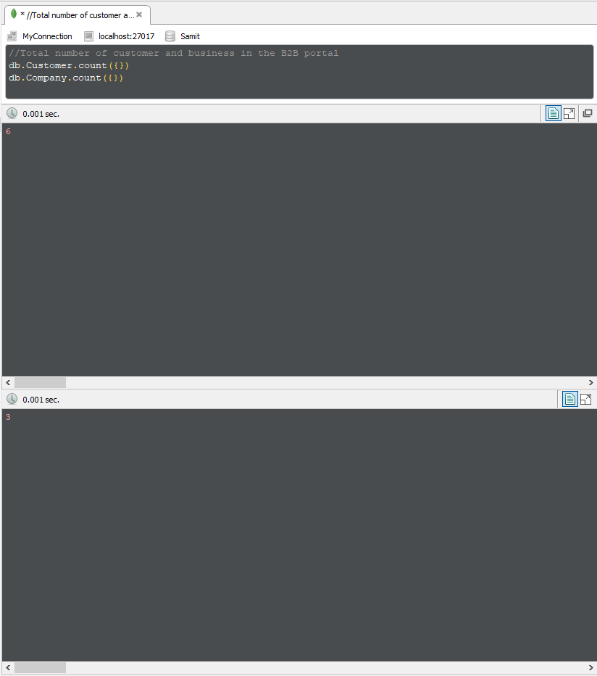

Figure : Total Customers and Comanies

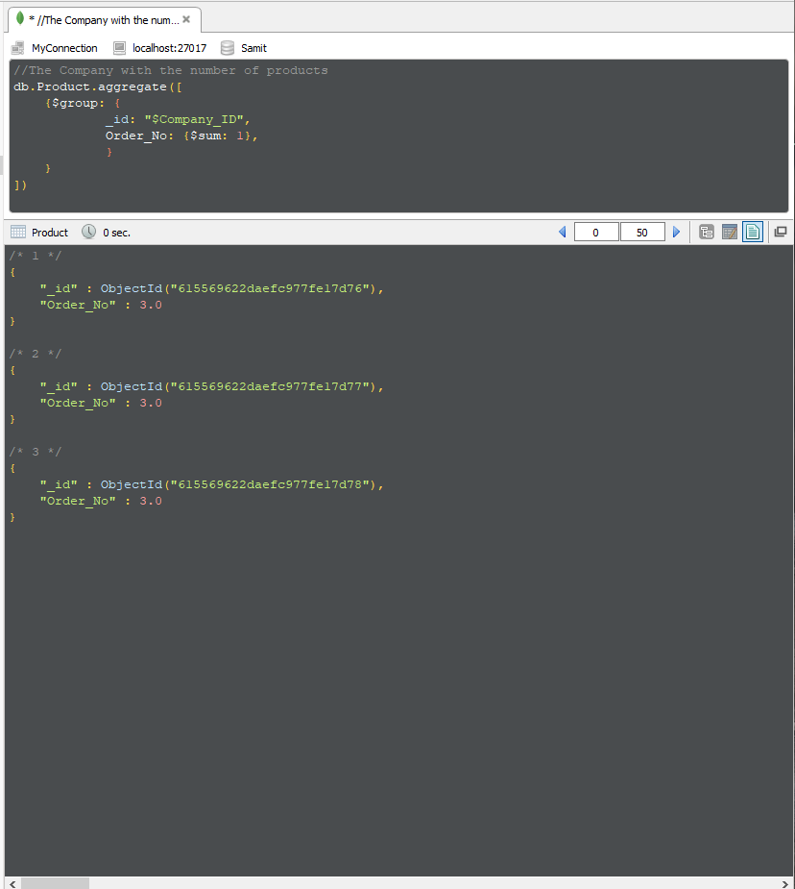

Figure : Company with the number of products