# **Abstract**

# **Keywords**

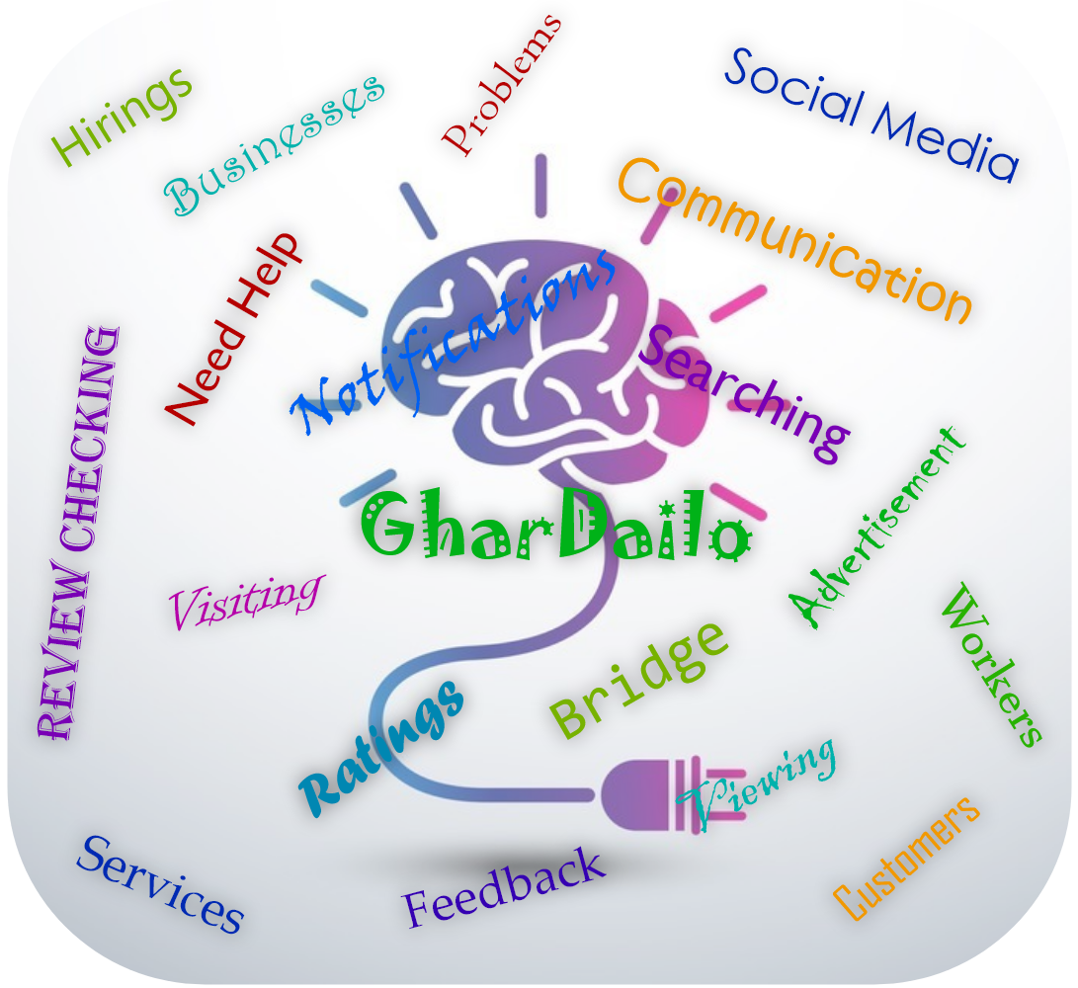

Figure 1: GharDailo Project Keywords

**Table of Contents**

**Abstract** 1

**Keyword** 1

**Introduction** 1

**Mission and Vision Statement** 3

**Aim** 4

**Objectives** 4

**Mind Map** 4

**Justification** 4

**Scope** 4

**Stakeholder Analysis** 5

**Business Canvas Model** 6

# **Introduction**

Sometimes people could not get the required services that they needed due to some reasons even though there are lots of services providing companies or businesses available in the market. Nowadays people are very busy at their works and they cannot complete all their daily activities every day. Some people are busy with their house works, some people are sick, some people are not at home. People don’t have enough time for their work. Therefore, the GharDailo project is the best solution for time and money-saving purposes.



Figure 2: Person being busy at his works

With the GharDailo website, people can solve almost every home problem by hiring any services they want like repairing, plumbing, cleaning, health caring, security, Cookman, event planning, etc. People don’t have to travel to the business location to get a servicer for their home problems. They can solve their daily problems by using a functional electronic device by staying at their home. People can visit through various service-providing businesses, hire services, give feedback and ratings.



Figure 3: People hiring services from their home

The GharDailo website can help people to hire services in pandemic conditions too like lockdown, natural disasters, etc. This becomes possible because it's an online process and people don’t have to involve in it physically, they don’t have to travel to the business location. People who live in remote areas and don’t have any kind of facilities around their areas can also hire services and save their valuable time and money. Therefore, the GharDailo website is a very useful online platform that provides services and helps people to save their time and money and get their required services at any condition at any time.

# **Mission and Vision Statement**

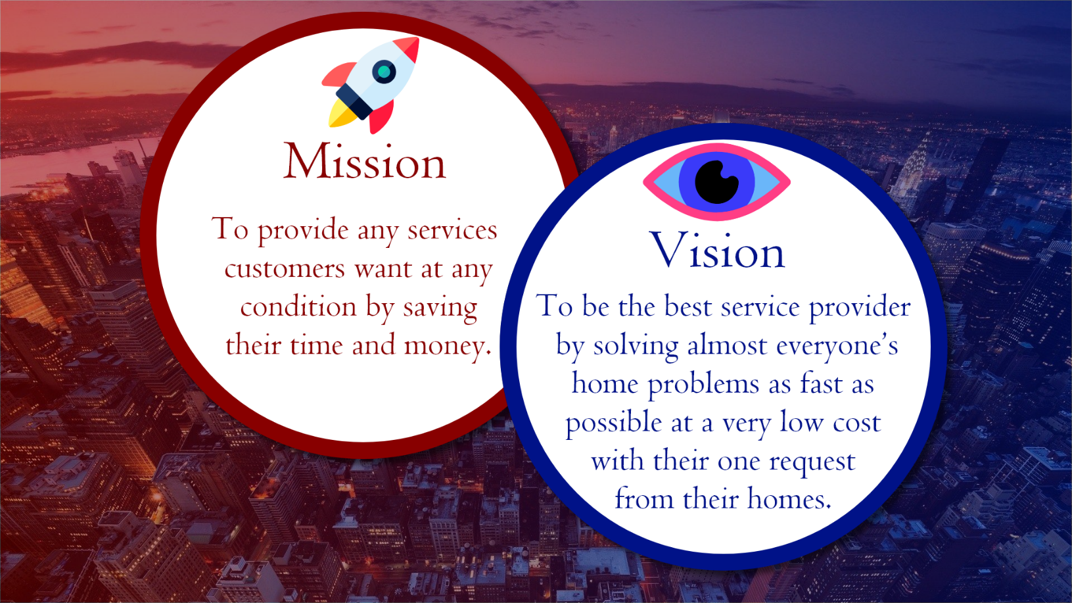

Figure 4: Mission and Vision of GharDailo Project

# **Aim**

To develop a service-providing website that will help people hire any services at any conditions at any time from anywhere to save their valuable time and money without being physically involved.

# **Objectives**

* A brief analysis of the daily problems faced at people's homes and the services that the people hired to solve them.
* Visiting the available service-providing websites and applications, and analyzing their designs and features to develop a better service-providing website.
* Requirement gathering and analysis for the development of the intended website.
* Gathering of the development teams and distributing the works.
* Testing of the website with few people and implementing some improvements.
* Collaborating with some service-providing businesses and adding services to the websites.
* Advertisement of the website through social media.
* Communications with the customers to provide services at the right time and place.
* Maintenance of the website.

# **Mind Map**

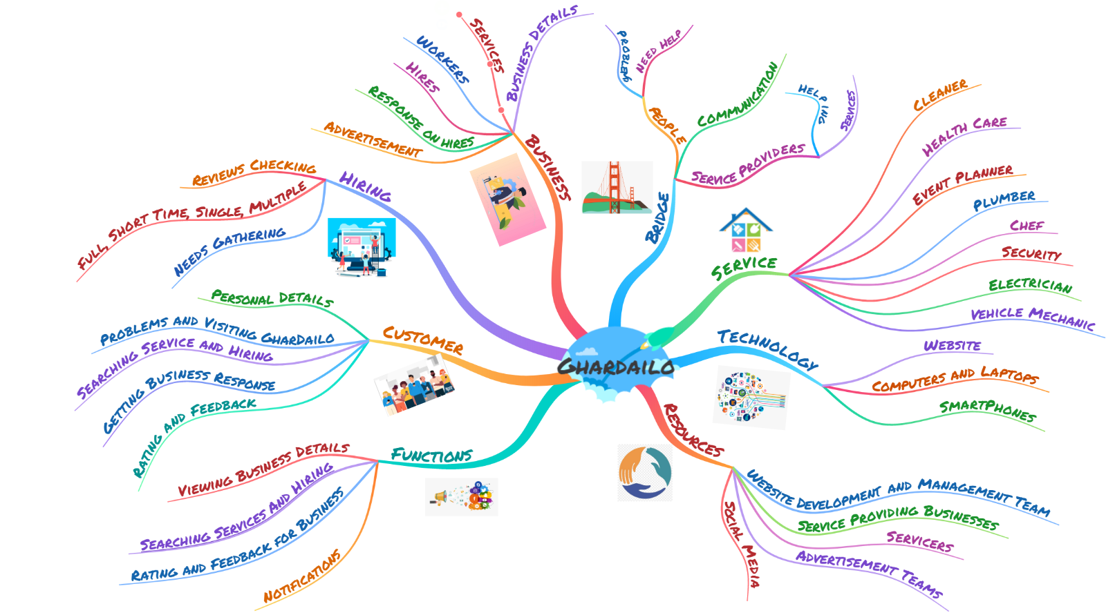

Figure 5: Mand Map of GharDailo

# **Justification**

# **Scope**

# **Stakeholder Analysis**

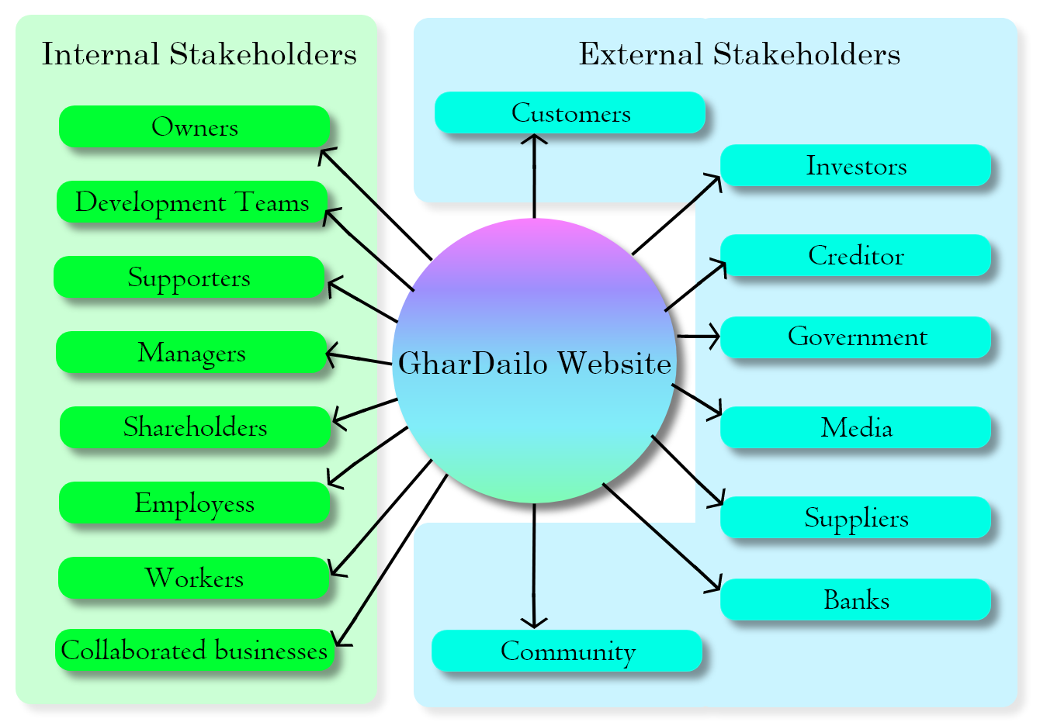

Figure 6: GharDailo Stakeholders

# **Business Canvas Model**

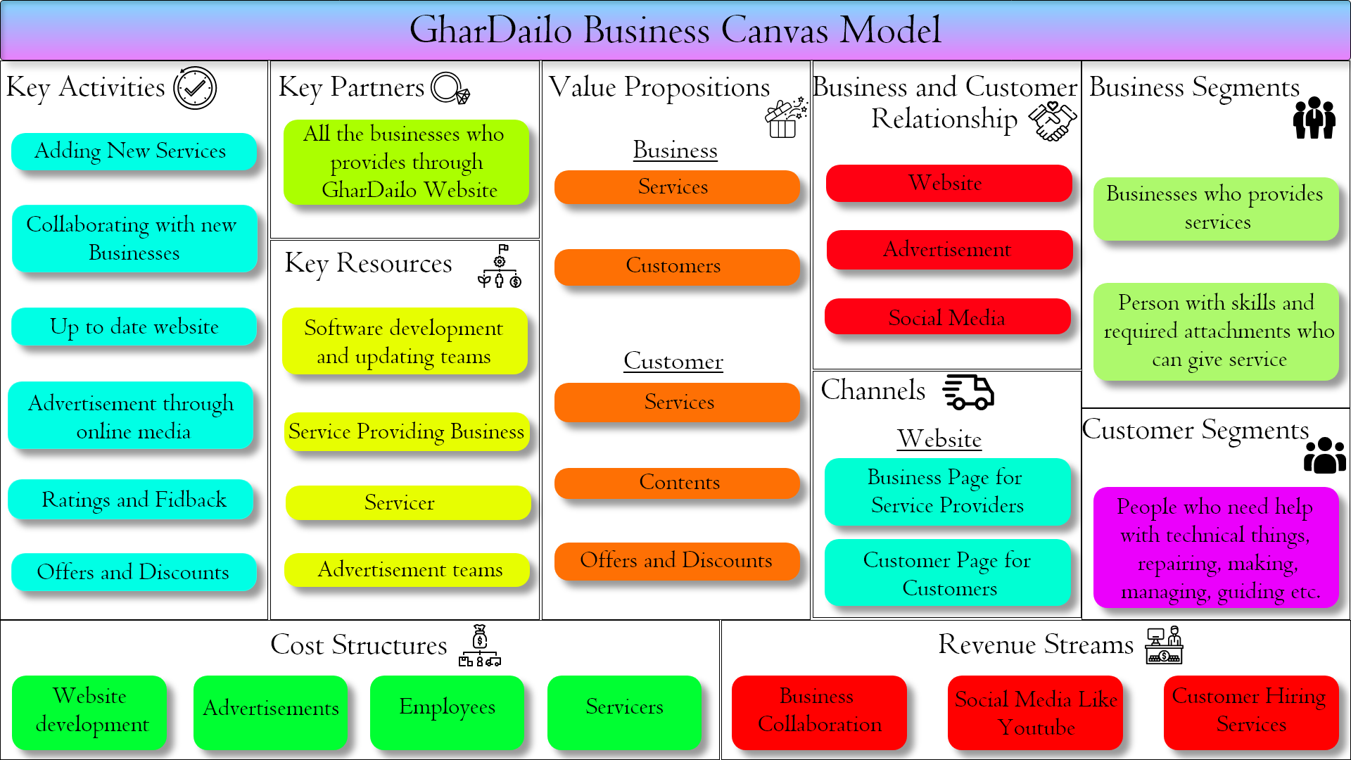

Figure 7: GharDailo Business Canvas Model