GharDailo: Flow Char Diagram

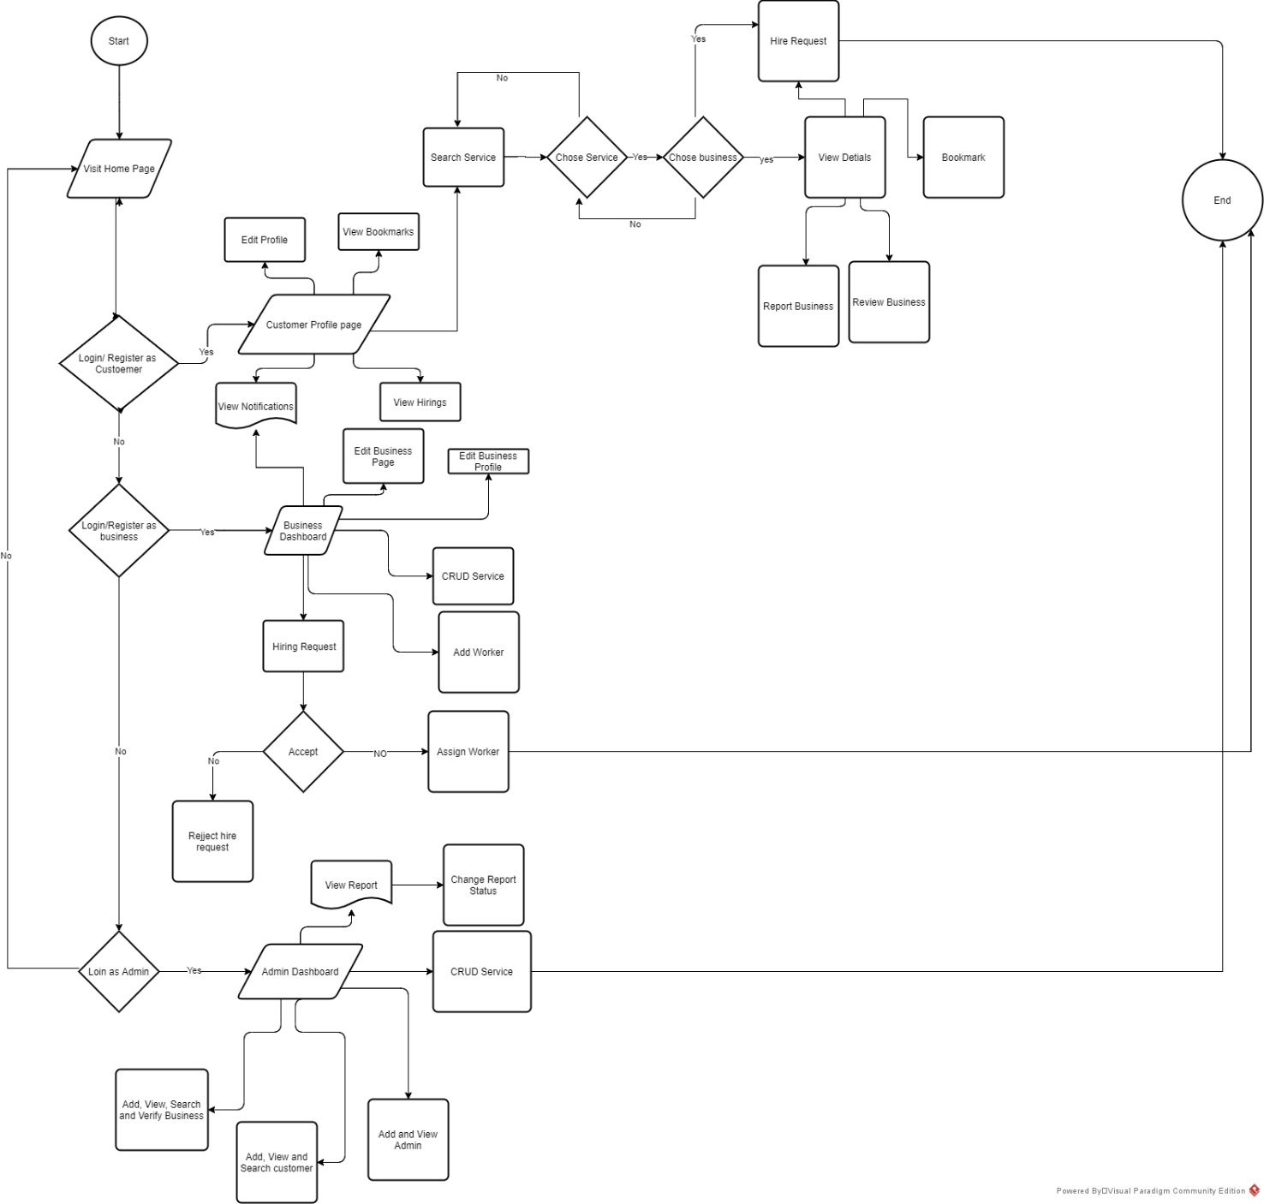

Limitations

**1. Chat:** Deliberately, we were expected to apply a chat feature but unfortunately due to apparent unexpected errors and bugs, we spent a lot of time debugging which alternatively caused a lack of time on adding a chat feature.

**2. Online Payment Integration:** Through our website, we link businesses and customers where customers can easily hire any service from any business. But while hiring a worker from a business organization there is an absence of a feature for an online payment method. Right now, we could only make cash in hand policy after the work got completed by a worker.

**3. Tracking an employee:** Currently, it’s not a crucial feature like GPS tracking in our bucket list but having it would prevent any business organization from occurring fraud and laziness done by any worker in their working hours.

**4. Login system for employees:** There is no login system made for the employees. They cannot edit their details and do other related activities.

**5. Admin Dashboard:** In the admin dashboard there are some limitations in customizing details used by admin and the template of this dashboard is not customized fully because due to time limitation we focused on the part which is directly seen by businesses and customers.

Future Work

Unintentionally, we were unable to add a chat feature even though it was on our bucket list due to insufficient time caused by errors and bugs. But sooner or later we will build it on our website. Similarly, there will be more addition of features like payment method to make a business organization more secure about their customer, and a tracker to track an employee of a specific business to prevent any business organization from facing a problem of fraud and laziness in an employee in their working hours. Furthermore, businesses will be made available according to the location of the customers where customers can contact the business near to them, and also, discounts will be provided to the regular customer during a special event.

Conclusion

In conclusion, the development of the website was successfully done, however with the changes in condition and situation we had to change some of the design. During this whole period of developing a website from a scratch with teammates, different unexpected challenges and problems came but without losing any hope and determination to finish the task, everyone gave their all efforts to complete the mission and vision of GharDailo. Working as a teammate made us realize the importance of teamwork, and gave hints about how real-world projects work are and how they can be completed.