Abstract

Everything Is digitalizing day by day; businesses have started to run with the help of the internet. The person can get their goods or services at their door by just simple step using computer or mobile phone by sitting in their couch. So, with the aim of digitalizing Nepal with an online-based service provider, GharDailo is started. GharDailo is an online platform that links businesses to customers. Its primary goal is to provide the service to customers based on business. There are thousands of businesses registered to GharDailo and each business have hundreds of services. Customer can choose their best service by just filtering business according to the business’s service to the customer according to the rating given by the customer.

Different technologies have been used to design and develop this website. Django is the main framework used for backend development while HTML5, CSS, Bootstrap, and JQUERY is used for the frontend and MySQL is used as a database. The main objective of this project is to develop a website where customers can get service online. This document will discuss each step discussed and implemented to make a real-world website GharDailo.

Justification

Nowadays, people have to be cautious of unpredicted problems knocking on their doors. Due to which they are always in need of service providers. There are lots of service providers but they are unable to provide service to all the needy customers even though they want too due to the lack of managed system. To minimize such a problem GharDailo is introduced. GharDailo is an e-commerce website that focuses on linking customers to the business having a different type of service which is basic in customer’s daily life. If a needy person is searching for plumber, an electrician and an event planner in their house at a same time. Traditionally, they have to call different businesses to acquire each service but with small step by tapping in their computer people can get all their services from one place online. Which will save customer’s time and money.

Activity diagram

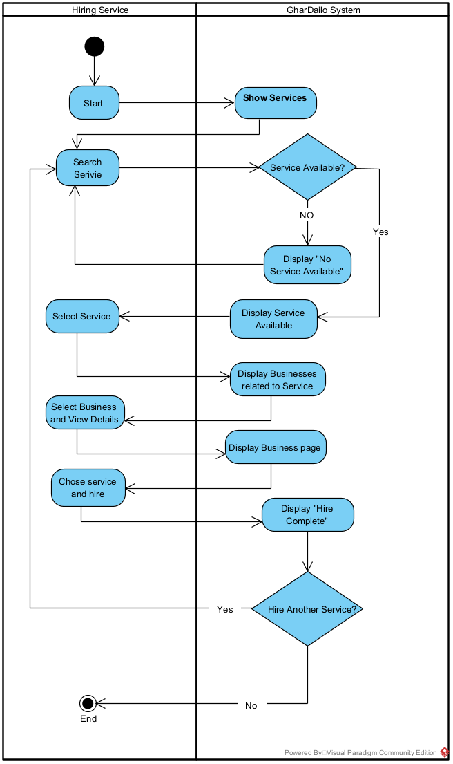

Risk analysis and issue log

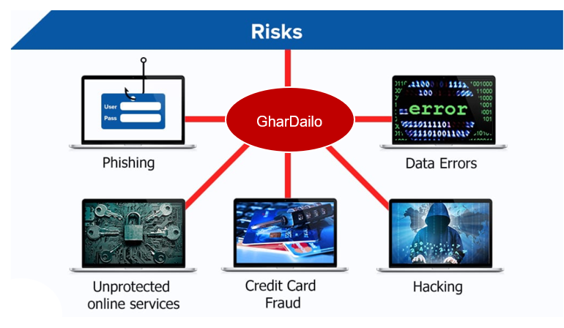

There is a risk in every business. While running an e-commerce website to minimize the risk that may occur in the future as well as in the present condition, an organization should focus on usability, responsiveness, and functionality. The risk that may occur during the design and development of the website are described below:

1. The risk from hackers like phishing, credit card fraud, and data error.
2. All the images product descriptions, logos, videos should be used on our own show that it may not harm others intellectual property.
3. Personal data of the customer should not be compromised which may cause identity thief and other privacy issues.
4. It is very hard to gain customers attention and trust towards newly build e-commerce.
5. It is very important to analyze the system error as well as errors done by the customer during the hiring process.

The issue log of GharDailo is described below:

|  |  |  |  |  |
| --- | --- | --- | --- | --- |
| S. N | Issue Title | Reported on | Severity | Status |
| 1 | Covid-19 breakthrough | 25/05/2021 | High | Unsolved |
| 2 | Dispute among teammate while choosing topic | 30/05/2021 | Medium | Solved |
| 3 | Never happened physical interactions and conferences | 10/06/2021 | Medium | Unsolved |
| 4 | Conflict during designing in figma. | 15/06/2021 | Low | Solved |
| 6 | Error in Django setup and Git version control | 25/06/2021 | Medium | Solved |
| 7 | System and code errors | 05/08/2021 | Medium | Solved |