**Here’s how to write a CV:**

* Make sure you know when to use a CV
* Pick the best CV format
* Add your contact information the right way
* Start with a CV personal profile
* List your relevant work experience and key achievements
* Build your CV education section correctly
* Put relevant skills that fit the job opening
* Include additional CV sections to impress the recruiter
* Organize this all on a professional CV template
* Complement your CV with a cover letter

Choose clear, legible fonts

**Font**: Times New Roman

**Font Size**: 12

**Line-Spacing**: 1.0 or 1.15

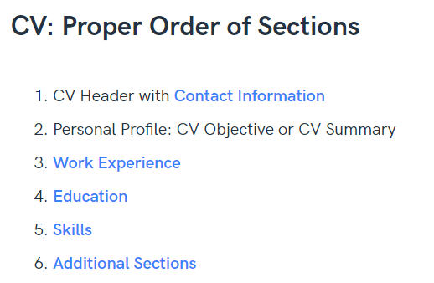

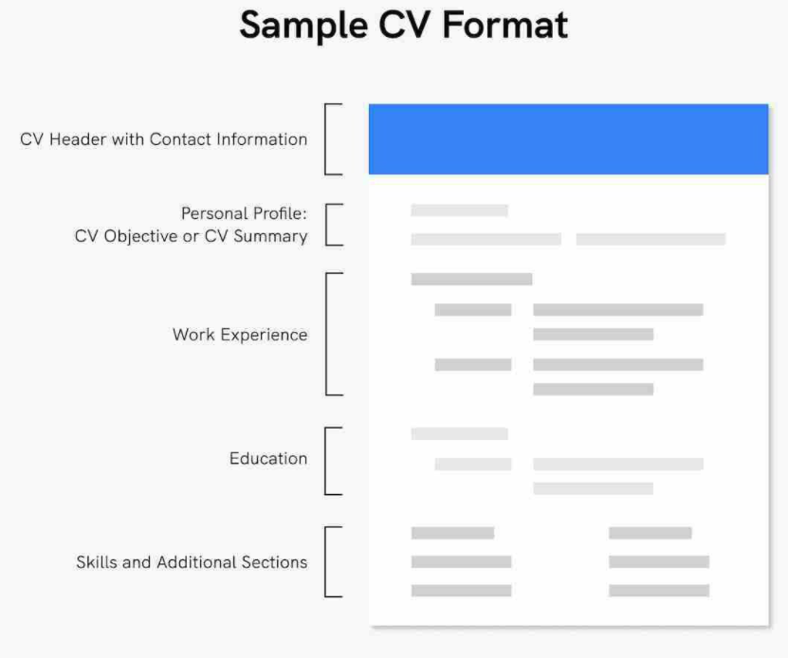

<https://www.youtube.com/watch?v=_fP43gcBywU>