Project Report: Daily Calorie Tracker CLI

College: K.R. Mangalam University
Name: Gauri Sharma
Roll No: 2501730108
Course: B.Tech CSE AIML
Section: A
Course: Programming for Problem Solving using Python

1. Introduction
The Daily Calorie Tracker is a Python-based Command Line Interface (CLI) tool designed to help users log their meals, count calories, compare them with a daily limit, and optionally save a session log. This project fulfils the requirements of the Mini Project Assignment: Daily Calorie Tracker CLI as described in the assignment file.
2. Objectives
- Accept user input for meal names and calorie values
- Store meal data using Python lists
- Calculate total and average calories
- Compare calorie intake with a user-defined daily limit
- Display formatted output using f-strings and escape characters
- Save session logs using basic file handling (bonus task)
3. Assignment Tasks Summary
The assignment included six main tasks:
1. Setup & Introduction – Create project folder and display welcome message.
2. Input & Data Collection – Accept meal names and calories using loops and lists.
3. Calorie Calculations – Compute total and average calorie intake.
4. Limit Warning System – Compare calorie total with daily limit using if-else.
5. Formatted Output – Print results in a clean table.
6. Bonus – Save session logs to a text file.
4. Working of the Program
1. The user is greeted with a welcome message and asked how many meals they wish to enter.
2. For each meal, the program collects:
- Meal Name
- Calorie Amount
3. The data is stored in two lists: meals[] and calories[].
4. Using sum() and arithmetic operations, the program computes:
- Total Calorie Intake
- Average Calories per Meal
5. The user enters their daily calorie limit, and the program compares the total intake with the limit.
6. Based on the comparison, the program displays:
- Warning message (if limit exceeded)
- Positive/within-limit message
7. The program prints a neatly formatted summary table.
8. If the user chooses, the session summary is saved into a .txt log file.
5. Output Screenshot
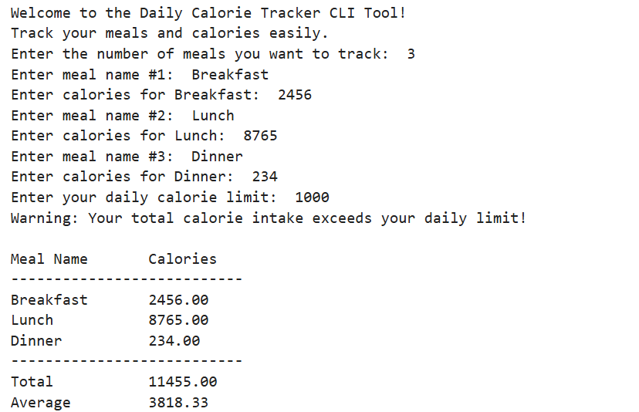
6. Bonus Task: Saving Session Logs
When the user chooses to save the report, the program creates a text file containing:
- Timestamp of the session
- All meals and their calorie values
- Total and average calorie intake
- Limit comparison status
- A well‑formatted summary table
- Saved log file preview
7. Conclusion
This mini project effectively demonstrates fundamental Python concepts such as input management, list utilization, looping structures, conditional statements, arithmetic operations, formatted output, and basic file input/output. It is practical, user-friendly, and illustrates how elementary programming principles can be applied to address real-world challenges such as calorie tracking.

