Project Report: Grade Analyzer

College: K.R. Mangalam University
Name: Gauri Sharma
Roll No: 2501730108
Course: B.Tech CSE AIML
Section: A
Course: Programming for Problem Solving using Python

1. Introduction
The Grade Analyser project is a Python-based tool that processes student marks, calculates grades, analyses performance, and generates meaningful insights. This report explains the project's purpose, how it works, and the key Python concepts used.
2. Objective
- Automate grade calculation
- Analyze class performance
- Read and process marks using Python
- Display results in a clean and understandable format
3. Working of the Program
The Grade Analyzer reads marks (either manually or from a list/dataset) and performs:
1. Total and percentage calculation
2. Grade assignment based on predefined criteria
3. Identification of the highest and lowest scoring subjects
4. Validation of marks entered by the user

SCREENSHOTS OF OUTPUT:-
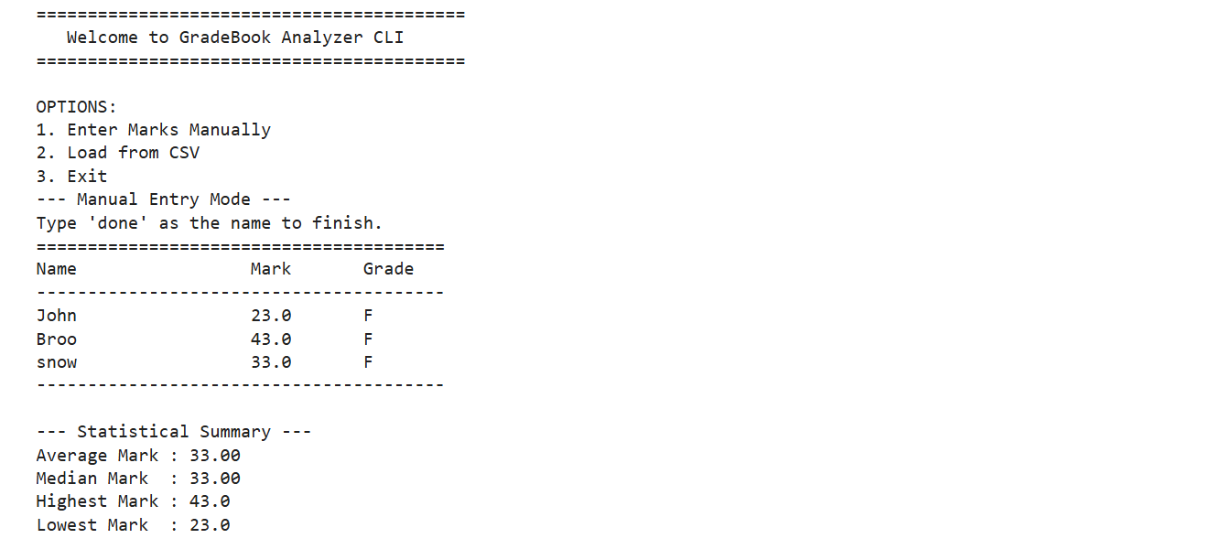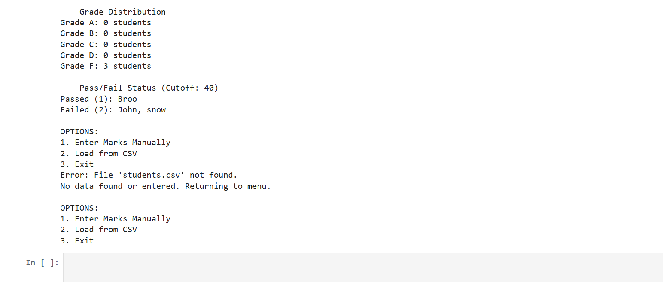

4. Features Implemented
- User-friendly Python script
- Conditional statements for grade logic
- List and loop-based data processing
- Error handling for invalid inputs
5. Python Concepts Used
- Variables and Data Types
- Lists & Looping (for and while)
- Conditional Statements (if-else)
- Functions for modular code
- Exception handling using try-except
6. Conclusion
This project helped in understanding the application of Python for real-world data processing. It demonstrates structured coding, logical thinking, and automation of a practical task such as grade evaluation.

