Project Report: Library Inventory Manager

College: K.R. Mangalam University
Name: Gauri Sharma
Roll No: 2501730108
Course: B.Tech CSE AIML
Section: A
Course: Programming for Problem Solving using Python

1. Introduction
The Library Inventory Manager is a simple command‑line Python project designed to help manage a small library system. It allows adding books, issuing and returning books, searching the catalog, and saving the entire inventory in a JSON file.
2. Objectives
- Implement Object-Oriented Programming using classes
- Handle persistent storage using JSON file I/O
- Provide a menu-driven CLI for user interaction
- Use exception handling and basic logging
3. System Components
1. **Book Class** – Represents each book with title, author, ISBN, and status.
2. **LibraryInventory Class** – Manages all Book objects, loads/saves data, and handles operations.
3. **CLI Script (main.py)** – Provides an interactive menu for users.
4. Features Implemented
- Add new books
- Issue a book
- Return a book
- Search by title or ISBN
- View all book records
- JSON-based catalog persistence
5. How to Run
1. Open the project folder in terminal.
2. Run the command:
python -m cli.main
3. Use the numbered menu to interact with the system.
6. Sample Execution (Insert your screenshots)
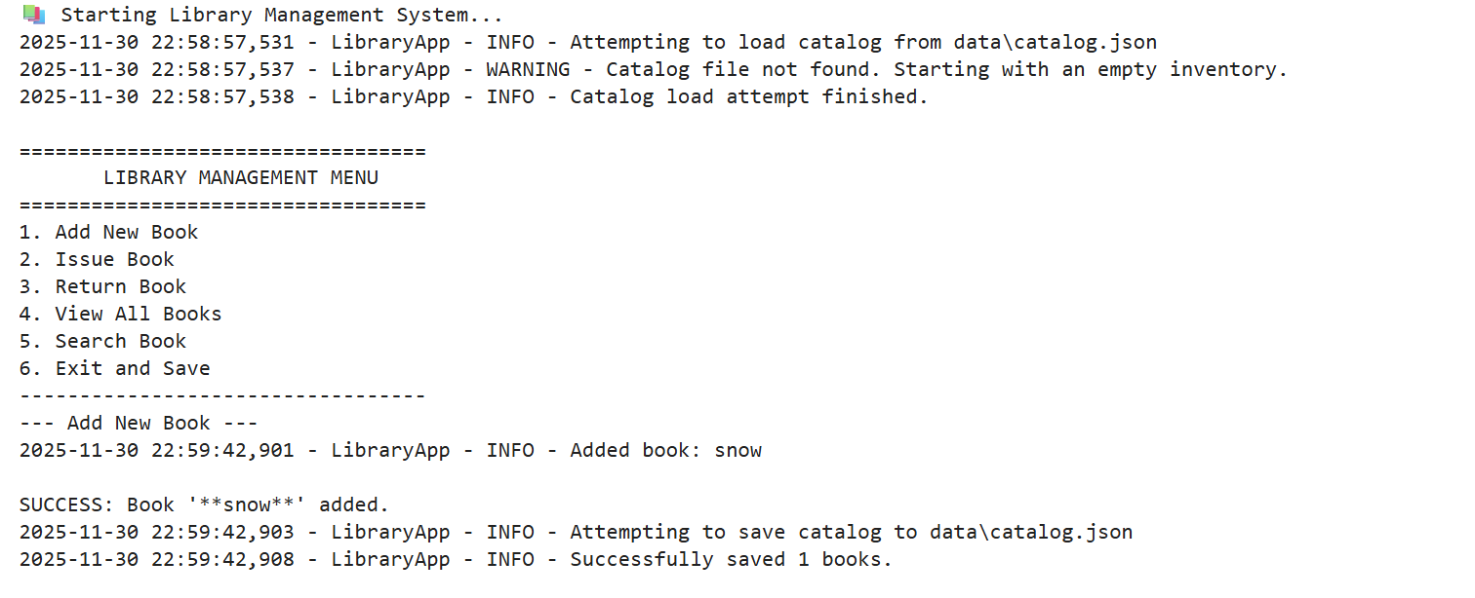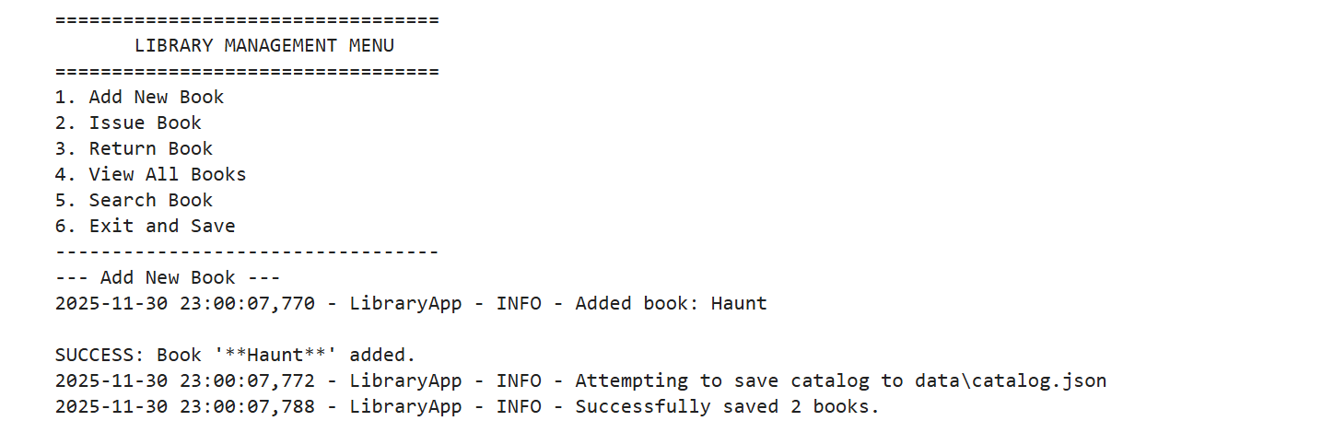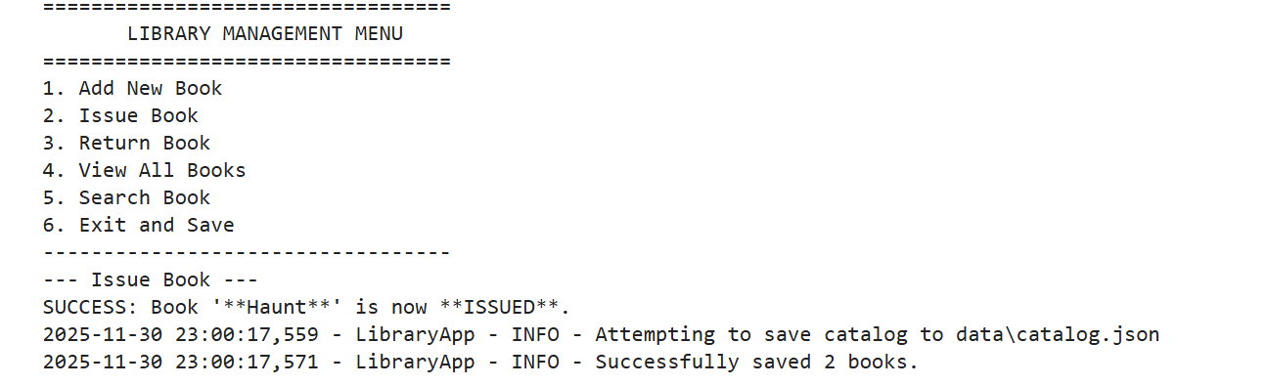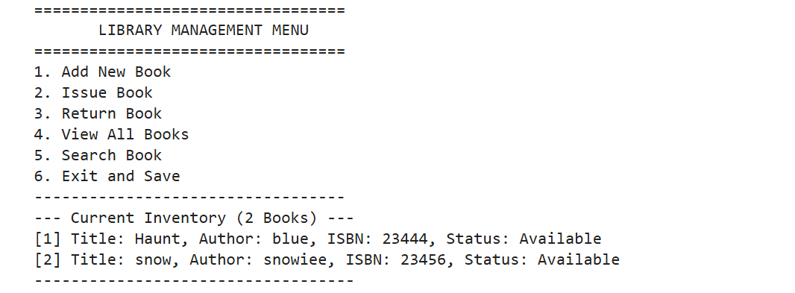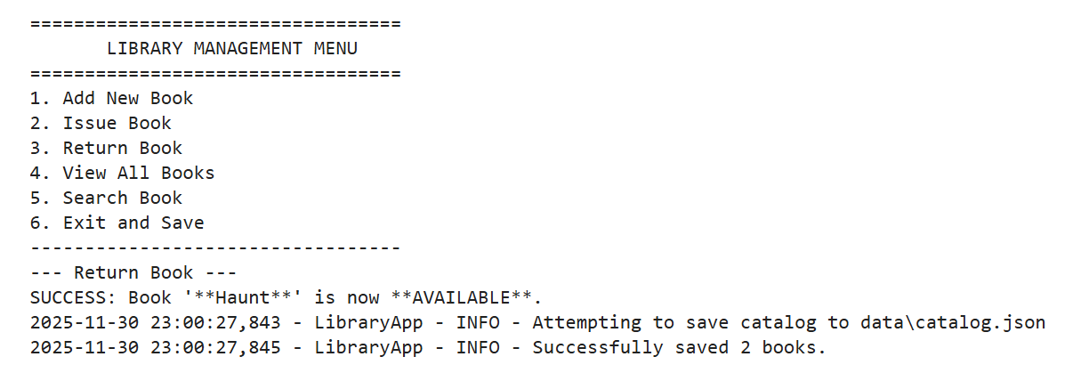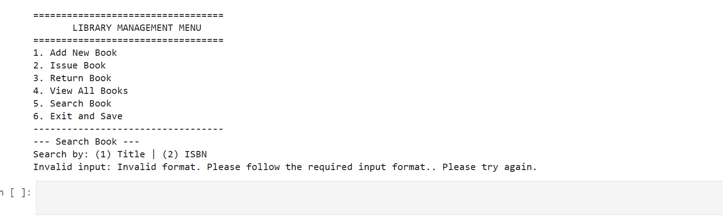
7. Conclusion
This project demonstrates a complete small-scale management system using Python OOP, JSON file storage, CLI interaction, and exception handling. It fulfils all required objectives of the assignment and provides a clear understanding of real-world data management workflows.

