Computer Science Fundamentals & Career Pathways

Assignment Number 02: Basics of Linux and Open-Source Tools

Name: Gauri Sharma
Roll no.: 2501730108
Course: B. Tech CSE AI & ML
Section: A
Course Code: ETCCCP105
Faculty: Mr. Rajesh Kumar

Introduction of Linux
Linux is a free and open-source operating system widely used in servers, development environments, and cybersecurity. It is known for its stability, flexibility, and powerful command-line interface. Learning Linux helps students understand how operating systems work and prepares them for careers in IT, DevOps, and software engineering.
This assignment focuses on installing Ubuntu Linux, using basic shell commands, writing shell scripts to automate tasks, and uploading work to GitHub. It provides hands-on experience with tools that are essential in the tech industry

Step 1 – Linux Installation
I am choosing: --------
- Option B — Install Ubuntu (WSL 2) on Windows 10/11 Prerequisites: Windows 10 or Windows 11. PowerShell (Admin) access.
Steps (PowerShell/Command Prompt as Administrator) 1.
# Enable WSL + Virtual Machine Platform
Open PowerShell as Administrator and run: wsl --install
This will automatically:
- Enables WSL
- Enables Virtual Machine Platform
- Installs WSL 2
- Installs Ubuntu (default distro)

#If you already have WSL but not WSL2 enabled,
run: wsl--update wsl--set-default-version 2

#Install Ubuntu from Microsoft Store (optional method)
If you didn’t use wsl --install, you can manually install a specific Ubuntu version:
Search and install:
- Open Microsoft Store
- Search for:
- Ubuntu
- Ubuntu 20.04 LTS
- Ubuntu 22.04 LTS
- Click Get to install

#Launch Ubuntu
After installation: in powershell and run-- ubuntu
(or launch from Start Menu)
On first launch:
- Ubuntu initializes the filesystem
- You will be asked to create a UNIX username and password

WSL install~~
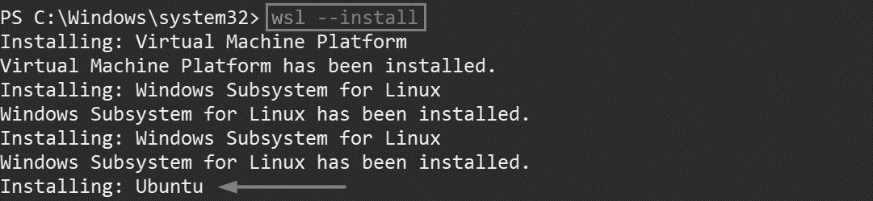
WSL update~~
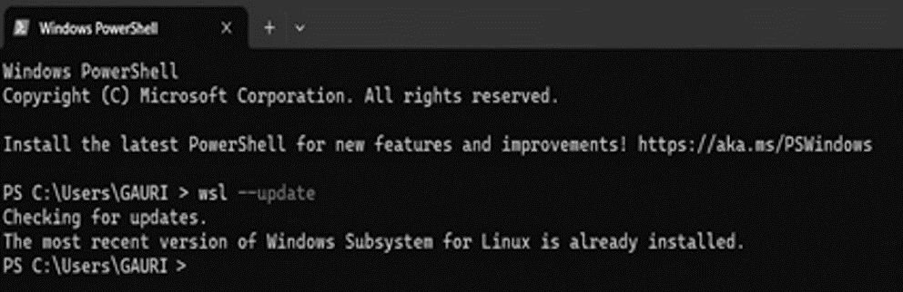

Ubuntu installation~~~
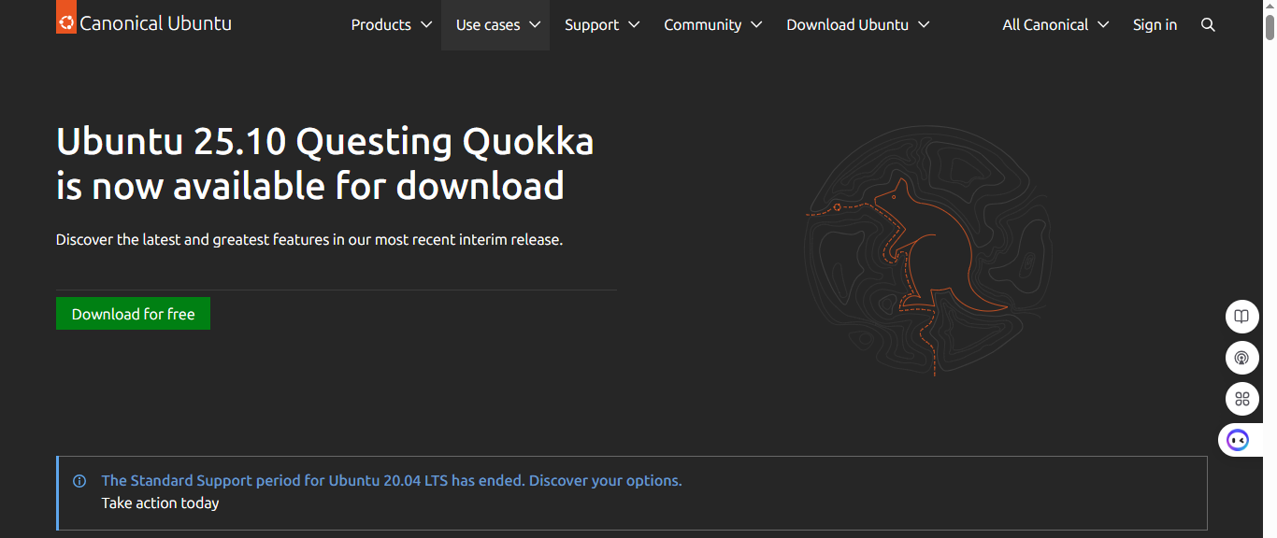
#Hardware Configuration:
- Host OS: Windows 11
- WSL version: WSL 2
- Ubuntu distro: Ubuntu 22.04 LTS
- Memory/ disk: WSL uses host resources
Step 2 — Shell command implementations and documentation
- File Navigation
      - pwd
Syntax: pwd
Description: Print working directory — shows current directory path. When/Why: Use to confirm your current directory before running file operations.
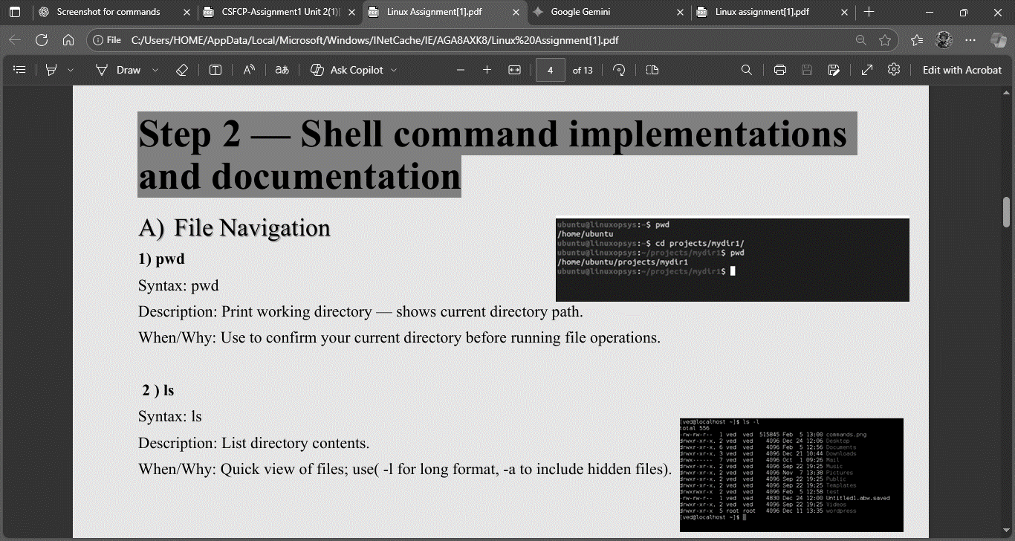

      - ls
Syntax: ls
Description: List directory contents.
When/Why: Quick view of files; use (-l for long format, -a to include hidden files).

      - Cd
Syntax: cd [directory]
Description: Change directory.
When/Why: Navigate filesystem to the folder where you want to operate.
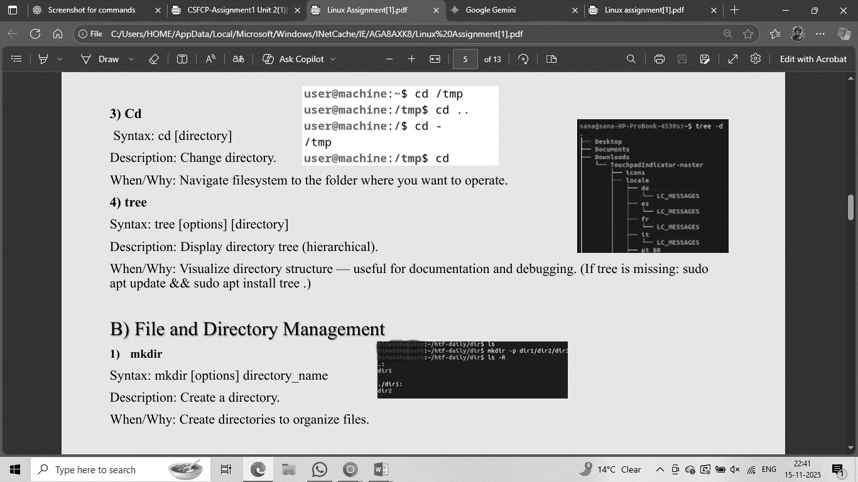

      - tree
Syntax: tree [options] [directory]
Description: Display directory tree (hierarchical).
When/Why: Visualize directory structure — useful for documentation and debugging. (If tree is missing: sudo apt update && sudo apt install tree.)

- File and Directory Management

- Mkdir
Syntax: mkdir [options] directory_name
Description: Create a directory.
When/Why: Create directories to organize files.

- touch
Syntax: touch filename
Description: Create an empty file or update timestamp.
When/Why: Quickly create placeholder files.

- cp
Syntax: cp [options] source destination
Description: Copy files or directories (-r for recursive).
When/Why: Duplicate files or folder trees.
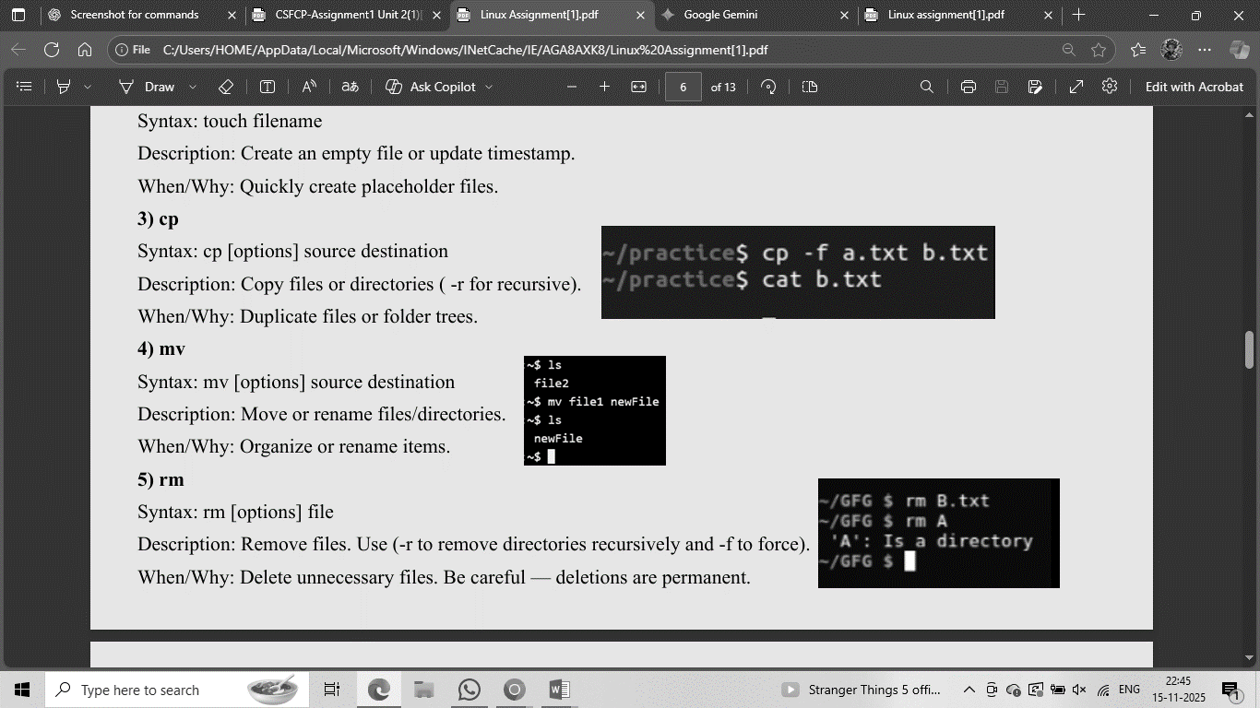

- mv
Syntax: mv [options] source destination
Description: Move or rename files/directories.
When/Why: Organize or rename items.
- rm
Syntax: rm [options] file
Description: Remove files. Use (-r to remove directories recursively and -f to force).
When/Why: Delete unnecessary files. Be careful — deletions are permanent.

- Permissions Management

- chmod
Syntax: chmod [options]
Description: Change file mode (permissions)
When/Why: Secure files by restricting write/execute permissions.
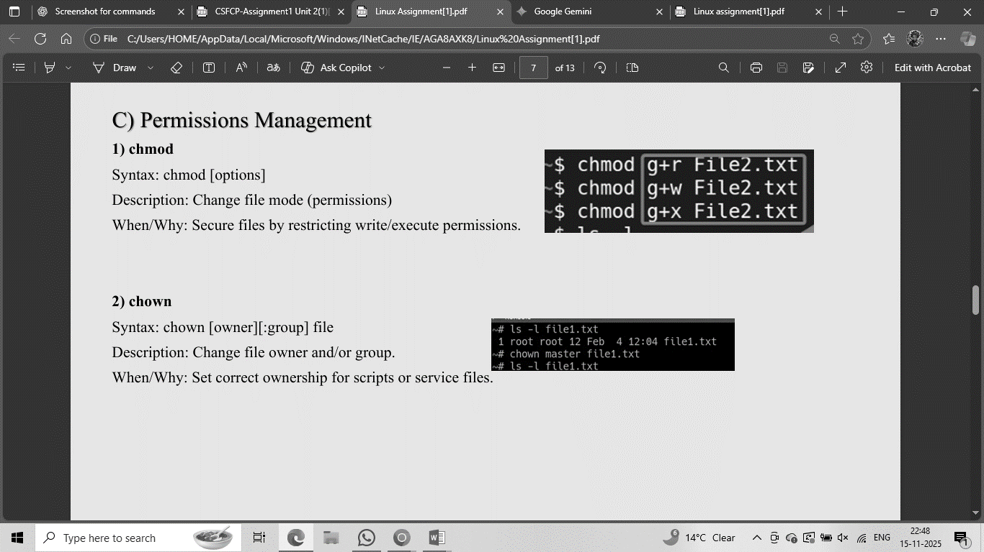

- chown
Syntax: chown [owner] [: group] file
Description: Change file owner and/or group.
When/Why: Set correct ownership for scripts or service files.
- Process Monitoring

- ps
Syntax: ps [options]
Description: Report snapshot of current processes. Common: (ps aux).
When/Why: Check running processes, PIDs for troubleshooting.

- top
Syntax: top
Description: Interactive process viewer with CPU/memory usage.
When/Why: Monitor system in real-time; kill misbehaving processes.

- kill
Syntax: kill [signal] PID or kill -9 PID
Description: Send signals to processes (terminate, etc.).
When/Why: Stop misbehaving processes when graceful shutdown fails.
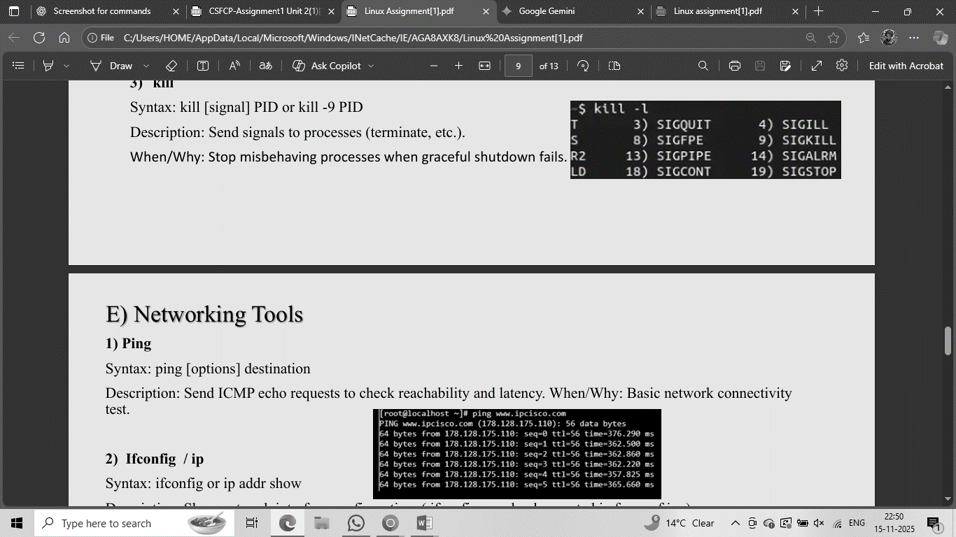
- Networking Tools

- Ping
Syntax: ping [options] destination
Description: Send ICMP echo requests to check reachability and latency. When/Why: Basic network connectivity test.

- ifconfig / ip
Syntax: ifconfig or ip addr show
Description: Show network interface configuration. (ifconfig may be deprecated in favor of ip.)
When/Why: See assigned IPs and interface states.

- netstat (or ss)
Syntax: netstat -tuln or ss -tuln
Description: List network sockets and listening ports.
When/Why: Debug network services and port conflicts.

Step 3 Shell Scripts
  - Script A — Backup a Directory (backup.sh)
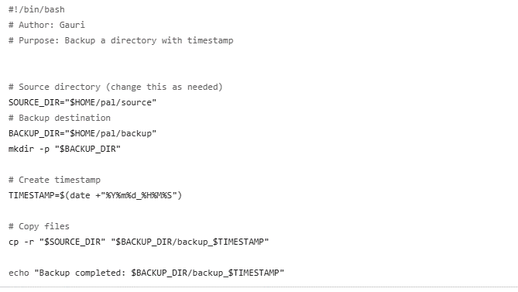

Explanation & usage: - The script accepts two arguments — the source path and a backup root directory. - It creates a timestamped backup directory and uses cp -a to preserve permissions and symbolic links.

- Script B — CPU/Memory Monitoring (cpu-mem.sh)
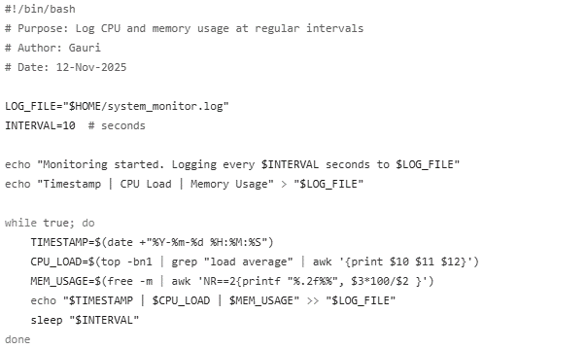

- Script C — Automated Download Task (auto_download.sh)
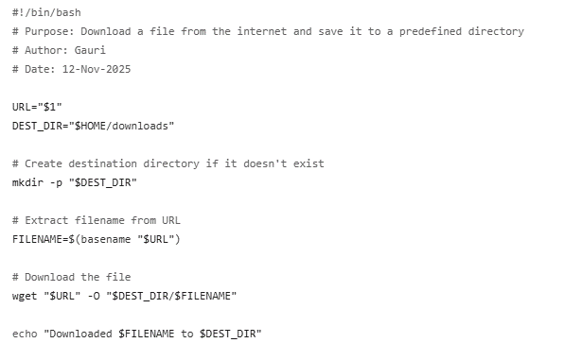

Github profile link
- https://github.com/gaurisharma-stack

Reflection
- Challenges Faced
I faced some difficulty while installing Ubuntu in WSL, especially with setting up the right hardware settings and managing the ISO file. Learning how each shell command works also took time, and writing scripts required testing and fixing small errors.

- What I Learned
I learned how to install and use Linux, run commands in the terminal, and write shell scripts to automate tasks. I also understood how to use GitHub to upload and share my work. These skills are useful for working with computers and solving technical problems.

- Real-World Relevance
Linux is used in many jobs like software development, cybersecurity, and server management. Knowing how to use Linux and write scripts helps in automating tasks and managing systems, which is important in real-world tech careers.

