Project Report: Weather Data Visualizer

College: K.R. Mangalam University
Name: Gauri Sharma
Roll No: 2501730108
Course: B.Tech CSE AIML
Section: A
Course: Programming for Problem Solving using Python

1. Introduction
This Weather Data Visualizer loads a local weather CSV file, cleans and processes the data, computes summary statistics, and produces plots showing daily temperature trends, monthly rainfall, and relationships between humidity and temperature. The design follows the assignment description.
2. Objectives
- Load and inspect a weather CSV
- Clean missing values and convert dates
- Compute daily/monthly statistics
- Create and save informative plots
- Export cleaned data for further use
3. Files Generated
- weather analyser.ipynb
- weather_data.csv (sample)
- cleaned_weather.csv (generated after run)
- plots/daily_temp.png
- plots/monthly_rainfall.png
- plots/humidity_vs_temp.png
- README.md
- requirements.txt
4. How to Run
1. Ensure Python 3.8+ is installed and packages are available (`pip install -r requirements.txt`).
2. From the project folder, run: `python weather_visualizer.py`.
3. After execution, check `cleaned_weather.csv` and the `plots/` folder for PNG images.
5. Summary of Results (example)
After running the script on the provided sample CSV, daily and monthly statistics are produced, and plots are saved. Replace the sample CSV with a real dataset to get more meaningful insights.
6. Execution / Screenshots
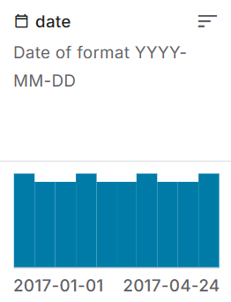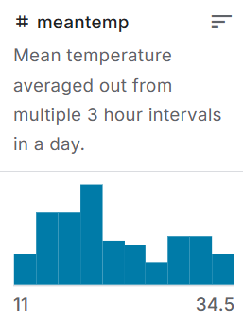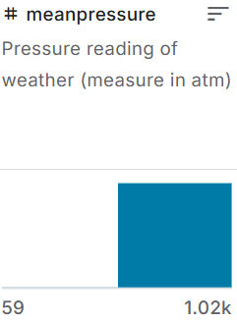
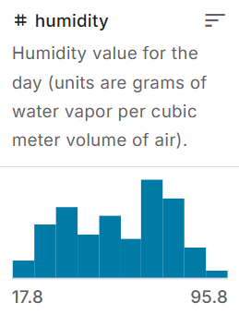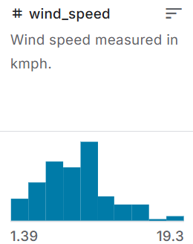

7. Conclusion
This project demonstrates data cleaning, aggregation, and visualisation using pandas and matplotlib. It is suitable for inclusion in the course submission and GitHub repository.

