- What I gathered based on Assignment Description
Issue: a significant number of customers are abandoning their shopping carts and leaving the store before reaching the checkout.
Suspected Cause: Excessive waiting time in the checkout queues
Central Problem: The central problem faced by the supermarket is clear: when customers perceive that the queueing time is too long, many choose to abandon their carts and exit the store, resulting in lost sales and customer dissatisfaction
What Management Wants: Management wants to understand when, where, and why these excessive delays occur.
Some sample questions suggested in pdf
• Which activities contribute most to queue buildup;
• How staff availability influences waiting times;
• Whether certain activities and/or resources create systemic bottlenecks;
• How customer behavior impacts queue selection dynamics; and,
• What operational changes could reduce abandonment rates
Questions based on common sense without checking what is in log what could be some common causes
Customer perspective:
I see all the queues are too long so I leave the store
I see that queues are moving very slowly customer have too much in their carts
I see that cashier is very slow
I see that not enough clerks are available due to which maybe cahier is has to do clerks job
I see that handover takes time but I am not sure how helpful would that be
Manger’s Role I am not sure
What does this mean?
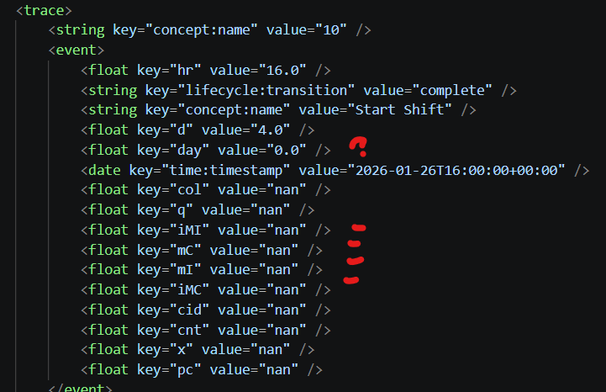
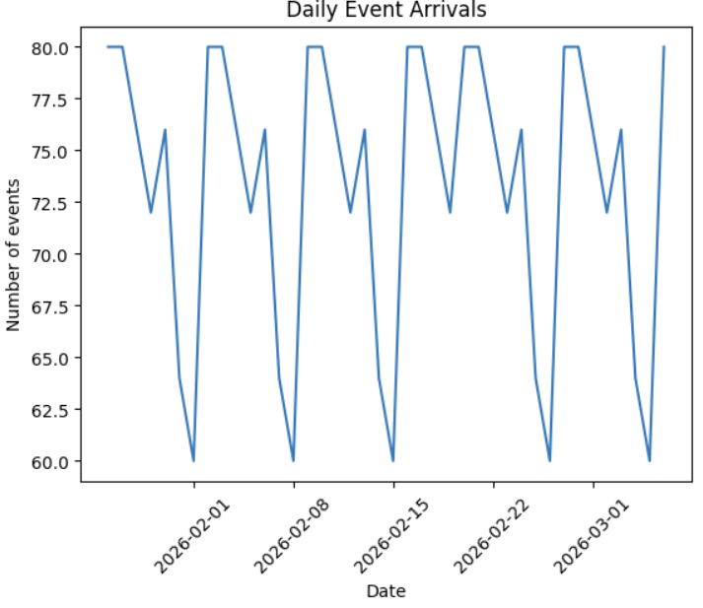
We can check if this pattern repeats else most things seem stable.
To be further studied :
- col: encoded description of the state of all counters, queue positions, and whether customers are waiting
• q: queue identifiers or queue structure at the moment of the event
• cnt: number of counters closed or opened in the activity

From the clerk log

- cid: counter ID where assistance is needed
- q: queue of pending assistance requests

Node-Average Sojourn Time
On Edges-Average waiting time between two activities across all cases
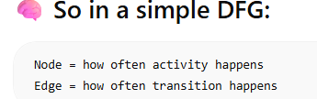

For Counter Dataset
Find out time it takes in Scanning items~ because if a lot then more counters would be required
If any anomaly pairing that with cashier would also help in analysing if more counter/cashier are required
Time it takes to start and end price check~ because more of it would mean more clerks required for a particular time
Time to complete the payment Maybe Payment Method Used also influences
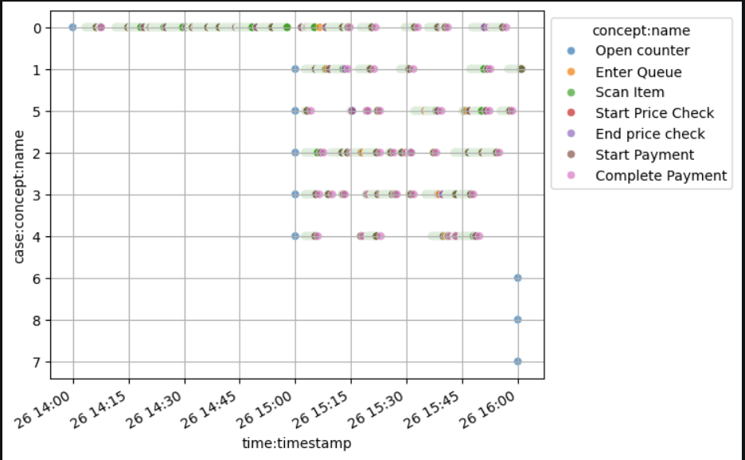
How many Counters need to be simultaneously are there specific days or?
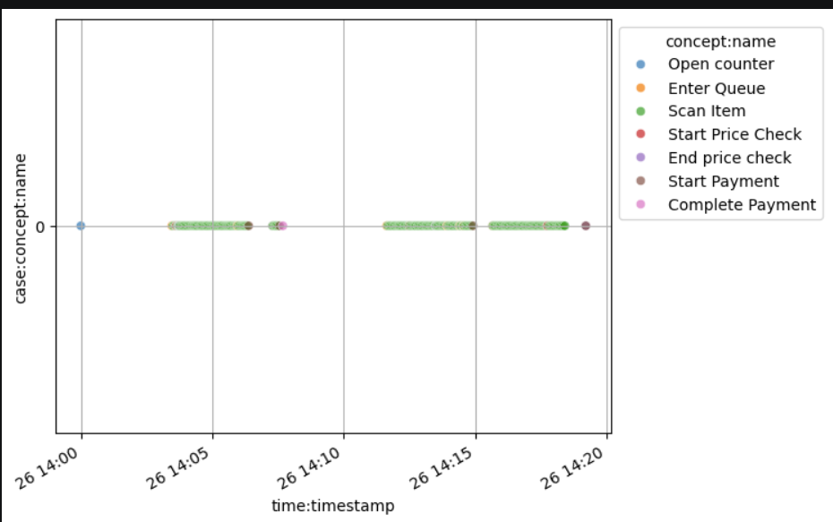
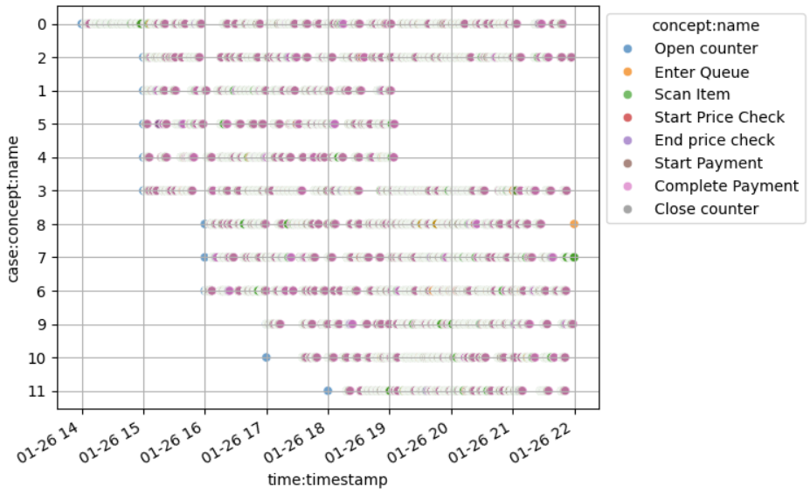
Time being wasted each time new counter is opened, also why are some counters shut after 19?
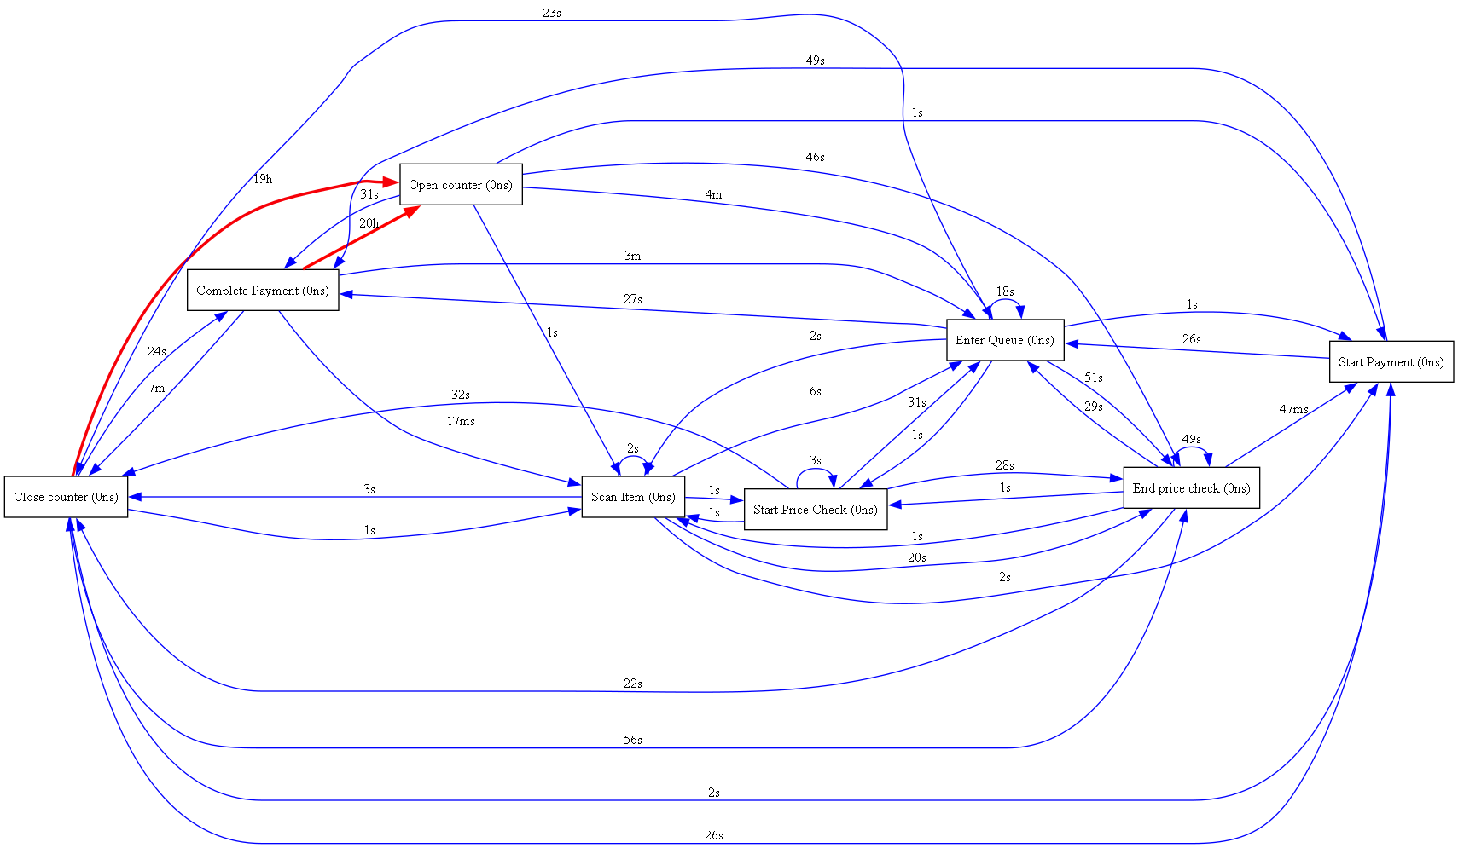
Complete Payment to Open Counter area of concern
For Customer Log
Total Time from Entry to Exit
Time taken to go from checkout to scanning item—if more detail then (time from checkout to enter queue and enter queue to scan)~ this can give idea about whether the customer is thinking about the queue ahead or not.

Time taken from Scanning to full payment
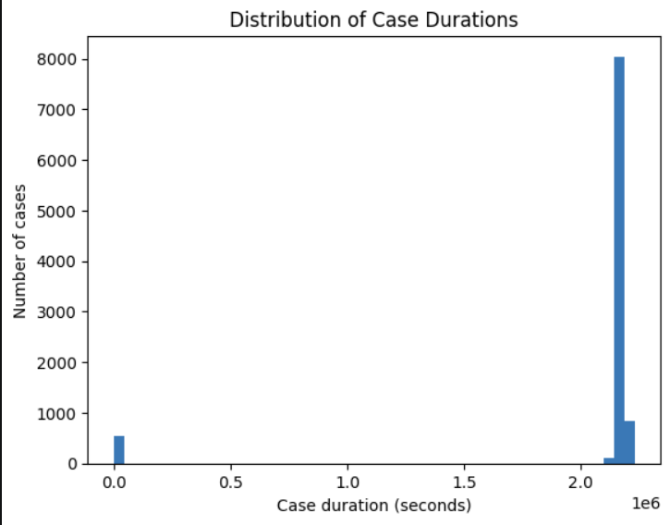
Inspecting cases with 0 duration and those that are greater than 2 compare them
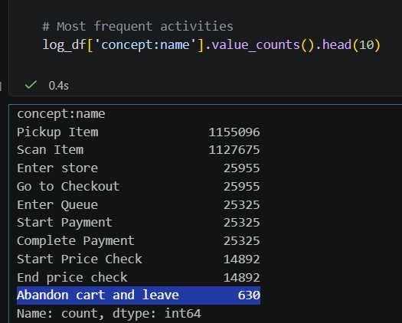
Also these
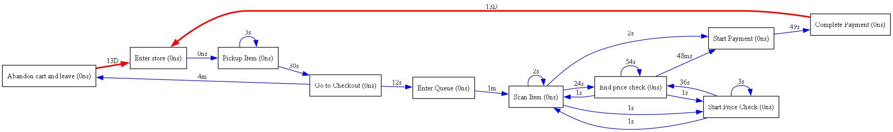
Why carts are being abandoned? Why 13 days could be potential flaw?
For Manager Log
Analyse cases when there is vs no manger
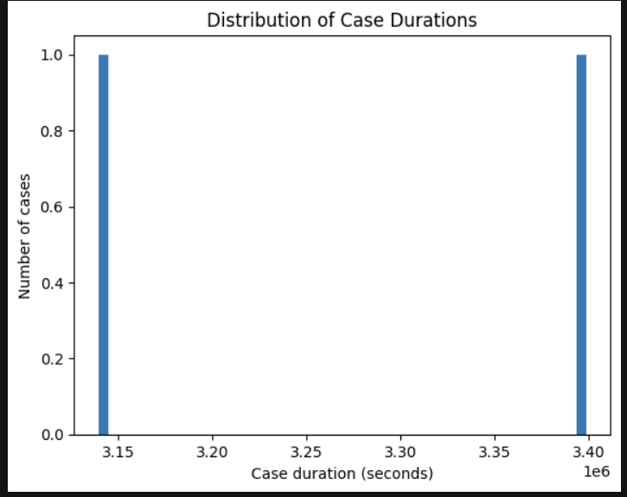
Comparing different case durations.

Can we combine datasets and analyse?

