
JAYPEE INSTITUTE OF INFORMATION TECHNOLOGY, NOIDA
B.TECH
III-SEMESTER PROJECT SYNOPSIS
TITLE OF PROJECT:
WEB ARCHIVE TIME MACHINE: A DBMS-BASED WEBSITE SNAPSHOT AND VERSION TRACKING SYSTEM
Submitted by:
Name | Enrollment No
Gaurish Sethia | 2501030328
Manas Sehgal | 2501030322
Akshar Dulloo | 2501030325
Pranav Agarwal | 2501030331

1. Project Title
Web Archive Time Machine: A DBMS-Based Website Snapshot and Version Tracking System

2. Brief Description of the Project
Web pages change or disappear over time, and there is rarely a simple way to see what a page looked like on an earlier date. This project builds a small web-archive system, in the spirit of the Wayback Machine, with the database as its core. A user submits a URL; the system fetches the page and stores a snapshot (the HTML, a timestamp, an HTTP status code and a content hash). Over time every URL accumulates a history of snapshots that users can browse on a timeline and compare.
The project is chosen to demonstrate the main ideas of a DBMS course on a realistic problem: schema design, normalization up to 3NF, keys and constraints, indexing, triggers, stored procedures, views and time-based queries.

Key features
- Snapshot timeline: all versions of a URL ordered by capture time, with date-range queries.
- Closest snapshot to a date: a nearest-timestamp lookup that returns the version of a page nearest to a date chosen by the user.
- Duplicate avoidance: a snapshot is stored only if its content hash differs from the latest one for that page, enforced by a stored procedure.
- Change statistics: snapshots per month and most-archived domains, using GROUP BY, aggregate functions and views.
- Audit trail: a trigger records every snapshot insert in an audit table.
- Indexing study: a composite index on (page_id, captured_at), with query times compared before and after.
- Version comparison: a text diff between any two snapshots of a page.

Proposed technology
MySQL or PostgreSQL as the database; Python (Flask) for the application layer, using the requests library to fetch pages and difflib to compare snapshots; and a simple HTML frontend.

3. Database Introduction with ER Diagram and Mapping

3.1 Database introduction
The database stores which websites and pages are being archived, every captured version of those pages, and which users asked for captures. It has six entities: WEBSITES, PAGES, SNAPSHOTS, USERS, CAPTURE_REQUESTS and TAGS. A website has many pages, a page has many snapshots, and each snapshot is an immutable record of a page at one moment. Users submit capture requests for pages, and snapshots can be labelled with tags (for example "news" or "homepage").

3.2 Entities and attributes
Entity | Attributes (primary key underlined in diagram) | Description
WEBSITES | site_id (PK), domain, added_on | A domain being archived
PAGES | page_id (PK), site_id (FK), url, title | A specific URL on a website
SNAPSHOTS | snap_id (PK), page_id (FK), captured_at, content_hash, html_content, status_code | One captured version of a page
USERS | user_id (PK), name, email | A person using the system
CAPTURE_REQUESTS | req_id (PK), user_id (FK), page_id (FK), requested_at, status | A user's request to capture a page
TAGS | tag_id (PK), tag_name | A label that can be attached to snapshots

3.3 ER diagram
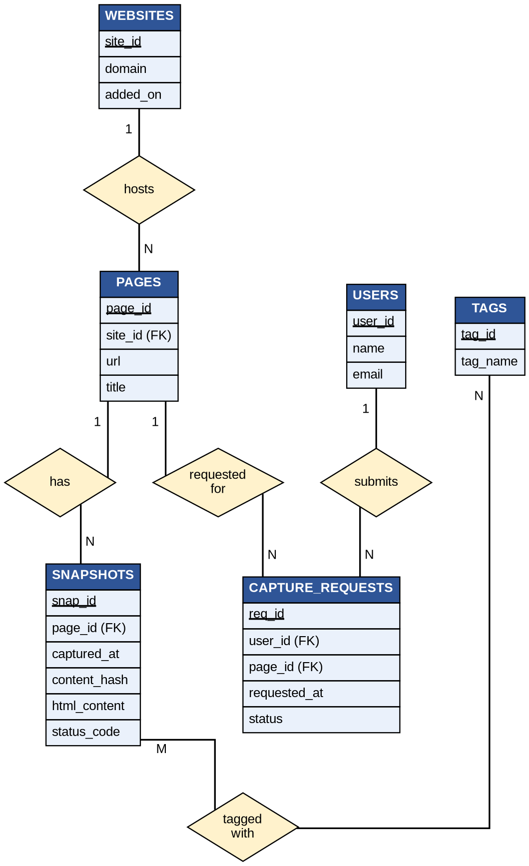
Figure 1: ER diagram of the Web Archive Time Machine database

3.4 Mapping (relationships and cardinality)
Relationship | Entities | Cardinality | Participation
hosts | WEBSITES – PAGES | 1 : N | A website has many pages; each page belongs to exactly one website (total on PAGES)
has | PAGES – SNAPSHOTS | 1 : N | A page has many snapshots; each snapshot belongs to exactly one page (total on SNAPSHOTS)
submits | USERS – CAPTURE_REQUESTS | 1 : N | A user can submit many requests; each request is made by one user (total on CAPTURE_REQUESTS)
requested for | PAGES – CAPTURE_REQUESTS | 1 : N | A page can be requested many times; each request targets one page (total on CAPTURE_REQUESTS)
tagged with | SNAPSHOTS – TAGS | M : N | A snapshot can have many tags and a tag can label many snapshots (partial on both sides)

USERS and PAGES are indirectly related through CAPTURE_REQUESTS, which resolves that many-to-many association into two 1:N relationships.

4. ER to Table Conversion
The ER diagram is converted to relational tables using these rules:
- Each entity becomes a table, and its key attribute becomes the primary key.
- Each 1:N relationship is implemented by placing the primary key of the "1" side as a foreign key in the table of the "N" side.
- The M:N relationship (SNAPSHOTS–TAGS) becomes a separate junction table whose primary key is the combination of both foreign keys.

4.1 Relational schema
Table | Columns | Keys and constraints
websites | site_id, domain, added_on | PK (site_id); domain UNIQUE, NOT NULL
pages | page_id, site_id, url, title | PK (page_id); FK site_id → websites(site_id); url UNIQUE, NOT NULL
snapshots | snap_id, page_id, captured_at, content_hash, html_content, status_code | PK (snap_id); FK page_id → pages(page_id); UNIQUE (page_id, captured_at); captured_at, content_hash NOT NULL
users | user_id, name, email | PK (user_id); email UNIQUE, NOT NULL
capture_requests | req_id, user_id, page_id, requested_at, status | PK (req_id); FK user_id → users(user_id); FK page_id → pages(page_id); status limited to a fixed set of values (e.g. pending, done, failed)
tags | tag_id, tag_name | PK (tag_id); tag_name UNIQUE, NOT NULL
snapshot_tags | snap_id, tag_id | PK (snap_id, tag_id); FK snap_id → snapshots(snap_id); FK tag_id → tags(tag_id)

4.2 Normalization
All tables are in Third Normal Form (3NF). Every column holds a single atomic value; each non-key column depends on the whole primary key and on nothing but the key. Website details live only in websites, page details only in pages, and snapshot content only in snapshots, so a domain name or page title is never repeated across rows.

4.3 Supporting database objects
- Index: composite index on snapshots (page_id, captured_at) to speed up timeline and nearest-date queries.
- Trigger: AFTER INSERT on snapshots writes a row to a snapshot_audit table (audit_id, snap_id, action, logged_at).
- Stored procedure: add_snapshot(page_id, html, hash, status) inserts a snapshot only if the hash differs from the page's latest snapshot.
- Views: monthly snapshot counts per page and most-archived domains.

4.4 Deliverables
ER diagram, relational schema, normalization steps, SQL scripts (tables, sample data, trigger, procedure, queries) and output screenshots.

